绝密★启封并使用完毕前
2010年普通高等学校招生全国统一考试(湖南卷)
英 语
本试题卷分四个部分，共13页。时量l20分钟。满分150分。
Part I Listening Comprehension (30 marks)
Section A (22.5 marks)
Directions: In this section, you will hear six conversations between two speakers. For each conversation, there are several questions and each question is followed by three choices marked A, B and C. Listen carefully and then choose the best answer for each question.
You will hear each conversation TWICE.
Example:
When will the magazine probably arrive?
A. Wednesday. B. Thursday. C. Friday. The answer is B.
Conversation 1
1. Why do they want to buy a gift for their mother?
A. It's her birthday. B. It's Mother's Day. C. It's Women's Day.
2. What are they going to buy?
A. Some flowers. B. A box of chocolates. C. A book.
Conversation 2
3, What does the woman ask the man to do?
A. Go to a bank. B. Mail letters. C. Buy some magazines.
4. What time will the man probably be back?
A. 9:00. B. 9:30. C. 10:00.
Conversation 3
5. What is the woman going to do tonight?
A. Go to a concert. B. Phone her doctor. C. Prepare for an exam.
6. What is the probable relationship between the two speakers?
A. Teacher and student. B. Classmates. C. Doctor and patient.
Conversation 4
7. Where does the man want to go?
A. The history museum. B. The Central Park. C, The high school.
8. How far away is the place?
A. Two blocks. B. Three blocks. C. Five blocks.
9. When is the place open?
A. From Monday to Friday. B. Through the whole week. C. On Saturday and Sunday.
Conversation 5
10. Why is Mr. Jackson out of the office?
A. He has been injured.
B. He has gone to London.
C. He is looking after his wife.
11. How long will he probably be away from work?
A. One week. B. Two weeks. C. Three weeks.
12. Who will do his work while he is away?
A. His wife. B. The boss. C. The secretary.
Conversation 6
13. Where are the two speakers?
A. In a dining hall. B. In a hospital. C. In a lecture room.
14. What did the man do?
A. He saw a doctor.
B. He took some medicine.
C. He had vegetables for lunch.
15. What does the woman think the man should do?
A. Have meals regularly.
B. Go to Dr. Kevin's office.
C. Pay attention to his health.
Section B (7.5 marks)
Directions: In this section, you will hear a short passage. Listen carefully and thenfill in the numbered blanks with the information you have heard. Fill in each blank with NO MORE THAN THREE WORDS.
You will hear the short passage TWICE.
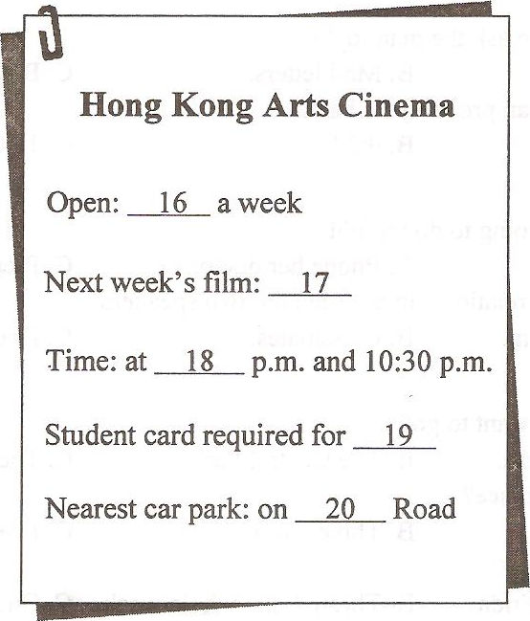
Part II Language Knowledge (45 marks) Section A (15 marks)
Directions: Beneath each of the following sentences there are four choices marked A,
B, C and D. Choose the one answer that best completes the sentence.
Example:
The wild flowers looked like a soft orange blanket the desert.
A. covering B. covered C. cover D. to cover
The answer is A.
21. Listen! Do you hear someone for help?
A. calling B. call C. to call D. called
22. Father goes to the gym with us although he dislikes going there.
A. hardly B. seldom C. sometimes D. never
23. You buy a gift, but you can if you want to.
A. must B. mustn't C. have to D. don't have to
24. This coastal area a national wildlife reserve last year.
A. was named B. named C. is named D. names
25. John's success has nothing to do with good luck. It is years of hard work has
made him what he is today.
A. why B. when C. which D. that
26. Dina, for months to find a job as a waitress, finally took a position at a local advertising agency.
A. struggling B. struggled C. having struggled D. to struggle
27. I was just going to cut my rose bushes but someone it. Was it you?
A. has done B. had done C. would do D. will do
28. I've become good friends with several of the students in my school I met in the
English speech contest last year.
A. who B. where C. when D. which
29. If he my advice, he wouldn't have lost his job.
A. followed B. should follow C. had followed D. would follow
30. So far nobody has claimed the money in the library.
A. discovered B. to be discovered
C. discovering D. having discovered
31. I walked slowly through the market, where people all kinds of fruits and vegetables.
I studied the prices carefully and bought what I needed.
A. sell B. were selling C. had sold D. have sold
32. Tim is in good shape physically he doesn't get much exercise.
A. if B. even though C. unless D. as long as
33. Listening to loud music at rock concerts caused hearing loss in some teenagers.
A. is B. are C. has D. have
34. I'm tired out. I all afternoon and I don't seem to have finished anything.
A. shopped B. have shopped
C. had shopped D. have been shopping
35. Cindy shut the door heavily and burst into tears. No one in the office knew she
was so angry.
A. where B. whether C. that D. why
Section B (18 marks)
Directions: For each blank in the following passage there are four words or phrases marked A, B, C and D. Fill in each blank with the word or phrase that best fits the context.
Behind our house is the start of a fascinating trail (小径). This trail is one of the old roads that wind through untold miles of forest. My 36 , Beans, and I walk the trail frequently. Normally, Beans sniffs alongside the trail to follow the smell of a deer track or 37 some cause known only to him.
Beans is a white dog, quite handsome and very 38 . He not only understands what
we tell him, but also often makes sounds as if he were trying to 39 back.
One morning, we took a different route, which led us to an unfamiliar trail. I was sure this trail would eventually lead us to our familiar 40 . But, no. We seemed to be far off course. After two hours, I suddenly realized that Beans probably 41 the way home. So I urged, "Beans, take me home." He ran down a new trail. But it merely led to an intersection (岔道口) of trails.
Soon it became 42 that we were getting nowhere. I began to picture the rest of the day in the 43 , without food or drink. We had walked about ten miles. But Beans seemed totally 44 . The sniffing and exploring was going well for him.
Finally, we 45 a crossroad near a highway. Lady Luck suggested I should turn left. We did and 46 reached a cottage beside a field. I knocked on the door and explained my situation to an old man. He laughed and then drove us home.
Since our adventure, I 47 that Beans probably knew all along how to get home.
He was just having too much fan exploring new trails.
36. A. deer B. dog C. lady D. man
37. A. imagine B. consider C. explore D. present
38, A. smart B. sweet C. slow D. shy
39. A. turn B. kick C. jump D. speak
40. A. driveway B. path C. crossroad D. highway
41. A. knew B. saw C. showed D. made
42. A, mysterious B. ridiculous C. fascinating D. apparent
43. A. house B. forest C. field D. cottage
44. A. unconcerned B. unconscious C. undecided D. uncomfortable
45. A. left for B. went off C. came to D. drove toward
46. A. punctually B. frequently C. formally D. shortly
47. A. regretted B. remembered C. concluded D. confirmed
Section C (12 marks)
Directions: Complete the following passage by filling in each blank with one word
that best fits the context.
Parents are busy people. If they are working, they are usually not at home 48
their children return from school. Sometimes it is necessary for a parent to write 49 after-school note for their children. They sometimes put the note on the kitchen table, the refrigerator, 50 another place where their children are sure to find it. A note is often a 51 way to "talk" with a child than using the telephone. For one thing, parents have time to think about 52 they want to say before they write. 53 another, the note lists all the information in one place. It is easy to read again and again People often forget all the details that 54 hear in a telephone call. Finally, cell phones can be turned 55 or telephone calls not answered. For these reasons, after-school notes are very popular with parents.
Part III Reading Comprehension (30 marks)
Directions: Read the following three passages., Each passage is followed by several questions or unfinished statements. For each of them there are four choices marked A, B,C and D. Choose the one that fits best according to the information given in the passage.
A
L1PITOR
ABOUT LIPITOR
Lipitor is a prescription medicine．Along with diet and exercise，it lowers “bad，’
Cholesterol (胆固醇) in your blood．It can also raise “good'’ cholesterol·
Lipitor can lower the risk of heart attack in patients with several common risk factors，
including family history of early heart disease，high blood pressure，age and smokin.
WHO IS LIPITOR FOR?
Who can take LIPITOR：
．People who cannot lower their cholesterol enough with diet and exercise
·Adults and children over l0
Who should NOT take LIPITOR：
．Women who are pregnant，may be pregnant，or may become pregnant. Lipitor may harm
your unborn baby．
．women who are breast-feeding．Lipitor can pass into your breast milk and may harm
your baby．
·People with liver(肝脏)problems
POSSIBLE SIDE EFFECTS OF LIPITOR
Serious side effects in a small number of people：
．Muscle(肌肉)problems that can lead to kidney(肾脏)problems，including kidney failure
．Liver problems．Your doctor may do blood tests to check your liver before you start
Lipitor and while you are taking it．
Call your doctor right away if you have：
．Unexplained muscle pain or weakness，especially if you have a fever or feel very fired
．Swelling of the face，lips，tongue，and／or throat that may cause difficulty in breathing or
swallowing
·Stomach pain
Some common side effects of LIPITOR are：
·Muscle pain
·Upset stomach
·Changes in some blood tests

HOW TO TAKE LIPITOR
DO：
’Take Lipitor as prescribed by your doctor．
‘Try to eat heart-healthy foods while you take Lipitor．
‘Take Lipitor at any time of day, with or without food．
‘If you miss a dose(一剂)，take it as soon as you remember．But if it has been more than
12 hours since your missed dose，wait．Take the next dose at your regular time．
Don’t：
‘Do not change or stop your dose before talking to your doctor．
·Do not start new medicines before talking to your doctor．

56.What is a major function of Lipitor?
A. To help quit smoking.
B. To control blood pressure.
C. To improve unhealthy diet.
D. To lower "bad" cholesterol.
57. Taking Lipitor is helpful for .
A. breast-feeding women
B. women who are pregnant
C. adults having heart disease
D. teenagers with liver problems
58. If it has been over 12 hours since you missed a dose, you should .
A. change the amount of your next dose B, eat more when taking your next dose
C. have a dose as soon as you remember D. take the next dose at your regular time
59. Which of the following is a common side effect of taking Lipitor?
A. Face swelling. B. Upset stomach.
C. Kidney failure.. D. Muscle weakness.
60. What is the main purpose of the passage?
A. To teach patients ways for quick recovery.
B. To present a report on a scientific research.
C. To show the importance of a good lifestyle.
D, To give information about a kind of medicine.
B
When Mary Moore began her high school in 1951, her mother told her, "Be sure and take a typing course so when this show business thing doesn't work out, you'll have something to rely on." Mary responded in typical teenage fashion. From that moment on, "the very last thing I ever thought about doing was taking a typing course," she recalls.
The show business thing worked out, of course. In her career, Mary won many awards. Only recently, when she began to write Growing Up Again, did she regret ignoring her mom," I don't know how to use a computer," she admits.
Unlike her 1995 autobiography, After All, her second book is less about life as an
award-winning actress and more about living with diabetes (糖尿病). All the money from the book is intended for the Juvenile Diabetes Research Foundation (JDRF), an organization she serves as international chairman. "I felt there was a need for a book like this," she says."I didn't want to lecture, but I wanted other diabetics to know that things get better when we're self-controlled and do our part in managing the disease."
But she hasn't always practiced what she teaches. In her book, she describes that awful day, almost 40 years ago, when she received two pieces of life-changing news. First, she had lost the baby she was carrying, and second, tests showed that she had diabetes. In a childlike act, she left the hospital and treated herself to a box of doughnuts (甜甜圈). Years would pass before she realized she had to grow up--again---and take control of her diabetes, not let it control her. Only then did she kick her three-pack-a-day cigarette habit, overcome her addiction to alcohol, and begin to follow a balanced diet.
Although her disease has affected her eyesight and forced her to the sidelines of the dance floor, she refuses to fall into self-pity. "Everybody on earth can ask, 'why me?' about something or other," she insists. "It doesn't do any good. No one is immune (免疫的) to heartache, pain, and disappointments. Sometimes we can make things better by helping others. I've come to realize the importance of that as I've grown up this second time. I want to speak out and be as helpful as I can be."
61. Why did Mary feel regretful?
A. She didn't achieve her ambition.
B. She didn't take care of her mother.
C. She didn't complete her high school.
D. She didn't follow her mother's advice.
62.We can know that before 1995 Mary 。
A. had two books published
B. received many career awards
C. knew how to use a computer
D. supported the JDRF by writing
63. Mary's second book Growing Up Again is mainly about her __
A, living with diabetes
B, successful show business
C. service for an organization
D. remembrance of her mother
64. When Mary received the life-changing news, she __.
A. lost control of herself
B. began a balanced diet
C. tried to get a treatment
D. behaved in an adult way
65. What can we know from the last paragraph?
A. Mary feels pity for herself.
B. Mary has recovered from her disease.
C. Mary wants to help others as much as possible.
D. Mary determines to go back to the dance floor.
C
People from East Asia tend to have more difficulty than those from Europe in distinguishing facial expressions--and a new report published online in Current Biology explains why.
Rachael Jack, University of Glasgow researcher, said that rather than scanning evenly
(均匀的) across a face as Westerners do, Easterners fix their attention on the eyes.
"We show that Easterners and Westerners look at different face features to read facial expressions," Jack said. "Westerners look at the eyes and the mouth in equal measure, whereas Easterners favor the eyes and neglect (忽略) the mouth."
According to Jack and her colleagues, the discovery shows that human communication of emotion is more complex than previously believed. As a result, facial expressions that had been considered universally recognizable cannot be used to reliably convey emotion in cross-cultural situations.
The researchers studied cultural differences in the recognition of facial expressions by recording the eye movements of 13 Western Caucasian and 13 East Asian people while they observed pictures of. expressive faces and put them into categories: happy, sad, surprised, fearful, disgusted, angry, or neutral. They compared how accurately participants read those facial expressions using their particular eye movement strategies.
It turned out that Easterners focused much greater attention on the eyes and made significantly more errors than did Westerners. "The cultural difference in eye movements that they show is probably a reflection of cultural difference in facial expressions," Jack said. "Our data suggest that whereas Westerners use the whole face to convey emotion, Easterners use the eyes more and mouth less."
In short, the data show that facial expressions are not universal signals of human emotion. From here on, examining how cultural factors have diversified these basic social skills will help our understanding of human emotion. Otherwise, when it comes to communicating emotions across cultures, Easterners and Westerners will find themselves lost in translation.
66. The discovery shows that Westerners __
A. pay equal attention to the eyes and the mouth
B. consider facial expressions universally reliable
C. observe the eyes and the mouth in different ways
D. have more difficulty in recognizing facial expressions
67. What were the people asked to do in the study?
A. To make a face at each other. B. To get their faces impressive.
C. To classify some face pictures. D. To observe the researchers' faces.
68. What does the underlined word "they" in Paragraph 6 refer to?
A. The participants in the study.
B. The researchers of the study.
C. The errors made during the study.
D. The data collected from the study.
69. In comparison with Westerners, Easterners are likely to __
A. do translation more successfully
B. study the mouth more frequently
C. examine the eyes more attentively
D. read facial expressions more correctly
70. What can be the best title for the passage?
A. The Eye as the Window to the Soul
B. Cultural Differences in Reading Emotions
C. Effective Methods to Develop Social Skills
D. How to Increase Cross-cultural Understanding
Part 1V Writing (45 marks) Section A (10 marks)
Directions: Read the following passage. Fill in the numbered blanks by using the
information from the passage.
Write NO MORE THAN THREE WORDS for each answer.
An apprenticeship is a form of on-the-job training that combines workplace experience and classroom learning. It can last anywhere from one to six years, but four years is typical for most. An apprentice spends the majority of the time in a workplace environment learning the practical skills of a career from a journeyman--someone who has done the job for many years. The rest of the apprentice's time is spent in a classroom environment learning the theoretical skills the career requires. Being an apprentice is a full-time undertaking.
One of the advantages of apprenticeship is that it does not cost apprentices anything. The companies that hire them pay for school. What's more, it offers apprentices an "earn while you learn" opportunity. They usually start out at half the pay of a journeyman, and the pay increases gradually as they move further along in the job and studies. Near the end of the apprenticeship, their wages are usually 90 percent of what a journeyman would receive. Apprenticeship also pays off for employers. It can offer employers a pool of well-trained workers to draw from.
Despite the advantages, apprentices are usually required to work during the day and attend classes at night, which leaves little time for anything else. Sometimes, they might be laid off (下岗) if business for the employers is slow.
Once they have completed the apprenticeship and become journeymen, they receive a nationally recognized and portable certification and their pay also increases again. Some journeymen continue employment with the companies they apprenticed with; others go onto different companies or become self-employed contractors.
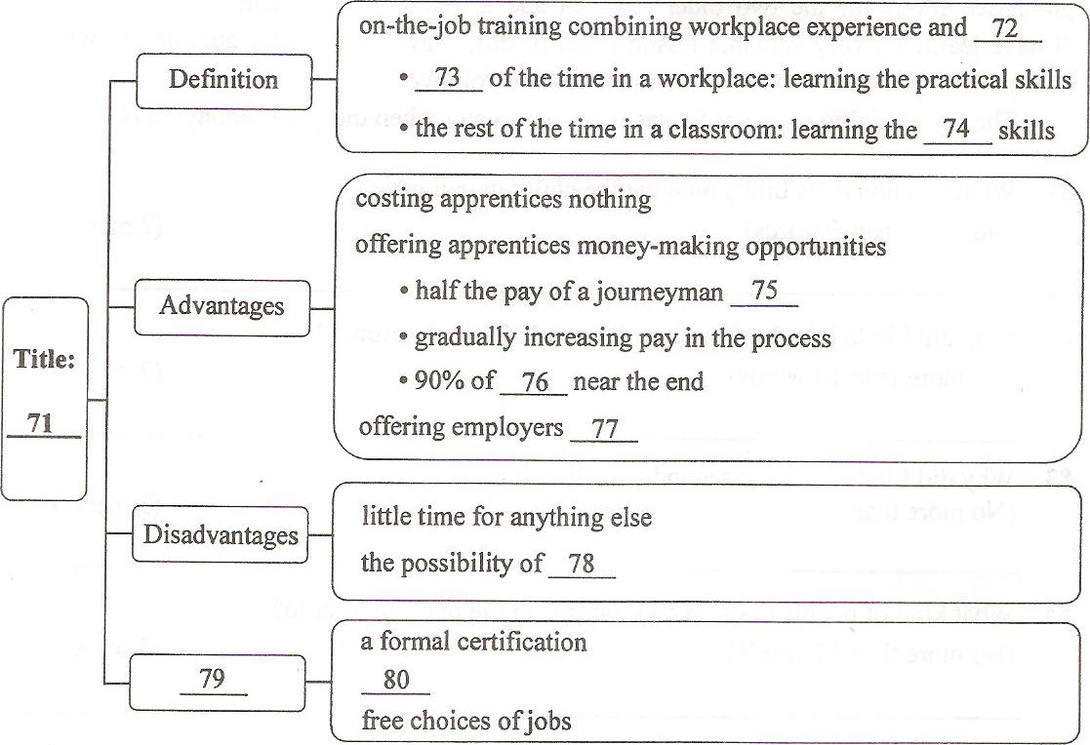
Section B (10 marks)
Directions: Read the following passage, Answer the questions according to the
information given in the passage.
Secret Santas
On Christmas morning, Linda wakes up, and tries to imagine the wide-eyed surprise of children in another household as they unwrap the presents she carefully chose for them. Linda has never met the children, but that’s all part of the joy of giving as secret Santas, she says.
"It's an amazing feeling to buy gifts on an anonymous (匿名的) basis," says Linda.
"It brings a whole new meaning to the holidays."
Linda and Tony are an American couple living in Toronto, Canada, and Linda did charitable work as a member of the American Women's Club of Toronto. As the name suggests, members are U.S. citizens living in Toronto, who join together for fellowship and community service.
To find her "adopted" family, Linda goes to the local schools and requests a wish list for a family that's struggling to survive. Last year she helped a single mother with three children. The mother works as a cleaning lady in a nursing home.
"The list is always heartbreaking. They have an opportunity to ask for anything and do just the opposite, asking for basic clothes or simple toys," she says. "We always buy the kids a new winter coat, hats, and gloves." She also buys gifts for the parents.
Last year Linda asked the mother for a second wish list--one that didn't include the basics. "Every child should have a Christmas that sticks with them for a lifetime." She purchased iPods for the two older children and a video game system for the youngest."I have learned a very valuable lesson in all of this," says Linda. "Pay attention to what's going on in your own backyard--no matter where you live."
The joy of giving as secret Santas is much sweeter when the gift is anonymous.
81. What reaction does Linda imagine the children will have?
(No more than 5 words) (2 marks)

82. Why did Linda join the American Women's Club of Toronto?
(No more than 10 words) (2 marks)

83. Why did Linda ask for a second wish list?
(No more than 15 words) (3 marks)

84. What kind of people does "secret Santas" in the passage refer to?
(No more than 12 words) (3 marks)

Section C (25 marks)
Directions: Write an English composition according to the instructions given below
in Chinese.
假设你和几位同学成立了一个英语俱乐部，开展了为期两个月的活动。现在，你将代表俱乐部在课堂上进行经验交流，请写一篇英语发言稿，主要内容如下：
1．简要描述俱乐部开展的一项与英语有关的主要活动：2．谈谈你们开展该活动的收获。
注意：
1．词数不少于120个；
2．不能使用真实姓名和学校名称。
2010年普通高等学校招生全国统一考试(湖南卷)英语答案
1-10. ACBBC BABAA 11-15. CCABC
16. 7 days 17. my happy life 18. 8:10 pm 19. a cheaper ticket/a student ticket
20. Nathan Road 21-30. ACDAD CBACA 31-35. BBCDD
36-45. BCADB ADBAC 46-47. DC 48. when/after 49 an 50 or
51 better 52 what 53 For 54 they 55 off
56-65. DCDBD DBAAC 66-70. ACACB
71. Apprenticeship 72. classroom learning 73. the majority 74. theoretical
75. at the beginning 76. a journeyman’s wages 77.many well-trained workers
78. being laid off 79. results 80. another pay increase
81. They will feel greatly surprised.
82. She joined it for fellowship and community service
83. She wanted to give the children some other gifts rather than the basics
84. It refers to people who give away anonymous gifts on Christmas

