衡阳县一中2016届高三下学期3月月考试卷
英 语
本卷分第Ⅰ卷(选择题)和第Ⅱ卷(非选择题)两部分，满分150分，考试时间120分钟。
注意事项：
1. 本试卷分第I卷(选择题)和第II卷(非选择题)两部分。
2. 答题前，考生务必先将自己的姓名、准考证号填写在本试卷相应的位置。
3. 全部答案在答题卡上完成，答在本试卷上无效。
4. 第I卷听力部分满分30分，不计入总分，考试成绩录取时提供给高校作参考。
5. 考试结束后，将本试卷和答题卡一并收回。
第 I 卷
第一部分：听力（共两节，满分30分）
做题时，先将答案标在试卷上。录音内容结束后，你将有两分钟的时间将试卷上答案转涂到答题卡上。
第一节(共5小题；每小题l.5分，满分7.5分)
听下面5段对话。每段对话后有一个小题，从题中所给的A、B、C三个选项中选出最佳选项，并标在试卷的相应位置。听完每段对话后，你都有10秒钟的时间来回答有关小题和阅读下一小题。每段对话仅读一遍。
1. Why doesn't the man want more ice cream?
A. Because he is not hungry.
B. Because he cares about his weight.
C. Because he wants some meat.
2. What is the woman's favorite month?
A. March. B. May. C. June.
3. How long did the woman stay in Canada?
A. 3 days. B. 5 days. C. 7 days.
4. What should the two speakers do now?
A. Cut the grass. B. See a film. C. Do some cleaning.
5. What do we know about the man?
A. He is quite confident.
B. He does his work very slow.
C. He is rather tired.
第二节 (共15小题，每小题1.5分，满分22.5分)
听下面五段对话或独白。每段对话或独白后有几个小题，从题中所给的A、B、C三个选项中选出最佳选项，并标在试卷的相应位置。听每段对话或独白前，你将有时间阅读各小题，每小题5秒钟；听完后，各小题将给出5秒钟的作答时间，每段对话或独白读两遍。
听第6段材料。回答第6、7题。
6. What did the woman want to do before going into the restroom?
A. Pay the bill. B. Get her wallet. C. Have a rest.
7. Where was the wallet found?
A. In the restroom. B. Under the table. C. On the table.
听第7段材料，回答第8至l0题。
8. Which subject does the man think difficult?
A. Math. B. Physics. C. English.
9. When will the man do his program?
A. In January. B. In June. C. In July.
10. What can you predict from the conversation?
A. The man will be busy in summer.
B. The program will be finished in July.
C. The woman will join the man in the program.
听第8段材料，回答第11至13题。
11. Who is probably Rogers?
A. Tom's friend. B. Tom's teacher. C. Tom's boss.
12. What did Tom tell his mother in his letter?
A. He had made a new discovery.
B. He had lost his new job.
C. He had just bought a car.
13. When did Tom take the part-time job?
A. Only yesterday.
B. About three months ago.
C. About three weeks ago.
听第9段材料，回答第14至l7题。
14. How old is the woman?
A. 16 years old. B. 30 years old. C. Over 30 years old.
15. How does the woman feel about the circus?
A. Satisfied. B. Excited. C. Sad.
16. When will the animal shows begin?
A. In an hour. B. In half an hour. C. In two hours.
17. How many places have the two speakers been to at the circus?
A. 4. B. 5. C. 6.
听第l0段材料，回答第l8至20题。
18. What can we conclude from the talk?
A. The weather conditions vary greatly in the USA.
B. People in the USA are having pleasant weather.
C. The Americans are suffering from bad weather.
19. What is the weather like in the Southern states?
A. Sunny. B. Snowy. C. Rainy.
20. Which state has a high temperature?
A. Florida. B. Arizona. C. Texas.
第二部分：阅读理解（共20小题；每小题2分，满分40分）
第一节（共15小题；每小题2分，满分30分）
阅读下列短文，从每题所给的四个选项（A. B. C和D）中，选出最佳选项，并在答题卡上将该项涂黑。
A

When 12-year-old Taylor Smith wrote a special letter to herself last spring, to be read in 10 years’ time, she didn’t know it would be opened before even a year had passed— and that it wouldn’t be her eyes reading the words.
“She had told me that she had written a letter to herself, and that she was excited that she was going to open it when she was older,”said Taylor’s mother, Mary Ellen Smith.
Instead, it was opened by Taylor’s parents after she died last spring. They posted the letter to Facebook, hoping it would inspire others.
It has. “We’ve gotten letters from lots of parents who have said it has encouraged them to love their kids and love each other,” said Mary Ellen Smith.
In the letter, Taylor congratulated herself on graduating from high school and asked, “Are you in college?”
She also wanted to know if she had been on a plane yet and if the show “Doctor Who” was still on the air.
Taylor also had some words for her future kids. After considering the idea of selling her iPad and getting an iPad mini instead, she told her future self to mention to her kids that “We’re older than the tablet.” She included a drawing of an iPad for them to see.
Taylor died suddenly of pneumonia (肺炎), leaving behind both her parents and an older brother.
“I just want people to know just what an awesome, awesome person she was,” her father, Tim Smith said.
Her mother said, “I can’t bring her back, but I’m so grateful people have been inspired by her story.”
Taylor’s father read the closing g words of her letter, which said, “It’s been years since I wrote this. Stuff has happened, good and bad. That’s just how life works, and you have to go with it.”
21. Taylor Smith decided to open her letter when she was ________.
A. 18 years old B. 20 years old C. 22 years old D. 24 years old
22. Why did Taylor’s parents post her letter to facebook?
A. To show Taylor Smith’s deep love for her parents.
B. To encourage parents and kids to love each other.
C. To make themselves well-known and make money.
D. To prove Taylor Smith was good at writing.
23. We can learn from the passage that Taylor Smith ________.
A. was a college student
B. had never got an iPad
C. had never taken a plane
D. wanted to join “Doctor Who”.
24. What is the message conveyed at the end of Taylor Smith’s letter?
A. We should develop the habit of keeping a diary.
B. We should accept everything that happens in life.
C. We should stop bad things from happening.
D. We should show our love for our parents in time.
B
Art Beat in January 2016
Beijing
Youth choir to perform
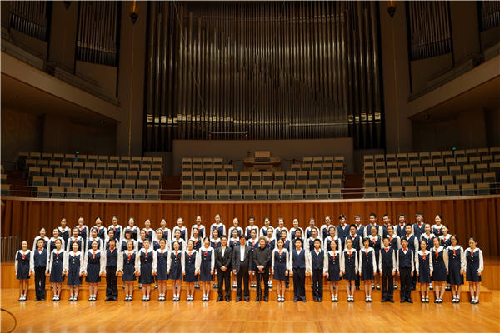
The youth choir of China National Symphony Orchestra will soon perform classics including the Mexican folk song, The Golden Nightingale, and the Blue Danube, adapted from a waltz by Johann Strauss II. Pianists Zhao Lin and Wang Tianyang will join in the show.
7:30 pm, Jan 23. Forbidden City Concert Hall, inside Zhongshan Park, west of Tian'anmen Square, Xicheng district. 010-6559-8285.
Orchestra recitals
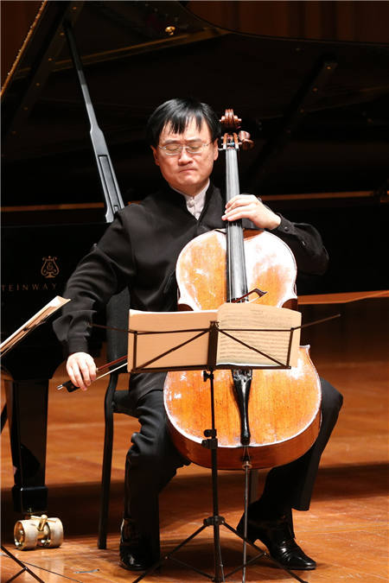
The China National Center for the Performing Arts Orchestra led by conductor Lyu Jia will give two recitals, featuring works including Beethoven's Coriolanus Overture and Mozart's Symphonies No 40 & No 41 Jupiter. Cellist Wang Jian will join in the performances, playing Schumann's Cello Concerto in A minor, Op 129 and Saint-Saens' Cello Concerto No 1 in A minor, Op 33.
7:30 pm, Jan 15; 2:30 pm, Jan 16. China National Center for the Performing Arts, No 2 West Chang'an Avenue, Xicheng District. 010-6655-0000.
Ballet from Paris

Paris Opera Ballet will present two gala performances in the city. Besides highlights of classical ballet, such as Swan Lake and Manon, the program will also include modern pieces from the company's repertoire. The leading etoiles are Ludmila Pagliero and Karl Paquette.
7:15 pm, Jan 15-16. Shanghai Oriental Art Center, 425 Dingxiang Road, Pudong district. 021-6854-1234.
Ensemble of swans
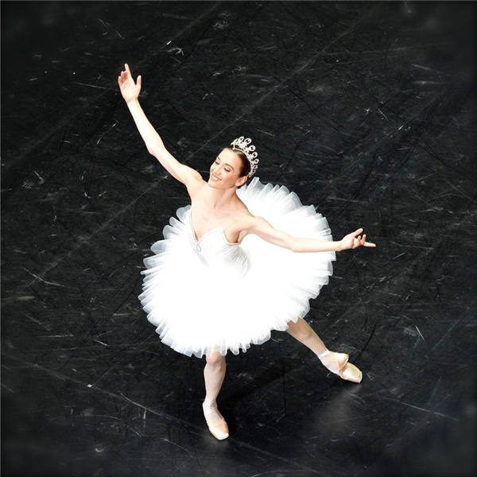
Shanghai Ballet will present two performances of Swan Lake. The production choreographed by British artist Derek Deane has just completed a tour in 26 cities of the Netherlands. The spectacular production features an ensemble of 48 dancers.
7:15 pm, Jan 22-23. Shanghai Grand Theater, 300 Renmin Avenue, Huangpu district. 400-106-8686.
25. If you only spare some time in the afternoon, you can enjoy ________.
A. Beethoven's Coriolanus Overture
B. Classical ballet Manon
C. The Golden Nightingale
D. Classical ballet Swan Lake
26. According to the text, we know that Ludmila Pagliero and Karl Paquette are ________.
A. Pianists B. ballet performers C. cellists D. violinists
27. If you are interested in ballet performances, which of the following places can you go to enjoy yourself?
A. Forbidden City Concert Hall and China National Center
B. Forbidden City Concert Hall Shanghai Grand Theater
C. Shanghai Oriental Art Center and Shanghai Grand Theater
D. China National Center and Shanghai Oriental Art Center
C

Black History Month is also known as the African-American History Month. It is celebrated all over the United States of America and Canada in the month of February, while in the United Kingdom it is celebrated in October. Each and every school and university conducts various activities to make the generation aware of the importance that African-American history holds in the nation. The electronic media is filled with themes in relevance to the occasion, and many activities are carried out across the country to remember the contribution made by African-American citizens in the development of this nation.
Black History Month was first started by a famous African-American historian Dr. Carter G. Woodson in the year 1926. February was chosen as the month to celebrate the African-American history because it was the birth month of two of the most highly valued people among African-Americans. These were President Abraham Lincoln, who freed the slaves, and Frederick Douglass, who was also the first vice presidential nominee (被任命者) among African-Americans. Initially, Black History Month was known as the “Negro History Week”. This was Dr. Woodson’s attempt to encourage awareness among citizens about the contribution of African-Americans towards the building of the nation. It was only in the early 1970’s that the name “Negro History Week” changed to “Black History Month”. And later, in the year 1976, the entire month of February was declared to be the National African-American History Month, or the Black History Month.
Every year, National African-American History Month is celebrated by many activities with various ideas and themes for the younger generation. In 2013, Black History Month celebrates the 50th anniversary of the March on Washington at which Martin Luther King, Jr. gave his famous speech “I have a dream”. It also marks the 150th anniversary of the Emancipation Proclamation (解放黑奴宣言). The theme for Black History Month in 2014 is “Civil Rights in America” remembering the important milestones by African-Americans and others in the battle for civil rights and equal treatment under the law.
28. What is the purpose of Black History Month in America?
A. To remember African-Americans’ contribution to America.
B. To remember the history of African-Americans in America.
C. To encourage African-American children to study hard.
D. To increase African-American children’s confidence.
29. February was chosen as Black History Month because ________.
A. Dr. Carter G. Woodson liked February.
B. slavery was officially ended in February.
C. African-Americans contributed a lot in February.
D. two great American leaders was born in February.
30. How is the second paragraph developed?
A. By giving examples.
B. By following time order.
C. By making comparisons.
D. By making classifications.
31. What does Black History Month in 2014 celebrate in America?
A. The 50th anniversary of the March of Washington.
B. Martin Luther King，Jr’s speech “I have a dream”.
C. The 150th anniversary of the Emancipation Proclamation.
D. Important people and occasion in the battle for civil rights.

D

Parents often assume that time spent with their kids will gradually decrease in adolescence. But a new study suggests that while teens try to avoid spending a lot of time together with their parents, private parent-child meetings may actually increase in their early adolescent years. And that may raise a teenager’s self-esteem (自尊) an social confidence, especially if it is time spent with Dad, the researchers added.
The researchers created a long-term study in which they invited families in 16 school districts in central Pennsylvania to participate. In each family, a teenager, a younger sibling, their mother and their father were interviewed at home and then asked about their activities and self-worth five times over a period of seven years.
The study authors were surprised to discover that when fathers spent more time alone with their teenagers, the kids reported they felt better about themselves. Something about the father’s role in the family seemed to improve self-esteem among the teenagers in the study, said study author Susan McHale, a professor of human development at Pennsylvania State University.
“Time spent with Dad often involves joking, teasing and other playful interactions. Fathers, as compared to mothers, were more involved in leisure activities and had more friend-like interactions with their children, which is crucial for youth social development,” the study showed.
But Marta Flaum, a psychologist in Chappaqua , New York, said, “How these findings reflect the real world is a real question. The sample in the study is so small and so unrepresentative of more families in the country today that I’m not sure how much we can generalizing from it. In my community, in Westchester County, I don’t see parents and teenagers spending much time together at all. Parents are often working so hard and have less time to be together with their kids.”
However, Flaum encourages parents tom make time for their kids no matter how much work they have to do. “Research like this reminds us of how important it is. The time we have with them is so short, ” she said.
32. According to the study, when teenagers spend more time alone with their fathers, ________.
A. their social skills will be improved
B. their fathers will better understand them
C. they will be willing to help their siblings
D. their family will spend more time together
33. What is Flaun’s attitude towards the findings of the study?
A. Unconcerned B. Favorable C. Puzzled D. Skeptical
34. What does the underlined word “it” in the last paragraph probably refer to?
A. The research by Susan McHale.
B. The work to be done.
C. Parents’ encouragement.
D. Parents’ making time for their kids.
35. Where is the passage more likely to have been taken from?
A. A science magazine B. A news report C. A research plan D. an advertisement

第二节（共5小题；每小题2分，满分10分）
根据短文内容，从短文后的选项中选出能填入空白处的最佳选项。选项中有两项为多余选项。
How to Care for Your Ears?
Ears not only let us hear, but they also play a role in maintaining our balance, which is vital to our ability to function in daily life. Yet, we ignore them. We can’t even see our ears, except in a mirror. We take for granted what they do for us day in and day out－until we notice something’s wrong, such as when an earache strikes or when we start having to ask people to repeat what they say. 36
◆ Clean your ear with a washcloth－covered finger only.
Never put anything inside your ear canal, including cotton swabs (药签). 37
◆ Leave earwax(耳垢) alone.
Wax is your ear’s way of eliminating(消除) anything foreign that gets into the ear canal. 38 If you find you have too much earwax, use a few drops of earwax remover(去除剂) in the canal. After a few minutes, wash the ear with warm water.
◆ Avoid noisy places.
Rock concerts and construction sites are just a few places that frequently have noise levels that can damage hearing. Any place where you have to shout to be heard should be avoided.
◆ 39
Be careful not to play MP3 too loud, especially if using earphone.
◆Be careful with illness and medications.
Respiratory (呼吸的) illnesses should be treated to avoid their spread to the ears. Certain medications can damage hearing, so follow the directions carefully before taking them.
See your doctor if you suffer from sudden hearing loss or hear noises in your head. 40
A. Most people don’t need to clean wax out of their ears.
B. In such case, go to see a doctor as soon as possible.
C. These can be symptoms of a serious illness which needs to be treated.
D. This article will show you how to care for your ears.
E. Turn the volume(音量)down
F. Avoid using earphones while listening to MP3.
G. Your ear canal is very narrow, and a swab can damage it.
第三部分： 英语知识运用 (共两节，满分45分)
第一节 完形填空（共20小题；每小题1. 5分，满分30分）
阅读下面短文，从短文后各题所给的四个选项（A、 B、C和D）中，选出可以填入的空白处的最佳选项，并在答题卡上将该选项涂黑。
We have a small back garden with several trees，so bird nest in abundance. Therefore, it is 41 year after year to find many young birds don’t 42 .
One morning two years ago, I found a young blackbird sitting still, very cold, in a corner. I 43 it up and moved it to a raised warmer spot, 44 it with tissue and made silly bird noises in the hope that it would 45 . It was breathing, though very weak and wouldn’t open its beak (喙). I knew it had 46 and was dying but it did start to feel warmer so there was 47 .
I kept coming to check on it, keeping our three 48 inside the house, as I didn’t want them to 49 it, as Toby, my cleverest dog had already spotted it. One time, I went to see the bird, it had 50 down, legs outstretched (伸直), so I placed it 51 back onto the tissue. Its eyes opened 52 and it seemed to look in my direction, 53 at times its head also moved round, which was not a good sign. I kept making bird noises and 54 it, saying “Come on, be strong.” I just felt so 55 , but I wanted it to know that there was someone who 56 . Unfortunately, it died. I did feel so regretful because I tried my best but I 57 .
To my 58 , last year I spotted two young blackbirds keeping each other company in one of our trees, and I’m 59 one of them had at least survived as one has been visiting 60 since and helping itself to seed from our feeders.
41. A. obvious B. strange C. usual D. special
42. A. leave B. survive C. fly D. adjust
43. A. picked B. put C. hung D. held
44. A. provided B. connected C. hid D. covered
45. A. play B. reply C. breathe D. wake
46. A. kept up B. made up C. given up D. turned up
47. A. hope B. life C. luck D. fun
48. A. birds B. dogs C. cats D. boys
49. A. visit B. annoy C. bother D. attack
50. A. fallen B. pulled C. lain D. showed
51. A. quickly B. happily C. gently D. carelessly
52. A. in vain B. in return C. in time D. in response
53. A. since B. although C. while D. unless
54. A. encouraging B. saving C. amusing D. calming
55. A. excited B. curious C. moved D. desperate
56. A. counted B. preferred C. cared D. differed
57. A. stopped B. failed C. declined D. missed
58. A. delight B. disappointment C. sorrow D. amazement
59. A. proud B. afraid C. sure D. grateful
60. A. casually B. unexpectedly C. suddenly D. regularly
第II卷
注意：将答案写在答题卡上。写在本试卷上无效。
第三部分：英语知识运用 (共两节，满分45分)
第二节（共10小题：每小题1.5分，满分15分）
阅读下面材料，在空白处填入适当的内容（1个单词）或括号内单词的正确形式。
My grandfather is a 61 (retire) worker. On summer evenings, we often sat together outside the house 62 (enjoy) the cool air. It was the time that he told me lots of his experiences before liberation.
When my grandfather was fourteen years old, he worked in a coal mine. One day, when he and his two workmates were working in the tunnel, an 63 (fortune) thing suddenly happened. A part of the tunnel fell down, and they were shut in it. They had no food 64 (eat). When they were hungry, they only drank some water there. It was very cold in it. In order to keep warm, they hugged one another. In the darkness, they didn’t know whether it was day 65 night, they only felt they had stayed there for a very long time. They were too hungry to speak or move, and thought they 66 (die). At last, the tunnel 67 (dig) through. They were saved. They had been there for fourteen days! My grandfather said they weren’t let out at once. If 68 , they would have died. They were kept at the entrance to the tunnel 69 it was very dim, and they were fed 70 some thin porridge. After a day or two, they had recovered a bit, and they were helped out.
第四部分：写作（共两节，满分35分）
第一节 短文改错（共10小题，每小题1分，满分10分）
假如英语课上老师要求同桌之间交换修改作文，请你修改你同桌的以下作文。文中共有10处错误，每句中最多有两处。错误涉及单词的增加、删除或修改。
增加：在缺词处加一个漏词符号∧，并在此符号下面写出该加的词。
删除：把多余的词用斜线＼划掉。
修改：在错词下面划一横线，并在该词下面写出修改后的词。
注意：
1、每处错误及其修改均仅限一词；
2、只允许修改10处，多者从第11处不计分。
As is known by all, with the improvement of people’s living standards, cars have become a popular means of transport, bring great convenience to our life. However, they have also caused some problems such as air pollution and traffic jam.
How can we solve these problems then? As far as I am concerning, riding bicycles is a good solution. For one thing, bicycles don’t need any petrol but they are energy-saving. For another, bicycles are environmentally friendly because of they won’t give off waste gas. Beside, riding bicycles is a good way for us to exercise and it is beneficial to our healthy.
As result, let’s take the responsibility to build up a low-carbon city by riding bicycles. Come on and join them.
第二节 书面表达（满分25分）
近些年来，随着人们生活水平的日益改善，饲养宠物的人们的数量与日俱增。饲养宠物给人们带来快乐的同时，也随之带来了一些问题。主要有：（一）、宠物发出的噪音非常扰民；（二）、动物的粪便会污染环境；（三）、当主人带着宠物去公共场所时，有些宠物会吓着孩子甚至咬人；（四）、 某些宠物会传播疾病，已经引起了人们的广泛关注。
假如你是李华，请你就上面提到的人们饲养宠物带了的问题给报社编辑写一封信，寻求帮助， 并期待媒体能够就解决该问题做一些事情。
注意：
1. 字数：100左右；
2. 可以适当增加细节，以使行文连贯；
3. 信的开头和结尾已经给出，不计入总词数。
Dear editor,
I’m sorry to occupy your precious time, but _______________________________________
__________________________________________________________________________________Yours Sincerely,
Li Hua

英语学科高三3月月考卷
参考答案
第一部分：听力
1—5 BCCCC 6—10 AAACA 11—15 CCBCB 16—20 ABACB
第二部分：阅读理解

第一节：
21-25. CBCBA. 26-30. BCADB. 31-35. DADDB.

第二节：36—40 DGAEC
第三部分：英语知识运用
第一节：完形填空
41-45. CBADB. 46-50. CABDA. 51-55. CDBAD. 56-60. CBACD.
第二节（共10小题：每小题1.5分，满分15分）
61.retired 62.enjoying 63. unfortunate 64.to eat 65.or
66. would die 67.was dug 68.so 69. where 70. on(或with)
第一节 短文改错
As is known by all, with the improvement of people’s living standards, cars have
to
become a popular means of transport, bring great convenience to our life. However, they
bringing
have also caused some problems such as air pollution and traffic jam.
jams
How can we solve these problems then? As far as I am concerning, riding bicycles
concerned
is a good solution. For one thing, bicycles don’t need any petrol but they are
and
energy-saving. For another, bicycles are environmentally friendly because of they

won’t give off waste gas. Beside, riding bicycles is a good way for us to exercise
Besides
and it is beneficial to our healthy.
health
As∧result, let’s take the responsibility to build up a low-carbon city by riding
a
bicycles. Come on and join them.
us
第二节 书面表达
One possible version:
Dear editor,
I’m sorry to occupy your precious time, but I really want to tell you something about the problem of some people keeping too many pets nowadays. I take the problem more and more seriously for the following reasons.
First of all, as it is known to people, pets make much noise that troubles residents a lot. What’s more, it is widely accepted that animal waste pollutes the environment, which makes people quite uncomfortable. Many owners like taking their pets to public places where they may frighten children or even bite people. The most important is that pets can spread some diseases and this has attracted much attention. Taking all these factors into consideration, I sincerely hope that I can get help from you and expect the media to do something for this.
Yours Sincerely,
Li Hua

附： 英语听力录音稿
Text 1
W: Mr. Smith, would you like some more ice cream?
M: No, thanks. It' s very good but I have to watch my weight.

Text 2
W: Which month do you like?
M: March is a nice month, but I think May is the best one. What about you?
W: I like June best because I can go swimming then.

Text 3
M: Hi, Jane. Did you go abroad on your vacation?
W: Yes, to Canada.
M: Did you visit some cities there?
W: Just 2 days in Vancouver, 3 days in Quebec, and 2 days in Ottawa.

Text 4
M: Shall we go and see a film?
W: No. We must do some cleaning first. Then we'll have to cut the grass in the garden.
M: Oh, it's hard work, dear.

Text 5
W: You look very tired.
M: Yes. I stayed up very late last night, rewriting my paper.
W: Haven't you finished it?
M: Not yet. I don't know when.

Text 6
W: I think my wallet was stolen, sir.
M: Do you have any reason to believe that your wallet was stolen?
W: Oh, yes. I left it on the table half an hour ago, but when I came back from the restroom, it was gone.
M: Are you sure you left your wallet on the table?
W: Of course, sir. I planned to pay the bill before I went to the restroom.
M: Is this your wallet? We found it in the restroom.
W: Oh, yes, it is, I must have left it there and I forgot. Sorry.

Text 7
W: How are you?
M: I' m fine, thanks. How about you?
W: I' m okay. What are you doing these days?
M: Not a lot, actually. Busy at school with my lessons, of course. I have difficulty in learning math.
W: Maybe you need to do some easy problems. And later on, you will be able to do difficult problems.
M: Yeah. I agree. We've got a big program in July. I may have to spend a few weeks of my summer vacation doing it.
W: That' s great. When are you starting?
M: Probably on July the 20th.
W: I hope you will be successful in finishing it.
Text 8
W: What are you doing, Tom?
M: I'm writing to my mother.
W: But you wrote to her only yesterday.
M: Yes, but I have something new to tell her.
W: Something new?
M: Yes. I am telling her I've decided to take up a part-time job as a shop assistant.
W: What do you mean? You've been working at one nearly three months. Have you been fired by Rogers?
M: No. My mother doesn't know I have a part-time job.
W: You mean you didn't tell her before?
M: No. I didn't want her to worry about my study.
W: But why are you telling her now?
M: Now, I don' t want her to worry about my life here. You see, I told her that I'd just bought a car in my letter.

Text 9
W: This is exciting. I've never been to a circus before. I feel like I' m 16 now.
M: You're already in your early 30's.
W: You don't have to tell me!
M: No hard feelings, OK?
W: OK. Where shall we go now? We've been to the Magic House, the Witch's Cottage, Snake Man, Satan's Castle, and Hypnotist.
M: What do you want to see now?
W: What is that huge tent over there?
M: Let's go and find out.
W: Oh, it' s for the evening show.
M: Are you interested in the animal shows and tricks?
W: That's why we're here, isn't it? Do you think we can still get good seats?
M: That makes no difference, since we've decided to watch it.
W: What time does it begin?
M: Six-thirty.
W: We still have one hour. What shall we do now?
M: Are you hungry?
W: No, but I wouldn't mind having a hot dog or something to drink.
M: There' s a hot dog stand...

Text 10
And now for the following 72-hour weather report. The national weather map shows a high pressure area all along the eastern coastline, which will bring them very pleasant, sunny weather from New York to Florida. But showers and thunderstorms are happening from the Ohio River all the way south to the Gulf coast, pouring down heavy amounts of rain over the Southern states. By far the worst of the storms has happened in and around Texas. Some Texas stations have reported up to fifteen inches of rain in a 24-hour period with high winds and thunderstorms. Two typhoons were reported along the Gulf coast of Texas, but we haven't got the exact information about any damages and injuries. Heavy amounts of snow were reported in the Rocky Mountain area with record cold temperatures in Denver and Boulder. As much as a foot of snow has fallen in some of the mountain stations.
In contrast, temperatures in Arizona and the desert Southwest went over the 100-degree mark again under bright, sunny skies.

