桥东中学2014-2015学年上学期期中考试高一年段英语试卷
第一部分：听力试题
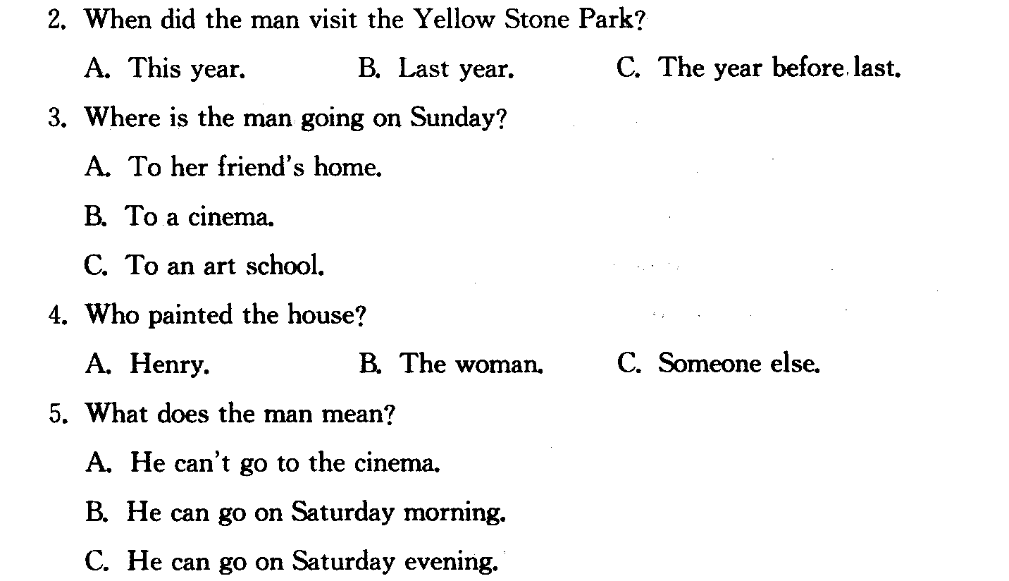
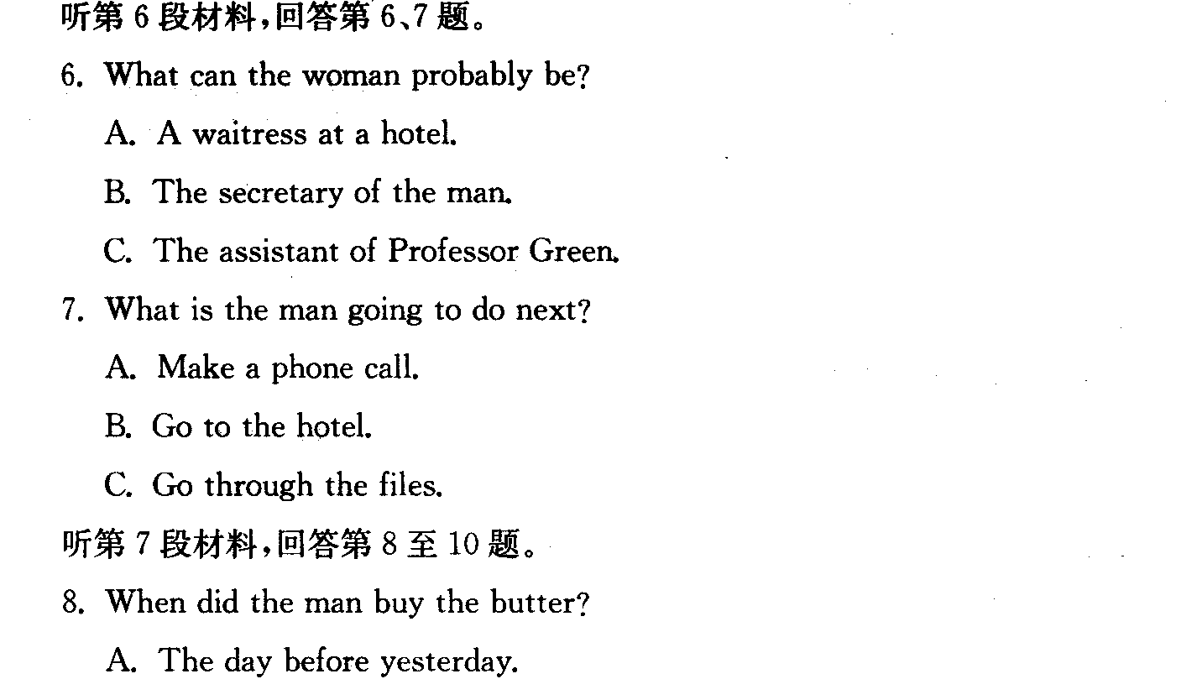
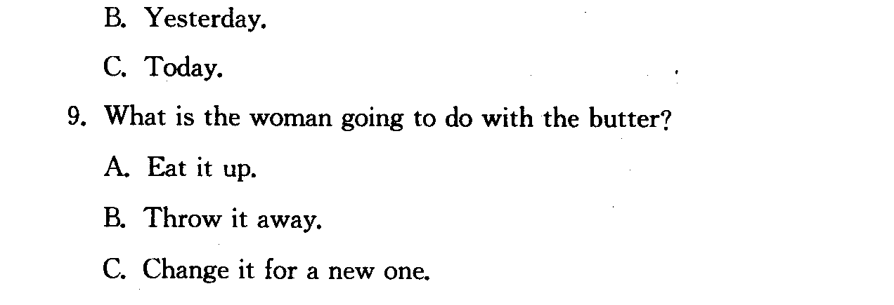
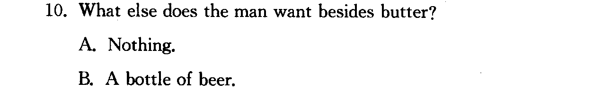
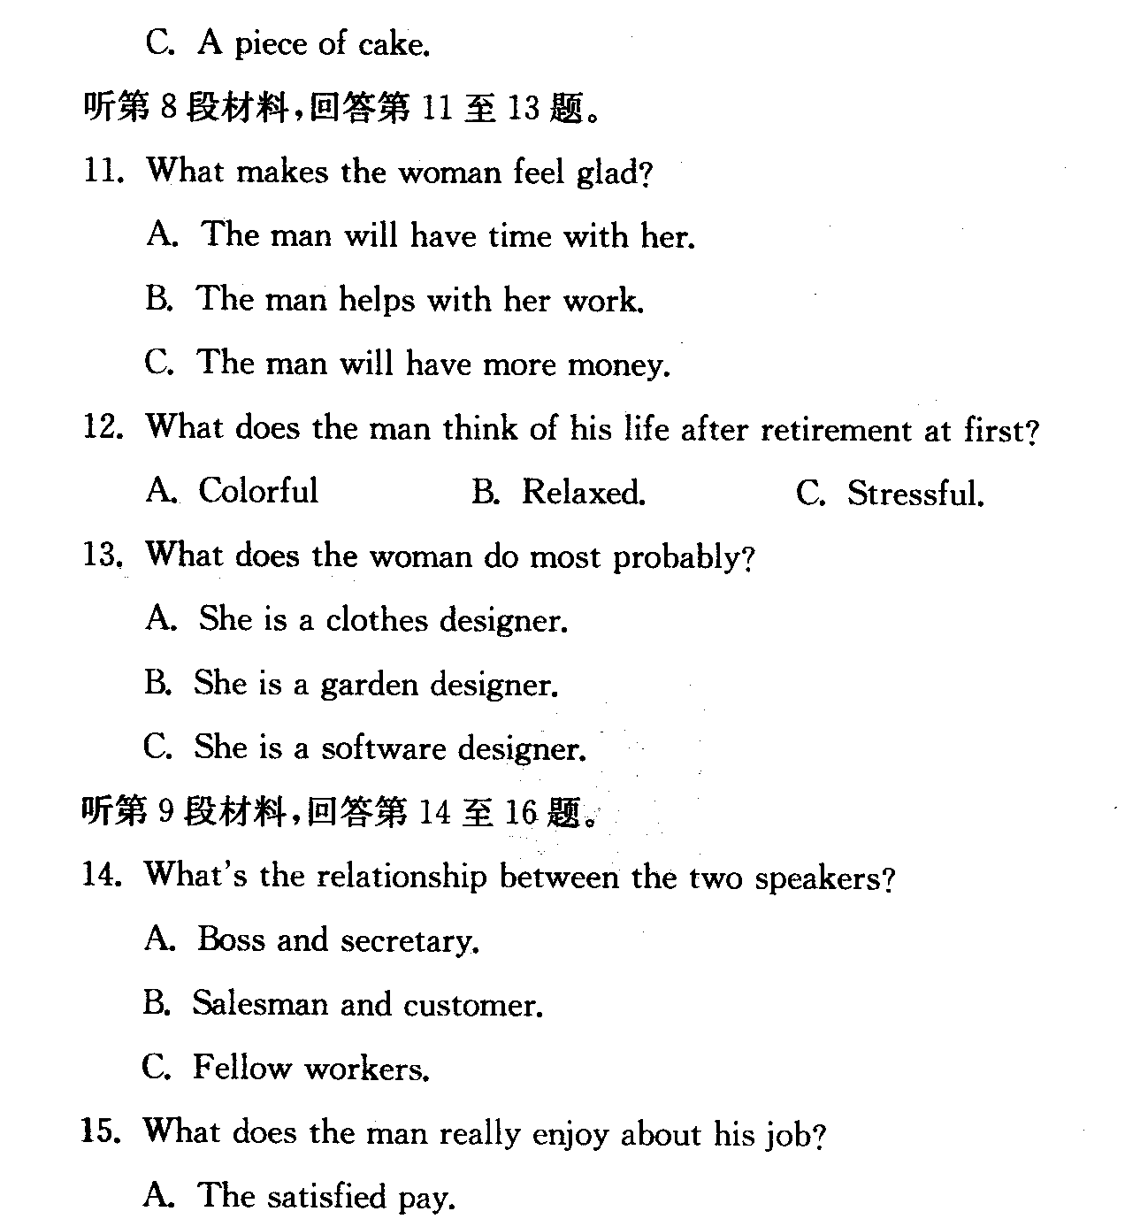
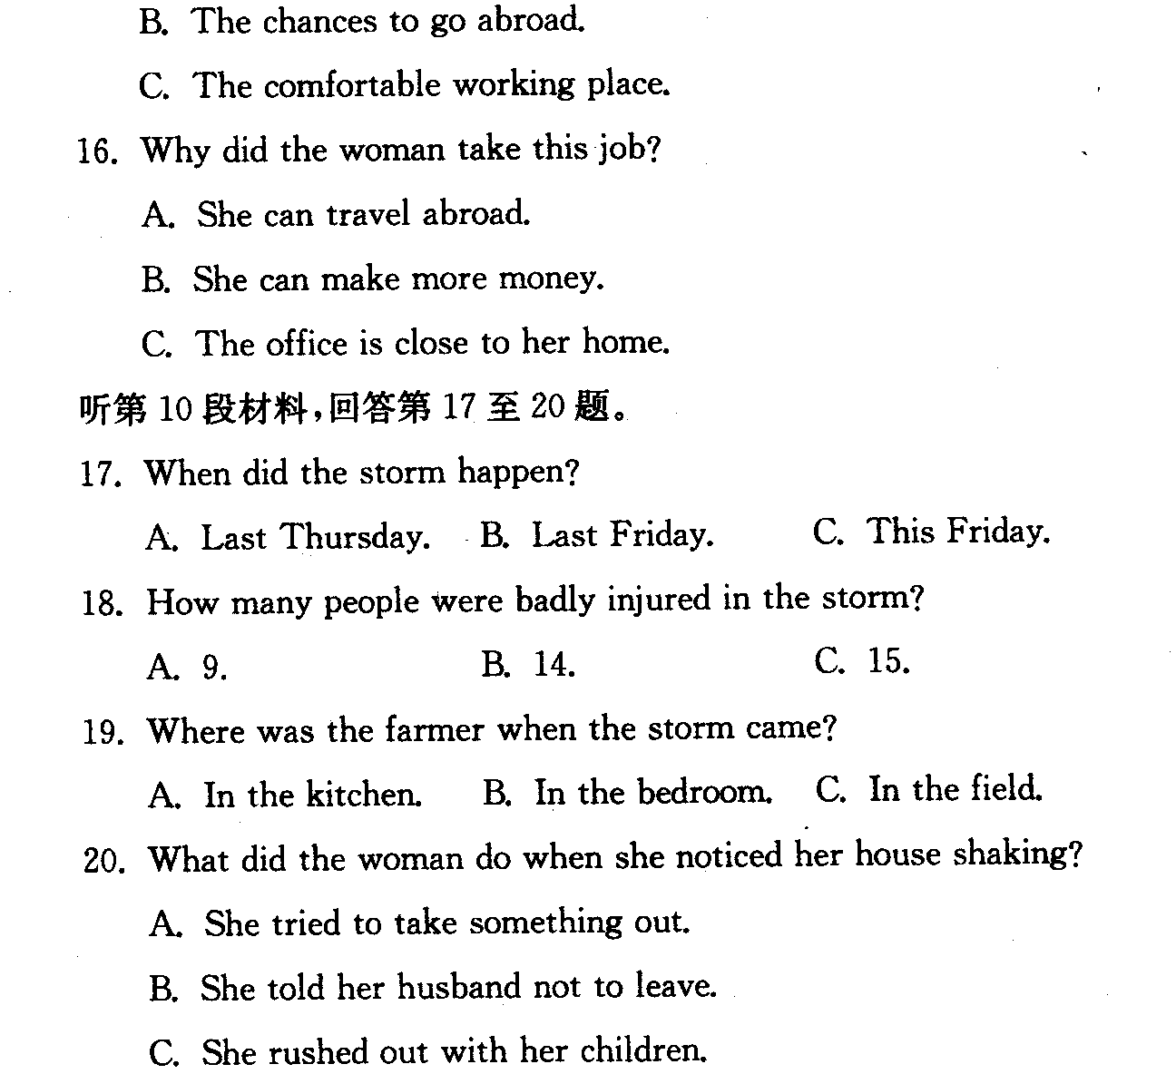
第二部分： 英语知识运用 （共两节，满分45分）
第一节：单项填空（共15小题；每小题1分，满分15分）
从A、B、C、D四个选项中，选出可以填入空白处的最佳选项。
21.These books are for students mother language is Chinese.
A. of whom B. that C. which D. whose
22.She was educated at Beijing University, she went on to have her advanced study abroad.
A. from which B. after which C. from that D. after that
23.The soldiers many trapped people after the earthquake.
A. rescued B. operated C. escaped D. sheltered
24.The new government promised that they would surely improve the of people`s life.
A. outline B. quality C .insurance D. attitude
25.Ten scientists were given great honour as they had devoted all their life the experiment.
A. to doing B. for doing C. in doing D. to do
26.-----I am going to Japan.
-----How long you there?
A. are, stayed B. are, staying C. have, stayed D. did, stay
27.My classmates insisted that I the school trip to Jilin.
A. organized B. would organize C. organize D. had organize
28. it rained heavily, we still worked on.
A. As if B. As though C. If only D. Even if
29. The number of the students of the university _______more than 50,000.
A. get B. gets C. reach D. reaches
30. We don’t need to do extra work this evening. The day’s work was almost ______ now.
A. at the end B. at an end C. at one end D. at our end
31. Do what you think right. Never ______ what others say.
A. care for B. care of C. take care of D. care about
32.The policeman warned the driver ________ so carelessly.
A. not to drive B. to never drive C. to not drive D. doesn’t drive
33.I came here with your mother ________ to see you.
A. specially B. special C. especially D. especial
34. Many questions ______ at the meeting, but he answered none.
A. came up B. raised C. were risen D. asked
35.Whenever we are in ________ , we must never lose ______ , but try to think of the way out.
A. the trouble; our heart B. troubles; hearts C. trouble; heart D. trouble; our heart
第二节．完型填空

Dick was a clever boy, but his parents were poor, so he had to work 36 his spare time and during his holidays to 37 his education． 38 this, he 39 get to the university, but it was 40 expensive to study there that during the holiday he found41 necessary to get two jobs 42 the same time 43 make enough money 44 his studies．
One summer he managed to 45 a job in a butcher’s shop（肉店）during 46 , and another in a hospital 47 ． In the shop, he learnt to cut meat quite nicely, so the butcher often 48 him doing all the serving 49 he went to the back room to do the accounts（账目）． In the hospital, 50 , he was, of course, allowed to do the simplest jobs, 51 helping to lift people and to 52 them from one part of the hospital to another． Both at the butcher’s shop and at the hospital, Dick had to 53 white clothes．
One evening at the hospital, Dick had to help a woman from her bed to the place 54 she was to have an operation． The woman was already feeling frightened at the 55 of the operation before he came to get her, but when she saw Dick, she fainted away（晕过去）．
36． A．on B．in C．at D．with
37． A．pay for B．pay off C．pay to D．pay back
38． A．Instead B．Instead of C．In spite of D．In need of
39． A．tried to B．hope to C．want to D．was anxious to
40． A．too B．very C．so D．much
41． A．it’s B．this C．that D．it
42． A．at B．on C．by D．for
43． A．in order that B．as to C．as so to D．so as to
44． A．with B．for C．to D．because of
45． A．look for B．find C．reach D．take
46． A．day time B．the night C．the night time D．the daytime
47． A．at night B．at noon C．in the morning D．in the daytime
48． A．let B．left C．made D．had
49． A．while B．as soon as C．after D．until
50． A．on other hand B．on another hand C．on the second hand D．on the other hand
51． A．like B．for C．as D．from
52． A．want B．fetch C．carry D．raise
53． A．on B．wear C．be on D．dress on
54． A．that B．which C．where D．there
55． A．thought B．time C．end D．beginning

第三部分： 阅读理解 （共20小题； 每小题2分，满分40分）
阅读下列短文，从每题所给的四个选项（A、B、C和D）中，选出最佳选项。
A
Will it matter if you don't take your breakfast? Recently a test was given in the United States. Those tested included people of different ages, from 12 to 83. During the experiment, these people were given all kinds of breakfasts, and sometimes they got no breakfast at all. Special tests were set up to see how well their bodies worked when they had eaten a certain kind of breakfast. The results show that if a person eats a proper breakfast, he or she will work with better effect than if he or she has no breakfast. This fact appears to be especially true if a person works with his brains. If a student eats fruit, eggs, bread and milk before going to school, he will learn more quickly and listen with more attention to class.
Opposite to what many people believe, if you don't eat breakfast, you will not lose weight. This is because people become so hungry at noon that they eat too much for lunch, and end up gaining weight instead of losing. You will probably lose more weight if you reduce your other meals.
56. During the test, those who were tested were given ________.
A. no breakfast at all
B. very rich breakfast
C. little food for breakfast
D. different breakfast or none
57. The results of the test show that ________.
A. breakfast has great effect on work and studies
B. breakfast has little to do with a person s work
C. a person will work better if he has a simple breakfast
D. those working with brains should have much for breakfast
58. The passage mentions that many people believe that if you don't eat breakfast, you will _________.
A. lose weight B. not lose weight
C. be healthier D. gain a lot of weight
59. Which of the following is not true according to the passage?
A. Poor breakfasts affect those who work with brains.
B. Morning diet may cause one to get fatter.
C. Reducing lunch and supper is of less value in weight losing.
D. Eating less in lunch and supper may help to lose weight.
60. According to the passage, if a student does not eat breakfast, ___________.
A. he will fall ill
B. he will fail to listen to his teacher
C. he will not make progress in his study
D. his mind will work more slowly
B
A young woman carrying a three-year-old child got on a bus. The conductor hurried to give her a warm welcome and then kindly asked the other passengers to make more room for the woman and her child. On seeing this, people began to talk. "You know this conductor used to be very rude. Now suddenly he has changed his bad behavior , "said a middle-aged man.
"Yes, he should be praised and we must write a letter to the company," said a second passenger. "That's right," another lady said, "I wish a newspaper reporter were here so that more people could learn from this conductor. "
Just then a gentleman who looked like a teacher turned to the conductor and said , "Excuse me, but can I know your name, please? Your excellent service must be praised..."
Before he could open his mouth, the three-year-old child sitting on the young woman's lap interrupted, "I know his name. I call him Dad."
61. The passengers were ________ to see the conductor's kindness to the woman and the child.
A. excited B. pleased C. interested D. surprised
62. One passenger suggested writing a letter to the company to ______.
A. make a demand for more buses
B. thank the conductor for his good service
C. criticize the conductor for his rude behavior
D. invite a newspaper reporter to write about the conductor
63. What was the gentleman?
A. A teacher.
B. A newspaper reporter.
C. Not known from the story.
D. The conductor's friend from his company.
64. The word "he" in the last paragraph refers to _______.
A. the gentleman
B. the conductor
C. the middle-aged man
D. the three-year-old child
65. It is clear from the story that the conductor _______.
A. has changed his attitude towards his work
B. has now been kind and polite to all passengers
C. has not changed his rude behavior to passengers
D. has now been kind and polite to women with children
C
Have you ever been afraid to talk back when you were treated unfairly? Have you ever bought something just because the salesman talked you into it? Many people are afraid to support themselves. Dr Robert Albert, author of Stand Up, Speak Out, and Talk Back thinks it' s because their self-respect is low. "There's always a' superior' around--- parent, a teacher, a boss---who knows better."
But Albert and other scientists are doing something to help people help themselves. They offer "assertiveness training" courses A.T. for short. In the A.T. Course people learn that they have a right to be themselves. They learn to speak out and feel good about doing so. They learn to be aggressive without hurting other people.
In one way, learning to speak out is to get rid of fear. A group taking an A.T. Course will help the timid(胆小的) person to lose his fear. But A.T. uses an even stronger motive--- he need to share. The timid person speaks out in the group because he wants to tell how he feels. Whether or not you speak up for yourself depends on your self-respect. If someone you face is more "important" than you, you may feel less of a person. You start to doubt your answers to problems. You can get to feel good about yourself. And once you do you can learn to speak out.
66. The problem the writer talks about is that __________.
A. some people buy things they don't want
B. some people are afraid to speak out for their rights
C. there are too many superiors
D. some people don't think enough of themselves
67. The cause of the problem talked about in this passage is that _________.
A. some people have a low self-respect
B. there is always someone around who "knows better"
C. salesmen talk people into buying things they don't want
D. people don t share enough
68. The A.T. Course often _______.
A. make people distrust their own answers
B. make things more favorable for "superiors"
C. help people know as much as their "superiors"
D. help people become more important
69. One thing the A.T. Course don't do is to __________.
A. share the need of people
B. show they have a right to be themselves
C. help people overcome fear
D. help people to help themselves even if others suffer
70. A good title for this passage could be "__________".
A. The Need to Share
B. Talk Back When Necessary
C. One Way to Build Self-Respect
D. One Way to Train Speaking Ability
D
Charlie studied in a famous college for four years． He studied hard and did well in all his subjects． He hoped to become a good teacher． This year he left the college and began to work in a middle school． He likes his students and is strict（严格的） with them． He does his best to make his classes lively and interesting．
One day he carefully explained a chemical reaction（反应） to the students of Grade 2 in the chemistry lab．
“Be careful， everyone，” he said loudly． “Before I make the experiment，there're twenty five atoms of carbon（碳原子），but after I finish it， there're twenty four atoms of carbon left！”
He stopped to watch the classroom and hoped his students would go on explaining it． But the young men looked at each other and nobody answered him． He had to ask， “What happens？ What makes the atom lost？”
The classroom was very quiet and none of the students looked at their teacher．
“Who can tell us where it has gone？”
Suddenly a soft voice came from the back row， “We did not see anybody leave the lab！”
71．Charlie began to work in the middle school because ＿＿＿＿＿＿＿．
A．he had been in the school for four years B．he couldn't do anything except teaching
C．he hoped to become a good teacher D．he did well in all his subjects
72．Charlie hopes ＿＿＿ ，so he does his best to make his classes lively and interesting．
A．all his students could understand him B．his students wouldn't be afraid of him
C．his students carefully watched him making the experiment
D．his students could do well in chemistry
73．That day Charlie wished ＿＿＿＿＿＿＿ ．
A．his students could learn the chemical reaction
B．his students could find the atom of carbon
C．his students could count（数） the atoms of carbon
D．his students could make the experiment
74．The students couldn't answer Charlie's questions because ＿＿＿＿＿＿＿ ．
A．none of them had seen the atoms B．they didn't understand their teacher
C．the chemical reaction was too complicated D．they all wanted to drop the subject
75．In fact，＿＿＿＿＿＿＿ ．
A．Charlie failed that day
B．the student in the back row didn't watch her teacher carefully
C．the student in the back row hadn't learned chemistry before
D．Charlie failed in making the experiment

第二节：书面表达
假设有一批英国中学生将来你校就读，校方要求你在开班典礼上介绍一下学校的有关要求。请按以下要点写一篇发言稿。
◎上学要穿戴整洁 ◎上课不迟到、早退 ◎保持校园清洁
◎走路靠右行；若要骑车上学，请办自行车许可证
注意：1.词数：100左右； 2.可适当增加细节，以使行文连贯； 3. 开头已为你写好。
参考词汇：许可证—permit
请把答案填（涂）写在答题卡上
桥东中学2014-2015学年上学期期中考试高一年段英语试卷答案
1-5AABCC 6-10BABCA 11-15ACBCB 16-20CBAAC
21-25DBABA 26-30BCDDB 31-35DAAAC
36-40 BACDC 445 DADBB 46-50 DABAD 51-55 ACBCA
56-60 DAACD 61-65 DBCBC 66-70 BADDC 71—75 CDABA
完成句子
- made up her mind 2.Ever since 3.fare , gave in 4.dig out 5.out of work
6.matter of fact , blow up
参考范文
One possible version:
Good morning, dear friends. Welcome to our school. Now please allow me to introduce you to some of our school rules. As high school students, firstly, we are expected to be neatly dressed when at school. Secondly, we should never be late for class or leave school early before it is over. The school is a place where we live and study, so we must keep it clean. Lastly, when you are on the road, please remember to keep to the right, and, if you want to cycle to school, you should have a permit.
Thanks

