浏阳一中2015年下学期高二数学第一次月考（理）
时量：120分钟 总分：150分
命 题人：黄杏芳 审题人：杨厚伟

一、选择题（共12小题；共60分）
1.设 Error: Reference source not found ，且 Error: Reference source not found ，则 ( )
 | A. | 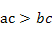 | B. | 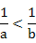 | C. | 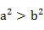 | D. | 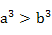
2. 在 Error: Reference source not found 中，Error: Reference source not found，Error: Reference source not found，Error: Reference source not found，则 Error: Reference source not found ( )
 | A. | 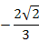 | B. |  | C. | 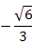 | D.
3. 已知等差数列 Error: Reference source not found 的前 Error: Reference source not found 项之和为 Error: Reference source not found，则 Error: Reference source not found 等于 ( )
 | A. |  | B. |  | C. |  | D.
4. 记等差数列 Error: Reference source not found 的前 Error: Reference source not found 项和为 Error: Reference source not found，若 Error: Reference source not found，Error: Reference source not found，则该数列的公差 Error: Reference source not found ( )
 | A. |  | B. |  | C. |  | D.
5. 已知等比数列 Error: Reference source not found 的公比为正数，且 Error: Reference source not found，Error: Reference source not found，则 Error: Reference source not found ( )
 | A. |  | B. |  | C. |  | D.
6. 已知 Error: Reference source not found 为等比数列，Error: Reference source not found，Error: Reference source not found，则 Error: Reference source not found ( )
 | A. |  | B. |  | C. |  | D.
7. 设 Error: Reference source not found 是等差数列 Error: Reference source not found 的前 Error: Reference source not found 项和，若 Error: Reference source not found，则 Error: Reference source not found ( )
 | A. |  | B. |  | C. |  | D.
8. 若 Error: Reference source not found 的内角 Error: Reference source not found 、 Error: Reference source not found 、 Error: Reference source not found 满足 Error: Reference source not found，则 Error: Reference source not found ( )
 | A. |  | B. |  | C. | 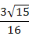 | D.
9. 若关于 Error: Reference source not found 的不等式 Error: Reference source not found 的解集为 Error: Reference source not found，则关于 Error: Reference source not found 的不等式 Error: Reference source not found 的解集为 ( )
 | A. | 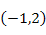 | B. |  | 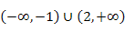
 | C. | 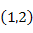 |  | D. | Error: Reference source not found
10. 已知等比数列的公比为 Error: Reference source not found，且前 Error: Reference source not found 项的和为 Error: Reference source not found，那么前 Error: Reference source not found 项的和等于 ( )
 | A. |  | B. |  | C. |  | D.
11. 已知数列 Error: Reference source not found 满足 Error: Reference source not found，Error: Reference source not found，则 Error: Reference source not found ( )
 | A. |  | B. |  | C. |  | D.
12. 已知两个等差数列 Error: Reference source not found 和 Error: Reference source not found 的前 Error: Reference source not found 项和分别为 Error: Reference source not found 和 Error: Reference source not found，且 Error: Reference source not found，则使得 Error: Reference source not found 为整数的正整数 Error: Reference source not found 的个数是 ( )
 | A. |  | B. |  | C. |  | D.

二、填空题（共4小题；共20分）
13. 已知数列 Error: Reference source not found 的前 Error: Reference source not found 项和为 Error: Reference source not found，某三角形三边之比为 Error: Reference source not found，则该三角形最大角为 ．
14. 设 Error: Reference source not found 的内角 Error: Reference source not found，Error: Reference source not found，Error: Reference source not found 所对的边分别为 Error: Reference source not found，Error: Reference source not found，Error: Reference source not found．若
Error: Reference source not found，则角 Error: Reference source not found ．
15. 若等差数列 Error: Reference source not found 满足 Error: Reference source not found，Error: Reference source not found，则当 Error: Reference source not found 时，Error: Reference source not found 的前 Error: Reference source not found 项和最大．
16. 已知数列 Error: Reference source not found 满足：Error: Reference source not found，Error: Reference source not found，Error: Reference source not found，Error: Reference source not found，Error: Reference source not found，且当 Error: Reference source not found 时，Error: Reference source not found，若数列 Error: Reference source not found 满足对任意 Error: Reference source not found，有
Error: Reference source not found，则 Error: Reference source not found ；
当 Error: Reference source not found 时，Error: Reference source not found ．

三、解答题（共6小题；共70分）
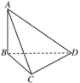
17. （本题10分）要测量底部不能到达的电视塔 Error: Reference source not found 的高度，在 Error: Reference source not found 点测得塔顶 Error: Reference source not found 的仰角是 Error: Reference source not found，在 Error: Reference source not found 点测得塔顶 Error: Reference source not found 的仰角是 Error: Reference source not found，并测得水平面上的 Error: Reference source not found，Error: Reference source not found，求电视塔的高度．

18. （本题12分）已知等差数列 Error: Reference source not found 的公差 Error: Reference source not found ，前 Error: Reference source not found 项和为 Error: Reference source not found ．
(1)若 Error: Reference source not found 成等比数列，求 Error: Reference source not found ；
(2)若 Error: Reference source not found ，求 Error: Reference source not found 的取值范围．

19. （本题12分）已知数列 Error: Reference source not found 的前 Error: Reference source not found 项和为 Error: Reference source not found，Error: Reference source not found．
(1)求数列 Error: Reference source not found 的通项公式；
(2)设 Error: Reference source not found 的前 Error: Reference source not found 项和为 Error: Reference source not found，求证 Error: Reference source not found．

20. （本题12分）（1）若数列 Error: Reference source not found 满足：Error: Reference source not found，Error: Reference source not found，（Error: Reference source not found，Error: Reference source not found），试求数列 Error: Reference source not found 的通项公式．
（2）在数列 Error: Reference source not found 中，已知 Error: Reference source not found，且 Error: Reference source not found，试求数列 Error: Reference source not found 的通项公式．

21. （本题12分）在等差数列 Error: Reference source not found 中，Error: Reference source not found 为其前 Error: Reference source not found 项和．
(1)求使 Error: Reference source not found 的最小的正整数 Error: Reference source not found；
(2)求 Error: Reference source not found 的表达式．

22. （本题12分）已知数列 Error: Reference source not found 满足 Error: Reference source not found，且 Error: Reference source not found．
(1)求证：数列 Error: Reference source not found 是等差数列，并求通项 Error: Reference source not found；
(2)若 Error: Reference source not found，且 Error: Reference source not found，求 Error: Reference source not found．

答案
第一部分
1. D 2. D 3. D 4. B 5. B 6. D 7. A 8. D 9. B 10. B 11. B 12. D
第二部分
13. Error: Reference source not found 14. Error: Reference source not found 15. Error: Reference source not found 16. Error: Reference source not found；Error: Reference source not found
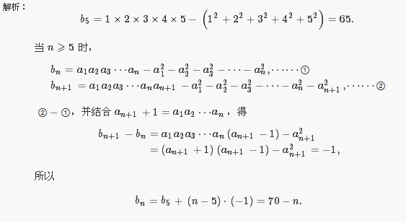
第三部分
17. (1) 如图，
设电视塔 Error: Reference source not found 的高为 Error: Reference source not found．
则在 Error: Reference source not found 中，由 Error: Reference source not found 得 Error: Reference source not found．
在 Error: Reference source not found 中，Error: Reference source not found，Error: Reference source not found．
在 Error: Reference source not found 中，由余弦定理，得：
即 Error: Reference source not found．
解得 Error: Reference source not found，Error: Reference source not found 电视塔的高度为 Error: Reference source not found 米．

18. (1) 因为数列 Error: Reference source not found 的公差 Error: Reference source not found ，且 Error: Reference source not found 成等比数列，所以 Error: Reference source not found
即 Error: Reference source not found 解得 Error: Reference source not found

(2) 因为数列 Error: Reference source not found 的公差 Error: Reference source not found ，且 Error: Reference source not found ，所以 Error: Reference source not found
即 Error: Reference source not found
解得 Error: Reference source not found

19. (1) Error: Reference source not found，
Error: Reference source not found，Error: Reference source not found（Error: Reference source not found），
Error: Reference source not found（Error: Reference source not found）．
(2) Error: Reference source not found，Error: Reference source not found．
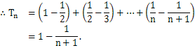
Error: Reference source not found，Error: Reference source not found，即 Error: Reference source not found．

20. (1) 由已知，可得 Error: Reference source not found；
在上面的递推式中，分别令 Error: Reference source not found 直到 Error: Reference source not found，得到 Error: Reference source not found 个等式：
Error: Reference source not found；Error: Reference source not found；Error: Reference source not found；
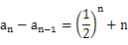
将这 Error: Reference source not found 个等式整体相加得：
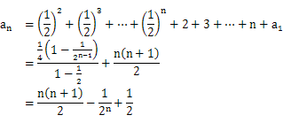
当 Error: Reference source not found 时，Error: Reference source not found，也适合上式，∴ Error: Reference source not found，Error: Reference source not found
(2)由 Error: Reference source not found 得
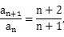
则当 Error: Reference source not found 时，
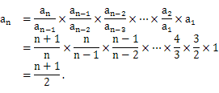
而 Error: Reference source not found 适合上式，所以 Error: Reference source not found．
21. (1) ∵ Error: Reference source not found，
∴使 Error: Reference source not found 的最小正整数 Error: Reference source not found 为 Error: Reference source not found．
(2) 由 Error: Reference source not found，知 Error: Reference source not found∴该数列从第 Error: Reference source not found 项开始为负，前 Error: Reference source not found 项为正．
当 Error: Reference source not found 时，Error: Reference source not found
当 Error: Reference source not found 时，Error: Reference source not found
所以
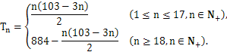

22. (1) 对 Error: Reference source not found 两端取倒数，得Error: Reference source not found
则数列 Error: Reference source not found 是首项为 Error: Reference source not found，公差为 Error: Reference source not found 的等差数列，从而
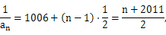
因此数列 Error: Reference source not found 的通项公式为 Error: Reference source not found．
(2) 由（1），得
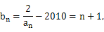
从而Error: Reference source not found
所以Error: Reference source not found
两端同乘以 Error: Reference source not found，得Error: Reference source not found
得
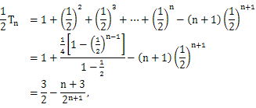
因此 Error: Reference source not found．

