北大附中河南分校2015-2016学年上学期九月考试试卷

高二英语

考试时间100分钟 满分120分
第二部分: 阅读理解 (共两节，满分40分)
第一节 (共15小题;每小题2分，满分30分)
阅读下列短文，从每题所给的四个选项 (A、B、C和D)中，选出最佳选项，并在答题卡上将该项涂黑。
A
On a hill 600 feet above the surrounding land, we watch the lines of rain move across the scene, the moon rise over the hills, and the stars appear in the sky. The views invite a long look from a comfortable chair in front of the wooden house.
Every window in our wooden house has a view, and the forest and lakes seldom look the same as the hour before. Each look reminds us where we are.
There is space for our three boys to play outside, to shoot arrows, collect tree seeds, build earth houses and climb trees.
Our kids have learned the names of the trees, and with the names have come familiarity and appreciation. As they tell all who show even a passing interest, maple（枫树）makes the best fighting sticks and white pines are the best climbing trees.
The air is clean and fresh. The water from the well has a pleasant taste, and it is perhaps the healthiest water our kids will ever drink. Though they have one glass a day of juice and the rest is water, they never say anything against that.
The seasons change just outside the door. We watch the maples turn every shade of yellow and red in the fall and note the poplars’（杨树）putting out the first green leaves of spring. The rainbow smelt fills the local steam as the ice gradually disappears, and the wood frogs start to sing in pools after being frozen for the winter. A family of birds rules our skies and flies over the lake.
21. What can be learned from Paragraph 2?
A. The scenes are colorful and changeable. B. There are many windows in the wooden house.
C. The views remind us that we are in a wooden house.
D. The lakes outside the windows are quite different in color.
22. By mentioning the names of the trees, the author aims to show that ______ .
A. the kids like playing in trees B. the kids are very familiar with trees
C. the kids have learned much knowledge D. the kids find trees useful learning tools
23. What does the underlined sentence in the last paragraph mean?
A. The change of seasons is easily felt. B. The seasons make the scenes change.
C. The weather often changes in the forest.
D. The door is a good position to enjoy changing seasons.
24. What is the main purpose of the author writing the text?
A. To describe the beauty of the scene around the house.
B. To introduce her children’s happy life in the forest.
C. To show that living in the forest is healthful.
D. To share the joy of living in the nature.
B
Spring peepers are found in wooded areas and grassy lowlands near pools in the central and eastern parts of Canada and the United States. These loud animals are rarely seen, but as temperatures begin to rise in March and April, the males certainly are heard. Their peep...peep... peep creates an other-worldly whistling sound that, to many, is the first sign of spring, compared with that of some birds.
Spring peepers are brown in color with dark lines that form an X on their backs. They grow to about 1.5 inches (3.8 centimeters) in length, and have large special toes for climbing. These creatures are active at night, coming out to feed on ants, beetles, flies, and spiders.
When the warmer weather arrives, male frogs attempt to attract a mate with a spring song. The frogs normally perform in singing. The one who starts each round usually has the deepest voice. The "vocal sacs" under their mouths allow the frogs to "sing". They fill their vocal sacs with air until they look like a balloon, and then they let out a "peep" as they release the air. They "peep" about once every second. These sounds can often be heard as far as a half-mile away
After a female and male peeper mate, the female lays her eggs in water and spends the remainder of the year in the forest. During the winter, they sleep under logs or behind loose bark on trees. The music dies down during the cold months, but the sounds of peepers will soon be heard again, sounding the coming of spring.
25. The text is written mainly to _____.
A. tell people what spring peepers look like B. let people know more about spring peepers
C. explain why spring peepers sing D. show environmental harmony in nature
26. What can we know about the spring peepers from the text?
A. They prefer to live in the dry areas in North America.
B. They are the first animals to make sounds in spring.
C. They can live both in water and on land.
D. They are active during the cold months of the year.
27. What does the underlined word "release" in Paragraph 3 mean?
A. turn out. B. break out. C. leave out. D. let out.
28. The best title for this text might be _____.
A. The Ring of Tiny Frogs in Spring B. The Relationship between Animals and Seasons
C. The Living Conditions of Spring Peepers D. The Invitation from a Male Peeper
C
Windbreaks are barriers formed by trees and other plants. Farmers plant these barriers around their fields, which help prevent the loss of soil, stop the wind from blowing soil away. They also keep the wind from damaging or destroying crops. Besides, extra trees and plants can be cut down and used or sold for wood.
Windbreaks can be highly valuable for protecting grain crops. For example, in parts of West Africa grain harvests were as much as twenty percent higher in fields protected by windbreaks compared to fields without them.
But here is something interesting about windbreaks. They seem to work best when they allow some wind to pass through the barrier of trees or plants around a field. If not, then the movement of air close to the ground will lift the soil. Then the soil will be blown away. For this reason, a windbreak works best if it contains only 60 to 80 percent of the trees and plants that would be needed to make a solid line. An easy rule to remember is that windbreaks can protect areas up to 10 times the height of the tallest trees in the windbreak.
There should be at least two lines in each windbreak. One line should be large trees. The second line, right next to it, can be shorter trees or other plants with leaves. Locally grown trees and plants are considered the best choices for windbreaks. Trees reduce the damaging effects of wind and rain. Their roots help protect soil from being washed away. And trees can provide animals outdoors with shade from the sun.
29. The advantages of building a windbreak are as follows except _____.
A. keeping the wind from destroying grain crops B. increasing the production of grain harvests
C. providing humans with shade from the sun D. reducing the damaging effects of wind and rain
30. The author thinks windbreaks are interesting because ______.
A. the movement of air lifts the soil B. windbreaks allow some wind to pass through
C. large trees are lined with short ones D. windbreaks can stop the wind getting through
31. If the trees grow to a height of 30 feet, the areas the windbreak can protect are ______.
A. 100 square feet B. 150 square feet C. 240 square feet D. 300 square feet
32. What can be inferred from the text?
A. Extra trees and plants can be cut down for wood.
B. The environment is going from bad to worse.
C. Trees and plants from abroad are the best for windbreaks.
D. Windbreaks can contribute to agriculture harvests.
D
Of the several films Hirokazu has made about childhood and children, this one is the most modest, but no less pleasing for its delicate style and small setting. I Wish was originally called Miracle, and the change is for the better. The two-word title makes you want to know who's wishing for what, while the single word sounds plain and self-praising. This wise and funny film works small miracles in describing such a moment when kids turn from the wishfulness of childhood into shaping the world for themselves.
The sweetly reflective hero, a sixth-grader named Koichi, starts out by wishing for a volcano to erupt. Not just any volcano, but the one that towers above his town, smoking heavily and giving off ash. An eruption would lead to a withdrawing, which would lead, at least in his mind, to a reunion with his father and kid brother, who've been living in Hakata while Koichi lives with his mother and retired grandparents in Kagoshima. The volcano, knowing nothing of this, refuses to erupt, but Koichi hears of another approach to realizing the desired miracle.
One of the pleasures of I Wish is watching how kids behave — how Koichi attacks his dinner, for example. Another pleasure is rediscovering how kids think. These kids can be logical and ever so tricky. But children's thought processes can also be fancy. A boy wishes he could play baseball like one of baseball stars, who eats curry for breakfast; so he, too, starts eating curry for breakfast, instead of practicing on the field. Another boy tries to wish his dead dog, Marble, back to life. And what does Koichi finally wish for? I wish you'd see this delightful film to find out.
33. Why has the name of the film been changed from Miracle to I Wish?
A. The former is ambiguous and self-praising.
B. The latter is easier to arouse audience's interest.
C. The latter is easy for audience to remember.
D. The former isn't related to the content of the film.
34. Koichi wishes the volcano to erupt so that he can _______ .
A. enjoy the wonderful scene of a volcano B. help those who suffer from the eruption
C. get together with his family members D. work miracles during the disaster
35. What does the writer intend to do in this text?
A. To share pleasures of watching a film. B. To make a review on a film.
C. To discuss kids' behavior and thoughts. D. To recommend a film.
第二节 (共5小题：每小题2分, 满分l0分)
根据短文内容, 从短文后的选项中选出能填入空白处的最佳选项, 选项中有两项为多余选项。
Are you preparing any gifts for your friends now? 36 , but choosing a proper gift can be a big headache, because it takes a lot of time and effort to think of the right gift for someone. Before you finish your list, keep these dos and don'ts m mind:
◆Do put thought into your gift.
If you like something, that doesn't mean that your friend is going to like it, too. 37 Don't get him/her an ordinary gift, and reflect back on your previous conversations to see if he/she talked about a certain gift he/she had been wanting to get.
◆ 38
Make sure the gift you're buying is appropriate for the person. For example, if you're buying a friend a gift, remember not to overspend or personalize it too much. Take a moment to think about how your relationship is with the person before getting him/her something.
◆Do get a gift receipt (收据)
If you're purchasing something for your friend, make sure you ask the salesperson to include a gift receipt. It's just a polite gesture, and you know your money won't go to waste. 39 .
◆Don't leave the price tag (标签) on.
Make sure you don't leave the price tag on the gift and that you're giving a gift receipt and not the original bill. 40 , and it's not important for him/her to know anyway.
A. Don't buy an inappropriate gift
B. Don't be afraid of spending money
C. Giving gifts has forever been so pleasant
D. Take some time to really think about what he/she likes
E. If your friend doesn't like the gift, he/she can just exchange it
F. Giving someone you care about a very special gift can be tough
G. It's not proper to let your friend know how much you spent on the gift
第二部分 英语知识运用 (共两节，满分45分)
第一节 完形填空(共20小题, 每小题l. 5分；满分30分)
阅读下面短文, 从短文后各题所给的四个选项(A、B、C和D)中, 选出可以填入空白处的最佳选项, 并在答题卡上将该项涂黑。
Six continuous days of spring rain had created a fierce and rapid river running by Nancy Brown's farm. As she tried to drive her 21 to higher ground to escape the disastrous flood, she 22 and hit her head on a 23 tree trunk. The fall knocked her 24 for a moment or two. When she came to, Lizzie, one of her oldest and 25 cows, was licking her 26 . The water was constantly 27 . Nancy got up and began walking 28 with Lizzie. The water was now waist high. Nancy's 29 got slower and slower. Finally, all she could do was to throw her arms 30 Lizzie’s neck and try to 31 . About 20 minutes later, Lizzie managed to 32 herself and Nancy out of the rough water and onto a bit of high land, a small island now in the middle of acres of 33 water.
However, even though it was about noon, the sky was so _34_ and the rain and lightning so bad that it took 35 another two hours to discover Nancy and her cows. A(n) 36 lowered a paramedic (医务辅助人员) , who 37 Nancy to a life-support hoist (吊架). They raised her into the helicopter and took her to the school gym, where the Red Cross had 38 an emergency shelter.
When the flood died down several days later, Nancy immediately 39 the island. Lizzie was
40 . She was one of the 19 cows that Nancy lost. "I owe my life to her," said Nancy sobbingly, knowing Lizzie, which rescued her, left helplessly, leaving her a new hope to live on, for which even thanks or miss seemed "unnecessary".
41. A. sheep B. cows C. horses D. cattle
42. A. shouted B. stood C. stopped D. slipped
43. A. fallen B. grown C. hidden D. spread
44. A. out B. in C. away D. down
45. A. last B. first C. favorite D. best
46. A. body B. head C. face D. mouth
47. A. increasing B. flowing C. running D. rising
48. A. easily B. slowly C. hardly D. hurriedly
49. A. move B. breath C. pace D. action
50. A. above B. around C. over D. into
51. A. hang on B. hold back C. stretch out D. take off
52. A. pull B. push C. carry D. force
53. A. clean B. blue C. white D. green
54. A. bright B. dark C. clear D. rainy
55. A. rescuers B. villagers C. soldiers D. policemen
56. A. lifeboat B. helicopter C. plane D. ambulance
57. A. sent B. attached C. connected D. dragged
58. A. worked out B. got into C. put down D. set up
59. A. ran out of B. went away from C. went back to D. reached out for
60. A. gone B. existed C. disappeared D. approached

第 II卷 (非选择题，共50分)
第二节 (共10小题, 每小题l.5分；满分15分)
阅读下面材料, 在空白处填入适当的内容或括号内单词的正确形式。
American English has its own idioms. Let's say you buy something in a shop. And 61 you pay for it, you say: This cost 62 an arm and a leg! What do you really mean by 63 (say) so? Do you have to give them your arm and your leg? I hope not. Let's listen to an American English conversation 64 (see) if we can find out what this means.
A: Did you buy that new computer?
B: Yeah, I did. But I 65 have bought it.
A: Why do you say so? Is there anything wrong with it?
B: Not exactly, but, as a matter of fact, it cost the way more than I 66 (expect) it to be.
A: How 67 did you pay for it?
B: Let me just tell you it cost an arm and a leg!
When you say in American English that something costs an arm and a leg, it actually means that 68 price is very, very high, much 69 (high) than we can accept. If you use this 70 in the United States, everyone there will understand you. But this is an informal phrase, so don't use it in a formal business setting.
第三部分 写作 (共两节，满分35分)
第一节 短文改错（共10小题；每小题1分，满分10分）
假定英语课上老师要求同桌之间交换修改作文，请你修改你同桌写的以下作文。文中共有10处错误，每句中最多有两处。错误涉及一个单词的增加、删除或修改。
增加：在缺词处加一个漏词符号（^），并在此符号下面写出该加的词。
删除：把多余的词用斜线（＼）划掉。
修改：在错的词下划一横线，并在该词下面写出修改后的词。
注意：1．每处错误及其修改均仅限一词；
2．只允许修改10处，多者（从第11处起）不计分。
April 23rd is World Reading Day, this reminds us of the importance of reading. We are supposed to read more in that special day. But the situation for we to read nowadays is not satisfying.
For example, when we are at home, we would rather to watch TV or go on the Internet than read books. As a result, we spend such little time on books. However, reading books have many advantages. Not only can our abilities and skills be improving, but also we can get some information from1 reading. Beside, reading can bring us happiness.
I think it good habit that in our spare times we read more books of great use.
第二节：书面表达(满分25分)
假如你是李华，下月你将去美国学习，写信给网友Peter，告诉他你想利用周末时间参加社区志愿活动，以便了解当地文化，同时锻炼自己。要点包括：
1．表达心情； 2．自己的特长（英语口语能力强，非常熟悉中国文化）：
3．询问相关信息； 4．表达愿望。
注意：
1．词数100左右；2．可以适当增加细节，以使行文连贯
3．邮件开头和结尾已为你写好。
Dear Peter，
How is everything going?
_______________________________________________________________________________
_______________________________________________________________________________
_______________________________________________________________________________
_______________________________________________________________________________
_______________________________________________________________________________
_______________________________________________________________________________
_______________________________________________________________________________
_______________________________________________________________________________
_______________________________________________________________________________
_______________________________________________________________________________
_______________________________________________________________________________
Yours．
Li Hua

焦作校区2015-2016学年上学期10月考试试卷
高二英语(宏志班）参考答案
第二部分 阅读理解
21-24 ACAD 25-28 BCDA 29-32 CBDD 33-35 BCD 36-40 CDAEG
第三部分 英语知识运用
41-45 BDAAC 46-50 CDBCB 51-55 AACBA 56-60 BBDCA
61. when/after 62.me 63. saying 64. to see 65. shouldn’t / oughtn’t to 66. expected / had expected 67. much 68. the 69. higher 70. phrase / idiom / expression
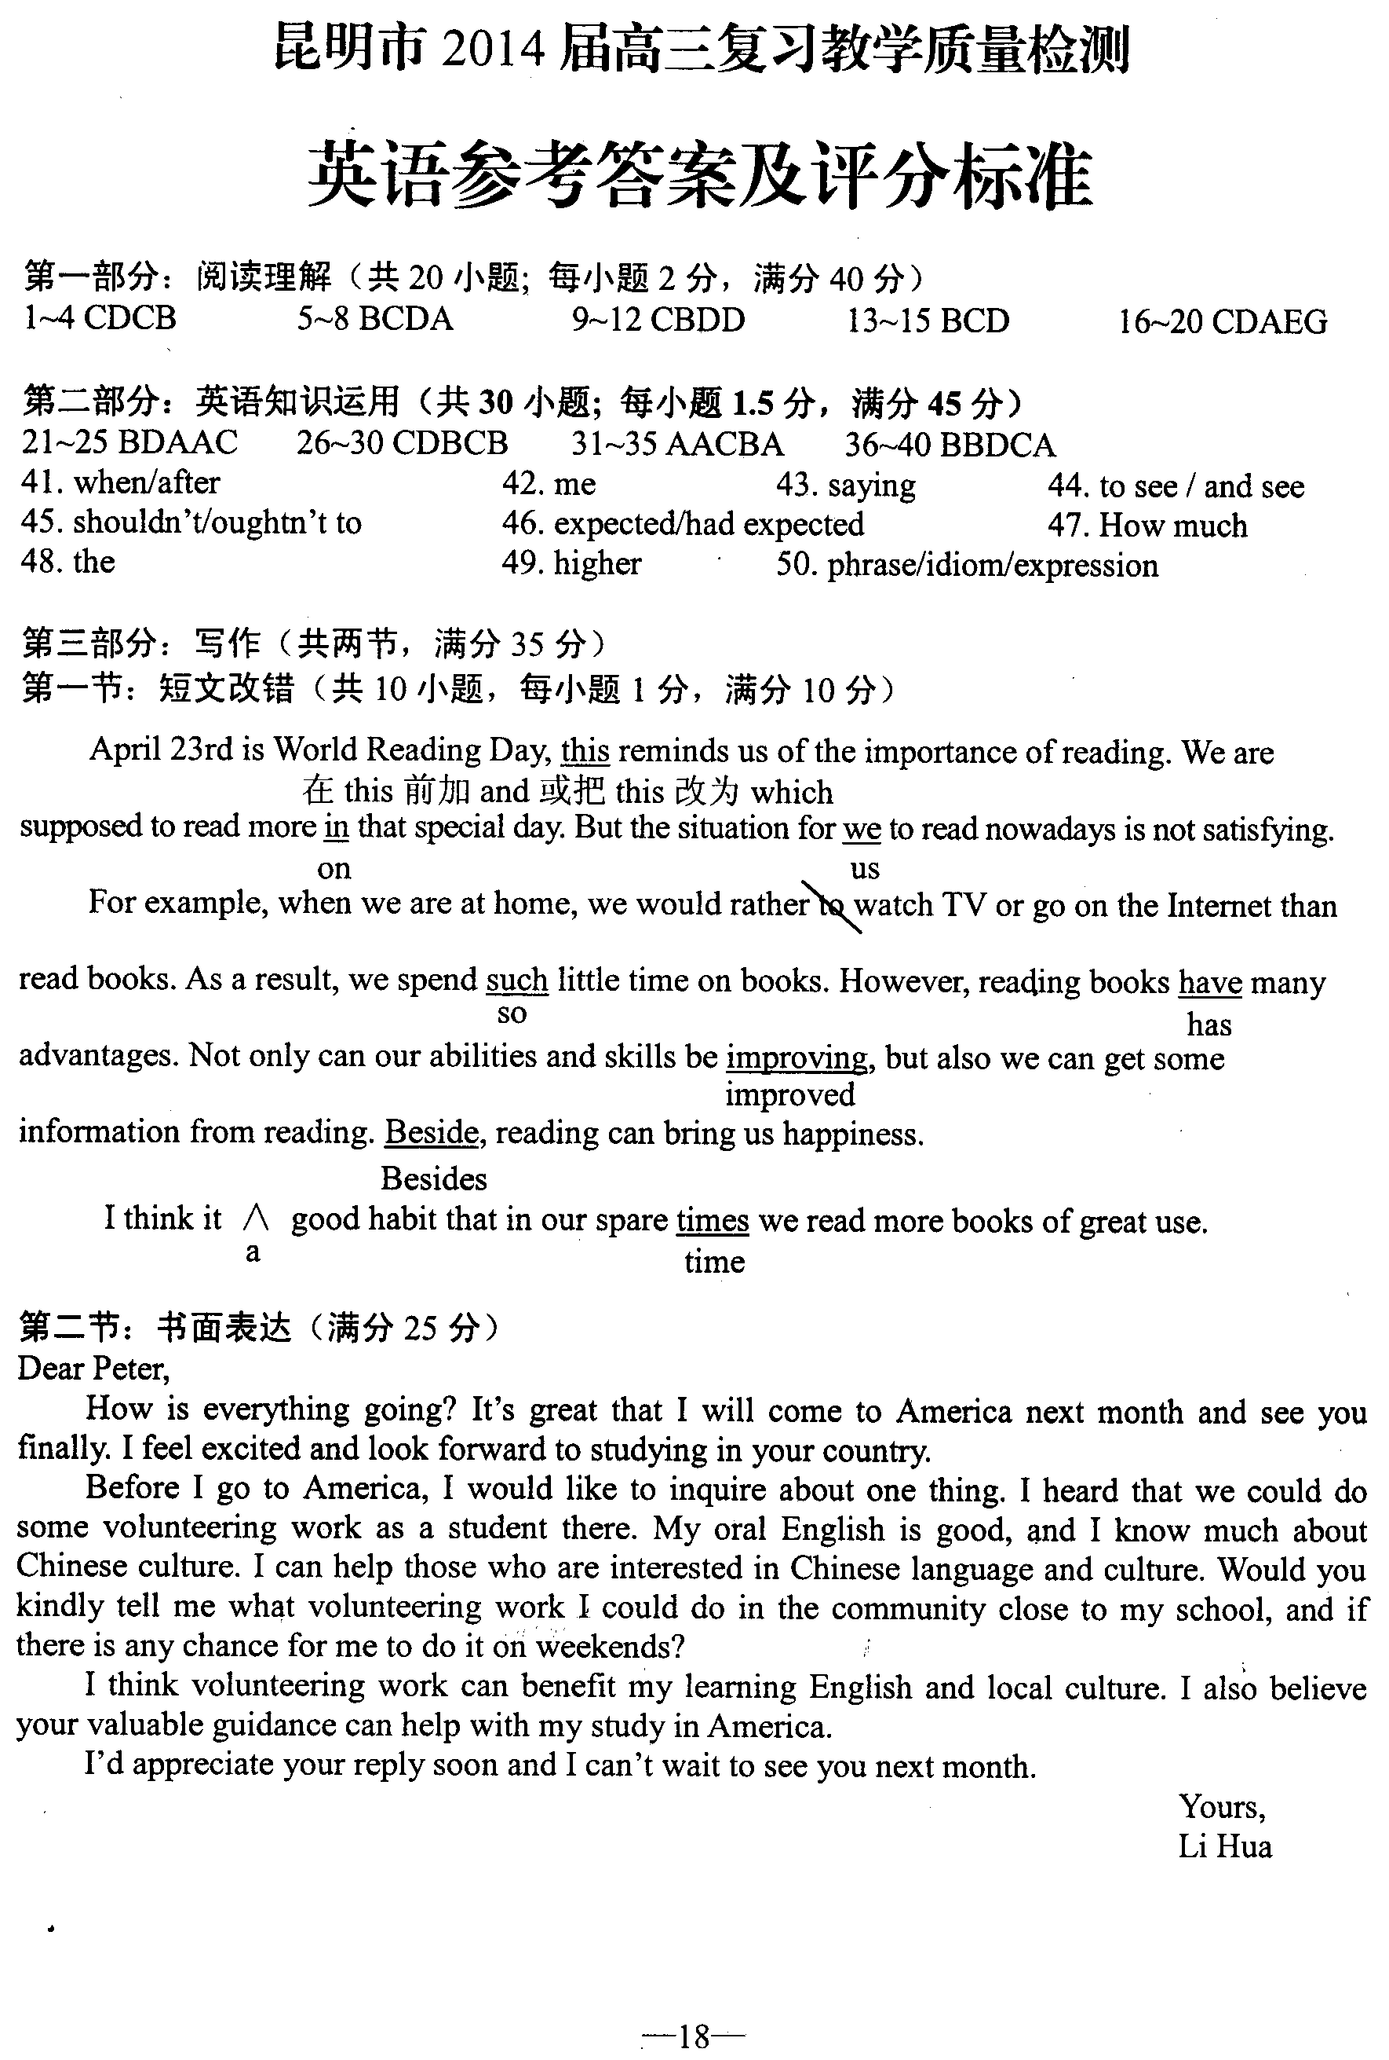

焦作校区2015-2016学年上学期10月考试试卷
高二英语(宏志班）参考答案
第二部分 阅读理解
21-24 ACAD 25-28 BCDA 29-32 CBDD 33-35 BCD 36-40 CDAEG
第三部分 英语知识运用
41-45 BDAAC 46-50 CDBCB 51-55 AACBA 56-60 BBDCA
61. when/after 62.me 63. saying 64. to see 65. shouldn’t / oughtn’t to 66. expected / had expected 67. much 68. the 69. higher 70. phrase / idiom / expression

