2014～2015学年度第二学期高二第三次月考
英语试卷

第I卷（选择题）
第一部分 听力（共两节，满分30分）
做题时，先将答案标在试卷上。录音内容结束后，你将有两分钟的时间将试卷上的答案转涂到答题卡上。
第一节（共5小题；每小题1. 5分，满分7. 5分）
听下面5段对话。每段对话后有一个小题，从题中所给的A、B、C三个选项中选出最佳选项，并标在试卷的相应位置。听完每段对话后，你都有10秒钟的时间来回答有关小题并阅读下一小题。每段对话仅读一遍。
1. What is the man most probably?
A. A doctor. B. A teacher. C. A writer.
2. How much will the woman pay?
A. $5.00. B. $ 4.90. C. $ 4.50.
3. What are the speakers doing?
A. Watching a movie. B. Enjoying a concert. C. Waiting to buy tickets.
4. Where is the man most probably right now?
A. In a shop. B. In his office. C. At McDonald’s.
5. What item do the speakers still need?
A. A sleeping bag. B. A tent. C. Food.
第二节（共15小题；每小题1. 5分，满分22. 5分）
听下面5段对话或独白。每段对话或独白后有几个小题，从题中所给的A、B、C三个选项中选出最佳选项，并标在试卷的相应位置。听每段对话或独白前，你将有时间阅读各个小题，每小题5秒钟；听完后，各小题将给出5秒钟的作答时间。每段对话或独白读两遍。
听第6段材料，回答第6至7题。
6. What does the woman regret?
A. Not coming to the ticket office before lunch.
B. Not having lunch before coming to the ticket office.
C. Not buying her tickets over the phone.
7. When will the ticket office close?
A. In 45 minutes. B. In two hours. C. In three hours.
听第7段材料，回答第8 至 9题。
8. Which of the following does the woman want to order?
A. Wine and steak. B. Water and steak. C. Fish and beer.
9. What will the man do next?
A. Make a phone call. B. Order the food. C. Find a seat.
听第 8段材料，回答第 10至 12题。
10. What food does the man dislike the most?
A. Fries. B. Noodles. C. Fish.
11. How does the woman feel about the man?
A. He dares not to try new things.
B. He has had too many new experiences.
C. He is hard to please with new food.
12. Why does the woman feel the man’s request is fair?
A. The man agrees with her suggestion.
B. The man chooses the restaurant for her.
C. The man doesn’t force her to eat new food.
听第 9段材料，回答第 13至 16题。
13. Where did the man put his wallet?
A. In his backpack. B. In his back pocket. C. In his front pocket.
14. What does the woman think of the robber?
A. Greedy. B. Careless. C. Skillful.
15. Who did the camera beong to?
A. The man’s younger sister.
B. The man’s older brother.
C. The man himself.
16. When does the conversation take place?
A. In the morning. B. At noon. C. In the afternoon.
听第10段材料，回答第17至20题。
17. Which of the following is what Chinese-All does every year?
A. Publishing about 100,000 e-books.
B. Working with 400 famous writers.
C. Producing good films or TV series.
18. How much does it cost users to have access to all the e-books on the website?
A. 28 yuan. B. 30 yuan. C. 32 yuan.
19. What do we know about Han Yingya?
A. She just reads free e-books online.
B. She has had more than 1,000 e-books.
C. She has been an e-book reader for several years.
20. What is the future of the e-book market according to the speaker?
A. Unpredictable. B. Difficult. C. Promising.
第二部分 阅读理解 （共两节，满分40分）
第一节 （共15小题; 每小题2分，满分30分）
阅读下列短文 ，从每题所给的四个选项 （A 、B 、C 和 D ）中 ，选出最佳选项
A
TEFL (Teaching English as a foreign language) England runs TEFL courses for English-speaking people wishing to teach English abroad. Our courses will give you the qualifications (资格证书) to find your first paid teaching job abroad.
We run TEFL courses across the whole of England. We offer a lot of courses, which are different in length, price and level of qualification. Once you have finished all your TEFL England courses, and get your TEFL certificate (结业证书), you will be able to get the TEFL job we offer. We now have TEFL jobs in Spain, Japan, China and other countries worldwide. Through our courses you will learn all you need to step into your first TEFL classroom. If you have lost your job we can offer you a 10% discount off the course cost.
TEFL England 24-hour weekend courses are taught in an interesting way and help you to be fit for your job in just 12 days. You’ll learn the rules of English language teaching and become skilled at how to plan, prepare and teach TEFL lessons with lots of hands-on activities. You’ll spend your weekend learning by doing, not by writing!
The cost of all the courses is 480 pounds. If you only attend half the courses, you have to pay 300 pounds. If you wish to attend the courses you should let us know ahead of time. For more information visit www.teflengland.co.uk, call 0800 9 888 200 between 9 am and 5:30 pm Monday to Friday to talk to one of our TEFL trained advisors or e-mail info@tefleng-land.co.uk.
21. What can we learn from this text?
A. TEFL England has schools all over the world.
B. TEFL England offers two 2-hour courses each day.
C. If you get the certificate you can get a job.
D. If you study half the courses you should pay half of the fees.
22. If you have no job and want to attend all the courses you have to pay ______.
A. 300 pounds B. 480 pounds
C. 270 pounds D. 432 pounds
23. Which of the following best describes the courses?
A. Interesting and practical.
B. Friendly and active.
C. Funny but serious.
D. Useful but strict.
24. How many ways are mentioned to get in touch with TEFL England?
A. Two. B. Three. C. Four. D. Five.

B
The most common problem that worries all of us today is the fear of insecurity. Life has become so competitive that every now and then we are struck (遭遇) by the fear of the unknown. With every new turn of events our self-confidence takes a blow. The biggest challenge before every person today is not to lose confidence in one’s ability.
There are several reasons that affect a person’s self-confidence. The most important reason is lack of success. Not being able to succeed affects one’s self-confidence greatly. This is when one begins to doubt his own ability. In many cases one’s self-confidence is low when he feels rejected by society. For example, a person who loses his job gives a wide berth to other people for fear of being questioned about his work. However, this isn’t right at all. One needs to think along positive lines in spite of failures. After all it is your life and you have every right to live your life as you wish.
The challenge lies in not allowing your self-confidence to decrease. It is very important to believe in yourself. Self belief is the secret to success. When success doesn’t come to you, you should not allow your self-belief to be affected. Always keep in mind that success is sure to come in time. So, there is nothing wrong with your ability. Whenever lack of success causes you to doubt your ability, don’t forget to remind yourself that quick success does not last long. Also remember not to compare yourself to others. These tips will do a world of good to your confidence.
In order to be self-confident, you need to have a lifestyle that is right for you. Create one and live a life as you want to. Leave others to themselves.
25. According to the text, what causes people to fear the unknown?
A. The low abilities. B. The lack of security.
C. The loss of self-confidence. D. The severe competition in life.
26. What does the underlined phrase “give a wide berth to” in Paragraph 2 mean?
A. Introduce something to. B. Hold a birthday party for.
C. Make friends with. D. Keep away from.
27. What’s Paragraph 3 mainly about?
A. How to achieve success.
B. How to keep one’s self-confidence.
C. The challenges that one should overcome.
D. The reasons that affect one’s self-confidence.
28. In the author’s opinion, it’s important that one _____.
A. should not forget his failures B. should follow others’ advice
C. should not lose heart D. should believe life
C
Can you smell two things at once? This experiment comes from the research of two scientists from Rice University. Denise Chen and Wen Zhou have been experimenting with the science of smell, and have made some very interesting discoveries.
To explore that, you will need two things with strong, characteristic smells and, of course, your nose. The idea is to smell a different smell with each nostril (鼻孔). Hold one smell very close to your right nostril, and the other smell very close to your left nostril. Then breathe in and pay close attention to what you smell.
What you should find is that one smell will be very strong. After another sniff (嗅) or two, the first smell will go away, and you will smell the other smell. Keep sniffing, and the first smell will come back. Instead of smelling the two smells evenly (均匀地) mixed, they will work in turns, one after the other.
Why? Chen and Zhou found that your sense of smell acts much like your sense of sight. Hold a book in front of your nose, so that your left eye sees things on the left side of the book, and your right eye sees things on the right side of the book. You will find that your sight works in turns, first on the left side of the book and then on the right side. Notice that you can’t focus your left eye on one object while focusing your right eye on another object. Your brain jumps back and forth (来回地), paying attention to one and then the other. The same thing happens with your nostrils. If they are smelling different smells, your brain pays attention to one and then the other.
29. Which of the following is TRUE about the experiment?
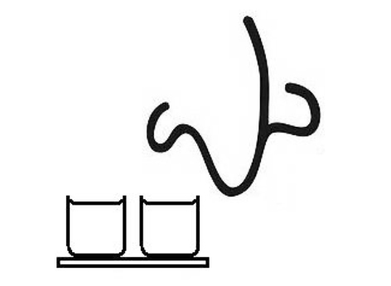
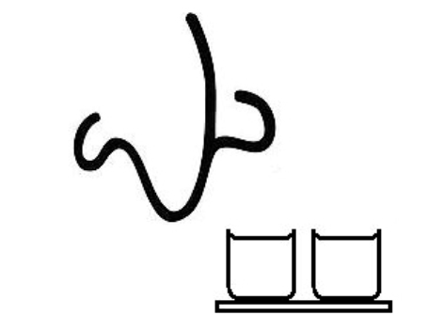
- B B.
.
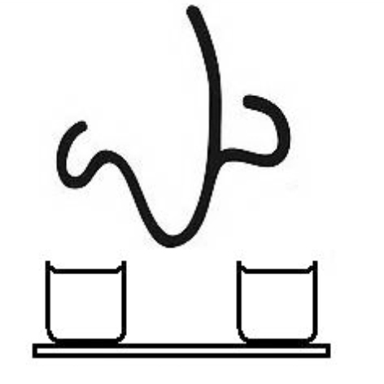
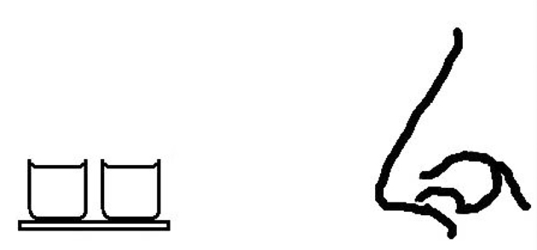

C. D.

30. Denise Chen and Wen Zhou discovered that ______.
A. our brain focuses on one thing at a time
B. our two nostrils act differently towards the same smell
C. our nose prefers to smell stronger smells
D. our sense of smell is connected with our sense of sight
31. The last paragraph is developed by ______.
A. giving examples B. making a comparison
C. telling a story D. showing the results
32. The main purpose of the text is to ______.
A. report an important event
B. describe a scientific experiment
C. study how the sense of sight works
D. introduce two scientists from Rice University
D
Half the world’s population could face a shortage of food by 2100 due to climate change, a new report by US scientists warns. Rapid global warming is likely to reduce crop production in the tropics and subtropics (热带和亚热带地区), according to Professor David Battisti of the University of Washington.
The most extreme summers of the last century will become common, he says. We must immediately create crops that can bear heat and drought if we are to adapt (适应) in time, he writes in Science journal.
“The stresses on global food production from temperature alone are going to be huge,” said Mr Battisti. “And that doesn’t take into account water supplies stressed by the higher temperatures.”
He worked with Professor Rosamond Naylor on Food Security and the Environment, to examine the influence of climate change on the world’s food supplies. They predict there is a greater than 90% probability that by 2100, the average growing-season temperatures in the tropics and subtropics will be higher than any temperatures recorded there to date.
“We are taking the worst of what we’ve seen historically and saying that in the future it is going to be a lot worse unless there is some kind of adaptation,” said Professor Naylor. “This is a powerful reason for us to invest (投资) in adaptation, because it is clear that this is the direction we are going in terms of temperature and it will take decades to develop new food crop varieties that can better bear a warmer climate.”
In the tropics, the higher temperatures could be expected to cut production of the primary food crops by 20-40%, the researchers said. Rising temperatures are also likely to reduce soil moisture (湿度), cutting production even further.
Three billion people live in the tropics and subtropics now, and their number is expected nearly to double by the end of the century.
“You are talking about hundreds of millions of additional people looking for food because they won’t be able to find it where they find it now,” said Professor Battisti.
Crop failures would not be limited to the tropics, the scientists concluded.
33. According to Professor David Battisti, what should be done to deal with crops reduction caused by global warming?
A. To plant more crops.
B. To develop new crops.
C. To control population growth.
D. To improve farming technology.
34. What does the underlined word “this” in Paragraph 5 refer to?
A. To reduce the temperature. B. New food crop variety
C. To invest in adaptation. D. Some kind of adaptation.
35. The text intends to tell us that _____.
A. our world is becoming warmer and warmer
B. high temperatures may cause food shortages
C. the consequences of global warming
D. the ways to adapt to high temperatures
第二节（共5小题；每小题2分，满分10分）
根据短文内容，从短文后的选项中选出能填入空白处的最佳选项。选项中有两项为多余选项。
Kids who have autism (自闭症) see the world differently than other people do, so they sometimes react to it in unexpected ways. 36 __.She hopes that people can understand autism and treat those who have autism with respect. So if you meet someone who has autism, you can try...
37
It can be hard for some kids who have autism to approach groups of kids to make friends. But Gina says that making friends with someone who has autism isn’t a big deal. “Just say hi — even if you’re shy. Every-one has to get used to a new friend.” 38
Learning about them
39 . For example, a person who has autism might be very bothered by a noisy classroom. You might have no problem with the noise, but a kid with autism might be so upset that she has to leave the room. Gina says, “To understand a kid like me, you just have to be patient.”
Being kind to them
Words can hurt a kid with autism and sometimes it’s very hard for them to get over it after someone is mean to them. Gina says, “ 40 . Try to have a nice heart.”
A. Saying hello to them
B. Making friends with them
C. Be nice to people who are different.
D. Autism can cause a kid to be afraid in public.
E. That includes kids who don’t have autism, too, she says.
F. Autism can make some kids uncomfortable in certain situations.
G. Gina is such a girl who has made great success through her efforts.
第三部分 英语知识运用（共两节，满分45分）
第一节 完形填空（共20小题；每小题1. 5分，满分30分）
阅读下面短文，从短文后各题所给的四个选项（A、B、C和D）中，选出可以填入空白处的最佳选项，并在答题卡上将该项涂黑。
As a teacher, I often make it a rule that when we are on a field trip, there will be no talking as we enter a building. This rule 41 to entering any place, whether it is a cinema, a church, a theatre, or any other place.
Once, in New Work City, I took my class to see a(n) 42 near Times Suqare. When we arrived at the theatre, there were about twenty other classes 43 outside waiting to get in. the students from the other schools were not 44 and there was pandemonium(乌烟瘴气). I told my students to stay in a line and keep 45 .I told them that we would not carry ourselves like those other 46 . Soon we started to file into the theatre, and it was very disorganized. There was a lady trying to 47 the groups and get them to their seats, 48 students were everywhere and 49 really knew where to go. My class, observing our rule, walked in 50 in two single-file lines. We stood near the door behind everyone else, and we 51 . All of a sudden, the lady who was 52 noticed us and she walked 53 our direction. She asked the students 54 the teacher was for our group, and I raised my 55 . She asked, “Very, very nice to meet you come this way.” We were led into the theatre, 56 , and we were given front-row seats.
Sometimes 57 for others may not seem like it is going to have an effect, especially when you 58 no one around who is taking manners into 59 . However, that is usually the time when such 60 actions will be most appreciated and recognized.
41. A. leads B. applies C. turns D. belongs
42. A. play B. lady C. teacher D. exhibition
43. A. sorted out B. settled down C. turned away D. lined up
44. A. behaving B. listening C. concentrating D. watching
45. A. order B. contact C. watch D. time
46. A. places B. seats C. classes D. teachers
47. A. scold B. dismiss C. attract D. organize
48. A. and B. but C.so D.while
49. A. anyone B. nobody C. everyone D. somebody
50. A. anxiously B. immediately C. quietly D. hurriedly
51. A. passed B. chatted C. rushed D. waited
52. A. in trouble B. on guard C.in charge D.on business
53. A. in B. to C. for D. under
54. A. how B. where C. what D.whether
55. A. voice B. arm C. head D .hand
56. A. finally B. somehow C. first D. instead
57. A. respect B. love C.concern D. support
58. A. receive B. visit C. recognize D. meet
59. A. practice B. effect C. account D. operation
60. A. urgent B.kind C. legal D. firm

第Ⅱ卷（非选择题）
第三部分 英语知识运用（共两节，满分45分）
第二节 （共10小题；每小题1. 5分，满分15分）
阅读下面材料，在空白处填入适当的内容（1个单词）或括号内单词的正确形式。
Jennifer and Molly are having a stroll (闲逛) in a market.
Jennifer: Molly, how about this dress?
Molly: Wow, you have such good taste! It’s 61 (expensive) one in the market.
Jennifer: So, I need to bargain (讲价) with the seller.
Molly: Oh, bargaining is the last thing in this world I’d do. Bargaining over the price takes so long and sometimes turns into a(an) 62 (argue). In fact that’s 63 I don’t like shopping in a marketplace.
Jennifer: But the salesgirls in a shopping mall also talk to you.
Molly: That’s different. They give me some information about the product 64 never persuade me 65 (buy) it like the marketplace sellers do. Besides, I can’t bear spending half an hour 66 (bargain) without buying anything in the end because both sides can’t compromise (妥协) on the price.
Jennifer: Yes, it takes time. But looking for bargains in a market can be 67 (real) exciting.
Molly: How can that be?
Jennifer: Bargaining 68 (involve) good communication. Do you know why I got the silk scarf at such 69 low price?
Molly: No, why?
Jennifer: Every time I stopped there, I chatted as I bargained with the seller. Now we are acquainted (熟识的) and I can always buy something cheaply. You can never do that in a mall 70 the prices are fixed(固定的).
Molly: That’s true. But I just don’t like shopping in a marketplace.

第四部分 写作（共两节；满分35分）
第一节 短文改错（共10小题；每小题1分，满分10分）
文中共有10处语言错误，每句中最多有两处。错误仅涉及一个单词的增加、删除或修改。
增加：在缺词处加一个漏字符号(∧)，并在其下面写出该加的词。
删除：把多余的词用(＼)划掉。
修改：在错的词下画一横线，并在该词下面写出修改后的词。
注意：1. 每处错误及其修改均仅限一词；
2. 只允许修改10处，多者（从第11处起）不计分。
My neighbor Mrs. Li is a curious lady. Yesterday morning, a mailman rang my doorbell. Hear the bell, Mrs. Li put her head out of the windows immediately and asked in a loud voice, “What’s the matter?” “Are you Li Xia? There’s package for you,” answer the man. “Where is it come from?” Mrs. Li asked. “It’s from London.” Then Mrs. Li asked the mailman to open it. Feeling puzzling, he replied that he couldn’t open the package and asked Mrs. Li to come down and open it herself. Mrs. Li refused polite. The mailman was a little bit angry but asked impatiently, “Why?” “Because I’m not Li Xia. She lives next door. I played a joke of you.” Mrs. Li explained.
笫二节 书面表达（满分25分）
最近，某英语报社就全球变暖这一话题向在校高中生征稿，请你根据以下表格信息，写一篇100词左右的英语短文投稿。
原因 | 二氧化碳的排放
原因 | 森林减少
原因 | 大气污染、环境破坏
应对措施 | 减少二氧化碳排放
应对措施 | 种草种树、保护环境
应对措施 | 不用一次性产品
参考词汇：排放物 emissions 二氧化碳 carbon dioxide
一次性的 disposable
高二英语参考答案
听力
1----5 ACCBB 6---10 ACBAB 11----15 AABCA 16---20 AABCC
阅读
21----25 CDABD 26----30 DBCCA
31----35 BBBCB
七选五
36-40 GAEFC
完形填空
41—45 BADAA 46—50 CDBBC
51—55 DCABD 56—60 CADCB
语法填空
61. the most expensive 62. argument 63. why 64. but
65. to buy 66. bargaining 67. really 68. involves
69. a 70. where
短文改错
71. ... rang my doorbell. my → her
72. Hear the bell ... Hear → Hearing
73. ... out of the windows ... windows → window
74. There’s package ... package前加a
75. ... answer the man. answer → answered
76. ... is it come from ... is → does或去掉come
77. Feeling puzzling ... puzzling → puzzled
78. ... refused polite. polite → politely
79. ... but asked impatiently ... but → and
80. ... a joke of ... of → on
作文
One possible version:
As is known to all, global warming has done great harm to Earth.
There are several reasons for global warming. Firstly, carbon dioxide emissions are to blame. Secondly, more and more forests have been cut down. Thirdly, the air is being polluted and the environment is being damaged.
In my opinion, to stop Earth from becoming warmer and warmer, we must firstly try our best to reduce carbon dioxide emissions. Secondly, we should plant more grass and trees and take effective measures to protect the environment. Lastly, we should not use disposable products.
Let’s make a great effort together to stop global warming and make Earth a better place to live in.

