广西钦州市高新区2016-2017学年高二年级上学期12月份考试
英 语 试 题
(时间：120分钟 满分：150分)
注意事项：1.本试卷分为第Ⅰ卷（选择题）和第Ⅱ卷（非选择题）两大部分。
2.全部答案在答题卡上完成，答在本试卷上无效。
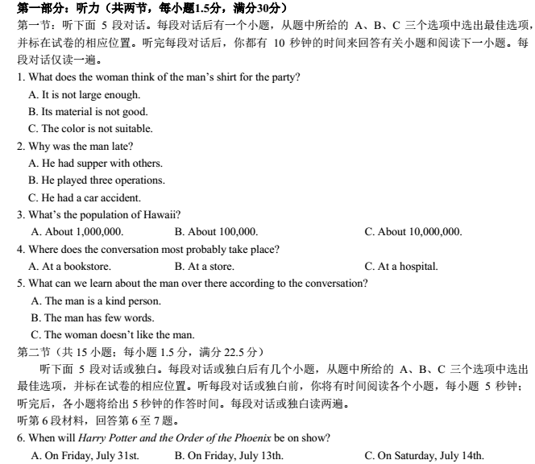
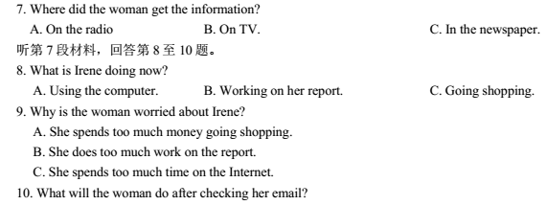
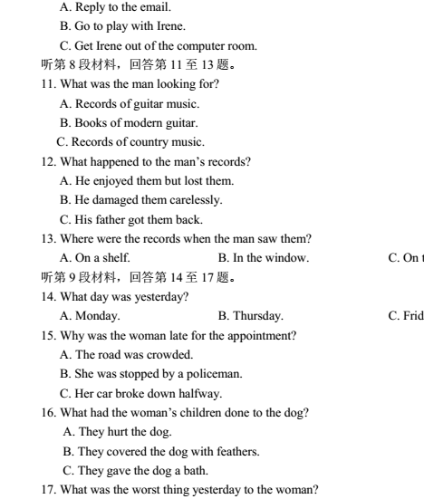
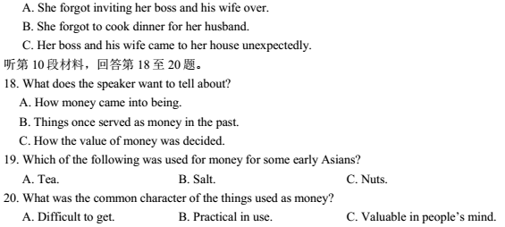
第二部分：阅读理解（共两节，40分）
第一节 （共15小题；每小题2分，共30分）
阅读下列短文，从每题所给的A、B、C、D四个选项中，选出最佳选项，并在答题卡上将该项涂黑。
A
When I was younger, bedtime was always my favorite part of the day. Wearing soft pajamas and with Ian, my stuffed monkey, in my arms, I felt no pressure at all.
I named Ian after my uncle when I compared Ian’s long arms and legs to his. One night I ran up to Uncle Ian at a family party and told him I had named my monkey after him. His eyebrows wrinkled in confusion, then a chuckle（哈哈笑）escaped his lips. I guess he didn’t understand how important it was to me.
Even if Uncle Ian didn’t think my monkey was special, I certainly did. I dressed him in a white baby nightgown. My mother thought that Ian was the best-dressed stuffed animal in the world. Yes, he was certainly a fashionable creature. The strong cologne（科隆香水）I used on him years ago makes him still smell “pretty”.
For a long time, Ian went everywhere with me. He was my best friend, and I told him everything. But when I turned twelve, I realized I was too old for stuffed animals. I thought people would think I was babyish, so I put him in the cupboard with the rest of my teddy bears and dolls. I begged him to understand why I was doing this, but at the same time I longed to talk to him again.
It took me several years to realize that it was OK to miss Ian. I know now that maturity（成熟）doesn’t only mean growing up and taking on more responsibility. It also means holding on to your childhood and acting young sometimes.
Ian has been with me since I was six years old holding him in my arms connects me to my past and my present as I continue to grow and understand myself.
21．Which of the following is not true according to the text?
A．Bedtime used to be the writer’s favorite part of the day because of the stuffed monkey.
B．Uncle Ian liked the stuffed monkey as much as the writer.
C．The writer used to carry the monkey with her wherever she went.
D．Years later the writer realized that it was not wrong to miss Monkey Ian.
22．The writer loved Monkey Ian deeply because __________.
A．he could understand her
B．he was a fashionable monkey
C．he could talk with her
D．he was her most honest listener
23．We can learn from the text that the writer believes ________.
A．keeping stuffed animals is babyish
B．maturity doesn’t mean growing up and taking on more responsibility
C． one should keep to his childhood and act young sometimes even when he has grown up
D．human beings should be kind to animals
24．We can infer from the text that _________.
A．the writer is still a teenager
B．the writer is now a middle-aged woman
C．Monkey Ian got angry for being left alone
D．Uncle Ian has a monkey-like face
B
The Hawaiian Islands are situated about two thousand miles away from North America, right in the middle of the Pacific Ocean. Despite(尽管) the distance the islands actually make up the fiftieth state of the United States. The islands were all formed by volcanic eruption and on the largest of the islands, Hawaii, or the Big Island, there are still two active volcanoes, the Mauna Loa and the Kilauea, which still erupt every few years.
On the Hawaiian islands the natives have a particularly strange way of indicating directions. They don’t use the north, south, east and west system common to the rest of the world. They use the mauka and makai system. Mauka means “mountain”. The mountains in Hawaii are always at the center of the islands, as these are volcanic islands. Makai means “the sea”. The islands are small and the system is simple. Wherever you want to visit, it can always be described in terms of where it lies in relation to the mountains and the sea. A typical conversation between a native Hawaiian and a tourist might go as follow.
TOURIST: Excuse me! Could you tell me where the Sheraton Hotel is?
HAWAIIAN: Well… Let me see! From here it’s two blocks mauka, and then one block makai. You can’t miss it!
25. Choose the most suitable title for the article.
- The Big Island. B. Volcanoes.
ziyuanku.com C. Giving Directions in Hawaii D. The Hawaiian Islands.
26. Which of the following items does the passage NOT discuss?
A. Hawaii’s location. B. How to give directions in Hawaii.
C. Volcanoes. D. The climate.
27. In Hawaii the mountains are in the center of the islands because .
- of the weather
- the islands were created by volcanic eruptions
- of the geological conditions
- of the islands’ location in the Pacific
28. To find your way in Hawaii, you must .
- refer to geographical directions
- refer to well-known establishments
- refer to the earth and the sea
- refer to the location of the mountains and the sea
C
If you wish to become a better reader, here are four important points to remember about rate, or speed, of reading:
1. Knowing why you are reading—what you are reading to find out—will often help you to know whether to read rapidly or slowly.
2. Some things should be read slowly throughout. Examples are directions for making or doing something, arithmetic problems, science and history books, which are full of important information. You must read such things slowly to remember each important step and understand each important idea.
3. Some things should be read rapidly throughout. Examples are simple stories meant for enjoyment, news, and letters from friends, items, or bits of news from local, or hometown, paper, telling what is happening to friends and neighbors.
4. In some of your readings, you must change your speed from fast to slow to fast, as you go along. You need to read certain pages rapidly and then slow down and do more careful readings when you come to important ideas which must be remembered.
29. According to the passage, your reading speed depends on ________.
A. whether the reading material is easy or difficult
B. what you are reading
C. what your purpose in reading something is
D. both B and C
30. If one wants to be relaxed by reading, one should take up ________.
A. a story book B. a book on science and technology
C. news, letters from friends D. some material full of information
31. Which of the following readings should you read slowly and carefully?
A. Fairy tales. B. Aesop’s Fables.
C. Directions for use of a machine D. An evening paper.
32. Which of the following can best express the main idea of the passage?
A. How to decide your reading speed. B. How to raise your reading speed.
C. How to improve your reading skills. D. How to choose your reading materials.
D
TEFL (Teaching English as a foreign language) England runs TEFL courses for English-speaking people wishing to teach English abroad. Our courses will give you the qualifications (资格证书) to find your first paid teaching job abroad.
 We run TEFL courses across the whole of England. We offer a lot of courses, which are different in length, price and level of qualification. Once you have finished all your TEFL England courses, and get your TEFL certificate (结业证书), you will be able to get the TEFL job we offer. We now have TEFL jobs in Spain, Japan, China and other countries worldwide. Through our courses you will learn all you need to step into your first TEFL classroom. If you have lost your job we can offer you a 10% discount off the course cost.
TEFL England 24-hour weekend courses are taught in an interesting way and help you to be fit for your job in just 12 days. You’ll learn the rules of English language teaching and become skilled at how to plan, prepare and teach TEFL lessons with lots of hands-on activities. You’ll spend your weekend learning by doing, not by writing!
The cost of all the courses is 480 pounds. If you only attend half the courses, you have to pay 300 pounds. If you wish to attend the courses you should let us know ahead of time. For more information visit www.teflengland.co.uk, call 0800 9 888 200 between 9 am and 5:30 pm Monday to Friday to talk to one of our TEFL trained advisors or e-mail info@tefleng-land.co.uk.
33. What can we learn from this text?
A. TEFL England has schools all over the world.
B. TEFL England offers two 2-hour courses each day.
C. If you get the certificate you can get a job.
D. If you study half the courses you should pay half of the fees.
34. If you have no job and want to attend all the courses you have to pay ______.
A. 300 pounds B. 480 pounds
C. 270 pounds D. 432 pounds
35. Which of the following best describes the courses?
A. Interesting and practical.
B. Friendly and active.
C. Funny but serious.
D. Useful but strict.
第二节 (共5小题；每小题2分，满分10分)
根据短文内容，从短文后的选项中选出能填入空白处的最佳选项。选项中有两项为多余选项。
The benefits of walking to school
Encouraging your child to walk to school has many benefits. 36
The rates of childhood obesity and illnesses such as type II Diabetes (糖尿病) can be prevented by a healthy dose of walking. 37 On average around half of all children do not do the minimum one hour a day of physical activity advised by the Health Education Authority. A quick walk to school can help them get their daily exercise and arrive at school or home, refreshed and energized.
38 There was very strong evidence that walking to school improves children’s social development. This related to social contacts, independence and road sense. The walkers reported a happy social experience. It is believed that getting a lift to school each day can lead to a child becoming lethargic (无生气的).
According to research, the average drive to school and back releases 800g of CO2 into the air. 39 If walking to school once a week can save 20 per cent of CO2 gas produced by driving every day, how much CO2 can be saved a year!
Last but not least, encouraging your child to walk to school will save you money. 40
Since walking to school has so many health, social, environmental and economical benefits, why not let your child walk from now on?
A. It is enough to blow over 60 balloons.
B. The following are some of them in different aspects.
C. Walking can have a positive effect on a child’s emotional health.
D. You will spend less money on transport fares or petrol of course.
E. Furthermore, 50 per cent of children still don’t regularly walk to school.
F. In fact, walking helps protect the body from many serious illnesses later on in life.
G. Parents, children and teachers are asked to think about the benefits of walking to school.
第三部分 英语知识运用（共两节，满分40分）
第一节 完形填空（共20小题；每小题1.5分，满分30分）
阅读下面短文，从短文后各题所给的四个选项（A、B、C和D）中，选出可以填入空白处的最佳选项，并在答题卡上将该项涂黑。
My grandson is seven now. He lives 100 miles away. He 41 my mobile phone number when he was only four. 42 , he has called me every night.
$来&源：ziyuanku.com He also 43 calls me at other times during the day just to 44 a happy or sad moment. Many times he is holding a basketball with one hand, or 45 with a friend about something I don’t quite 46 , or crying about something. I just 47 and laugh or cry with him — just share his emotion. I always let him be in 48 of the conversation, the emotion, and the amount of time he’s on the 49 with me. Many times I just listen to him 50 or listen while he does his homework aloud.
The 51 time I take control of the conversation is when he’s 52 to say goodbye at night. Then I say, “I love you, baby”. One 53 I thought maybe he was 54 of hearing those words, so I didn’t say them. He immediately called me back and told me that I 55 to say the sentence! Since then I have never 56 saying it again!
All my friends know he takes precedence over (比……重要) all other things. If I’m at a place where I really can’t take his 57 , I always excuse myself and
58 tell him I’ll call him back in a few minutes. I want him to know that he takes first place in my 59 .
Every child needs at least one 60 in their life to listen and share with. I am glad to give my grandson the love he needs.
41. A. memorized B. kept C. noticed D. wrote
42. A. Once again B. Since then C. Later on D. Shortly after
43. A. briefly B. directly C. instantly D. frequently
44. A. express B. discuss C. share D. mark
45. A. comparing B. laughing C. studying D. quarrelling
46. A. understand B. enjoy C. believe D. remember
47. A. look B. talk C. sit D. listen
48. A. charge B. need C. support D. face
49. A. conversation B. phone C. way D. game
50. A. play B. sleep C. lie D. act
51. A. last B. only C. perfect D. right
52. A. willing B. determined C. ready D. eager
53. A. day B. night C. weekend D. morning
54. A. afraid B. tired C. aware D. ashamed
资*源%库55. A. decided B. learnt C. agreed D. forgot
56. A. escaped B. failed C. missed D. denied
57. A. invitation B. call C. help D. attention
58. A. naturally B. politely C. simply D. happily
59. A. work B. brain C. appointment D. heart
资*源%库60. A. friend B. grandparent C. adult D. teacher
第二节：单项填空（共10小题；每小题1分，满分10分）
从A、B、C、D四个选项中，选出可以填入空白处的最佳选项。
61. ―When will they be back?
―_____ I didn’t receive any message from them.
A. Take it easy. B. Don’t mention it.
C. How is everything? D. How should I know?
62. The play, _____ style is quite formal, is typical of the period.
$来&源：ziyuanku.comA. whose B. which C. that D. what
63. We must give up the project now. We _____ money.
$来&源：ziyuanku.comA. are running out of B. will run out of
C. had run out of D. have run out of
64. If you’d listened to me, you _____ in such trouble now.
A. needn’t have been B. needn’t be
C. wouldn’t be D. wouldn’t have been
65. The thief jumped into the water with the policemen _____ him.
A. running after B. run after
C. to run after D. ran after
66. Not all of us can deal with the _____ of modern life.
A. prejudices B. judgment C. stresses D. convenience
67. The young girl was _____ to ask such a simple question and nodded like the others.
A. shamed B. ashamed
C. shameful D. shameless
68. The medicine bought at a high price turned out to have no _____.
A. influence B. result C. effect D. risk
69. There was a long _____ silence between them after Jim’s angry words.
A. automatic B. abnormal
C. desperate D. awkward
70. Adolescents need adults to guide them; otherwise, _____ is easy for them to get into trouble.
A. that B. which C. it D. what
温馨提醒：请将第一卷答案涂到答题卡上。
资*源%库 ziyuanku.com第二卷 非选择题（非选择题共40分）
学校

第一节 语法填空（共10小题；每小题1.5分，满分15分）
阅读下面材料，在空白处填入适当的内容或括号内单词的正确形式。
There are various reasons 1 people write poetry. Some 2 (诗歌)give the reader a strong impression. Others try to 3 （传达）certain emotions. In this text, some simple forms of English poems are introduced. Such 4 nursery rhymes, which may seem 5 (concretely), but they are easy to learn and recite. List poems have a 6 （灵活的） line length and repeated phrases. Students can also write the cinquain , a poem 7 (make) up of five lines. Haiku is a Japanese form of poetry with 17 syllables. English speakers also 8 (翻译) Tang poems into English. 9 so many different forms of poetry to choose from, students may 10 (eventual) want to write poems of their own.
第二节 书面表达（共25分）
在春暖花开的春游（go spring outing）时节，某校学生就“高三学生要不要参加春游活动”展开讨论。请根据以下讨论结果，写一篇短文。
６５％的学生认为 | ３５％的学生认为
１．应该春游 | １．不应该春游
２．接触大自然，呼吸新鲜空气，有利健康 | ２．高考临近，没有心情玩
３．活动使精神放松，大脑休息，有利于学习 | ３．春游耽误学习
注意：1.字数100词左右
2.可以适当增加细节，以使行文连贯
________________________________________________________________________________________________________________________________________________________________________________________________________________________________________________________________________________________________________________________________

参考答案
KEYS: 1-5. CBABC 6-10. BCACC 11-15. ABBCC 16-20. CABAC
21-24 BDCA 25---28. C A B C 30---32 D A C A
33-35 CDA 36-40 BFCAD 41-45 ABDCB 46-50 ADABA 51-55 BCBBD 56-60 CBBDC 61-70 D A D C A C B C D C
答案：1. why 2.poems 3.convey 4.as 5.concrete
6.flexible 7.made 8.translate 9.With 10. eventually
Whether or not should Senior 3 students go spring outing? We have had a heated discussion. Opinions are divided on the question.
Most students, about 65%, are for the idea that Senior 3 students should go spring outing. They think it good for their health to be close to nature and breathe some fresh air and what’s more, they can relax themselves for a while and rest their brains so that they will be more energetic. They think it will do good to their students.
On the other hand, about 35% students are against the idea. They say that with college entrance examination drawing near, they don’t feel like going anywhere. Besides, they think going spring outing will take at least a day off. They can’t afford the time. They think they should fix their attention on their studies

