广西钦州市高新区2016-2017学年高一年级上学期12月份考试

英 语 试 题

(时间：120分钟 满分：150分)
第一部分：听力（共两节，满分30分）
做题时，先将答案标在试卷上。录音内容结束后，你将有两分钟的时间将试卷上的答案转涂到答题卡上。
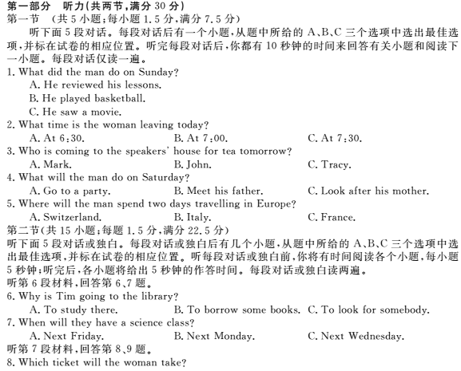
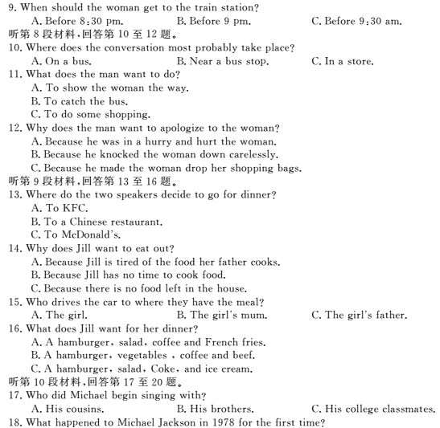
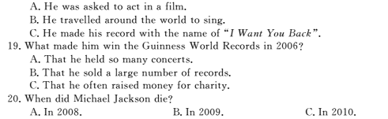
第二部分阅读理解（共两节，满分40分）
第一节（共15小题；每小题2分，满分30分）
阅读下列短文，从每题所给的四个选项（A、B、C和D）中，选出最佳选项，并在答题卡上将该项涂黑。
A
Basketball Statistician Help Wanted
The Athletic Department is looking for students to help assist staff during the Fall 2016, Winter 2016-17 and Spring 2017 semesters. Students in this position will be keeping live statistics during basketball games. Students must meet all of the following requirements:
Good computer skills
Available evenings and weekends
Knowing basketball rules and statistics
Students interested in working for the Athletic Department should contact the Athletic Coordinator at their respective(各自的) campuses.
TP/SS Athletic Coordinator, Michael Simone,240-567-1308
Rockville Athletic Coordinator, Jorge Zuniga,240-567-7589
Springfield Athletic coordinator, Gary Miller,240-567-2273
Germantown Athletic Coordinator, Gavri Chavan, 240-567-6915
21.When will the job start?
A .In May 2016B. In May 2017
C. In September 2016D. In September2017
22.Who is more likely to get the job?
A. Sam, English major, member of the college basketball team
B. Judy, IT staff with night classes, children’s basketball team coach
C. Ted, computer major, basketball fan, free on evenings and weekends
D. Molly, part-time programmer, high school basketball player, new mother
23. Whom should you contact if you want to apply for the job in Rockville?
A. Michael B. Jorge C. Gauri D. Gary

B
For Chinese, it’s a time for dragon boat racing and Zongzi（粽子）. But across the Yellow Sea, South Korea, wrestling（摔跤）and swing play are the highlights. However, both events go by the same name---the Dragon Boat Festival---which falls on May5 of the lunar calendar.
One festival, two cultures: does one nation have the right to call its own? It has been reported that South Korea will apply（申请）to the United Nations Educational, Social and Cultural Organization（UNESCO联合国教科文组织）to make the celebration its cultural heritage（文化遗产）. If successful, people from other countries may see the Dragon Festival as a Korean creation.
As the birthplace of the yearly event more than 2,000 years ago, China is not happy with the situation. “It would be a shame if another country successfully made a traditional Chinese festival part of its own cultural heritage ahead of China,” said Zhou Heping, deputy culture minister. The Ministry of Culture is even thinking of making its own application to UNESCO, covering all traditional Chinese festivals, including the Dragon Boat event.
Over the years, the Dragon Boat Festival has spread throughout the world. In Japan and Viet Nam, as well as South Korea, the festival has mixed with and become part of local culture.
With this in mind, some experts say that it is meaningless to argue about which country the festival belongs to. “No one can deny that it came from China,” said Long Haiqing, an expert from Hunan Province. “But if all the countries involved can protect culture heritage together, they will all benefit.”
24. The underlined word “highlights” can be probably replaced by “ “.
A. most exciting events B. highest lights on the building
C. brightest lights at night D. most famous festivals
25. It can be inferred that South Korea .
A. has proclaimed（宣布）the Dragon Boat Festival as a part of its cultural heritage
B. has the exactly same Dragon Boat Festival as China
C. has no idea that China has such a festival
D. is paying more attention to its cultural heritage than China
26. China is not happy with the situation because .
A. it created the festival
B. it is also making an application
C. South Korea has no right to call the festival its own
D. UNESCO may approve（批准）South Korea’s application
27. If South Korea’s application to UNESCO is successful, .
A. China will also make its own application to UNESCO
B. it will be meaningless to celebrate the Dragon Boat Festival
C. people from other parts of the world will think South Korea created the festival
D. the Dragon Boat Festival will become part of local culture
C
One morning, I stepped out of bed and put my feet on the floor. Suddenly, a mean little man jumped out from under the bed and stabbed (刺，扎) an ice pick (碎冰锥) through my left foot.
Figuratively (比喻地) speaking, yes.
I took another step and he stabbed it again. This went on all day. Step, stab, scream. Over the next few days, I started limping (跛行). My whole body hurt. Even my hair. I kept thinking that the little man would get tired of stabbing me and go pick on somebody else. We often take things for granted until we lose them or they start to hurt.
My brother deals with pain every day. He’s also blind and suffers from cerebral palsy (脑瘫), needs a walker to walk, doesn’t take much for granted. I had to wonder: What would he think about my foot?
Finally, after a week of pain, I went to see a very nice foot doctor. The doctor studied my foot, took X-rays, shook his head, and said the little man’s name: Arthur Itis, or Arthritis (关节炎).
I knew it well. I’d often heard it hissed angrily by my grandparents and parents, all attacked by Arthur’s ice pick when they got older.
“Wait,” I said. “Doesn’t Arthur usually just pick on old people?”
The doctor smiled, looking at my chart. “How old are you?”
I gave him a look. “Never mind,” I said. “Can you fix it?”
“Well,” he said, “we can try.”
He listed several options and I chose the injection (打针). It didn’t hurt much. Not half as much as the ice pick.
That was yesterday. This morning, I awoke, took a few careful steps and … hallelujah! It hurt just a bit, but no ice pick. I looked under the bed. No sign of Arthur. Maybe he was hiding in the closet, waiting for another day. But for now, he was gone, and I was grateful. My mind began to race with plans to do all the things I’d been putting off for days: unpack, clean the house, wash my hair …
Then it hit me. Another stab. Not in my foot. In my heart. I remembered that I hadn’t called my brother in a long time.
It’s easy to take some things for granted. But it should never be the people we love.
28. Why didn’t the author go to see the doctor for the first week?
A. Because she was afraid that her brother would laugh at her.
B. Because she thought it was too cold to step out of her room.
C. Because she expected that the pain would gradually disappear.
D. Because she believed that she could endure the pain like her brother did.
29. Who had a disease that was different from the other people mentioned?
A. The author. B. The author’s brother. C. The author’s parents. D. The author’s grandparents.
30. After having the injection, the author’s _______.
A. felt regretful because it hurt so much
B. was first satisfied with her recovery
C. felt better but could still feel the “ice pick” pain
D. was busy with housework that had been delayed for days
31. From her experience of arthritis, the author learned that _______.
A. a stabbing pain in the heart is as painful as one in the foot
B. people who help us relieve pain should be thanked properly
C. we should always remember to show our love to those we love
D. we should never take for granted the pain we experience in life
D
If you think about World Heritage Sites, you probably think of places connected with ancient art and culture, historical buildings and monuments. And of course, many of these are on the World Heritage List (WHL)（世界遗产名录）. But the WHL contains a lot of sites that are not so obvious. Let’s look at a few of them.
Citadel of Haiti
These monuments were built at the end of the nineteenth century when Haiti（海地）became independent and the many thousands of black slaves in Haiti were free for the first time. These ex-slaves built the monuments, which the WHL describes as “a universal symbol of liberty”.
Robben Island in South Africa
This island was used through the centuries as a prison, a hospital and a military base. But it’s probably most famous as a maximum-security prison for political prisoners in the twentieth century. Nelson Mandela was one of its most famous residents. The WHL says it represents “the triumph of democracy and freedom over oppression and racism”.
The Darjeeling Himalayan Railway in India
This railway was opened in 1881 and is still operating today. It crosses a difficult area of mountain landscape and it is a great example of railway engineering. The WHL says that it is “the first, and still the most outstanding example of a hill passenger railway”.
Borders of France and Spain
This is an area of great natural beauty and the mountains have many interesting geological formations. But it is also an area of small farms. People there still use a type of agriculture that used to be common in mountainous areas of Europe but has almost completely disappeared in modern times.
The city of Brasilia, Brazil
Brasilia is a capital city that was created from nothing in 1956. The WHL calls it “a landmark in the history of town planning”. The different areas of the city and the buildings themselves were all designed at the same time carefully. Every part of the city shows the ideas of the planer and architect.
Alto Douro, Portugal
This is an area in the North of Portugal where wine has been produced for thousands of years. The WHL says that this long tradition of winemaking “has produced a cultural landscape of outstanding beauty that reflects its technological, social and economic evolution”.
Rio Platano Reserve, Honduras
The WHL says that this site is “one of the few remains of a humid tropical forest in Central America”. It’s a mountainous area on the Caribbean coast with many different species of plants and animals. The people who have always lived there still have the same traditional lifestyle.
Simien National Park, Ethiopia
Simien National Park was one of the first sites to be listed in 1978. It is one of the highest mountain areas in Africa, and the WHL calls it “one of the most spectacular landscapes in the world”. It is also important for its wildlife. The population of some rare animals is getting smaller and smaller.
32. The passage mainly talks about .
A. the remains of ancient cultures on the WHL
B. the household heritage sites on the WHL
C. some of the more unusual sites on the WHL
D. places of artistic or cultural importance
33. Which of the following sites were listed in WHL for political symbol?
A. Simien National Park and Rio Platano Reserve.
B. Alto Douro and the city of Brasilia.
C. The Darjeeling Himalayan Railway and Borders of France and Spain.
D. Citadel of Haiti and Robben Island.
34. Which of the following sites was listed in WHL for the wonderful plan of buildings?
A. Robben Island in South Africa
B. The city of Brasilia, Brazil.
C. Rio Platano Reserve, Honduras.
D. Simien National Park, Ethiopia
35. From the passage we can infer that the WHL lists places .
A. only concerned with ancient monuments and buildings
B. only concerned with technology, natural beauty, wildlife and traditional ways of life
C. not only concerned with ancient monuments and buildings, but with technology, natural beauty, wildlife and traditional ways of life
D. neither concerned with ancient monuments and buildings nor with technology, natural beauty, wildlife and traditional ways of life.
第二节 (共5小题；每小题2分，满分10分)
E
根据短文内容，从短文后的选项中选出能填入空白处的最佳选项。选项中有两项为多余选项。
Ziyuanku.comBoth men and women are living longer these days in industrialized countries. 36 In general, they can expect to live six or seven years more than men. One reason for this is biological.
One important biological factor that helps women live longer is the difference in hormones between men and women. 37 Between the ages of about 12 and 50, women produce hormones that are involved in fertility(生育能力). These hormones also have a positive effect on the heart and blood flow. In fact, women are less likely to have high blood pressure or to die from heart attacks.
38 They help the body defend itself against some kinds of infections. This means that women generally ger sick less often and less seriously than men. The common cold is a good example: women, on average, get fewer colds than men.
39 Scientists are still not exactly sure how influence aging, but they believe that they do. Some think that a woman’s body cells have a tendency(向) to age more slowly than a man’s. Others think that a man’s body cells have a tendency to age more quickly. 40
A．However, women, on average, live longer.
B .The biological factor plays an important part.
C. Women are also helped by their female genes.
D. The female hormones also protect the body in another way.
E. Recent research seems to support both of these possibilities.
F. Therefore, women are more healthy than men and can live a better life.
G. Hormones are chemicals which are produced by the body to control various body functions.
第三部分 英语知识运用 （共两节，满分 45）
第一节 完形填空（共 20 小题；每小题 1.5 分，满分 30 分）
阅读下面短文，从短文后各题所给的四个选项（A、B、C 和 D）中，选出可以填入空白处的最佳选项，并在答题卡上将该项涂黑。
A Heroic Driver
Ziyuanku.com Larry works with Transport Drivers. Inc. One morning in 2009. Larry was __41__
along 165 north after delivering to one of his 42 . suddenly, he saw a car with its bright lights on. 43 he got closer, he found 44 vehicle upside down on the road. One more look and he noticed 45 shooting out from under the 46 vehicle. Larry pulled over, set the brake and 47 the fire extinguisher (灭火器). Two good bursts from the extinguisher and the fire was put out.
WWW.ziyuanku.comThe man who had his bright lights on 48 and told Larry he had 49 an emergency call. They 50 heard a woman’s voice coming from the wrecked (毁坏的) vehicle. 51 the vehicle, they saw that a woman was trying to get out of the broken window. They told her to stay 52 until the emergency personnel arrived, 53 she thought the car was going to 54 . Larry told her that he had already put out the fire and she should not move 55 she injured her neck.
Once fire and emergency people arrive, Larry and the other man 56 and let them go to work. Then, Larry asked the 57 if he was needed or 58 to go. They let him and the other man go.
One thing is 59 —Larry went above and beyond the call of duty by getting so close to the burning vehicle! His 60 most likely saved the woman’s life.
41. A. walking B. touring C．traveling D．rushing
42. A. passengers B. colleagues C. employers D. customers
43. A. Since B. Although C. As D. If
44. A. each B. another C. that D. his
45. A. flames B. smoke C. water D. steam
46. A. used B. disabled C. removed D. abandoned
47. A. got hold of B. prepared C. took charge of D. controlled
48. A. came down B. came through C. came in D. came over
49. A. returned B. received C. made D. confirmed
50. A. then B. again C. finally D. even
51. A. Starting B. Parking C. Passing D. Approaching
52. A. quiet B. still C. away D. calm
53. A. for B. so C. and D. but
54. A. explode B. slip away C. fall apart D. crash
55. A. as if B. unless C. in case D. after
$来&源：ziyuanku.com56. A. stepped forward B. backed off C. moved on D. set out
57. A. woman B. police C. man D. driver
58. A. forbidden B. ready C. asked D. free
59. A.for certain B. for consideration C. reported D.checked
60. A.patience B. skills C. efforts D.promise
第 II 卷
第三部分 英语知识运用
第二节 语法填空（共10小题；每小题1.5分，满分15分）
阅读下面材料，在空白处填入适当的内容（不多于3个单词）或括号内单词的正确形式。
In my opinion, we should try our best 61 (realize) our goals even though 62 is little hope. The efforts seem to be the lights in the darkness, leading the way to hope and success.
I used to be 63 shy girl in my primary school. I was weak in English at that time, especially for 64 (speak) English. So I was afraid to answer the teacher’s questions during English classes. After I entered my dream middle school. Something 65 (change). I started to read many 66 (interest) English stories and my English teacher was patient to help me a lot. I studied hard in class and practiced by watching English films and listening to English songs in my free time. Little 67 little, I found 68 more and more interesting to learn English. I could even talk with my classmates 69 (fluent) in English and I was not shy any more. At last, I got high grades in English and I had 70 ( confident) to do it better in the future.
第四部分 写作 （共两节 满分 35）
- 短文改错（10 分）
- 假定英语课上老师要求同桌之间交换修改作文，请你修改你同桌写的以下作文。
文中共有10处语言错误，每句中最多有两处。每处错误仅涉及一个单词的增加、删除或修改。
增加：在缺词处加一个漏字符号（），并在其下面写出该加的词。
删除：把多余的词用斜线（）划掉。
修改：在错的词下划一横线，并在该词下面写出修改后的词。
注意：1.每处错误及其修改均仅限一词；
2.只允许修改10处，多着（从第11处起）不计分。
Long long ago, people had gather leaves and fruit of plants to eat with. They didn’t know how to plant crops and how to keep animals for their food. We call them Stone Age people. Thing for them were terrible and hard. Now there have still some people living liked those Stone Age people. They live in places that are hard reach. They do not know of our invention, for they keep themselves away our civilized world. For many years a group of people call Aruntas have lived alone in the center .
第二节 书面表达（满分25分）
假设你是临川中学高一（一）班的学生李华。你班同学参加了学校的“地球日”系列活动。请按照以下四幅图的先后顺序，以“Actions for a Greener Earth”为题，给校刊“英语角”写一篇英文稿件，介绍活动的全过程。
注意：词数不少于100。
Ziyuanku.com提示词：地球日Earth Day

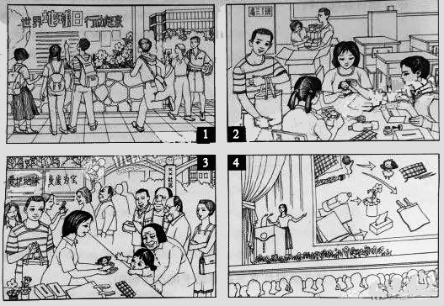
参考答案
第一部分听力（1—20小题，每小题1.5分，满分30分）
第二部分阅读理解（共两节，满分40分）
第一节（21—35小题，每小题2分，满分30分）
21. C 22. C 23.B 24-27. ADAC 28-31 CBBC 32-35. CDBC

第二节（36—40小题，每小题2分，满分10分）
36. A 37. G 38.D 39.C 40. E
第三部分英语知识运用（共两节，满分45分）
第一节完形填空（41—60小题，每小题1.5分，满分30分）
41- 45 CCCBA 46-50 DADCA 51-55 DB DA C 56-60 BBCAC
Ziyuanku.com
第II卷（非选择题 满分50分）
第二节 语法填空（61—70小题，每小题1.5分，满分15分）
61. to realize 62. there 63. a 64. spoken 65. changed
66. interesting 67. by 68. it 69. fluently 70. confidence
第四部分写作（共两节，满分35分）
第一节短文改错（共10小题；每小题1分，满分10分）
. 71. had改为had to 72. 去掉with 73. and 改为or
74. Thing改为things 75. have 改为are 76. liked改为like 77. reach改为to reach 78. invention改为inventions
79. away 后加from 80. call 改为called

第二节书面表达（满分25分）
One possible version:
A week before Earth Day, posters were put up around our school, calling upon us to join in the actions for a greener earth.
Our class came up with the idea to make better use of used materials. We brought to our classroom worn-out clothes, pieces of cardboard and empty plastic bottles, and turned those into dolls, handbags, issue boxes and small vases. That weekend, we went to a nearby neighborhood and gave them away to the people there. All were very happy with those unexpected gifts, especially little kids and elderly people. We did so well that we were invited to share our idea and experience with all the students of our school.
We are very proud of ourselves and believe we can do more for a better world.
WWW.ziyuanku.com

