高三年级考试
英 语 试 题
2017.11
本试卷由四个部分组成。其中，第一、二部分和第三部分的第一节为选择题。第三部分的第二节和第四部分为非选择题，共12页。试卷满分150分，考试时间120分钟。考试结束后，将本试卷和答题卡一并交回。
注意事项：
1．答题前，考生务必将自己的姓名、准考证号、考试科目涂写在答题卡上。
2．答选择题时，每小题选出答案后，用铅笔把答题卡上对应题目的答案标号涂黑。如需改动，用橡皮擦干净后，再选涂其他答案标号。不能答在试卷上。
3．答非选择题时，将答案写在答题卡上。写在本试卷上无效。

第I卷(共100分)
第一部分 听力(共两节，满分30分)
做题时，先将答案标在试卷上。录音内容结束后，你将有两分钟的时间将试卷上的答案转涂到答题卡上。
第一节(共5小题；每小题1.5分，满分7.5分)
听下面5段对话。每段对话后有一个小题，从题中所给的A、B、C三个选项中选出最佳选项，并标在试卷的相应位置。听完每段对话后，你都有10秒钟的时间来回答有关小题和阅读下一小题。每段对话仅读一遍。
1．What’s the color of the sofa?
A．Green． B．Light blue． C．Brown．
2．Where will the speakers sit?
A．In area 1. B．In area 2． C．In area 3．
3．Who is the best British writer according to the man?
A．Jane Austen． B．D．H．Lawrence． C．Charles Dickens．
4．What does the woman advise the man to do?
A Eat some food B．Drink some water C．Take some medicine．
5．Where does the conversation take place?
A．In an office． B．In Tom’s home． C．In a hospital．
第二节(共15小题；每小题1.5分，满分22．5分)
听下面5段对话或独白。每段对话或独白后有几个小题，从题中所给的A、B、C三选项中选出最佳选项，并标在试卷的相应位置。听每段对话或独白前，你将有时间阅读各个小题，每小题5秒钟；听完后，各小题将给出5秒钟的作答时间。每段对话或独白读两遍
听下面一段对话，回答第6和第7两个小题。
6．What did the man do last night?
A．He worked all night．
B．He watched a football game．
C．He read a story by Shakespeare．
7．How much of the film did the woman see?
A．The beginning． B．The end． C．The whole film.
听下面一段对话，回答第8和第9两个小题。
8．Who does the woman buy the beef for?
A．Her daughter． B．Her husband． C．Her son．
9．What does the woman say about the chicken?
A．It’s expensive．
B．It’s her favorite．
C．It’s perfect in the salad．
听下面一段对话，回答第10至第12三个小题。
10．What’s the probable relationship between the speakers?
A．Doctor and patient． B．Boss and assistant． C．Husband and wife．
11．What can we learn about the man?
A．He has a cold．
B．He often tells lies．
C．He’s staying in bed．
12．What did the woman do with the man’s problem?
A．She put his cigarette out．
B．She gave him some medicine．
C．She prepared some hot water for him．
听下面一段对话，回答第13至第16四个小题。
13．Why is the man helping the woman?
A．She’s been busy．
B．She isn’t feeling well．
C．She doesn’t know what to do．
14．What does the woman ask the man to do?
A．Boil the water．
B．Take care of the kids．
C．Get the ingredients(原料)out．
15．What will the speakers make at last?
A．The sauce． B．The noodles． C．The meatballs．
16．How often does the man help out in the kitchen?
A．Never． B．All the time． C．Not usually．
听下面一段独白，回答第17至第20四个小题。
17．Who is the speaker?
A．A doctor． B．A headmaster． C．A policeman．
18．What is happening at the school?
A．A fire． B．An earthquake． C．A safety exercise．
19．What should teachers do?
A．Set the alarm．
B．Keep the students calm．
C．Lock all classroom doors．
20．When should students return to their normal activities?
A．Once the bell stops．
B．At the end of the day．
C．After the second announcement．
第二部分 阅读理解(共两节，满分40分)
第一节(共15小题；每小题2分，满分30分)
阅读下列短文，从每题所给的四个选项(A、B、C和D)中，选出最佳选项，并在答题卡上将该项涂黑。
A
Where to see amazing colours around the world
Lake District
As you wander along Windermere to the centre of Ambleside，autumn colours are abundant．Looking across the water，it seems that the treeline is alight with red and orange leaves．As you round the bend on to the road into town，you are faced with a hillside that celebrates autumn at its best．
CANADA and USA Dorset Lookout Tower，near Toronto
Before you reach Dwight，climb the Dorset Lookout Tower，142 metres above the Lake of Bays．From up here，the canopy(树冠)is an autumnal quilt reaching to the horizon，refreshing the eyes and invigorating the spirit．
Great Smoky Mountains，Tennessee／North Carolina
Fall in this national park is amazing．Just outside quaint Townsend，Tennessee，it is a bikeable and driveable 11-mile loop(环形车道)，but be sure to explore the cabins and fields on foot．Late October and early November is my favoufite time to visit；the colours are great and the weather is cool enough to allow nice walks and hikes．
Kamikochi national park，Honshu
In central Honshu，three hours’drive north—east of Nagoya，is one of the most charming places in the Japanese Alps．The mountain slopes are covered with forests of larch and beech that blaze scarlet and orange in the autumn．Wisps of smoke hang in the still air above Yakedake volcano，and the glass surface of Taisho Pond perfectly reflects the trees and snow-dusted mountains．
21．What season scenery does the text describe?
A．Spring． B．Summer． C．Autumn． D．Winter．
22．Where would you go if you like to ride a bike?
A．Lake District．
B．CANADA and USA Dorset Lookout Tower．
C．Great Smoky Mountains，Tennessee／North Carolina．
D．Kamikochi national park，Honshu．
23．What is different from others about Kamikochi national park?
A．People can enjoy colorful leaves from up．
B．You can appreciate the snow scene．
C．The scenery here is the most charming．
D．No smoke can be seen above the volcano．
B
The first time I saw Feifei she was chasing a motorcycle．My China Daily colleague，Greg Fountain，was chasing her．Feifei had been left in a trash box on a sidewalk in the Sanlitun area of Beijing．Some kind people rescued it，then Greg and his lovely bride，Maria，volunteered to take care of it temporarily．
I took Feifei home that afternoon and sent a Wechat message to my Chinese wife that I had a surprise waiting for her．She probably thought I meant good food，or flowers．She had never had a dog before and was a bit afraid of them．I’m sure that she initially agreed that we could keep Feifei just because I had been badly missing having a dog．I had to go on a four-day reporting trip the first week after Feifei moved in．My wife would call frequently and say，“She’s barking．What does she want?!!!”Now，a month later，I hear her whispering，“I love you，little girl．”
I’ve found that Chinese culture and American culture is usually not that different．But，I have to say，with respect to dogs，Americans have it right．It saddens me to see small kids shying away in fear from a five-kilogram puppy．In the US，they would run up and give her a hug．On the other hand，this attitude is changing．I walk Feifei every morning in the great park by the Yuan dynasty(1271-1378)walls，where many people walk dogs．
Growing up，my big collie(牧羊犬)named Lad was my best friend．I can’t imagine going through the difficult middle-school years without him．
Young children with dogs were found to learn language faster，read better，and have larger vocabularies．Adolescents with dogs are more emotionally stable and self-confident．Dogs are not just for the kids．My wife says I smile a lot more since we got Feifei．The scientific evidence says she’s right about that．
24．Why did the author take Feifei home?
A．His wife needed a dog friend．
B．He wanted to send a gift to his wife．
C．He loved to keep a dog deeply．
D．His wife was good at looking after a dog．
25．What made the author believe the Chinese love dogs too?
A．Many people walking dogs in China．
B．His wife treating Feifei carefully．
C．His difficult middle-school years．
D．His China Daily colleague’s work．
26．The author mentioned his collie Lad in Paragraph 4 to________．
A．recall his happy childhood
B．show it’s helpful to raise a dog
C．show Lad helped him learn language
D．prove all Americans love dogs
27．What can we learn from the text?
A．Dogs are human’s friends．
B．Few people love dogs in China．
C．Dogs are good only for kids．
D．Chinese and American culture is quite different．
C
In any given week，about four dozen kids visit Dr．David Abramson’s preschool—like clinic at Memorial Sloan Kettering Cancer Center in New York City．And while most of them are barely old enough to speak，because of Dr．Abramson and the groundbreaking medical procedure he has created for a rare and potentially deadly eye cancer called retinoblastoma，they can see．
The technique Dr．Abramson pioneered is called ophthalmic artery chemosurgery(OAC)，and it involves delivering one fifth of a teaspoon of chemotherapy to a blood vessel in the eye．In the past，if the cancer didn’t respond well to then-available treatments，survival required removing the cancerous eye-if the parents would allow that．Throughout Asia and Africa，says Dr．Abramson，parents whose children have been diagnosed with retinoblastoma will often choose to let their children die with their eyes intact(完好无缺)rather than live without them．
“This was a transformational change in our field，”says Dr．Abramson，who began using the technique in 2006．“Overnight，we went from taking out children’s eyes to not taking out children’s eyes．”OAC is now performed in 45 countries，where it allows doctors to save 95 percent of eyes with retinoblastoma．
But there’s an aspect of OAC that Dr．Abramson doesn’t talk about much，even though it is as inspirational as the technique itself．He won’t make a dime off OAC，because he refused to patent it．Pursuing a patent，he feared，would have meant keeping the technique under wraps for a long period of time while the paperwork was approved by the U．S．Trademark and Patent Office．In the meantime，untold numbers of children would have suffered and perhaps died．
By not patenting，Dr．Abramson chose to give up the profits．“I want people to know that when I endorse(认可)something，it’s from my scientific heart，not because I had any financial benefit，”he says．“And eventually，our goal was to help children．Our driving force in this was not to make money．”
28．What does this text mainly talk about?
A．Abramson’s application for his patent．
B．Abramson’s medical career and fame．
C．Abramson’s technique and medical virtue．
D．Abramson’s research process．
29．What’s the biggest advantage of OAC?
A．It could save the eye of the patient．
B．It has changed people’s health concept．
C．It can save much money for patients．
D．It can be easy to popularize．
30．What does the underlined part“make a dime”in Paragraph 4 refer to?
A．Win fame． B．Earn money．
C．Get inspiration． D．Achieve success．
31．Why did Dr．Abramson refuse to patent his technique?
A．To save money． B．To avoid trouble．
C．To save more life． D．To keep secret．
D
If you’re planning to go on a diet，or if you suffer from serious conditions like diabetes(糖尿病)，knowing exactly what and how much you’re eating is essential．In this day and age，we have calorie and nutritional calculators even on our smartphones，but they act only as guides，whereas Panasonic’s revolutionary new device，CaloRieco，actually analyzes the food on your plate and provides accurate information about in just a flew seconds．
You’ve probably used calorie calculators before，and you know that they only offer general information．For example，a calculator will tell you the average number of calories in a hamburger，but it can’t tell you exactly how many calories are in the hamburger．The same goes for nutrients like protein or fats．And this is what makes the new CaloRieco so special．
Displayed at a recent tech show，CaloRieco is a high-tech device that uses light reflection technology to determine the nutritional values of almost any food and also provide accurate calorie estimates．All you have to do is put your plate in the box-shaped device and wait behveen10 and 20 seconds for it to analyze all the food on there．
Once it's done analyzing the various ingredients in your meal，CaloRieco displays the number of calories，as well as the nutritional content on an LED display．According to Panasonic，the device is able to recognize the vast majority of foods，except soups and very dark dishes．
CaloRieco can also connect to your smartphone via an app，and send all the data about analyzed foods to your handheld，so you can access it whenever you need．
Panasonic said that its outstanding invention is aimed at dieters and diabetes sufferers，both of which make up a sizable market．Unfortunately，you’11 have to wait a bit longer to get your hands on your very own CaloRieco，as the device presented at the show is just a prototype(样品)which needs to be improved．It’s scheduled to hit the market sometime in the next few years，but the price remains a mystery．
32．What is special about CaloRieco?
A．It can present the exact data of analyzed food．
B．It is a high-tech device working as a guide．
C．It uses light reflection technology．
D．It only offers general information of food．
33．According to the text，CaloRieco_________．
A．needs a long time to analyze the food
B．can display the food data on the smartphone directly
C．can count the calories of all foods on your plate
D．may be well received among dieters and diabetes sufferers
34．What does the underlined word“it”in Paragraph 5 refer to?
A．Smartphone． B．App． C．Data． D．Food．
35．What can we infer about CaloRieco from the last paragraph?
A．It’s perfect． B．It’s promising．
C．It’s costly． D．It’s portable．
第二节(共5小题；每小题2分，满分10分)
根据短文内容，从短文后的选项中选出能填入空白处的最佳选项。选项中有两项为多余选项。
National Symbols
When many people in the west think of China，the animal that they think of is the dragon． 36 Many popular legends tell of how dragons killed brave knights and ate beautiful maidens．
For Chinese people however，the dragon is not an evil monster． 37 The dragon’s main task is to create harmony and bring rain．Dragons are celebrated in art and architecture，and of course the dragon dance is a very popular ritual．Millions of Chinese have the word‘long’，meaning dragon，as part of their name．
38 Wales，one of the four countries in the UK，has a red dragon proudly displayed on its flag．The only other country in the world with a dragon on its flag is Bhutan，the tiny country，between China and India．
Almost all countries in the world have an animal symbol to represent their country，and it is particularly obvious during sports．The English see lions as brave，proud animals and the England football team have three lions on the front of their football shirts． 39 The national rugby team is more commonly known as the Wallabies，a kind of small kangaroo．
All countries are proud of their symbols，which they feel reflect national characteristics．Recently，a professor claimed using the dragon as a national symbol could make western countries have a negative view of China． 40 As we are all familiar with that Chinese symbol，people in the west would no doubt want China to keep the dragon too．
A．Australia is famous for kangaroos，of course．
B．There are many other countries to use the dragon symbo1．
C．China isn’t the only country to have the dragon as its symbo1．
D．For them，the dragon is an aggressive monster that breathes fire．
E．It’s a cultural and spiritual symbol for prosperity and good luck．
F．The kangaroo is not only loved，but highly respected in Australia．
G．But in an internet survey 90％of Chinese people wanted to keep the dragon．
第三部分 英语知识运用(共两节，满分45分)
第一节 完形填空(共20小题；每小题1.5分，满分30分)
阅读下面短文，从短文后各题所给的四个选项(A、B、C、和D)中，选出可以填入空白处的最佳选项，并在答题卡上将该项涂黑。
It’s a clear April morning in Olympia，Washington．Alan Erickson，63， 41 an eyesore(碍眼)on the side of the road．Blotches of black spray paint spoil(弄脏)a 42 for a local forest．Erickson wants the graffiti(涂鸦) 43 ．“It disheartened me that you could 44 read it，”he says of the sign．Fortunately，Erickson had all the 45 he needed in the bed of his truck to 46 the mess．After 15 minutes of spraying and 47 ，the sign was clean again．“I go by there every now and then and am so 48 because it stands out in such a beautiful way，”he says．
He has made it his duty to 49 graffiti for the past 30 years．He 50 in E1 Paso，Texas，where he would paint over graffiti that would 51 on properties he owned through his business，and he continued when he and his wife 52 to Olympia in 2011．Erickson 53 roughly two graffiti sites a week on his own in addition to 54 city organizations with their efforts．“Anytime I can stop and spend a few minutes getting rid of 55 ，I do it，”he says．
One 56 Erickson has planned to deal with is the constant vandalism(有意破坏)of a home on a busy Olympia road．“I told them I’d paint the house all one color for free，and 57 they get any graffiti，I’11 have it 58 by the end of the day，”he says．“Fighting graffiti is a small 59 to pay to live here．I go home 60 that I’ve changed the look of a beautiful town．”
41．A．hears B．spots C．ignores D．recognizes
42．A．photo B．card C．sign D．signal
43．A．gone B．broken C．deserted D．preserved
44．A．easily B．barely C．clearly D．totally
45．A．goods B．possessions C．souvenirs D．tools
46．A．clean B．make C．replace D．avoid
47．A．drawing B．painting C．scratching D．spreading
48．A．amazed B．nervous C．proud D．puzzled
49．A．care about B．set aside C．give up D．wipe out
50．A．ended B．started C．paused D．hesitated
51．A．appear B．fade C．shine D．stick
52．A．slid B．escaped C．moved D．floated
53．A．destroys B．discovers C．misses D．handles
54．A．assisting B．providing C．equipping D．1inking
55．A．anything B．everything C．nothing D．something
56．A．subject B．technique C．project D．procedure
57．A．if B．though C．unless D．since
58．A．checked B．covered C．designed D．produced
59．A．bill B．tax C．fare D．price
60．A．afraid B．content C．anxious D．sorry
第Ⅱ卷(共50分)
注意事项：
第II卷共2页。考生必须使用0．5毫米黑色签字笔在答题卡上各题目的指定答题区域内作答，在试卷上作答无效。
第二节(共10小题；每小题1.5分，满分15分)
阅读下面材料，在空白处填入适当的内容(1个单词)或括号内单词的正确形式。
Recently people have lined up long queues for 61 unique experience inside the pavilion(亭子)in spite of hot sun or rain—reading．
The pavilions first appeared in Beijing，initially 62 (inspire)by the new CCTV program，“Readers”．Aimed at 63 (invite)more people to show off their reading talent，citizens can record themselves reading．Each person 64 (allow) to read into the microphone for three minutes．The best readers will have a chance to appear on the CCTV program．
Many people from different age groups lined up for hours just to read their favorite literature．
The peak time in Shanghai is said to be as long as nine hours．And the opening time was even extended for three 65 (many)hours on Sunday because of the unexpected crowds．
“It’s 66 (total)okay if it doesn’t make me step on to the stage of CCTV，”said a citizen in line．“I 67 (be)here just to read．”
The reading pavilion， 68 will last about half a month 69 locals to walk in，has now moved on to its 70 (four)leg in Xi’an，capital of northwest China’s Shanxi Province．
第四部分 写作(共两节，满分35分)
第一节 短文改错(共10小题；每小题1分，满分10分)
假定英语课上老师要求同桌之间交换修改作文，请你修改你同桌写的以下作文。文中共有10处语言错误，每句中最多有两处。每处错误仅涉及一个单词的增加、删除或修改。
增加：在缺词处加一个漏字符号(∧)，并在其下面写出该加的词。
删除：把多余的词用斜线(＼)划掉。
修改：在错的词下划一横线，并在该词下面写出修改后的词。
注意：
1．每处错误及其修改均仅限一词；
2．只允许修改10处，多者(从第11处起)不计分。
Our English club was set up two months before．There’re 20 members now．We met once a week on Saturday afternoon．So far we have conducted a variety of activity on English learning．
We held an English story-telling competition in last week．The stories were both presented in English．Every member took an actively part in the activity．Two foreign English teachers invited to act as judges．Many members said the activity benefited us in many ways．Not only did it improve their speaking English，but also it brought much fun．They hope much such competitions can be held．
第二节 书面表达(满分25分)
假如你是李华，你的英国朋友Tom想参加市电视台组织的中国民歌大赛，写信征求你的意见。请你给他写封回信，内容要点如下：
1．鼓励他参加大赛；
2．告诉他参赛注意事项；
3．预祝他取得好成绩。
注意：
1．词数100左右；
2．可适当增加细节，以使行文连贯。
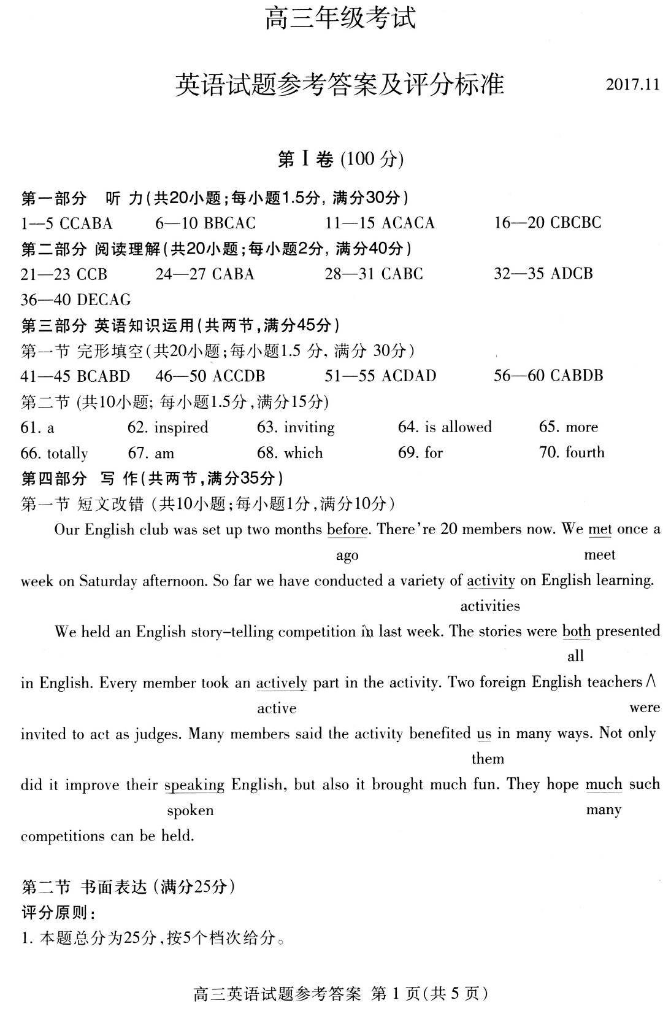
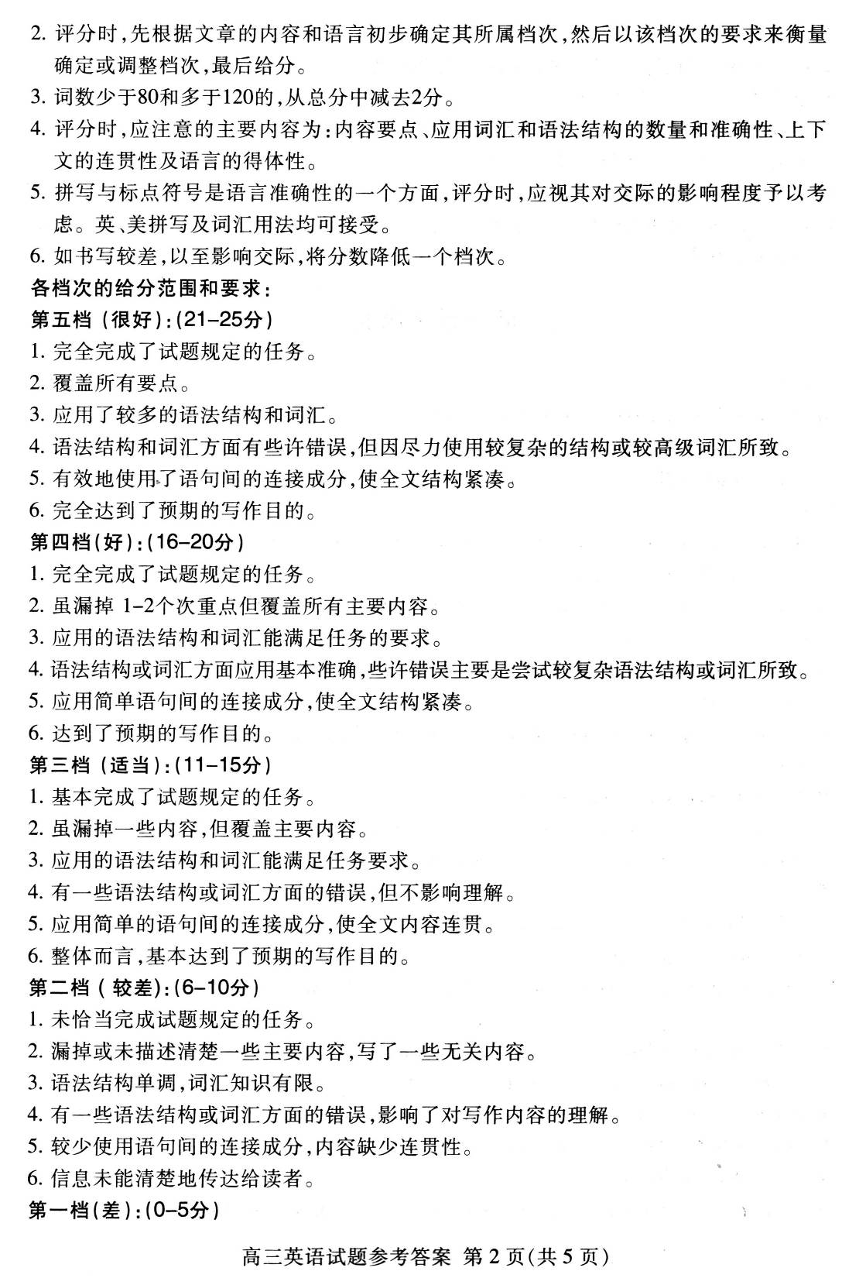
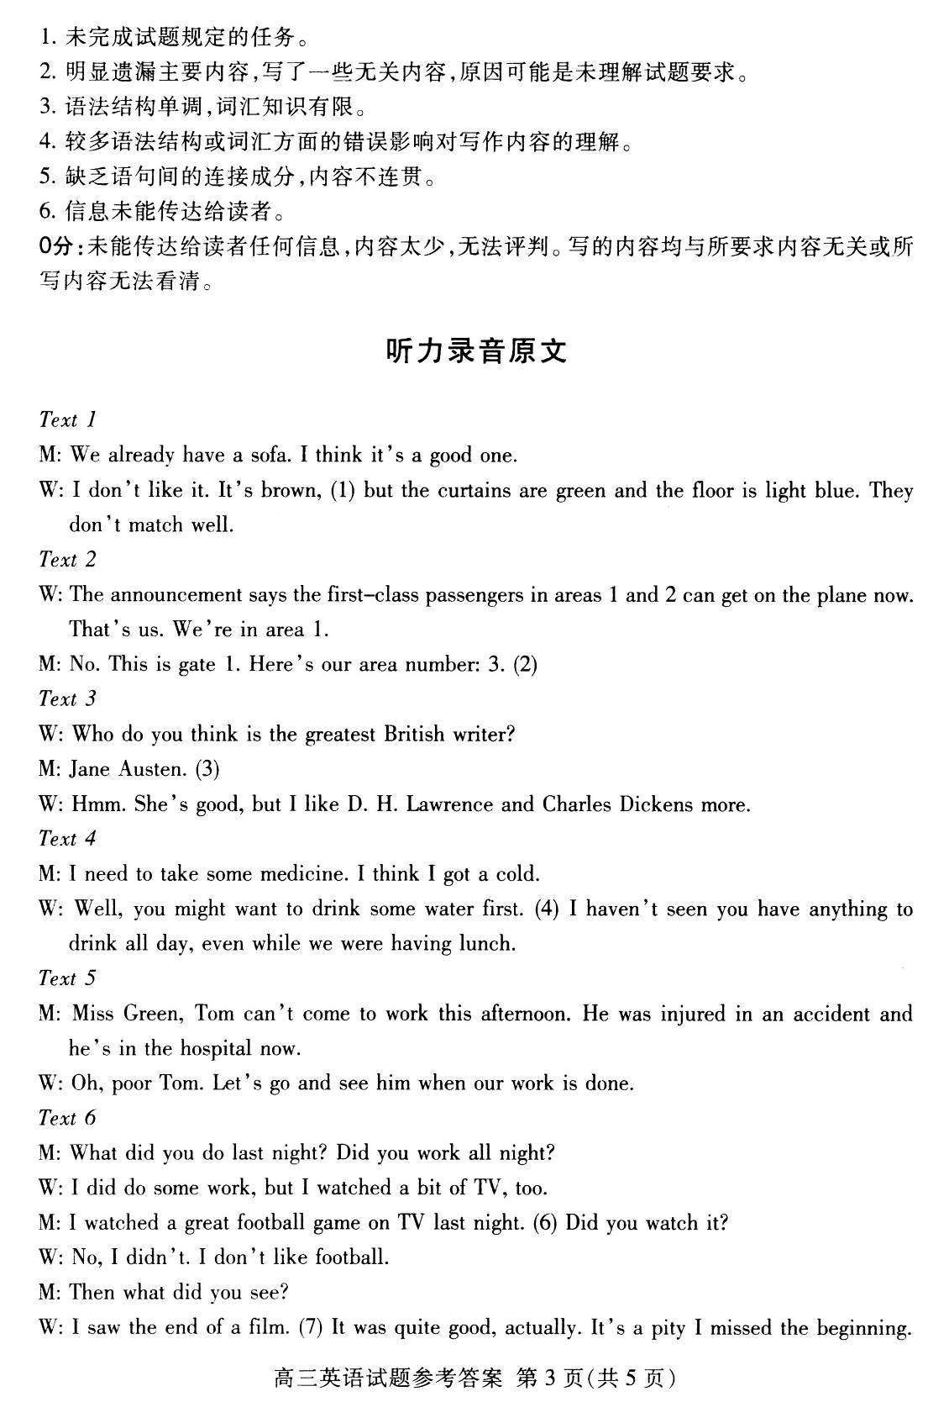

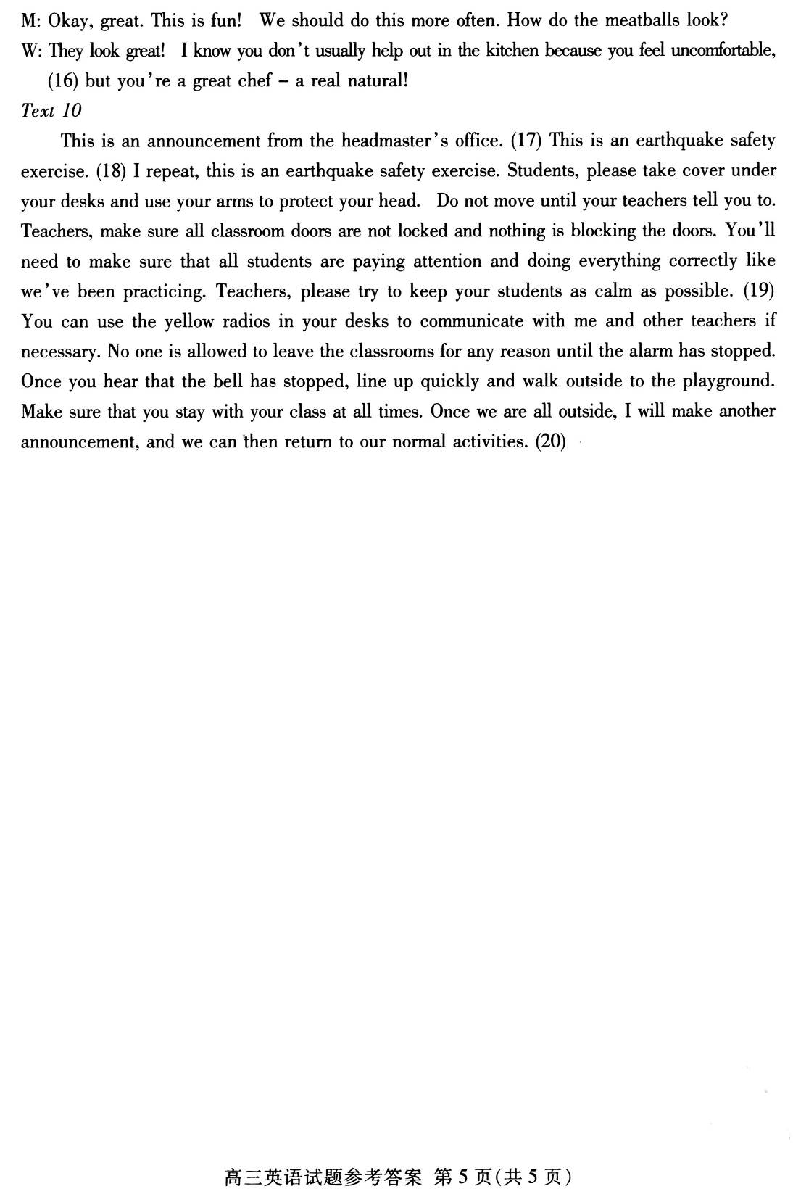

欢迎访问“高中试卷网”——http://sj.fjjy.org

