新余市第四中学2018届高三上学期第三次段考
英语试卷
注意事项：
1.本试卷分第I卷（选择题）和第II卷（非选择题）两部分。
2.答题前，考生务必将自己的姓名、准考证号填写在本试卷相应的位置。
3. 全部答案在答题卡上完成，答在本试卷上无效。
第I卷（选择题，共100分）
第一部分：听力（共两节，满分30分)
第一节 听下面5段对话。每段对话后有一个小题，从题中所给的A、B、C三个选项中选出最佳选项，并标在试卷的相应位置。听完每段对话后，你都有10秒钟的时间来回答有关小题和阅读下一小题。每段对话仅读一遍。
1. What does the man play?
A. Sports. B. Musical instruments. C. Computer games.
2. What will the woman probably do today?
A. Attend the wedding. B. Go over her lessons. C. Eat out with the man.
3. What’s the man’s major?
A. Journalism. B. Business. C. International relations.
4. Where does this conversation take place?
A. At a bus stop. B. At the railway station. C. At the airport.
5. What does the man mean?
A. He has been to the restaurant many times.
B. He heard about the restaurant from Tom.
C. He intends to try a better restaurant.
第二节 听下面5段对话或独白。每段对话或独白后有几个小题，从题中所给的A、B、C三个选项中选出最佳选项，并标在试卷的相应位置。听每段对话或独白前，你将有时间阅读各个小题，每小题5秒钟；听完后，各个小题将给出5秒钟的作答时间。每段对话或独白读两遍。
听第6段材料，回答第6、7题。
6. Who says organic food tastes better?
A. The man. B. The woman. C. The woman’s friend.
7. What does the woman suggest doing?
A. Only buying organic products.
B. Trying some organic vegetables.
C. Asking Joe for advice about food.
听第7段材料，回答第8、9题。
8. What does the woman think of washing clothes by herself?
A. Troublesome. B. Fun. C. Not a big deal.
9. Why will she take her clothes to the laundry tomorrow?
A. It’s too tiring to hand-wash sheets.
B. She has too much work to do. C. She just heard about the laundry.
听第8段材料，回答第10至12题。
10. What happened to Tony today?
A. He lost his job.
B. He was criticized by his boss.
C. His vacation in summer was cancelled.
11. How did he feel about it?
A. Astonished. B. Extremely angry. C. Sad but not surprised.
12. What is he going to do?
A. Wait to be called back to the company.
B. Talk with his boss about his problems.
C. Start to look for a new job.
听第9段材料，回答第13至16题。
13. Where did chopsticks originate?
A. In Japan. B. In China. C. In Korea.
14. What kind of chopsticks are often used by ordinary Chinese people?
A. Wood or bamboo ones. B. Jade ones. C. Plastic ones.
15. Why did ancient kings and emperors use silver chopsticks?
A. To show their wealth. B. To see if their food was poisoned. C. To show their power.
16. What do Chinese people think knives and forks suggest?
A. Violence. B. High quality life. C. Gentleness.
听第10段材料，回答第17至20题。
17. What course is English Literature 201?
A. A course on the works of William Shakespeare.
B. A course on the history of English literature.
C. A course on classics of English literature.
18. When will the midterm exam be held?
A. After Romeo and Juliet. B. Right after Macbeth. C. During Week 6.
19. Which of the following is NOT on the list of books?
A. Hamlet. B. Macbeth. C. Henry VI.
20. What is the talk mainly about?
A. Changes in homework assignments.
B. The life of William Shakespeare.
C. William Shakespeare’s masterpieces.

第二部分：阅读理解（共两节，满分40分）
- （共15小题；每小题2分，满分30分）
阅读下列短文，从每题所给的四个选项（A,B,C,和D）中，选出最佳选项，并在答题卡上将该项涂黑。
A
When I was in fourth grade, I worked part-time as a paperboy. Mrs. Stanley was one of my customers. She'd watch me coming down her street, and by the time I'd biked up to her doorstep, there'd be a cold drink waiting. I'd sit and drink while she talked.
Mrs. Stanley talked mostly about her dead husband, "Mr. Stanley and I went shopping this morning." she'd say. The first time she said that, soda went up my nose.
I told my father how Mrs. Stanley talked as if Mr. Stanley were still alive. Dad said she was probably lonely, and that I ought to sit and listen and nod my head and smile, and maybe she'd work it out of her system. So that's what I did, and it turned out Dad was right. After a while she seemed content to leave her husband over at the cemetery.
I finally quit delivering newspapers and didn't see Mrs. Stanley for several years. Then we crossed paths at a church fund-raiser. She was spooning mashed potatoes and looking happy. Four years before, she'd had to offer her paperboy a drink to have someone to talk with. Now she had friends. Her husband was gone, but life went on.
I live in the city now, and my paperboy is a lady named Edna with three kids. She asks me how I'm doing. When I don't say "fine", she sticks around to hear my problems. She's lived in the city most of her life, but she knows about community. Community isn't so much a place as it is a state of mind. You find it whenever people ask how you're doing because they care, and not because they're getting paid to do so. Sometimes it's good to just smile, nod your head and listen.
21. Why did soda go up the author's nose one time?
A. He was talking fast. B. He was shocked.
C. He was in a hurry. D. He was absent-minded.
22. Why did the author sit and listen to Mrs. Stanley according to Paragraph 3?
A. He enjoyed the drink. B. He wanted to be helpful.
C. He took the chance to rest. D. He tried to please his dad.
23. Which of the following can replace the underlined phrase "worked it our of her system"?
A. recover from her sadness B. move out of the neighborhood
C. turn to her old friends D. speak out about her past
24. What does the author think people in a community should do?
A. Open up to others. B. Depend on each other.
C. Pay for other's help. D. Care about one another.
B
It's surprising how much simple movement of the body can affect the way we think. Using expansive gestures with open arms makes us feel more powerful, crossing your arms makes you more determined and lying down can bring more insights.
So if moving the body can have these effects, what about the clothes we wear? We're all well aware of how dressing up in different ways can make us feel more attractive, sporty or professional, depending on the clothes we wear, but can the clothes actually change cognitive performance or is it just a feeling?
Adam and Galinsky tested the effect of simply wearing a white lab coat on people's powers of attention. The idea is that white coats are associated with scientists, who are in turn thought to have close attention to detail.
What they found was that people wearing white coats performed better than those who weren't. Indeed, they made only half as many errors as those wearing their own clothes on the Stroop Test(one way of measuring attention). The researchers call the effect "enclothed cognition," suggesting that all manner of different clothes probably affect our cognition in many different ways.
This opens the way for all sorts of clothes-based experiments. Is the writer who wears a fedora more creative? Is the psychologist wearing little round glasses and smoking a cigar more insightful? Does a chef's hat make the restaurant food taste better?
From now on I will only be editing articles for PsyBlog while wearing a white coat to help keep the typing error count low. Hopefully you will be doing your part by reading PsyBlog in a cap and gown(学位服).
25. What is the main idea of the text?
A. Body movements change the way people think.
B. How people dress has an influence on their feelings.
C. What people wear can affect their cognitive performance.
D. People doing different jobs should wear different clothes.
26. Adam and Galinsky's experiment tested the effect of clothes on their wearers'______.
A. insights B. movements C. attention D. appearance
27. How does the author sound in the last paragraph?
A. Academic. B. Humorous. C. Formal. D. Hopeful.
C
At first sight, Elana Schlenker’s pop-up store, Less Than 100, which was open in Pittsburgh during the month of April appeared just like any other gift store. However, when shoppers went to pay, they were in for a surprise. That's because while men paid full price, women received a 24% discount.
Though that may appear to be blatant (公然的) discrimination, Elana was merely obeying the store’s slogan “pay what you are paid”. And since women in the US get paid an average of 76 cents for every dollar men earn for the same job, it is only fair that they pay less.
As the store’s pricing policy was not enough to get the message across, Elana also distributed pamphlets(小册子). Entitled “What Are Women Worth?”, it explained the status of the wage gap both in Pennsylvania and across the country, and also gave women tips on how to better negotiate salaries. A 2015 study conducted by the Institute for Women’s Policy Research found that although the rate of women’s income has been rising, men still earn more in every state in the country.
Though the Less Than 100 project will not resolve the wage inequality, it is a thought-provoking way to bring to the forefront an issue that is increasingly causing a lot of worry among women. Fortunately, Elana is not the only one trying to change the unfair system. Ellen Pao, appointed as the temporary CEO of Reddit, recently announced that new employees would be forbidden from negotiating salaries. She believes that men are better negotiators than women, and therefore, tend to receive higher wages!
What’s encouraging is that male CEOs are also joining the fight! Earlier this month, Salesforce CEO Marc Benioff launched a company wide program to address the issue. Called “Women Surge” it aims to remove all gender-based pay inequalities, hire and promote more women and ensure that they are better included in meetings! With all these visionaries taking the lead, it will not be long before gender pay inequality is something we will only read about in history books!
28. Men had to pay more at Less Than 100 probably because _______.
A. the shop was operated by a young woman B. they received more salary than women
C. the gifts in the store were very expensive D. the owner of the shop didn’t like men at all
29. Elana handed out pamphlets to _______.
A. sell more goods in the store B. seek more support from others
C. teach women to ask for more salary D. beg for the customers’ forgiveness
30. Ellen Pao may agree that_______.
A. the wage system should be reformed B. Elana does well in her jo
C. women don’t care about salary at all D. men should get more salary than women
31. What is the author’s attitude towards pay equality between men and women?
A. doubtful B. negative C. unsure D. hopeful

D
Traffic jam and cities, it seems, go hand in hand. Everyone complains about being stuck in traffic; but, like the weather, no one seems to do anything about it. In particular, traffic engineers, transportation planners, and public officials responsible for transportation systems in large cities are frequently criticized for failing to solve traffic jam.
But is traffic jam a sign of failure? Long queues at restaurants or theater box offices are seen as signs of success. Should transportation systems be viewed any differently? I think we should recognize that traffic jam is an unpreventable by-product of successful cities, and view the "traffic problem" in a different light.
Cities exist because they promote social interactions and economic transactions (交易) .
Traffic jam occurs where there are lots of people but limited spaces. Culturally and economically successful cities have the worst traffic problems, while decaying cities don't have much traffic. New York and Los Angeles are America's most crowded cities. But if you want access to major stock markets, you will find them easier to reach in crowded New York than in any other large cities. And if your firm needs access to satellite-guidance engineers, you will reach them more quickly through the crowded freeways of LA than through less crowded roads elsewhere.
Despite traffic jam, a larger number and wider variety of social interactions and economic transactions can be made perfect in large, crowded cities than elsewhere. Seen in this light, traffic jam is an unfortunate consequence of prosperity, not a cause of economic decline and urban decay.
So while we can consider traffic jam as increasing costs on the areas of big cities, the costs of inaccessibility in uncrowded places are almost certainly greater.
There is no doubt that traffic jam brings the terrible economic and environmental damage in places like Bangkok, Jakarta, and Lagos. But mobility is far higher and traffic jam levels are far lower here in the US, even in our most crowded cities. That's why, for now, we don't see people streaming out of San Francisco and Chicago, heading for cities like Phoenix, and Cleveland.
32. We can conclude from the first paragraph that _________.
A. traffic jam and weather are the two factors preventing the development of a big city
B. traffic jam seems to be very difficult to deal with
C. if traffic engineers try their best, traffic jam can be solved
D. public officials are always criticized for misusing their power
33. According to the passage, what's the author's opinion towards traffic jam?
A. Traffic jam is unavoidable in large cities.
B. Traffic jam is both a sign of success and a sign of failure.
C. Traffic jam is the consequence of successful cities.
D. Traffic jam is not unpreventable for a successful city.
34. According to this passage, which of the following is TRUE?
A. Crowded cities tend to promote economic transactions.
B. New York and Los Angeles have less limited spaces than other cities.
C. The satellite-guidance engineers are needed most by the firms in LA.
D. Despite the traffic jam in LA, it's easier to reach your destination than in other cities.
35. What can we learn from the last paragraph?
A. Traffic jam has caused terrible bad effects in cities such as Bangkok and Lagos.
B. The traffic jam in San Francisco has resulted in the city becoming empty.
C. The traffic jam level in Chicago is lower than that in Cleveland.
D. Phoenix is as crowded and successful as San Francisco.
第二节（共5小题；每小题2分，满分10分）
根据短文内容，从短文后的选项中选出能填入空白处的最佳选项。选项中有两项为多余选项。
How to Remember What You Read
Reading is important. But the next step is making sure that you remember what you've read! __36__you may have just read the text. But the ideas, concepts and images（形象）may fly right out of your head. Here are a few tricks for remembering what you read.
● __37__
If the plot, characters, or word usage is confusing for you, you likely won't be able to remember what you read. It's a bit like reading a foreign language. If you don't understand what you're reading, how would you remember it? But there are a few things you can do... Use a dictionary; look up the difficult words.
● Are you connected?
Does a character remind you of a friend? Does the setting make you want to visit the place? Does the book inspire you, and make you want to read more? With some books, you may feel a connection right away. __38__ How willing are you to make the connections happen?
● Read it; hear it; be it!
Read the lines. Then, speak them out loud. And, put some character into the words. When he was writing his novels, Charles Dickens would act out the parts of the characters. He'd make faces in the mirror, and change his voice for each character. __39__
● How often do you read?
If you read frequently, you'll likely have an easier time with remembering what you’re reading and what you've read. __40__As you make reading a regular part of your life, you'll make more connections, stay more focused and understand the text better. You’ll learn to enjoy literature- as you remember what you read!
A. Are you confused?
B. Practice makes perfect.
C. What's your motivation?
D. Memory is sometimes a tricky thing.
E. Marking helps you remember what you read.
F. But other books require a bit more work on your part.
G. You can do the same thing when you are reading the text!

第三部分：英语知识运用（共两节，满分45分）
第一节：完形填空（共20小题；每小题1.5分，满分30分）
阅读下面短文, 从短文后各题所给的四个选项（A、B、C和D）, 选出可以填入空白处的最佳选项，并在答题卡上将该项涂黑。

Lightning flashed through the darkness over Sibson’s bedroom skylight（天窗）. Sibson was shaken by a clap of thunder ____41___ he knew what was happening. The storm had moved directly _____42____ his two-story wooden house. Then he heard the smoke alarm beeping.
Sibson rushed down the stairs barefoot to 43 ; he opened the door to the basement, and flames 44 out. Sibson ran back upstairs to call 911 from his bedroom. “I felt 45 because the room had a separate outdoor stairway,” he explains.
But the phone didn’t work, and when he tried to go down the outdoor stairway, he was 46 by a wall of flames. Sibson realized he was trapped.
Sibson’s house was three kilometers 47 the main road and was so well hidden by trees that he knew calling for help would be 48 .
Up a hill nearby lived Sibson’s neighbor, Huggons. He was lying in bed when something like a smoke alarm 49 his ears. He jumped out of bed, took his 50 and flashlight, and headed down the hillside toward the 51 . That was when he saw the rolling heavy smoke.
Huggons dialed 911, and the operator warned him not to 52 the house. But Huggons said, “There is no way I am going to listen to Sibson 53 and die in that fire.”
“Anyone there?” Huggons called out. Then he heard “Help! I’m trapped!” coming from the second floor balcony. He entered the house, but soon had to run back to catch his 54 .
After one more 55 inside the house, Huggons gave up and 56 around back.
The wind parted the smoke just 57 for him to catch sight of Sibson. But there was no way to get to him. He 58 the flashlight into the woods and noticed a ladder. He took it over to the balcony and 59 Sibson down just as the second floor of the house fell off.
Sibson is still 60 when he tells the story. “ I was alone that night,” he says. “Then I heard the most beautiful sound in my life. It was Huggons.”
41. A. before B. while C. since D. until
42. A. on B. in C. through D. over
43. A. hide B. wait C. check D. escape
44. A. moved B. gave C. went D. exploded
45. A. safe B. worried C. glad D. tired
46. A. burned B. stopped C. shocked D. covered
47. A. beside B. off C. across D. along
48. A. limited B. false C. fruitless D. regretful
49. A. struck B. missed C. touched D. passed
50. A. coat B. key C. basin D. phone
51. A. noise B. road C. smoke D. danger
52. A. search B. enter C. leave D. damage
53. A. call B. roll C. scream D. sigh
54. A. breath B. attention C. ladder D. flashlight
55. A. stay B. chance C. thought D. attempt
56. A. climbed B. circled C. looked D. jumped
57. A. clear B. open C. enough D. fit
58. A. led B. put C. drove D. shone
59. A. persuaded B. kicked C. pulled D. forced
60. A. nervous B. surprised C. proud D. thankful
第II 卷（非选择题，共50分）
第二节 语法填空（共10小题，每小题1.5分，满分15分）
阅读下面短文,按照句子结构的语法性和上下文连贯的要求，在空格处填入一个适当的词或使用括号中词语的正确形式填空。
You know you have to read “between the lines” to get the most out of anything. I want to persuade you to do something (61)_________(equal) important in the course of your reading --- “writing between the lines”. (62)________ you do that, you are not likely to do the most efficient kind of reading.
I insist that marking up book (63) ________(be) not an act of damage but of love.
There are two ways one can own a book. One is to get the ownership (64) _________ paying for it just as you pay for clothes and furniture. But this act of purchase is only the first step to (65)________( possess). Full ownership comes only when you have made it part of yourself and the best way (66)_________(make) yourself part of it is by writing in it. (67)________ following example may make this point clear. You buy a beefsteak (68)_________ you do not own the beefsteak in the most important sense until you consume it, (69) __________ (get) it into your bloodstream. I am arguing that books too must (70)__________(absorb) in your bloodstream to do you any good.
第四部分 写作（共两节，满分35分）
第一节 短文改错（共10小题；每小题1分，满分10分）
英语课上,老师要求同桌同学相互修改作文。假设以下小作文为你同桌所写，请你对其进行修改。文中共有10处错误,每句中最多有两处。错误涉及一个单词的增加,删除或修改。
增加：在缺词处加一个漏词符号（^），并在此符号下面写出该加的词。
删除：把多余的词用斜线（\）划掉。
修改：在错的词下划一横线，并在该词下面写出修改后的词。
注意：1．每处错误及其修改均仅限一词。
2．只允许修改10处，多者（从第11处起）不计分。
3．必须按答题要求做题
The long-desired winter vacation was arrived in the end．As soon as the bell rang, announced the end of the class, we couldn’t wait to rush out of the classroom．Half an hour late, my good friend Li Ming and I were on the way back home．Such crowded was the train we took that they had to stand．Thinking of the coming Spring Festival and the two-weeks stay with parents, we both felt exciting．All of a sudden, I saw a man picking an old lady’s pocket．With help of Li Ming, I caught the thief and force him to give back the purse to the old lady．The thief was taken away by the guard．Praised by other passengers, we felt proudly of what we had done．
第二节 书面表达（共25分）
假设你是李华，你购买了一部某外国生产的手机，因有质量问题，要求该公司更换。请根据下列要点，用英文写一封电子邮件。
1. 问题：手机铃不响；不能发短信；该产品已售完，无法更换；型号新，无配件，无法修理。
2. 要求：公司应尽快予以更换。
注意：1. 词数为100词左右； 2. 参考词汇：配件 spare part;
Dear sir,
______________________________________________________________________________________
______________________________________________________________________________________
______________________________________________________________________________________
______________________________________________________________________________________
______________________________________________________________________________________
______________________________________________________________________________________

Sincerely yours,
Li Hua

参考答案
听力1—5ABBCB 6—10CBCAA 11—15CCBAB 16—20AACCA
阅读：21-24 BBAD 25-27 CCB 28-31 BCAD 32-35 BCDA 36-40 DAFGB
完形填空：41-45 ADCDA 46-50 BBCAD 51-55 ABCAD 56-60 BCDCD
语法填空：61. equally 62. Unless 63. Is 64. by 65. possession
66. to make 67. The 68. but 69. getting 70. be absorbed
改错1.去掉was 2. announcing 或 announce前加which 3. later 4.such改为so 5.they改为 we
6. two-week 7.excited 8.help前 加the 9. forced 10.proud
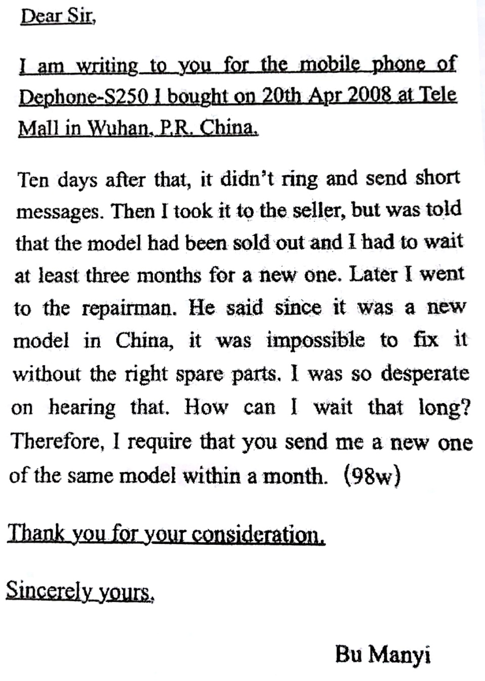

欢迎访问“高中试卷网”——http://sj.fjjy.org

