通榆县第一中学2018届高三12月月考
英 语 试 题
（120分钟，满分150分）
第一卷
第一部分：听力（共两节，满分30分）
第一节（共5小题；每小题1.5分）
听下面5段对话。每段对话后有一个小题，从题中所给的A、B、C三个选项中选出最佳选项，并标在试卷的相应位置。听完每段对话后，你都有10秒钟的时间来回答有关小题和阅读下一小题。每段对话仅读一遍。
- What is Dr. Greenspan most probably?
A. A dentist B. A nurse C. A professor
- When should Peter and Sophia leave according to the man?
A. This Tuesday B. Next Tuesday C. Next Thursday
- What does the man suggest the woman do?
A. Read the notice on the window.
B. Get a new bus schedule.
C. Go and ask the staff.
- What are the speakers mainly talking about?
A. The design of the room B. Smoking C. The woman’s health
- Where was the woman when she saw the fish?
A. In the water B. In a boat C. On the shore
第二节（共15小题；每小题1.5分,满22.5分）
听下面5段对话或独白。每段对话或独白后有几个小题，从题中所给的A、B、C三个选项中选出最佳选项，并标在试卷的相应位置。听每段对话或独白前，你将有时间阅读各个小题，每小题5秒钟；听完后，各小题将给出5秒钟的作答时间。每段对话或独白读两遍。
听第6段材料，回答第6至8题。
- What is the woman’s problem?
A. Her money has been stolen.[来源:学科网]
B. She has left her book at the bank.
C. Her purse is missing
- Why did the woman go to the bank?
A. To pay the bill B. To cash the cheque C. To open an account
- Which is the right order of the places the speakers have been to?
A. Coffee shop--bookshop---bank
B. Bookshop---bank---coffee shop
C. Bank---coffee shop---bookshop
听第7段材料，回答第9至11题。
- What is the man doing through the Internet?
A. Looking for information B. Learning a course C. Writing an e-mail
- How much time does the man spend on the Internet?
A. One or two hours every day.
B. Several hours every month.
C. Two or three hours a week.
- Which of the following does the woman prefer?
A. Sending e-mails B. Making pen friends C. Writing letters
听第8段材料，回答第12至14题。
- Why did the speakers visit the place last Friday?
A. To build a highway there
B. To set up a factory there
C. To find some workers there
- What is true about the place?
A. The space is too small there
B. It’s close to the highway
C. It will be difficult to find skilled workers around there.
- How does the woman like their goods to be transported?
A. By rail B. By truck C. By ship
听第9段材料，回答第15至17题。
- Why did the woman eat the berries in the forest?
A. Because she was very hungry.
B. Because she wanted to have a taste.
C. Because the berries were beautiful
- How did the woman feel when she failed to find a river?
A. Relaxed B. Frustrated C. Unconcerned
- What saved her life at last?
A. A local hunter B. A dog C. A monkey
听第10段材料，回答第18至20题。
- What is the news report mainly about?
A. Global economic recovery
B. Rising unemployment worldwide
C. Basic social protection for the poor.
- What does the director general say?
A. Many countries haven’t taken effective measures.
B. Few countries know how to deal with the crisis.
C. Few countries have realized the seriousness of the crisis.
- How long would it take to recover back?
A. 4-5 years B. 5-10 years C. 6-10 years

第二部分 阅读理解 （共两节，满分40）
第一节（共15小题，每小题2分，满分30分）
阅读下列短文，从每题所给的四个选项（A、B、C和D）中，选出最佳选项。
A.
The China Daily newspaper group is looking for English-language senior business editors, senior copy editors, copy editors and graphic designers to strengthen its international team. We offer a competitive salary package, free accommodation with utilities paid for, 90 per cent medical reimbursement, a seven-day paid leave, eleven-day public holidays and a return ticket to the country of residence.
Senior Business Editor
You must:
assist the business editor in setting goal and working on achieving them;
be an excellent team person who can generate ideas and think creatively and be able to rewrite totally if needed;
ideally have been working or have worked in a position of responsibility and understand what leadership entails;
have had at least five years’ editing experience working on editing the Business Desk and be familiar with industry software.
Senior Copy Editor
You must:
work on shifts in the Business Desk and usually have the last word before the page is sent to print;
edit or rewrite copy and give snappy headlines and captions;
have had at least two years’ editing experience working on editing desks and be familiar with industry software.
Copy Editor
You must:
be good at editing or rewriting copy and writing snappy headlines and captions;
be able to work on shifts for different pages, and usually have the last work before the page is sent to print;
have two years of editing experience working on copy desks, and be familiar with industry software.
Graphic Designer
You must:
have excellent skills in information graphics;
be good at illustrations and freehand drawing;
be experienced in newspaper or magazine layouts;
have a good sense of typography;
have good news judgment;
be well-skilled with Macintosh software, including InDesing,Illustrator and Photoshop;
be fluent in English.
For enquiries or to apply, write to job@chinadaily.com.cn.
- Which of the following is TRUE according to the passage?
A. The employees have to pay for their own food and accommodation.
B. The workers there can enjoy a seven-day leave without pay.
C. The employees have the right to enjoy eleven-day public holidays.
D. The senior business editor’s only job is to help the business editor to set goals.
- How many positions need editing experience?
A. 1 B. 2. C. 3. D. 4
- Which can be the title of the advertisement?
A. China Daily: New Employees Wanted.
B. China Daily: Newspaper
C. China Daily: An international Team.
D. China Daily: The Best Working Condition
- What is NOT required about Graphic Designer?
A. Be well-skilled with Photoshop
B. Have excellent skills in information graphics.
C. Having a good sense of typography.
D. Writing snappy headlines and captions.
B.
Once when I was a teenager, my father and I were standing in line to buy tickets for the circus (马戏表演). Finally there was only one family between us and the ticket counter. This family made a big impression on me. There were eight children, all probably under the age of 12. You could tell they didn’t have a lot of money. Their clothes were not expensive, but they were clean. The children were well-behaved, all of them standing in line, two-by-two behind their parents. The children were excitedly talking about the clowns, elephants and other acts they would see that night. One could sense they had never been to the circus before.
The father and mother were ahead standing, proud as they could be.
The ticket lady asked the father how many tickets he wanted. He proudly responded, “Please let me buy eight children’s tickets and two adult tickets.”
The ticket lady told him the price.
The father leaned a little closer and asked, “How much did you say?
The ticket lady again told him the price.
The man didn’t have enough money. How was he supposed to turn and tell his eight kids that he didn’t have enough money to take them to the circus.
Seeing what was going on, my dad put his hand into his pocket, pulled out a $20 bill and dropped it on the ground. (We were not wealthy in any sense of the world!) My father reached down, picked up the bill, tapped the man on the shoulder and said, “Excuse me, sir, this fell out of your pocket.” The man knew what was going on. He looked straight into my dad’s eyes, took my dad’s hand in both of his, pressed tightly onto the bill, and with his lip quivering and a tear streaming down his cheek, he replied, “Thank you, thank you , Sir. This really means a lot to me and my family.”
My father and I went back to our car and drove home. We didn’t go to the circus that night, but we could go without.
- Why was the poor man unhappy after he spoke with the ticket lady?
A. The tickets were too expensive.
B. His children were noisy.
C. He had lost his money.
D. The tickets were sold out.
- It can be inferred from the text that the writer’s father didn’t give the money to the father directly
because _____.
- he wanted to make the father feel ashamed.
- he was not very willing to help the man and his family.
- he wanted to pretend to be very wealthy
- he didn’t want to hurt the man’s pride and respect.
- We can conclude from the last sentence of the story that ______.
- they felt it a pity that they didn’t go to the circus
- They didn’t feel bad though they didn’t go to the circus.
- They felt they would be blessed for their behavior
- They had never gone to the circus ever since.
C.
Imagine having an idea, drawing it on paper, bringing it to a store and seeing it turned into an object. This is now possible with the help of 3D printers. Such machines were once used just by universities and big companies, but now, stores with 3D printing services are appearing around the Untied States.
Bryan Jaycox and his wife opened The Build Shop LLC in Los Angeles two years ago. The Jaycoxs offer 3D printing classes and services for anyone who is interested. “I think 3D printing is going to be huge. It’s going to have a huge influence on society as a whole.” says KiChong Tran, one of the students in a recent class. He plans to open a 3D printing business in Cambodia.
3D printing services are coming into American people’s life. The UPS Store is a nationwide retailer that provides copying and other services. The UPS Store recently put 3D printers in three of its independently-owned stores. Burke Jones owns one of the stores in San Diego. “The demand has been amazing. There has been a lot of interest from people. It’s been much more than I would have imagined.” The UPS Store plans to add 3D printers in three more stores.
At the UPS Store, the cost of the object depends partly on the amount of materials used. The store also charges up to $95 an hour to design the object with computer software that creates a digital file to guide the printer. Mr. Jaycox predicts that within five years 3D printing technology could become more consumer-friendly. But KiChong Tran says even today’s technology can make a difference in a developing country like Cambodia. With 3D printing you can give them tools, so they are responsible more for their own development and they learn skills beyond just like learning English and becoming a tour guide or something like that. You can actually create things that give value to the world.” He says it’s not just Cambodia but anywhere where there is a 3D printers, it can turn a good idea into reality.
- What do we know about the UPS Store according to the text?
A. It will add 3D printers in 3 more stores to meet people’s demand.
B. It provides various services around the world.
C. It charges customers for the time to design the object only.
D. It offers 3D printing classes and services.
- Which of the following statement is TRUE according to the text?
A. 3D printing is becoming popular in the world.
B. There is no 3D printing business in Cambodia.
C. The UPS Store is the biggest 3D printing company.
D. 3D printing plays the most important role in daily life.
- The attitude of KiChong Tran towards the development of 3D printing technology is _____.
A. uncertain B. critical C. objective D. positive
- What is the best title for the text?
A. 3D Printers’ History B. 3D Printing Services in America
C. 3D Printing Technology D. 3D Printers’ Development
D.
If you make a list of the world’s top ten most challenging jobs, chances are that being a teacher will not make the cut. But think about the discouraging task millions of educators face each day as they try to shape a group of often bad-tempered, wild kids into intelligent, well-rounded individuals. That surely has to be the toughest job in the world, especially given that there is no promotion or bonus awaiting them even if they are wildly successful!
What if the all-important individuals that we often take for granted disappear from our lives? That was what Project ED and Participant Media’s Teach campaign asked filmmakers of all ages to imagine in their recently-held competition. Entitled “A World Without Teachers”, its purpose was to inspire more young people to become teachers. However, the 62 amazing video submissions also serve as a reminder of how horrible things would be if we didn’t have these selfless individuals guiding us through life. What was interesting was that even the youngest participants did not appear to be happy at the idea of not having anybody telling them what to do.
High-school student Savannah Wakefield reflected if art, as we know it today, would have been different without teachers. Would Monet have discovered his talent for impressionism? Los Angeles-based Miles Horst, who won the 1000 USD prize for the best adult submission imagines a world where teachers are replaced by a “brain box” in his fun lively entry.
Youth category winner Marina Barham’s video represents a fact we all know but often forget. Teachers don’t just teach, they inspire something that no electronic device, no matter how smart, can do! So the next time you think your teacher is being “mean” for trying to channel you in the right direction, imagine a life without him or her. We have a feeling that it will no appear as rosy!
- What is the text mainly about?
A. The campaign to promote teachers’ salary.
B. The significance of teachers.
C. The survey of people’s views about teachers.
D. The possibility of a world where teachers are replaced.
- From the passage we can learn that ______.
A. teaching naughty kids is a very discouraging task
B. being a teacher is one of the most challenging jobs in the world.
C. a successful teacher has the greatest chance to be promoted
D. teachers have little influence on kids’ individual development
- What is the purpose of the project “ A World Without Teachers”?
A. to attract kids to submit more videos of their teachers.
B. to expect teachers to devote themselves to their jobs.
C. to remind students to appreciate teachers’ hard work
D. to encourage more people to go into teaching career.
- What can we infer from the underlined sentence?
A. Teaching is quite different from other jobs.
B. The future of teachers’ work appears inspiring.
C. A world without teachers will be unimaginable.
D. Many people attach more importance to teaching.
- 阅读理解七选五
根据短文内容，从短文后的选项中选出能填入空白处的最佳选项。选项中有两项为多余选项。
When you are dealing with a stressful situation or going through a hard time, people in your life can help you. When someone who cares knows what you’re going through, it helps you feel understood and not so alone. 36 . Problems seem smaller when you talk about them with the right person. You can do better and find out solutions more easily when you share your problems.
There are lots of different ways to get and give help. 37 . Other times you need advice on things. Help can be very easy, like a homework project. Or it can go on for a while, like teaching someone to bring up a failing grade or advising someone to get through a difficult personal situation.
It’s likely that you remember times when someone helped you. Friends helped you get through sadness or deal with disappointment. 38 . Teachers might have guided you through the college application process. 39 . You might give a hand to your classmate who met difficulty.
Friends, parents, teachers and other adults can be great resources when you need help. 40 . Doctors can offer specialized help for a health problem. Accountants can be consulted about the tax laws.
- Having a right person means a lot.
- Difficulties are everywhere in your life.
- Parents taught you to stop a bad habit.
- Sometimes you just want to hear an encouraging word.
- You need to learn to give help in the right way.
- And you can also remember times when you helped others.
- There are also times when you need the extra help that a professional can provide.
第三部分 英语知识运用 （共两节，满分45分）
第一节 完形填空（共20小题；每小题1.5分，满分30分）
阅读下面短文，从短文后各题所给的四个选项（A、B、C和D）中，选出可以填入空白处的最佳选项。
Mother’s day, 2017 was the last time that all my three kids would be kids at home. I was 41 a Mother’s Day to remember.
That morning, I got up early and left for 42 . The boys and I were going 43 , not unusual, so I expected the time I’d have with the three of them surrounding me during break. I entered the office after my class, 44 the crowd for their faces. I didn’t find the boys, but wasn’t too worried 45 their classes often ran late. I found a row with plenty of room for all the four of us, 46 spots for my handsome your men.
The longer I sat there, the more 47 and angry I got. How could they 48 their mother on this of all days? I couldn’t 49 my work, only on how I’d been wronged. 50 the time the last morning class ended, I could hardly wait to get home and give them a piece of my mind.
Arriving home, I notice a pile of roses on the ground. I looked closer and saw they were the 51 of a track made from fresh flowers, which led to our room. As I 52 the flowers, the door got opened and three 53 faces greeted me. They let me see what they’d been working on all 54 .
55 the entire floor were the words, Happy Mother’s Day. We Love You. They were spelled out with 56 . The space was 57 with the sweetness of roses and other flowers. They’d asked for a leave and worked all morning, gathering the fresh flowers and 58 them into a surprising message.
I immediately realized I’d been hurrying in my 59 of the situation. While I had been feeling unloved, they had spent their time writing a 60 to show how much they really cared.
- A. allowing B. realizing C. expecting D. declaring
- A. church B. hospital C. shopping D. work
- A. completely B. separately C. actually D. sincerely
- A. asking B. leaving C. calling D. searching
- A. because B. though C. until D. once
- A. changing B. saving C. choosing D. marking
- A. hurt B. absurd C. guilty D. confident
- A. cheat B. consume C. ignore D. frighten
- A. focus on B. throw away C. cut down D. figure out
- A. Since B. For C. In D. By
- A. introduction B. beginning C. requirement D. opening
- A. followed B. selected C. smelled D. picked
- A. shouting B. smiling C. flying D. running
- A. day B. night C. afternoon D. morning
- A. Flooding B. Transforming C. Covering D. Replacing
- A. books B. flowers C. hardship D. effort
- A. eye-catching B. tasty C. precious D. alive
- A. pushing B. tricking C. arranging D. urging
- A. change B. improvement C. judgment D. explanation
- A. message B. word C. letter D. promise
第二节 （共10小题；每小题1.5分，满分15分）
阅读下面材料，在空白处填入适当的内容（不多于3个单词）或括号内单词的正确形式
- In everyday communication, information ______ (convey) by gestures is often misinterpreted.
- He didn’t make ______ clear when and where the meeting would be held.
- Wanda Plaza in Xiamen, located in ______ was a remote village several years ago, is now a busy area
- There is a growing _______(tend) for people to work at home instead of in offices.
- There were on the point of setting out ______ it began to rain.
- There’s no time left and I don’t know where ______(go).[来源:学|科|网]
- I can’t have you _______(waste) water any longer.
- Hearing the sudden shot, the little boy was almost _______(scare) to death.
- It is often said that the joy of traveling is not in arriving at your destination ______ in the journey
itself.
- For some people, travelling abroad is the thing they enjoy most in life; for others, though cultural
differences make them feel ________(comfort)
第四部分：写作（共两节，满分35分）
- 短文改错（共10小题；每小题1分，满分10分）
假定英语课上老师要求同桌之间交换修改作文，请你修改你同桌写的以下作文．文中共有１０处语言错误，每句中最多有两处．每处错误仅涉及一个单词的增加，删除或修改．
增加：在缺词处加一个漏字符号（∧），并在其下面写出该加的词。
删除：把多余的词用斜线（＼）划掉。
修改：在错的词下划一横线，并在该词下面写出修改后的词。
注意：１，每处错误及其修改均仅限一词；
２，只允许修改１０处，多者(从第１１处起)不计分．
- The liquid medicine requires shake before taken.
- I do invite Mr Green to the party that day, but he forgot it completely.
- Tom runs very fast. In the 100-metre race yesterday, he soon ran ahead other.
- Would you please go away and leave me lonely?
- I was out of the breath after running 1,600 metres.
- The mother was standing at the gate, anxiously to see her son.
- Quantities of food was on the table.
- Next time when you pay a visit to Shanghai, I’ll show you around.
- Who would you rather have to go there with you?
- Is there anything for particular in today’s newspaper?
书面表达（满分25分）
假如你是光明中学学生会主席李华，根据学校安排，你给即将到你校任教的外籍教师Peter推荐一名学生助手。请根据所给提示给Peter写封推荐信。
- 欢迎Peter的到来；2. 推荐田蕊做学生助手； 3. 田蕊的基本情况（18岁，高三等）； 4.田蕊的特点与特长（电脑技能；沟通能力；英语水平等）。
注意：
- 词数100左右； 2.可适当增加细节，以使行文连贯；3. 开头和结尾部分已写好。
Dear Peter,
I’m Li Hua, Chairman of the Students’ Union. _________________________________
_________________________________________________________________________
_________________________________________________________________________
Looking forward to your coming.
Yours Sincerely
Li Hua
My father and I went back to our car and drove home. We didn’t go to the circus that night, but we could go without.
- Why was the poor man unhappy after he spoke with the ticket lady?
A. The tickets were too expensive.
B. His children were noisy.
C. He had lost his money.
D. The tickets were sold out.
- It can be inferred from the text that the writer’s father didn’t give the money to the father directly
because _____.
- he wanted to make the father feel ashamed.
- he was not very willing to help the man and his family.[来源:Z.xx.k.Com]
- he wanted to pretend to be very wealthy
- he didn’t want to hurt the man’s pride and respect.
- We can conclude from the last sentence of the story that ______.
- they felt it a pity that they didn’t go to the circus
- They didn’t feel bad though they didn’t go to the circus.
- They felt they would be blessed for their behavior
- They had never gone to the circus ever since.
C.
Imagine having an idea, drawing it on paper, bringing it to a store and seeing it turned into an object. This is now possible with the help of 3D printers. Such machines were once used just by universities and big companies, but now, stores with 3D printing services are appearing around the Untied States.
Bryan Jaycox and his wife opened The Build Shop LLC in Los Angeles two years ago. The Jaycoxs offer 3D printing classes and services for anyone who is interested. “I think 3D printing is going to be huge. It’s going to have a huge influence on society as a whole.” says KiChong Tran, one of the students in a recent class. He plans to open a 3D printing business in Cambodia.
3D printing services are coming into American people’s life. The UPS Store is a nationwide retailer that provides copying and other services. The UPS Store recently put 3D printers in three of its independently-owned stores. Burke Jones owns one of the stores in San Diego. “The demand has been amazing. There has been a lot of interest from people. It’s been much more than I would have imagined.” The UPS Store plans to add 3D printers in three more stores.
At the UPS Store, the cost of the object depends partly on the amount of materials used. The store also charges up to $95 an hour to design the object with computer software that creates a digital file to guide the printer. Mr. Jaycox predicts that within five years 3D printing technology could become more consumer-friendly. But KiChong Tran says even today’s technology can make a difference in a developing country like Cambodia. With 3D printing you can give them tools, so they are responsible more for their own development and they learn skills beyond just like learning English and becoming a tour guide or something like that. You can actually create things that give value to the world.” He says it’s not just Cambodia but anywhere where there is a 3D printers, it can turn a good idea into reality.
- What do we know about the UPS Store according to the text?
A. It will add 3D printers in 3 more stores to meet people’s demand.
B. It provides various services around the world.
C. It charges customers for the time to design the object only.
D. It offers 3D printing classes and services.
- Which of the following statement is TRUE according to the text?
A. 3D printing is becoming popular in the world.
B. There is no 3D printing business in Cambodia.
C. The UPS Store is the biggest 3D printing company.
D. 3D printing plays the most important role in daily life.
- The attitude of KiChong Tran towards the development of 3D printing technology is _____.
A. uncertain B. critical C. objective D. positive
- What is the best title for the text?
A. 3D Printers’ History B. 3D Printing Services in America
C. 3D Printing Technology D. 3D Printers’ Development
D.
If you make a list of the world’s top ten most challenging jobs, chances are that being a teacher will not make the cut. But think about the discouraging task millions of educators face each day as they try to shape a group of often bad-tempered, wild kids into intelligent, well-rounded individuals. That surely has to be the toughest job in the world, especially given that there is no promotion or bonus awaiting them even if they are wildly successful!
What if the all-important individuals that we often take for granted disappear from our lives? That was what Project ED and Participant Media’s Teach campaign asked filmmakers of all ages to imagine in their recently-held competition. Entitled “A World Without Teachers”, its purpose was to inspire more young people to become teachers. However, the 62 amazing video submissions also serve as a reminder of how horrible things would be if we didn’t have these selfless individuals guiding us through life. What was interesting was that even the youngest participants did not appear to be happy at the idea of not having anybody telling them what to do.
High-school student Savannah Wakefield reflected if art, as we know it today, would have been different without teachers. Would Monet have discovered his talent for impressionism? Los Angeles-based Miles Horst, who won the 1000 USD prize for the best adult submission imagines a world where teachers are replaced by a “brain box” in his fun lively entry.
Youth category winner Marina Barham’s video represents a fact we all know but often forget. Teachers don’t just teach, they inspire something that no electronic device, no matter how smart, can do! So the next time you think your teacher is being “mean” for trying to channel you in the right direction, imagine a life without him or her. We have a feeling that it will no appear as rosy!
- What is the text mainly about?
A. The campaign to promote teachers’ salary.
B. The significance of teachers.
C. The survey of people’s views about teachers.
D. The possibility of a world where teachers are replaced.
- From the passage we can learn that ______.
A. teaching naughty kids is a very discouraging task
B. being a teacher is one of the most challenging jobs in the world.
C. a successful teacher has the greatest chance to be promoted
D. teachers have little influence on kids’ individual development
- What is the purpose of the project “ A World Without Teachers”?
A. to attract kids to submit more videos of their teachers.
B. to expect teachers to devote themselves to their jobs.
C. to remind students to appreciate teachers’ hard work
D. to encourage more people to go into teaching career.
- What can we infer from the underlined sentence?
A. Teaching is quite different from other jobs.
B. The future of teachers’ work appears inspiring.
C. A world without teachers will be unimaginable.
D. Many people attach more importance to teaching.
- 阅读理解七选五
根据短文内容，从短文后的选项中选出能填入空白处的最佳选项。选项中有两项为多余选项。
When you are dealing with a stressful situation or going through a hard time, people in your life can help you. When someone who cares knows what you’re going through, it helps you feel understood and not so alone. 36 . Problems seem smaller when you talk about them with the right person. You can do better and find out solutions more easily when you share your problems.
There are lots of different ways to get and give help. 37 . Other times you need advice on things. Help can be very easy, like a homework project. Or it can go on for a while, like teaching someone to bring up a failing grade or advising someone to get through a difficult personal situation.
It’s likely that you remember times when someone helped you. Friends helped you get through sadness or deal with disappointment. 38 . Teachers might have guided you through the college application process. 39 . You might give a hand to your classmate who met difficulty.
Friends, parents, teachers and other adults can be great resources when you need help. 40 . Doctors can offer specialized help for a health problem. Accountants can be consulted about the tax laws.
- Having a right person means a lot.
- Difficulties are everywhere in your life.
- Parents taught you to stop a bad habit.
- Sometimes you just want to hear an encouraging word.
- You need to learn to give help in the right way.
- And you can also remember times when you helped others.
- There are also times when you need the extra help that a professional can provide.
第三部分 英语知识运用 （共两节，满分45分）
第一节 完形填空（共20小题；每小题1.5分，满分30分）
阅读下面短文，从短文后各题所给的四个选项（A、B、C和D）中，选出可以填入空白处的最佳选项。
Mother’s day, 2017 was the last time that all my three kids would be kids at home. I was 41 a Mother’s Day to remember.
That morning, I got up early and left for 42 . The boys and I were going 43 , not unusual, so I expected the time I’d have with the three of them surrounding me during break. I entered the office after my class, 44 the crowd for their faces. I didn’t find the boys, but wasn’t too worried 45 their classes often ran late. I found a row with plenty of room for all the four of us, 46 spots for my handsome your men.
The longer I sat there, the more 47 and angry I got. How could they 48 their mother on this of all days? I couldn’t 49 my work, only on how I’d been wronged. 50 the time the last morning class ended, I could hardly wait to get home and give them a piece of my mind.
Arriving home, I notice a pile of roses on the ground. I looked closer and saw they were the 51 of a track made from fresh flowers, which led to our room. As I 52 the flowers, the door got opened and three 53 faces greeted me. They let me see what they’d been working on all 54 .
55 the entire floor were the words, Happy Mother’s Day. We Love You. They were spelled out with 56 . The space was 57 with the sweetness of roses and other flowers. They’d asked for a leave and worked all morning, gathering the fresh flowers and 58 them into a surprising message.
I immediately realized I’d been hurrying in my 59 of the situation. While I had been feeling unloved, they had spent their time writing a 60 to show how much they really cared.
- A. allowing B. realizing C. expecting D. declaring
- A. church B. hospital C. shopping D. work
- A. completely B. separately C. actually D. sincerely
- A. asking B. leaving C. calling D. searching
- A. because B. though C. until D. once
- A. changing B. saving C. choosing D. marking
- A. hurt B. absurd C. guilty D. confident
- A. cheat B. consume C. ignore D. frighten
- A. focus on B. throw away C. cut down D. figure out
- A. Since B. For C. In D. By
- A. introduction B. beginning C. requirement D. opening
- A. followed B. selected C. smelled D. picked
- A. shouting B. smiling C. flying D. running
- A. day B. night C. afternoon D. morning
- A. Flooding B. Transforming C. Covering D. Replacing
- A. books B. flowers C. hardship D. effort
- A. eye-catching B. tasty C. precious D. alive
- A. pushing B. tricking C. arranging D. urging
- A. change B. improvement C. judgment D. explanation
- A. message B. word C. letter D. promise

第二节 （共10小题；每小题1.5分，满分15分）
阅读下面材料，在空白处填入适当的内容（不多于3个单词）或括号内单词的正确形式
- In everyday communication, information ______ (convey) by gestures is often misinterpreted.
- He didn’t make ______ clear when and where the meeting would be held.
- Wanda Plaza in Xiamen, located in ______ was a remote village several years ago, is now a busy area
- There is a growing _______(tend) for people to work at home instead of in offices.
- There were on the point of setting out ______ it began to rain.
- There’s no time left and I don’t know where ______(go).
- I can’t have you _______(waste) water any longer.
- Hearing the sudden shot, the little boy was almost _______(scare) to death.
- It is often said that the joy of traveling is not in arriving at your destination ______ in the journey
itself.
- For some people, travelling abroad is the thing they enjoy most in life; for others, though cultural
differences make them feel ________(comfort)
第四部分：写作（共两节，满分35分）
- 短文改错（共10小题；每小题1分，满分10分）
假定英语课上老师要求同桌之间交换修改作文，请你修改你同桌写的以下作文．文中共有１０处语言错误，每句中最多有两处．每处错误仅涉及一个单词的增加，删除或修改．
增加：在缺词处加一个漏字符号（∧），并在其下面写出该加的词。
删除：把多余的词用斜线（＼）划掉。[来源:学科网]
修改：在错的词下划一横线，并在该词下面写出修改后的词。
注意：１，每处错误及其修改均仅限一词；
２，只允许修改１０处，多者(从第１１处起)不计分．
- The liquid medicine requires shake before taken.
- I do invite Mr Green to the party that day, but he forgot it completely.
- Tom runs very fast. In the 100-metre race yesterday, he soon ran ahead other.
- Would you please go away and leave me lonely?
- I was out of the breath after running 1,600 metres.
- The mother was standing at the gate, anxiously to see her son.
- Quantities of food was on the table.
- Next time when you pay a visit to Shanghai, I’ll show you around.
- Who would you rather have to go there with you?
- Is there anything for particular in today’s newspaper?
书面表达（满分25分）
假如你是光明中学学生会主席李华，根据学校安排，你给即将到你校任教的外籍教师Peter推荐一名学生助手。请根据所给提示给Peter写封推荐信。
- 欢迎Peter的到来；2. 推荐田蕊做学生助手； 3. 田蕊的基本情况（18岁，高三等）； 4.田蕊的特点与特长（电脑技能；沟通能力；英语水平等）。
注意：
- 词数100左右； 2.可适当增加细节，以使行文连贯；3. 开头和结尾部分已写好。
Dear Peter,
I’m Li Hua, Chairman of the Students’ Union. _________________________________
_________________________________________________________________________
_________________________________________________________________________
Looking forward to your coming.
Yours Sincerely
Li Hua

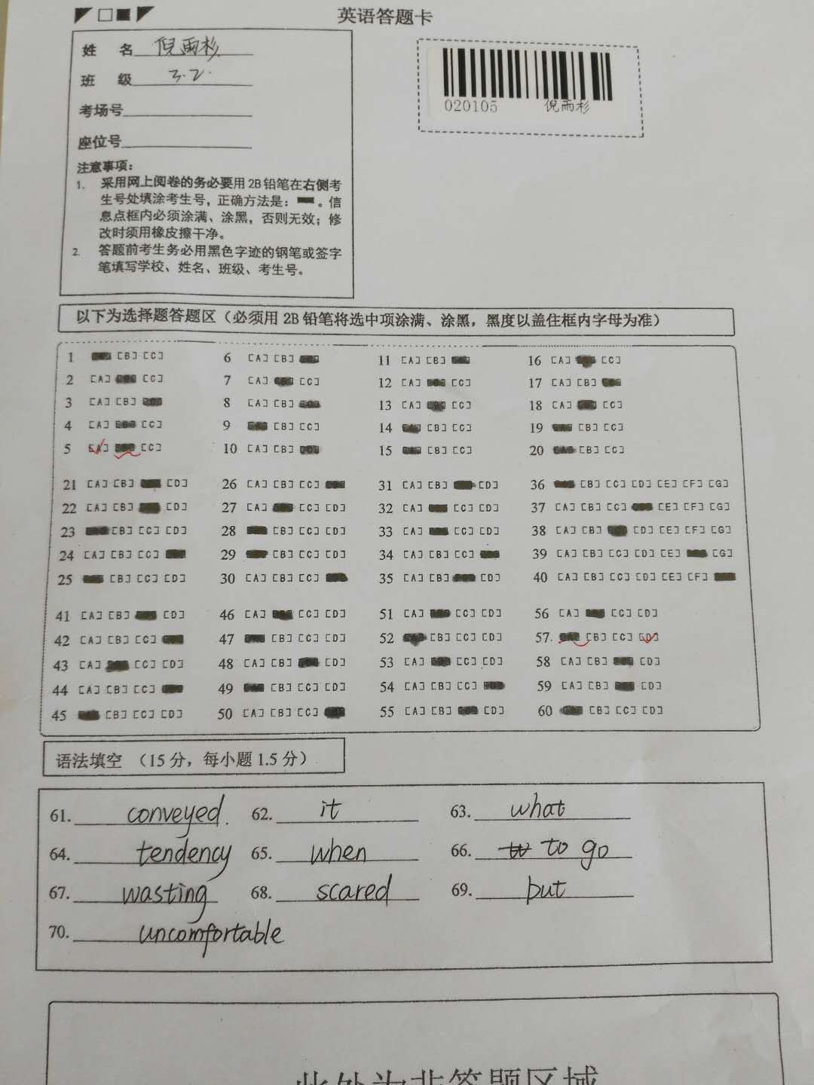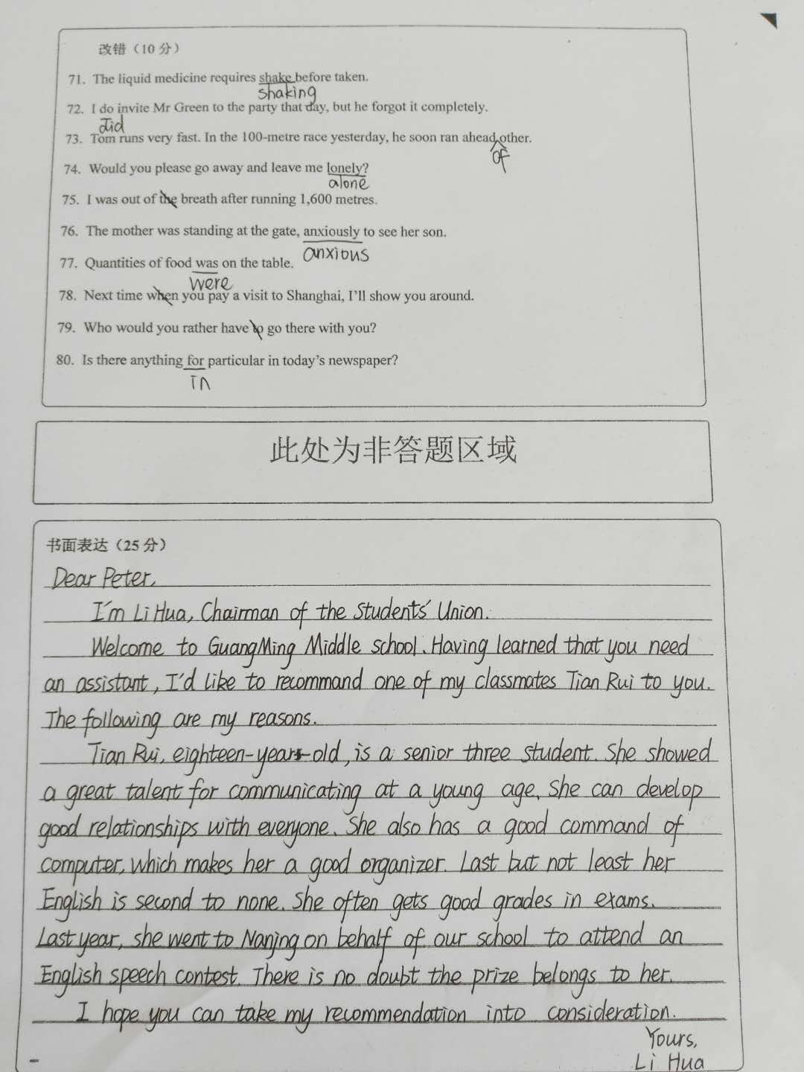

欢迎访问“高中试卷网”——http://sj.fjjy.org

