广西陆川县中学2017年秋季期高三期考
英语试题
试卷说明：1.本试卷满分150分，考试时间120分钟。
2.请将所有答案填涂在答题卡上的正确位置。
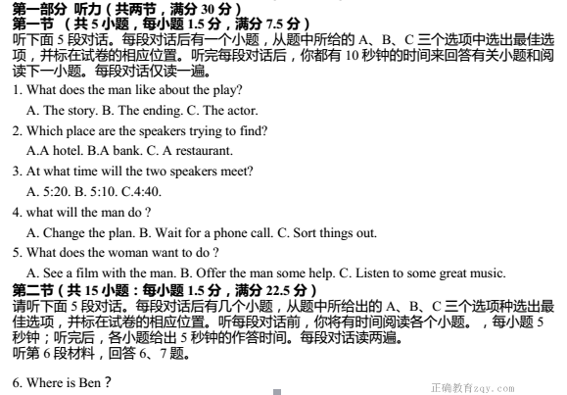

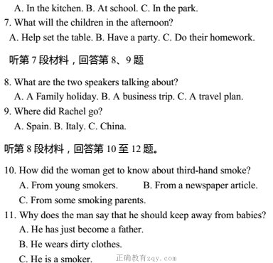
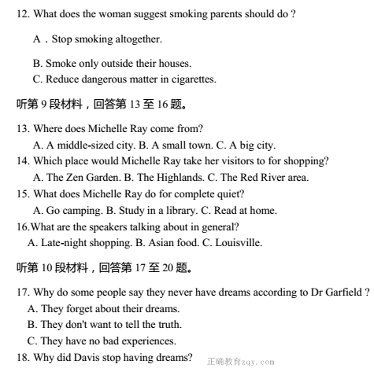
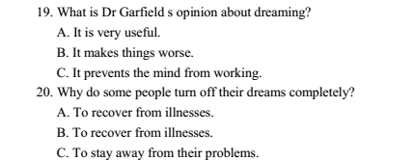
第二部分 阅读理解（共两节，满分 40 分）【来源：全,品…中&高*考+网】
第一节 （共 15 小题；每小题 2 分，满分 30 分）
阅读下列短文，从每题所给的四个选项（A、B、C、和 D）中，选出最佳选项，并在答题卡上将该项涂黑。
A
Most people don’t notice giraffes have different patterns of spots. Certain kinds of giraffes have small spots.
Other kinds have large spots. Some kinds have spots that are regular. You can tell where one spot ends and another begins.
Other kinds have spots that are not separate from each other as clearly as the kinds mentioned above. These are only two of many kinds of spots. The patterns of giraffes’ spots are called “markings”. No two giraffes have exactly the same markings.
There is one very rare giraffe. It is totally black! Have you ever seen one? This kind of giraffe is called a melanistic giraffe. The name comes from the word “melanin”, which is the thing in the cells that causes them to be dark. Giraffe’s spots help them to exist, because they are not easy to be seen when they are in tree trunks and leaves in Africa where they live. If a lion can’t see a giraffe, he certainly can’t eat it. This is called “protective coloration”. The animal’s color helps protect it. A black giraffe’s color would not help protect it. Maybe that is why these giraffes are so rare.
Another thing that protects giraffes is their good eyesight. Their large eyes are on the sides of their heads. Giraffes see anything that moves. They can see another animal a mile away! It is very hard to climb up on a giraffe. Those who try usually get a quick kick with a powerful back leg.
21. What would be the best title for the passage?
A. Giraffes and the Ways that Protect Them
B. The Pattern of a Giraffe’s Spots
C. Different Kinds of Giraffes
D. About Milanistic Giraffes
22. According to the passage, what protects the giraffes?
A. Their spots. B. Their good eyesight.
C. Their powerful back leg. D. Their eyesight and markings.
23. When it sees a lion a mile away the giraffe would ____________.
A. get ready to fight B. hide in tree trunks and leaves
C. kick the lion with a powerful back leg D. scream so that other giraffes may come to help

B
After her parents separated, things at Tami’s house changed. Her mom started working, and Tami became responsible for caring for the house and making meals for herself and her younger sister. Though money was tight, they never went without. They had a nice home in a modest neighborhood, and the girls never wanted for the necessities — food, clothing and shelter. What Tami missed most of all, though, was family.
Tami spent the summer during her ninth grade year working at a park to earn extra spending money. Her job was to organize activities for the kids who spent their summer days at the park. The kids absolutely loved Tami. She was constantly going out of her way to do things for them. She would plan picnics, organize field trips and even buy ice cream for all of them, using her own money. She always did more than the job required, even if it did mean using her own money.
She got to know one little boy who lived in an apartment across the street from the park. His parents both worked at fast-food restaurants, and she knew that they didn’t have much money. The boy talked about his upcoming birthday and the fire truck he wanted so badly. He said he was going to be a fireman some day and needed the truck to practice. He told Tami more details about the truck than she knew a toy truck could have.
The boy’s birthday came and went. The next day when Tami saw the boy, she expected to see a shiny red truck in his arms. When he arrived empty-handed, she asked whether he had got the truck. The boy said no. His parents were going to get it for him later, when things were better. He seemed a little sad.
That week, Tami cashed her paycheck and headed for the toy stores. She found the truck easily— after all, from his descriptions, she felt she knew it inside out. She used the money from her paycheck to buy the truck, and then had it wrapped in birthday paper.
24. What can we learn from the first paragragh?
A. They didn’t need to worry too much about their living.
B. Tami’s sister became more responsible.
C. Tami began to earn money.
D. Her mother changed her job.
25. Why did Tami buy the birthday present for the boy using her own money?
A. Because he was poorer than she.
B. Because he was her best friend.
C. Because she wanted him to be a fireman.【来源：全,品…中&高*考+网】
D. Because she wanted him to feel love around him.
26. What can we learn from the underlined sentence?
A. She knew how much money she would pay.
B. She knew she should check the toy truck inside out.
C. She was fully aware which toy truck the boy wanted.
D. She walked inside and then out of the toy store several times.
27. Which of the following could be the opening sentence of the next paragraph?
A. The next morning, Tami rode to the boy’s house and left the truck at the door.
B. When the boy showed up at the park that day, he was more excited than ever.
C. He showed off his new truck to Tami, and then played with it all day long.
D. That afternoon, the boy’s mom came to the park and walked over to Tami.

C
Backpacks are convenient. They can hold your books, your lunch, and a change of clothes, leaving your hands free to do other things. Someday, if you don’t mind carrying a heavy load, your backpacks might also power your MP3 player, keep your cell phone running, and maybe even light your way home.
Lawrence C. Rome and his colleagues from the University of Pennsylvania in Philadelphia and the Marine Biological Laboratory in Woods Hole, Mass., have invented a backpack that makes electricity from energy produced while its wearer walks. In military actions, search-and-rescue operations, and scientific field studies, people rely increasingly on cellphones, global positioning system (GPS)receivers, night-vision goggles, and other battery powered devices to get around and do their work.
The backpack’s electricity-generating feature could dramatically reduce the amount of a wearer’s load now devoted to spare batteries, report Rome and his colleagues in the Sept Science. The backpack’s electricity-creating powers depend on springs used to hang a cloth pack from its metal frame. The frame sits against the wearer’s back, and the whole pack moves up and down as the person walks. A gear mechanism converts vertical movements of the pack to rotary motions of an electrical generator, producing up to 7.4 watts.
Unexpectedly, tests showed that wearers of the new backpack alter their gaits in response to the pack’s oscillations, so that they carry loads more comfortably and with less effort than they do ordinary backpacks. Because of that surprising advantage, Rome plans to commercialize both electric and non-electric versions of the backpack.
The backpack could be especially useful for soldiers, scientists, mountaineers, and emergency workers who typically carry heavy backpacks. For the rest of us, power-generating backpacks could make it possible to walk, play video games, watch TV, and listen to music, all at the same time. Electricity-generating packs aren't on the market yet, but if you do get one eventually, just make sure to look both ways before crossing the street!
28. Backpacks are convenient because ___________.
A. they can be very large.
B. they can hold as many things as you want to carry.
C. your hands are freed to do other things.
D. you do not have to carry things with you.
29. The word “springs” in Paragraph 3 means ______________.
A. a small stream of water flowing naturally from the earth.
B. the season of the year, occurring between winter and summer.
C. the act or an instance of jumping or leaping.
D. a length of metal wound around, which returns to its original shape after being pushed.
30. According to Paragraph 4, what does Rome plan to do?
A. To make the backpack more comfortable for the wearer.
B. To put the backpack on the market.
C. To test the advantage of the backpack.
D. To promote the backpack in a newspaper or on television.
31. What is implied in “if you do get one eventually, just make sure to look both ways before crossing the street!”?
A. You will be too excited to watch the traffic.
B. Enjoying electronic devices while walking may invite traffic accidents.
C. It is not possible for you to get such a backpack.
D. It is wise of you to have such a backpack.

D
There are two types of people in the world. Although they have equal degrees of health and wealth and the other comforts of life, one becomes happy, the other becomes miserable. This arises from the different ways in which they consider things, persons, and events1, and the resulting effects upon their minds.
The people who are to be happy fix their attention on the conveniences of things, the pleasant parts of conveniences, the well-prepared dishes, the-goodness of wines, the fine weather. They enjoy all the cheerful things. Those who are to be unhappy think and speak only of the contrary things. Therefore, they are continually discontented. By their remarks, they sour the pleasures of society, offend many people, and make themselves disagreeable everywhere. If this turn of mind were founded in nature, such unhappy persons would be the more to be critical. The tendency to criticize and be disgusted is perhaps taken up originally by imitation. It grows into a habit, unknown to its possessors. The habit may be strong, but it may be cured when those who have it are convinced of its bad effects on their interests and tastes.
Although in fact it is chiefly an act of imagination, it has serious consequences in life, since it brings on deep sorrow and bad luck. Those people offend many others, nobody loves them, and no one treats them with more than the most common politeness and respect, and scarcely that. This frequency puts them in bad temper and draws them into arguments. If they aim at obtaining some advantage in rank or fortune, nobody wishes them success. If they bring on themselves public disapproval, no one will defend or excuse them, and- many will join to criticize their misconduct. These people should change this bad habit. If they do not, it will be good for others to avoid any contact with them. Otherwise it can be disagreeable and sometimes very inconvenient, especially when one becomes mixed up in their quarrels.
32. According to the author, the major reason to cause the difference between happy and unhappy people is__________.
A. that they have different life styles
B. that they have fewer friends
C. that they look at things differently
D. that they are not on good terms with the people around them 33. The basic difference between happy and unhappy people lies in the facts that__________.
A. they focus on different aspects of their life
B. they have different attitudes towards other people
C. they have different personalities
D. they come from different family backgrounds
34. The sentence “The tendency to criticize and be disgusted is perhaps taken up originally by
Imitation” in paragraph 2 means__________.
A. criticizing has become a habit and no one wants to imitate them
B. criticizing and being disgusted has become a tendency and it is caused initially by imitation
C. this tendency should not be imitated
D. imitation is one of the reasons why they always criticize others 35. What is the writer’s advice for others if the unhappy persons don’t change their bad
behavior?
A. Avoid contact with them. B. Criticize their misconduct.
C. Help them recognize its bad effects. D. Show no respect and politeness to them.

第二节 （共 5 小题，每小题 2 分，满分 10 分）
根据短文内容，从短文后的选项中选出能填入空白处的最佳选项。选项中有两项为多余选项。
I am afraid of the summer. While most people think of hot weather as a time for playing in the pool, picnics and other activities, I keep an eye out for wildfires. I’ve lived in the mountains of Montana and Colorado for more than 30 years. 36 What will you do when a real disaster strikes, like floods, fires, tornadoes, hurricanes, earthquakes or other disasters? I’ll tell you what I’ve done to prepare.
Nobody wants to think about natural disasters, except perhaps at the local movie theatre watching the latest movie, but that’s burying your head in the sand. 37
Look at where you live. What are the possible natural disasters? Wildfires are easy to break out in forested areas. Coasts are easy to suffer from floods, hurricanes, tornadoes and tsunamis.38 If the Yellowstone super volcano goes, I’m probably out of luck too.
The trick of living in a disaster-prone area is planning. 39 In my case, I need to know where my exit routes are and also where I’m going to stay. Depending on how big the disaster is, I know where I need to go.
40 So ask beforehand, especially if you have pets, if you can bring them over in case of a natural disaster. No matter how carefully you plan, when things get rough, your family and friends may not be able or willing to help you. The disaster may be widespread. In that case, your family and friends may be in the same situation as you are.
【来源：全,品…中&高*考+网】
A. Natural disasters take place frequently nowadays, bringing much trouble to us humans.
B. It is necessary for you to know where your safer areas are, such as places you can escape the disaster there.
C. In my case, I have possible earthquakes, heavy snow and wildfires.
D. Not all shelters allow pets.
E. And I have been through at least seven major fires in my area.
F. We ought to take great care about those disasters so that we can well protect us from danger.
G. Avoiding thinking about disasters doesn't mean they won’t take place.

第Ⅱ卷
第三部分 英语知识运用 （共两节，满分 45分）
第一节 完形填空（共 20 小题；每小题 1.5 分，满分 30 分）
阅读下面短文，从短文后各题所给的四个选项（A、B、C 和 D）中，选出可以填入空白处的最佳选项，并在答题卡上将该项涂黑。
One man planned to meet his wife in the city center and spend some time shopping with her. He waited 41 for 20 minutes. Then he waited impatiently for 20 minutes more. After that， he became 42 . When he saw a photograph booth nearby, he had 43 . He wore the most unhappy expression he could manage, which was not 44 in the situation. In a few moments， he was holding four small prints of photos that 45 even himself.
He wrote his wife’s name on the back of the photos and handed them to a 46 behind the desk in the booth. “ 47 you see a small, dark lady with brown eyes and an apologetic expression, obviously 48 someone, would you please give her this?” he said. He then 49 his office in Garden Square Building, 50 that if a picture is worth a thousand words, then the four photos must be a good 51 ! He sat down with a smile.
His wife 52 those pictures. She carries them in her purse now and shows them to anyone who asks if she is married.
53 is what we call “wait training”. It seems that there is always something we are 54 .We wait on traffic and we wait in lines. We wait about a new job. We wait to complete school. We wait for someone to change his or her mind. Patience is an important 55 of a happy and rewarding life. 56 , some things are worth waiting for in life. 57 presents many
opportunities for wait training. We can hate waiting or 58 it and even become good at it! But one thing is 59 -- We cannot avoid it. How is your 60 coming along?

41. A. gratefully B. respectfully C. patiently D. mentally
42. A. angry B. optimistic C. scared D. embarrassed
43. A. a conclusion B. a concept C. an advantage D. an idea
44. A. aggressive B. difficult C. regular D. typical
45. A. bothered B. inspired C. convinced D. shocked
46. A. clerk B. representative C. passer-by D. director
47. A. Since B. Until C. As D. If
48. A. looking for B. praying for C. sending for D. reaching for
49. A. marched into B. returned to C. spotted D. observed
50.A. alarmed B. upset C. satisfied D. annoyed
51. A. description B. guidance C. combination D. lecture
52.A. tore B. saved C. ignored D. inspected
53. A. Complaint B. Justice C. Patience D. Investigation
54. A. competing for B. waiting for C. longing for D. struggling for
55. A. explanation B. application C. purpose D. quality
56. A. For example B. After all C. right now D. So far
57.A. Every district B. Every behavior C. Every day D. Every post
58. A. accept B. adjust C. admire D. defend
59.A. certain B. logical C. precious D. awkward
60. A. photo taking B. job hunting C. decision making D. wait training
第二节 （共10小题；每小题1.5分，满分15分）
阅读下面材料，在空白处填入适当的单词或括号单词的正确形式。
The first time you meet someone, in the first moment you form an 61 (impress) in your mind of that person. Your reactions to other people, however, are really just barometers (晴雨表)for how you feel yourself, saying more about you 62 they do about others. You cannot really love or hate about yourself. Usually, we are drawn to those who are most like us and tend to dislike those 63 display those aspects of ourselves that we dislike.
Therefore, you can allow others 64 (be) the mirror for you to see more clearly your own feelings of self-worth. Also, you can view the people you judge negatively 65 mirrors to show you what you are not accepting about yourself.
66 (live) together peacefully with others, you will need to learn tolerance. A big challenge is to shift your idea 67 ( complete) from judgment of others to a lifelong exploration of yourself. Your task is to assess (评估) all 68 decisions. judgments you make onto others and to begin to view them as clues to how you can heal 69 (you) and become whole.
When you approach life in this manner, those with whom you have the greatest dislikes as well as those you admire and love can be seen as mirrors, 70 (guide) you to discover parts of yourself that you reject and to embrace your greatest quality.

第四部分 写作 （共两节 满分 35）
第一节 短文改错（共10小题；每小题1分，满分10 分）
假定英语课上老师要求同桌之间交换修改作文，请你修改你同桌写的以下作文。
文中共有10处语言错误，每句中最多有两处。每处错误仅涉及一个单词的增加、删除或修改。
增加：在缺词处加一个漏字符号（ ∧），并在其下面写出该加的词。
删除：把多余的词用斜线（\ ）划掉。
修改：在错的词下画一横线，并在该词下面写出修改后的词。
注意： 1.每处错误及其修改均仅限一词；
2.只允许修改10处，多者（从第11处起）不计分。
Which is more important, health or wealth? It was until I witnessed my uncle’s real life did I realize that health is of great important. Devoted for his business, my uncle, a successful businessman, works from morning till night every day with no spare time to relax himself. He often said, “I must earn little money so that I can get whatever I want.” As a result, he was serious ill. Rich as he was, he could do nothing but to lie in the hospital bed. So, I think health is less important than wealth. People can do nothing if they are always of poor health, let alone live happily. Whether we are poor and not, we cannot ignore the importance of health.

第二节 书面表达 （满分25分）
假设你是红星中学高三学生李华，你校将举办“中华传统文化周”活动。请给你班的交换生Jim写封电子邮件，希望他一起参加。邮件的内容包括：
1. 介绍活动的安排（如时间、地点、内容等）；
2. 说明活动的目的；
3. 询问对方的意向。
注意：1. 词数100左右，
2. 邮件的开头和结尾已给出，不计入总词数。
Dear Jim,
___________________________________________________________________________
Yours,
Li Hua

英语试题答案
第一部分 听力 （共两节， 满分30分）
听力：1-5CABBA 6-10 CBACB 11-15CAABC 16-20CABAC
阅读理解：
21. A 22. D 23. B 24. A 25.D 26.C 27.A 28.C 29.D 30.B
31. A 32. C 33. A 34. B 35.A 36.E 37. G 38.C 39.B 40.D

完形填空：【来源：全,品…中&高*考+网】
41. C 42. A 43. D 44. B 45. D 46. A 47. D 48. A 49. B 50. C
51. D 52. B 53. C 54. B 55. D 56. B 57. C 58. A 59. A 60. D

语法填空：
61. impression 62. than 63. who 64. to be 65. as
66. To live 67. completely 68. the 69. yourself 70. Guiding【来源：全,品…中&高*考+网】

短文改错：
Which is more important, health or wealth? It was ∧ until I witnessed my uncle’s real life did I realize that health is of great important . Devoted for his business, my uncle, a successful businessman, works from morning till night every day with no spare time to relax himself. He often said, “I must earn little money so that I can get whatever I want.” As a result, he was serious ill. Rich as he was, he could do nothing but to lie in the hospital bed. So, I think health is less important than wealth. People can do nothing if they are always of poor health, let alone live happily. Whether we are poor and not, we cannot ignore the importance of health.
(改为worked)
(改为much)
(改为seriously)
(去掉to)
(改为more)
(改为in)
(改为or)
（加not）
(改为importance)
（改为to）

写作：
One possible version:
Dear Jim,
I am writing to tell you about the Chinese Traditional Culture Week. Hopefully, we will have you with us to have fun.
This cultural event will be held next week in the Arts Building and various activities are arranged. There will be lectures on Chinese festivals, exhibitions of Chinese artworks, competitions of culture knowledge, etc. Also included is an evening of traditional culture next Friday. Sounds great, doesn’t it? These activities will surely offer teenagers, like you and me, a good chance to explore Chinese traditional culture.
Are you interested? Will you be available then? I am looking forward to your reply and hope to see you at the event.
Yours,
Li Hua

欢迎访问“高中试卷网”——http://sj.fjjy.org

