信阳市2017—2018学年普通高中高三第二次教学质量检测
英 语
注意事项：
1．答题前，考生务必用0．5毫米黑色签字笔将自己的姓名、座号、准考证号填写在答题卡和试卷规定的位置上。
2．本试卷分第Ⅰ卷和第Ⅱ卷两部分，满分150分。考试用时120分钟。第工卷每小题选出答案后，用2B铅笔把答题卡上对应题目的答案标号涂黑；如需改动，用橡皮擦干净后，再选涂其他答案标号。
3．第Ⅱ卷必须用0．5毫米黑色签字笔作答，答案必须写在题目指定区域内相应的位置；如需改动，先划掉原来的答案，然后再写上新的答案；不能使用涂改液、胶带纸、修正带。不按以上要求作答的答案无效。
第Ⅰ卷（选择题，共100分）
第一部分：听力理解（共两节，满分30分）
第一节（共5小题；每小题1．5分，满分7．5分）
听下面5段对话，每段对话后有一个小题。从题中所给的A、B、C三个选项中选出最佳选项。听完每段对话后，你都有10秒钟的时间来回答有关小题和阅读下一小题。每段对话仅读一遍。
1. When did Sally arrive in Paris?
A. Seven days ago. B. Last night. C. During National Day.
2. What does the man mean?
A. Jeff won’t attend the meeting.
B. Jeff won’t speak in public. C. Jeff doesn’t have any good ideas.
3. Which bus does the man advise the woman to take?
A. A15. B. A50. C. A55.
4. What does the woman ask the boy to do?
A. Take the piano lesson. B. Go to a dentist. C. Visit his grandparents.
5. What was the woman looking for?
A. Mr. Smith’s phone. B. Mr. Smith’s card. C. Information about Mr. Smith.
第二节（共15小题；每小题1．5分，满分22．5分）
听下面5段对话或独白。每段对话或独白后有几个小题，从题中所给的A、B、C三个选项中选出最佳选项。听每段对话或独白前，你将有时间阅读各个小题，每小题5秒钟；听完后，各小题将给出5秒钟的作答时间。每段对话或独白读两遍。
听第6段材料，回答第6、7题。
6. What was the man doing while the accident happened?
A. Turning into his drive.
B. Turning around the corner. C. Looking into the back mirror.
7. Who should be responsible for the accident?
A. The man. B. The other driver. C. Both of them.
听第7段材料，回答第8、9题。
8. What is Mr. Brown doing?
A. Visiting his family. B. Answering a call. C. Taking a shower.
9. Where will the man go next?
A. To the coffee house. B. To the supermarket. C. To the guest room.
听第8段材料，回答第10至12题。
10. What does the man prefer in the room?
A. The extra bedroom. B. The color TV. C. The pool.
11. What is the policy of the hotel?
A. Registering in the office. B. Paying in advance. C. Paying in cash.
12. What will the man do next?
A. Go to the room. B. Park his car. C. Call his family.
听第9段材料，回答第13至16题。
13. What is the girl going to do?
A. Watch an opera. B. Perform in an opera. C. Visit her grandfather.
14. What will the girl wear tonight?
A. A black dress. B. A blue suit. C. A blue dress.
15. How long is the performance?
A. 5 hours. B. 3.5 hours. C. 4 hours.
16. Who are the two speakers probably?
A. Classmates. B. Brother and sister. C. Father and daughter.
听第10段材料，回答第17至20题。
17. What was Joe’s first story about?
A. Stock market. B. The United States. C. World War Ⅱ.
18. Where did Joe go after his first story?
A. To Europe. B. To Africa. C. To Asia.
19. What happened to Joe in 1946?
A. He won a big award. B. He became an editor. C. He had cancer.
20. When did Joe die?
A. In 1967. B. In 1968. C. In 1976.
第二部分：阅读理解（共两节，满分40分）
第一节（共15小题；每小题2分，满分30分）
阅读下列短文，从每题所给的四个选项（A、B、C和D）中，选出最佳选项。
A
Are you interested in visiting historical swimming pools? If you’re, here are some pools that you shouldn’t miss in America.
McCarren Park Pool
During the summer of 1936, the Works Progress Administration opened eleven huge pools in
New York City. One was the McCarren Park Pool, designed by Aymar Embury Ⅱ. A 2012 restoration（修复）project brought the long-closed Brooklyn facility into the 21st century while keeping the original brick bathhouse building and grand entry arch（拱门）.
Berkeley City Club Pool
Open to members and hotel guests of Berkeley City Club in Berkeley, California, this Julia Morgan-designed pool dates from 1930. It looks like a pool in a fairy tale. There’s an observation deck（望台） for those who just want to enjoy the architecture without actually swimming.
Roman Pool
Part of Hearst Castle, the indoor Roman Pool is a masterpiece filled with natural light and amazing artworks by artist Camille Solon. Julia Morgan built the pool under a tennis court and designed it in an artistic style. The water’s gleaming surface reflects the room’s curved marble ladders, lamps and marble statues.
Neptune Pool
The Neptune Pool is also one of the main attractions of Hearst Castle. Julia Morgan designed it. It has an amazing ocean-view setting. For more on the Neptune Pool and the castle, visit the Hearst Castle website.
21. What can we know about the McCarren Park Pool?
A. It was opened in the early 1930s.
B. It isn’t open to the public today.
C. It was restored by Aymar Embury Ⅱ.
D. The original brick bathhouse building still exists.
22. What can we do at the Roman Pool?
A. Having an ocean view through the windows.
B. Enjoying views on an observation deck.
C. Enjoying artworks by Camille Solon.
D. Staying at Berkeley City Club.
23. What’s the author’s purpose in writing the text?
A. To introduce the Hearst Castle website.
B. To introduce some historical swimming pools.
C. To recommend some major attractions in the U.S.
D. To tell readers about some pools designed by Julia Morgan.
B
Everyone knew I wanted to be an astronaut. Most people knew that I was also fascinated（迷住）by basketball, and I just assumed that if I wanted to be in the NBA, I could. Few people knew that I read every John Grisham novel starting from the age of 12 and wanted to be a lawyer.
As a young girl, I used to see Space Camp, the movie shown just after the Challenger Space Shuttle disaster. Every time I watched it, I got lost in my imagination. I was Katherine, the lead character who wanted to be the first female space shuttle commander. I had a robot friend named Jinx who could cause a major failure and send me into space. Because of that movie, I decided to become an astronaut.
All these Hollywood shows have an opportunity to inflence kids. I am the living proof that young kids watch the products of Hollywood and are inspired by them or turned away by them. It’s a serious responsibility.
Even as an adult today, my interests change much more quickly than I wish they did. I am truly addicted to trying new things! But I am proud of myself for trying. I hope I never lose that desire — to try. After all, my greatest achievement isn’t actually achieving the fial goal but rather that I at least tried.
To my joy, I was selected for an interview in the 2013 astronaut selection. I didn’t actually get selected as an astronaut that year, but the experience alone was enough to inspire me never to give up. In the end, if I never make it into space to witness the beauty of this planet with my own eyes, at least I can say I have tried.
24. Who was Katherine according to Paragraph 2?
A. The author herself. B. A female astronaut.
C. A character of a movie. D. An astronaut of the Challenger.
25. What did the author think of Hollywood movies about exploring space?
A. They are good scientifi movies.
B. They have a deep effect on children.
C. They are made to select new astronauts.
D. They frighten children away from space.
26. Why does the author take great pride in herself?
A. She keeps attempting. B. She has many dreams.
C. She never loses heart. D. She achieved her fial goal.
27. What can be concluded from the last paragraph?
A. The author was satisfid with the interview.
B. The author gave up the career as an astronaut.
C. The author still stuck to her astronaut dream.
D. The author felt sorry for her failure in the selection.
C
In the United States, Mother’s Day falls on the second Sunday in May. It was back in 1908 when a woman named Anna Jarvis created this unofficial holiday to honor mothers. Traditionally, children and husbands honor mothers of all ages by buying flowers, cards and other gifts or taking them to dinner in a nice restaurant. But today, we will talk about some expressions that use the word “mother”, instead.
Some cultures believe Mother Earth gave birth to everything that exists on our planet. In Greek mythology, a goddess named Gaia was the great mother of all. She was said to have created the Earth and the Universe. Mother Nature is a little different. This term relates to the natural world as if it were a woman.
The mother lode（矿脉）comes from mining. It means a place where the largest amount of gold, silver, or anything else of value can be found. But now, the term mother lode means a rich supply of anything. We often use the word “strike” with this expression. For example, you might say, “She just graduated from college and struck the mother lode with her new job!”
When we call something “the mother of all”, it means it is the biggest or best of something. Here is an example: We are going to throw the mother of all parties this weekend. So you’d better come on time!
You might think all expressions about mothers are sweet and loving. Not so. For example, a boy who is “tied to his mother’s apron strings” is controlled by his mother. We can also call him a “mama’s boy”. Both of these terms are even more impolite, especially if you are talking about an adult man.
28. How does the author explain Mother Earth?
A. By making a comparison. B. By telling a historical story.
C. By introducing a Greek myth. D. By analyzing different words.
29. What does the underlined sentence in Paragraph 3 mean?
A. She could find something valuable. B. She earned quite a lot from her new job.
C. She was trying her best to do her job. D. She was busy with her work every day.
30. Which of the following has a negative meaning according to the text?
A. Mother Nature. B. The mother lode.
C. The mother of all. D. Tied to his mother’s apron strings.
31. What does the text mainly tell us?
A. The history of Mother’s Day. B. The legendary life of Anna Jarvis.
C. Tips on gifts for Mother’s Day. D. Different meanings of mother expressions.
D
It is a popular Internet thing to focus on the upside of being in your 30s, and it is nice to know how to do basic modern-human-being things like paying your taxes and cooking a simple meal. But it can be a less-encouraging story at work: People in their late 20s to early 40s tend to report lower levels of job satisfaction and higher levels of emotional exhaustion than other age groups, according to new research.
There’s an obvious reason: These tend to be the ages when people have young children at home, and the researchers did find that this group reported feeling increasingly crunched for time. But adding to that pressure, coworker support also tends to decline at this age. Some researchers interpret the findings:
Support from co-workers probably decreases in midlife as peers compete for limited resources（promotion bottlenecks are often encountered during this career stage）. Also, where as younger co-workers are often hungry to make up new social networks, and older workers seek identity-affirming（确认）work experiences in their remaining tenure（任期）, midlifers find it demanding enough just to maintain existing social networks. Meanwhile, time pressure likely increases as colleagues are all trying to enrich their own knowledge and experience.
But the good news is that after about a decade of struggle, things start to pick back up again. Occupational psychologists say that happiness at work recovers when people reach their 40s, and that people in their 50s are more satisfied with their jobs than any other age group. Hang in there, 30-somethings-soon you will be older, but at least work will meet less frustration（挫折）!
32. What can we learn about people in their 30s according to the text?
A. They may feel more pressured at work.
B. They are more satisfied with their work.
C. They tend to feel less emotionally exhausted.
D. They don’t know how to do basic modern-human-being things.
33. Which of the following can replace the underlined word “crunched” in Paragraph 2?
A. encouraged B. pressed C. relaxed D. satisfied
34. Why do people in their late 20s to early 40s have less support from co-workers?
A. Because they have a family to support.
B. Because they are eager to form new social networks.
C. Because they try to seek identity-affirming work experiences.
D. Because they are faced with strong competition in promotion.
35. What would be the best title of the text?
A. Job satisfaction and ages
B. Why people are dissatisfied with work
C. Tips on improving your job satisfaction
D. Work is worst when you are in your 30s
第二节（共5小题；每小题2分，满分10分）
根据短文内容，从短文后的选项中选出能填入空白处的最佳选项。选项中有两项为多余选项。
Reading comprehension is an important skill to master for academic success. Many students have difficulty in understanding the point of a story and remembering what a story is about—the basics of this task. Luckily, by following some basic tips, you can improve at reading comprehension.
Work on your vocabulary. Keep up on vocabulary lessons in school, and look up definitions of words when you read to master as many words as you can. 36
Read with your mind, eyes and lips. 37 Just reading with your mind could mean you’re not paying enough attention. You don’t have to read aloud for reading comprehension, but go over each word with your eyes at least.
38 To understand what a paragraph is saying, you can often look through the first sentence. This should tell you the point of the paragraph, and the rest should be supplemental（附加的）information. Look at the last sentence to complete the idea.
Identify the structure of the story to know what to look for in analyzing it. Some stories are written in the order of time. Others start from the point of the future and backtrack（倒叙）. Still others are about proving the point of a thesis with examples. 39
Try to predict what’s going to happen next. Reading actively promotes reading comprehension. __40 This will help you remember the details after you’ve finished.
A. Be aware of the function of paragraphs.
B. Concentrate on the meaning of words when reading aloud.
C. The larger vocabulary you have, the easier reading comprehension will be.
D. While reading, guess which way the story is going or how the story will end up.
E. Reading with your eyes and lips helps you remember what you’ve read.
F. Figure out what kind of structure you’re looking at to understand the story better.
G. If you can understand the writer’s purpose between the lines, you’re doing a good job.
第三部分：英语知识运用（共两节，满分45分）
第一节 完形填空（共20小题；每小题1．5分，满分30分）
It was an unforgettable experience that happened many years ago.
Once, I 41 a booth （售货摊）across from a wonderful comedian. His name was Moonie. He was absolutely 42 , and his performance was done using nothing but 43 and actions instead of words. I remember watching his shows and always being entertained. Even when he was having a 44 day, the audience wasn’t cooperating, or his tight-rope skills weren’t as 45__ as he would have liked, he always 46 to keep things funny, lively, and fresh. That’s a very __47 thing to do, considering I watched him just do the same performances and jokes for 5 years several times a day, each weekend.
When I heard it would be his last year performing at the fair, I wanted to 48 him for all the amazing shows he had done on that 49 across from the booth where I worked. He was standing with the 50 after his last show of that day, and as each person dropped a 51__ into his big basket, he was saying playfully “No, you’re the greatest!” to each one.
I 52 him and dropped $ 20 into his basket, and he turned to me then, smiling very brightly, and 53 with another “No, you’re the greatest!” So I looked at him 54 and stopped him saying. “No, Moonie, you are the greatest. I have been watching your show for 5 years from that booth right over there, and here I 55 wanted to say thank you for the years of amazing shows that you have given me.”
The 56 on his face said that he was genuinely and truly 57 by that comment. He gratefully asked me what my name was and 58 to shake my hand. I accepted and we shared a very deep moment of mutual（相互的）respect and 59 . I walked away 60 , and I knew he did too.
41. A. built B. ran C. repaired D. decorated
42. A. amazing B. ordinary C. disappointing D. strange
43. A. quotations B. signals C. gestures D. indications
44. A. busy B. free C. wonderful D. bad
45. A. ideal B. unique C. necessary D. valuable
46. A. pretended B. refused C. managed D. promised
47. A. simple B. puzzling C. exciting D. hard
48. A. visit B. thank C. support D. praise
49. A. room B. castle C. stage D. border
50. A. children B. crowd C. beggars D. policemen
51. A. flower B. stone C. letter D. tip
52. A. approached B. comforted C. persuaded D. satisfied
53. A. covered B. ended C. dealt D. continued
54. A. nervously B. directly C. curiously D. shyly
55. A. never B. even C. just D. still
56. A. look B. embarrassment C. honesty D. sadness
57. A. touched B. inspired C. discouraged D. disturbed
58. A. decided B. agreed C. offered D. hesitated
59. A. friendship B. appreciation C. kindness D. sympathy
60. A. cheerfully B. hopefully C. respectfully D. faithfully

第Ⅱ卷（非选择题，共50分）
第三部分：英语知识运用（共两节，满分45分）
第二节（共10小题；每小题1．5分，满分15分）
阅读下面短文，在空白处填入1个适当的单词或括号内单词的正确形式。
Holidays in the United States usually take place at least once a month. Most national holidays __61 （celebrate）on Monday. In fact, it is 62 （special）arranged like this so that workers may have 3-day weekends, that is, Saturday, Sunday and Monday. Americans celebrate a 63__ （various）of holidays throughout the year. Major holidays in the United States include New Year’s Day, Christmas Day and the day when we remember the first 64 （settler）of the United States, __65 （call）Thanksgiving Day. In these holidays, many government offices are closed and some private businesses may close as well. If you plan 66 （visit）a government office on or around a national holiday, you should contact their staff to determine when 67 will be open.
Vacation can be from 2 weeks a year to 4 weeks a year. This usually depends 68 how long you’ve been working for a company and what position you have. Usually the more time you spend working for a company, the 69 （long）your vacation will be. Of course, 70 you can find someone to replace you, you might take several more days off at a time.
61. __________ 62. __________ 63. __________ 64. __________ 65. __________
66. __________ 67. __________ 68. __________ 69. __________ 70. __________
第四部分：写作（共两节，满分35分）
第一节 短文改错（共10小题；每小题1分，满分10分）
假定英语课上老师要求同桌之间交换修改作文，请你修改你同桌写的以下作文。文中共有10处语言错误，每句中最多有两处。每处错误仅涉及一个单词的增加、删除或修改。
增加：在缺词处加一个漏字符号（∧），并在其下面写出该加的词。
删除：把多余的词用斜线（＼）划掉。
修改：在错的词下划一横线，并在该词下面写出修改后的词。
注意：1．每处错误及其修改均仅限一词；
2．只允许修改10处，多者（从第11处起）不计分。
Last week I got a chance participate in the Chinese Characters Dictation Competition. I had been busy prepare for it. My classmate all volunteered to help. Some of whom dictated various characters they found in the dictionary to me when others offered to check my answers. As the competition was approaching, I felt more and more confidently. The day finally come. Some characters were such challenging that many of the competitors got stick, but I was able to write down most of them. Although I won first prize, I felt that the victory and honor are belonged to all of us.
第二节 书面表达（满分25分）
假如你是某国际中学的李华。你校的络教室每天只在中午开放一个小时，很难满足同学们使用络的要求，请你就此用英文给校长写封电子邮件。内容包括：1．提出申请的原因；2．如何减少可能的负面作用。
注意：
1．词数100左右；
2．可适当增加细节，以使行文连贯；
3．开头和结尾已为你写好，不计入总词数。
Dear Sir,
I am writing to ask for longer and more flexible opening times for the network classroom.
_____________________________________________________________________________________________________________________________________________________________________________________________________________________________________________
I am really looking forward to your positive reply.
Yours,
Li Hua

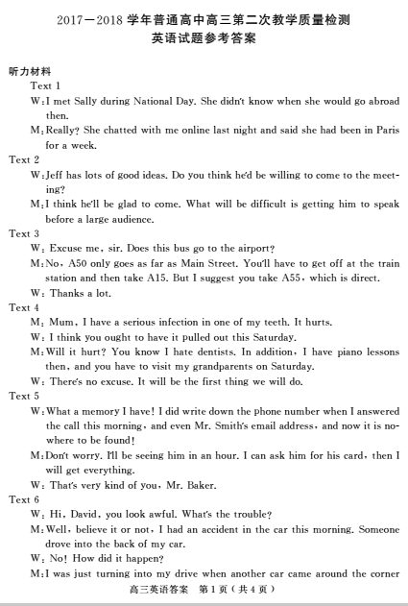

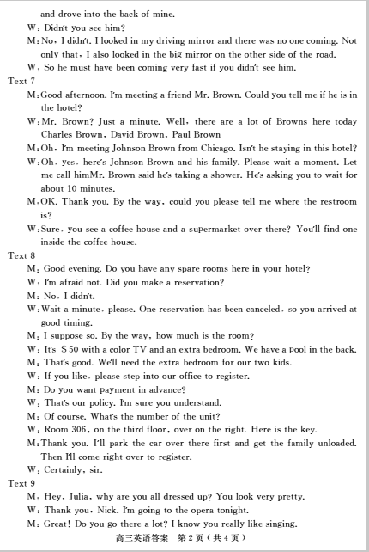

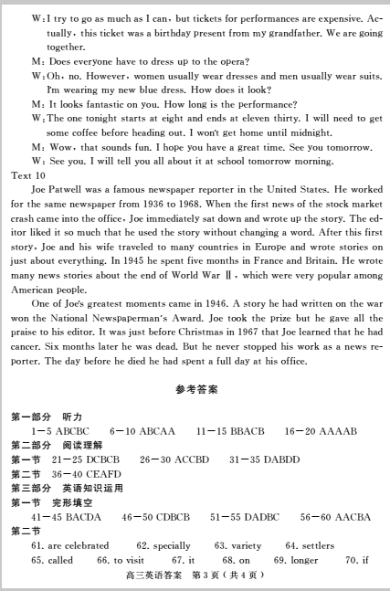

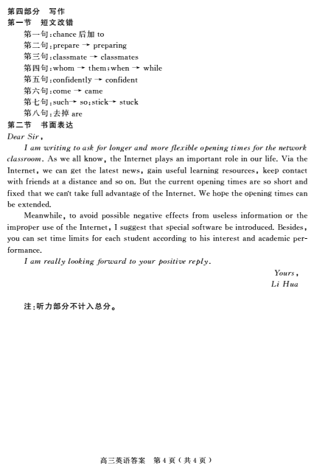
欢迎访问“高中试卷网”——http://sj.fjjy.org

