2015级高二年级二月联考英语试卷

第一部分 听力（满分30分）
第一节 （共5小题；每小题1.5分，满分7.5分）
听下面5段对话。每段对话后有一个小题，从题中所给的A、B、C三个选项中选出最佳选项，并标在试卷的相应位置。听完每段对话后，你都有10秒钟的时间来回答有关小题和阅读下一小题。每段对话仅读一遍。
1.Where does the conversation most probably take place?
A.At a theater. B.At a restaurant. C.At a bus station.
2.How much did the man spend altogether fixing his computer?
A.$67. B.$85. C.$92.
3.What does the woman want to know?
A.Whether the man can keep his job. B.Where the man got the bad news.
C.What items sell well in the store.
4.What is the man talking about?
A.His sister. B.His new job. C.His date（约会）.
5.What does the woman mean?
A.She will go to buy the gift herself. B.The gift should not be too expensive.
C.The man is not good at balancing his budget.
第二节（共15小题；每小题1.5分，满分22.5分）
听下面5段对话或独白。每段对话或独白后有几个小题，从题中所给的A、B、C三个选项中选出最佳选项， 并标在试卷的相应位置。听每段对话或独白前，你将有时间阅读各个小题，每小题5秒钟； 听完后，各小题将给出5秒钟的作答时间。每段对话或独白读两遍。
听下面一段对话，回答第6和第7两个小题。
6.What size shoes did the woman wear last year?
A.6. B.7. C.8.
7.Why did the woman's feet hurt?
A.Her shoes were the wrong size. B.She walked too much each day.
C.Her shoes were of very low quality.
听下面一段对话，回答第8和第9两个小题。
8.What can we learn from the conversation?
A.The woman is in a rush. B.It is going to rain soon. C.The traffic is heavy then.资*源%库
9.Where is the woman going?
A. Her house. B.An appointment. C.West 22nd Street.
听下面一段对话，回答第10至第12三个小题。
10.What will the man do on Tuesday?
A.Visit a factory. B.Meet a company boss. C.Go to the seaside.
11.When will the man go to the mountains?
A.On Monday. B.On Wednesday. C.On Thursday.
12.What will the man wear on Friday?
A.A blue shirt. B.A sweater. C.A jacket.
听下面一段对话，回答第13至第16四个小题。资*源%库 ziyuanku.com
13.When will John go to the game?
A.On Thursday. B.On Friday. C.On Saturday.
14.What does John ask Susan to do?
A.Help with his term paper. B.Go to a concert with him. C.Take care of his cousin.
15.What does John say about his cousin?
A.She enjoys concerts. B.She loves traveling. C.He isn't sure of her interests.
16.What's John and Susan's plan determined by?
A.John's cousin's idea. B.Susan's time. C.The weather.
听下面一段独白，回答第17至第20四个小题。
17.How soon will the exam be?
A.In ten days. B.In eight days. C.In a week.
18.Which is the most important about studying?
A.Remembering everything exactly B.Reviewing right before a test.
C.Planning the time well.
19.What will the students do during the two days before the exam?
A.Review at school. B.Have a rest. C.Study at home.
20.Why will the speaker stay after school?
A.To prepare some questions. B.To write the tests. C.To offer help.

第二部分 阅读理解（共两节，满分40分）
- （共15小题，每小题2分，满分30分）
阅读下列短文，从每题所给的四个选项（A、B、C、D）中，选出最佳选项，并在答题卡上将该项涂黑。
A
No poem should ever be discussed or analyzed, until it has been read aloud by someone, teacher or student. Better still, perhaps, is the practice of reading it twice, once at the beginning of the discussion and once at the end All discussions of poetry are, in fact, preparations for reading it aloud, and the reading of the poem is, finally, the most telling“interpretation”of it, suggesting tone, rhythm, and meaning all at once. Hearing a poet read the work in his or her own voice, on records or on films, is obviously a special reward. But even those aids to teaching can not replace the student and teacher reading it or, best of all, reciting(背诵) it.
I have come to think, in fact, that time spent reading a poem aloud is much more important than analyzing it if there isn’t time for both. I think one of our goals as teachers of English is to have students love poetry. Poetry is a criticism of life, and a heightening(提升) of life. It is an approach to the truth of feeling, and it can save your life. Ziyuanku.com
I am not saying that every English teacher must teach poetry. Those who don’t like it should not be forced to put that dislike on anyone else. But those who do teach poetry must keep in mind a few things about its essential nature, about its sound as well as its sense, and they must make room in the classroom for hearing poetry as well as thinking about it.
21.To have a better understanding of a poem, one should________.
A．analyze it by oneself B．copy it down in a notebook
C．practise reading it aloud D．discuss it with others
22.According to the writer, one of the purposes of teaching English is to get students________.
A．to enjoy poetry. B．to become teachers.
C．to become poets D．to understand life.
23.The underlined words“make room”in the last paragraph probably means .
A. to provide equipment B. to leave a certain amount of time
C. to set aside enough space D. to build a booth
24.The best title for the passage may be .
A. Analyzing Poems B. Discussing Poems
C. Learning English D. Reading Poems Aloud
B
Not long ago, people could only buy organic food in small shops. Today it is common in most major supermarkets. The reason for the increase is that more and more people are demanding food grown without chemicals. Since the 1990s, organic farm production has gone up 20 percent every year. This pattern is expected to continue around the globe.

Australia leads the world in land used for organic agriculture. It has four times as much land devoted to organic farming as all of Asia. However, most of the land is not very fertile, and it only produces a modest amount of food. Argentina is a distant second, followed by Brazil, the United States and China. In Africa, only a very small amount of land is registered for organic farming. That does not mean Africa relies on chemicals. In fact, many farmers do not use chemicals because they cannot afford them. Yet there are no programs for these farmers to prove they do not use chemicals. Without these programs their food can never be approved organic.

India has had the most dramatic recent increase in organic farming. Like many other countries, India sees continual growth in organic food sales around the world. This, of course, leads to growth in profits. Sales of organic food were more than doubled from 2000 to 2005. Like India, many countries are trying to increase commercial organic farming to get a share of the sales. This has led to criticism. Some people believe that organic farming should not just be about making money. They think the goal is to help the environment. Others say organic farming will not continue if it is not profitable. They say that people should be able to make money while providing food that is healthy to mankind. Ziyuanku.com
25.What is the passage mainly about?

A.Countries all want to make money from organic farming.

B.Organic food has become much more common.

C.People do not want to eat food with chemicals in it.

D.Farming organically is growing around the world.

26.Why do people want to increase organic farming?

A.Organic food is good for the Earth and the human beings.

B.More and more people demand chemicals to grow food.

C.Profits from organic farming help make approval programs.

D.There are fewer chemicals available to the human beings.
27.From the passage, it can be said that __________.
A.China and India have the same amount of organic farmland
B. India uses the least land to farm organically
C. the US is the fourth largest organic farming country
D. Brazil uses less land to farm organically than China
28.It can be inferred from the passage that __________.
A. there will be fewer organic farms if demand for organic food goes down
B. people who eat food with chemicals have shorter lifespan
C. India will soon become the largest grower of organic food
D. more countries will farm organically as the environment gets worse

C
The Summer Program
Program Highlights:
1. More outdoor Chinese study: All trips and activities focus on developing language skills in Chinese, as well as building up self-confidence and teamwork ability. Campers would get a clear awareness of the program theme---- “Observe-Think-Act”.
2. One-to-one Chinese tutoring; One hour per day, we have college students majoring in Teaching Chinese as a Foreign Language work as tutors.
3. Breakfast is upgraded to western buffet style and offered by the host four-star hotel.
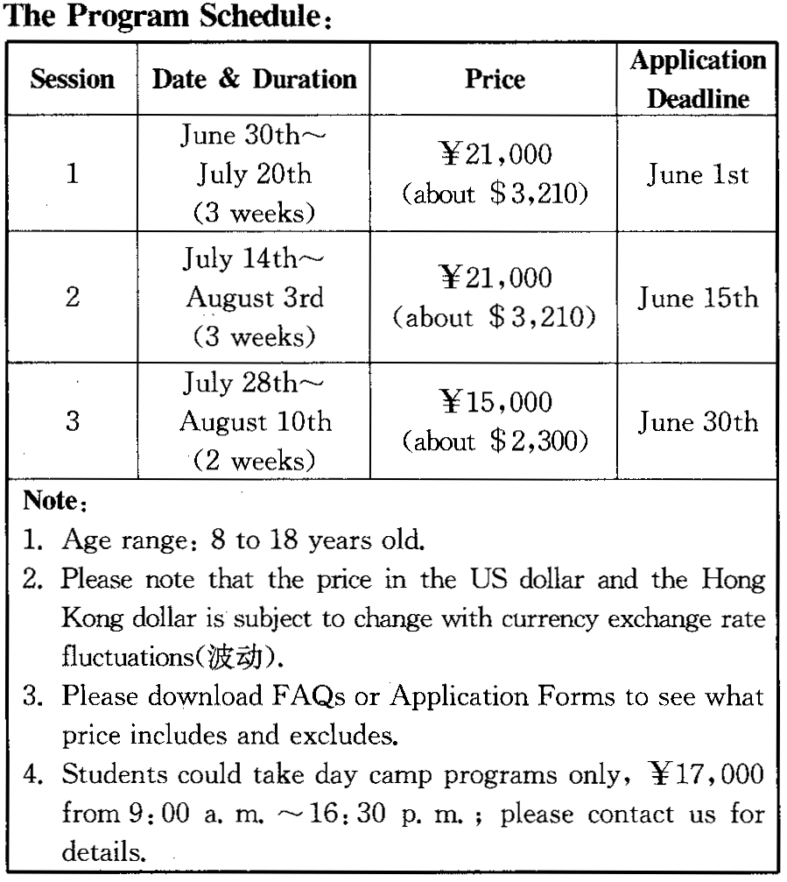

Discount Policy:
●￥1,000 off per student for early bird applications on or before March 31st;
●¥1,000 off per student for returning students;
●¥500 off per student for 2 family siblings;
●¥1,000 off per student for a group of 3 or above (siblings/friends).
Contact information: Ms Summer
E-mail : summer@richblcu . com
Tel: (+86) 10 8230-3067
29.What will campers do if they join in the program?
A. Study together with some college teachers.
B. Have a chance to improve their confidence.
C. Spend more time learning Chinese.
D. Have each meal in four-star hotels every day.
30.When should all the applications be submitted at the latest?
A. By late July. B. By late August. C. By late March. D. By late June.
31.What should we do to save some money according to the discount policy?
A. Attend the program with three or more students.
B. Hand in our applications as early as we can.
C. Make a trip with all our family members.
D. Come back to the program in a limited time.

D
In Antarctica, you learn not to take anything for granted. Everything people depend on has to be shipped or flown into the continent. Why? There are no farms on the icy continent. There are certainly no cows, pigs or chickens. As for drinking water, special systems and a great deal of energy are needed to take the salt out of seawater to make it useable.
Then there is the matter of waste. The US Antarctic Program is committed (致力于) to reducing its impact- or footprint--on the Antarctic environment. That means that every bit of garbage a person might produce in a day has to be transported off the continent. That's true whether it's the wrapper from your candy bar, the green beans you didn't want to eat or the paper towels you used to wipe your hands,
McMurdo Station has put into place technology that helps it reduce its footprint. It starts with energy. The US research base has partnered its nearby neighbor, New Zealand's Scott Base, to share energy produced from three large wind turbines. Scott Base gets 100% of its power from wind, says Ron Blevins, manager at a power plant, while the American base gets about 35% of its energy from wind. The much larger US base uses oil-fired generators(发电机) to supply the rest of its energy needs. The waste heat produced by the generators is then used to warm many of its buildings.
The McMurdo base also has a wastewater treatment plant. Yubecca Bragg, an organic farmer, manages the treatment plant. Bragg explains that treatment depends on allowing microorganisms(微生物) to break down the waste until the liquid part of the waste can be safely released into the ocean. Between 150, 000 and 180,000 pounds a year of the remaining solid waste is packed into containers and sent back to the US.
- We can learn from the first paragraph that .
A. farmers have to raise cows in Antarctica
B. people like taking the ships in Antarctica
C. it is not easy to live in Antarctica
D. water in Antarctica is useless at all
33.How do people in Antarctica deal with the solid garbage?
A. They have it taken away later. B. They wrap it in the paper towels.
C. They ignore it completely. D. They keep it in the dustbins.
34.It can be inferred from Ron Blevins’ words that .
A. the US base gets its most energy from wind
B. the US base doesn't need too much energy
C. Scott Base tries to remove its footprint
D. New Zealand's technology is advanced
35.Which of the following is harmful to the environment of Antarctica?
A. The large wind turbine. B. An oil-fired generator.
C. A wastewater treatment plant. D. Scott Base's power plant.
第二节（共5小题，每小题2分，满分10分）
The word “addiction” usually makes you think of alcohol or drugs.? 36 Some people are compulsive (难以自制的) shoppers. Others find it impossible to pull themselves away from their work. Still others spend countless hours watching TV or playing computer games.
_ 37 Many people enjoy going to malls or stores more and more every day, but it’s more than a common hobby for some of them. They have turned into shopaholics(购物狂). They are people who simply enjoy shopping and walking around spending money without being able to stop doing it. They are hooked(吸引) on shopping and usually buy things that they don’t need. Even though they don’t have enough money, they buy everything they want.
38 There isn't a specific answer. Some people go shopping when they are sad, worried, upset or lonely and they want to feel better. They use this activity as a way to forget their problems. Shopaholics say that they feel more important and better after they buy something. 39 .
Shopaholism seems to be a harmless addiction, but it can bring out problems. Some of them can be psychological. If this is the case, people addicted to shopping should go to a support group to help them break this habit. However, the process, like for most addictions, is long, and they suffer a lot. 40__ They just think about satisfying their feelings, so they spend money they don’t have. They get deep in debt, and they can even go bankrupt(破产的) and get sent to prison.
A.Once you are addicted to alcohol or drugs, it is difficult to get rid of.
B. Over the years, shopping has become a very common activity.
C. People addicted to computer games consider the games as great ways to amuse themselves.
D. However, in modern society we are seeing some new kinds of addictions.
E. The question is, why do they have this addiction?
F. They also tend to have this addiction when they feel guilty.
G. It can also cause financial problems
第三部分：英语知识运用（共两节，满分45分）
第一节：完形填空（共20小题，每小题1.5分，满分30分）
阅读下列短文，从每题所给的四个选项（A、B、C、D）中，选出最佳选项，并在答题卡上将该项涂黑。
Leonardo da Vinci began painting the Mona Lisa in 1503. He was working 41 a special painting for a church at that time, 42 the church painting was not 43 well. An Italian businessman asked da Vinci to paint a picture of his second 44 . This is the woman who 45 be seen in the Mona Lisa.
All in all, the Mona Lisa is a very good example of da Vinci's 46 , and it satisfied the husband. Da Vinci used 47 and light in a clever 48 in the painting.
Da Vinci loved science and 49 Right away a person can see that there is a lot of geometry(几何形状) in the Mona Lisa. The face of the Mona Lisa is made of many circles and 50 shapes like 51 . Even her 52 can be seen as a small part of a large circle.
The woman in the 53 is sitting on a balcony (阳台), and 54 can be seen behind her because Da Vinci loved to study rocks, and these can be seen 55 in his other paintings. The woman is sitting with her knees 56 the side. Her head is turned to look out of the painting. Her hands are 57 together in front of her. This way of 58 is now used by many 59 when they are 60 . The Mona Lisa is a remarkable master.
41．A．about B．up C．in D．on
42．A．so long as B．but C．in spite of D．however
43．A．working B．doing C．going D．making
44．A．wife B．servant C．daughter D．nurse ziyuanku.com
45．A．can B．must C．should D．might
46．A．novels B．photos C．works D．masterpiece
47．A．darkness B．oils C．heaviness D．blank
48．A．hand B．eye C．way D．picture
49．A．geography B．biology C．chemistry D．maths
50．A．long B．circular C．square D．round
51．A．cigars B．packets C．diamonds D．balls
52．A．emotion B．pattern C．preference D．smile
53．A．painting B．cottage C．exhibition D．canvas
54．A．sparrow B．mountains C．landscape D．kitten
55．A．that’s to say B．over and over C．on the other hand D．by and by
56．A．on B．by C．to D．beyond
57．A．hung B．caught C．held D．supported
58．A．sitting B．painting C．living D．smiling
59．A．models B．females C．bridegrooms D．brides
60．A．played B．being painted C．painting D．being played 第二节：语法填空（共10小题，每小题1.5分，满分15分）
Dear brother,
I'm now writing to you for your advice. How I wish you 61 (be) here with me!
Yesterday afternoon,I went to a bookstore with one of my friends. After we went out, he showed me 62 book he had stolen, 63 (consider)he was wrong, I suggested he 64 (go)back to return it or pay for it. 65 he didn’t listen to me, otherwise I wouldn’t have reported it to his mother.
Now I’m really 66 (regret). I would rather I 67 (not let)his mother know it. Ater all, he is my friend, without 68 help, I wouldn’t have made so rapid progress in study.
But 69 is now obvious that he has begun to hate me. It seems as if we hadn’t been friends before. Can you advise what I should do now?
70 (be) you in my position, what would you do?I hope you can give me some advice as soon as possible.资*源%库
第四部分：写作（共两节，满分35分）
- ：短文改错（共10小题，每小题1分，满分10分）
假定英语课上老师要求同桌之问交换修改作文，请你修改你同桌写的以下作文。文中共有10处语言错误，每句中最多两处。每处错误仅涉及一个单词的增加、删除或修改。
增加：在缺词处加一个漏字符号（），并在其下面写出该加的词；
删除：把多余的词用斜线(＼)划掉；
修改：在错的词下划一横线，并在该词下面写出修改后的词。
注意：1.每处错误及其修改均限一词；
2.只允许修改10处，多肯（从第11处起）不计分。
Some questions have only one correct answer. These types of question are called closed questions. It test your understanding at basic level.... Other questions have more than one right answer, or do not have any wrong answers. These are called open-ended questions. They help you to think more deep about what you learned and to make pessonal judgements. They encourage discussion with other students or help you develop your English by new and challenging ways. Both types of question are useful, so you should take both kind of sentence seciously. When answer open-ended questions, don’t worry whether your answer is right or wrong.Every of answer that has been well thought out is a correct answer.资*源%库 ziyuanku.com
- ：书面表达（满分25分）
在学习global warming之后请你谈谈对the warming of the earth的认识，并谈谈作为一名在校高二学生你应该做哪些事情来保护环境。（至少三件事）

英语答案
1~5 BCACB 6~10 BACAA 11~15 BABCC 16~20 CACAC
21-24CABD 25-28DACA 29-31BDA 32-35CACB 36-40DBEFG 41-45DBCAA
46-50CACDD 51-55DDABB 56-60CCAAB
- were 62.the 63.considering 64.(should)go 65.but
66.regretful 67.hadn’t let 68.whose 69.it 70.were
- It→They 72.ata basic level 73.deep→deeply
74.youhave learned 75.or→and 76.by→in
- kind→kinds 78.answer→answering 79.worryabout
80.Every of answer
书面表达：
As we all know, the earth is becoming warmer. During the 20th century the temperature of the earth rose about one degree Fahrenheit.This is a natural phenomenon. We needn’t worry about it.
There is no doubt that every individual can make a difference to improve our environment. As a middle school student, we should form a good habit of cleaning up our school yard and never throw away rubbish every where. And also it is ok to leave an electrical appliance on so long as we are using it—if not, turn it off. It’s important not to waste even a single grain of rice every meal.
There is a lot we can do to protect our earth. If every one contributes a bit, our earth will be better and better.

录音材料：
Text 1
W: Good evening, sir.Is there anything wrong?
M: I'm afraid there is.The service here has been terrible.We had to wait forty minutes for the soup and then it was stone cold.
Text 2
W: It sounds expensive.Why did they charge you so much for repairing the computer?
M: Well, it was $25 for labor to start with.A new modem cost another $50.On top of that I needed a new battery, and it cost $17.
Text 3
M: I got some bad news today.The store where I work is laying off staff.
W: Are they going to let you go?
Text 4
W: So what's new with you, Tom?
M: Well, I met a really nice woman.She works with my sister.We've been going out for a couple of months now and, well, things look good.
Text 5
M: Take a look at this catalogue.Maybe we can find some gifts for Jane's new house.
W: OK.But remember, we can't afford a lot.
Text 6
M: Hello, madam.What can I do for you?
W: My feet hurt.I think I need some new shoes.
M: What size do you wear?
W: (6)The last time I bought new shoes was about a year ago, and at that time, I was a 7.
M: Well, once you get to be in your twenties, your feet stop growing, so you are probably still a 7.But let's measure them just in case.
W: OK… So, what does it say?
M: Well, it looks like you're an 8.No wonder your feet have been hurting you.⑦You've been wearing shoes that are one size small!
Text 7
W: Whew! Thanks for stopping.Sometimes it can be impossible to get a cab in the rain.
M: No worries.Where to?
W: I'm going to Fifth Avenue and East 22nd Street.No rush at all, though.
M: ⑧Well, that's good because it looks like we're not going to be able to move more than a few feet per minute!
W: Well, that's what happens when it starts to rain during rush hour.I'm one of the lucky ones.Usually, I would have an appointment around this time, (9)but today I get to go home early!
M: That's great, madam.(9)I'll try to get you home as early as possible.
Text 8
W: You've packed so many clothes, Ben!
M: Well, it is a business trip, and the weather will be different everywhere I go.
W: I suppose on Sunday you'll travel in your jeans.
M: Yes.Then on Monday I'm going to meet the company boss, so I'll need my suit then.I can't wear jeans.
W: (10)What is happening on Tuesday?
M: (10)I'm visiting a factory in the south, so I've packed these grey trousers.They're light and I won't need a jacket.It'll be 35 degrees.
W: Oh! (11)Then you're in the mountains on Wednesday.
M: (11)Yes.A jacket won't be warm enough.I've got my coat for that day.
W: Are you taking a sweater as well?
M: There isn't room in the suitcase.On Thursday I'll be by the sea where we spent our honeymoon, so I'm taking my swim shorts.
W: (12)And what about Friday?
M: I'm having lunch with some colleagues.(12)I'll wear that blue shirt you bought me.Look! Here it is, under the suit.
W: Oh, good.
Text 9
M: Susan, I could really use your help this weekend.
W: What is it, John? Another term paper?
M: No, no.This is easy compared to that.My cousin is coming on Thursday.She has an interview at the college and I promised my aunt I'd look after her.(13)We are going to the game on Friday, (14)but on Saturday I'm on duty at the library all day and can't get out of it.Uh, I was wondering if you could show her around during the day and maybe we can all meet for dinner later.
W: Sure.I don't have any plans.What kind of things does she like to do?
M: (15)Actually I haven't seen her for three years.She lives so far away.But this will be her first time on a college campus; she is still in high school.So she probably enjoys anything on campus.
W: Well, there is a music festival in the auditorium(礼堂).That's a possibility.(16)Only I hope it doesn't snow.They are predicting 68 inches for the weekend.Everything will be closed down then.
M: Well, how about, for the time being, planning on dropping her off at your place on my way to work, around eleven? But if there is a snowstorm, I'll give you a call and see if we can figure something else out.
W: Sounds good.(16)We can touch base(再次联系) on Friday night when we have a better idea of the forecast.
M: I hope this works out.
Text 10
W: Now class, I'd like to tell you all about your final examination next week.As you know, the test will cover everything we have learned this year from the start of the term all the way until our last unit.That might sound like a lot of material to study, so I have some tips that I will share with you.
First, plan ahead.Do not wait until the night before the test to start reviewing.That will not work and you will be very upset with your results.We have a total of eight units.I suggest studying one unit every night for the next week.(17)We have ten days until the exam so you will have plenty of time if you choose to do it this way.
(18)Second, focus on studying only the most important topics we've discussed.Studying is mostly about using your time well.You cannot possibly remember everything so just review the main points.
(19)The two days before the exam will be review sessions where we will review together in class.(20)Please prepare any questions you have for those days.Otherwise, I will be available during lunch and after school for one hour every day until the exam.Good luck and keep a positive attitude.Success is what you make of it.

