未 考 先 知
——2018年高考英语全国卷信息归集与高考命题预测
一、高考信息归集
1.命题要求变化
2018年考纲说明稳定无变，2018年英语科高考命题将继续体现我国高考“一体四层四翼”的高考评价原则。基于高考真题研究和评价并综合我处和其他高考研究专家对2018年高考英语命题趋势做出提示，信息仅供参考。
（1）命题形式：从考纲说明推断，第三部分第二节（语法填空）命题素材仍为短文形式。
（2）考查方式：阅读理解推断题可能不仅限于简单推断类，而体现较高思维层次的推断。
2.考试中心领导同志重要讲话《牢记立德树人使命 写好教育考试奋进之笔》
2018年3月3日，教育部考试中心党委书记刘桔与教育部考试中心主任姜钢在《中国教育报》（2018年3月3日第5版）发表重要讲话， 这是学习贯彻党的十九大精神司局长笔谈系列之一，要求用党的十九大精神统领高考命题工作，全面落实立德树人要求，充分认识高考内容改革必须坚持把立德树人作为中心环节的极端重要性，把总书记提出的“四个坚持”和“四个服务”作为高考命题工作的基本遵循，把握好人才培养和人才选拔规律，使其贯穿于高考全过程，全面提升高考的育人功能和导向作用。坚持正确方向，就是要把党的十九大精神贯彻落实到参与命题的全体教师和全部学科中，确保命题工作政治方向不偏、政治纪律不懈；坚持立德树人，就是要通过考试内容的改革，引导学生树立正确的世界观、人生观、价值观，正确认识世界和中国发展大势；坚持服务大局，就是要紧紧围绕“提高教育质量”这一战略主题，在高考命题中去谋划、去设计、去实施；坚持改革创新，就是要把党的教育方针和人才培养的重点任务细化、实化、具体化，既为高考考试内容改革和高校选才提供科学的标准，又有力引导中学推进素质教育，创新落实立德树人根本任务的途径和载体。
二、高考考情报告
1.高考命题素材多元化，体裁多样化。
2.命题素材体现思想意义，落实立德树人。
3.弘扬中华优秀文明，引导树立民族自信。
4.试卷追求科学严谨，全面考查语言能力，引导核心素养教育。
三、高考命题预测
1.命题素材体现传统文化，在语境中考查知识
命题规划重视语境设置，突出考查考生在不同语境下对词汇、句法和语篇的理解和运用能力。 试题的语境化设计可体现在各种题型的设计中，特别是从2014年开始引入的新题型--语法填空，更加明显地体现了在语境中考查语法基础知识的特点。
例1：全国大联考 2018届高三第一次联考
语法填空
The Comac C919 is a narrow-body twinjet airliner ______(61) develop by Chinese aerospace manufacturer Comac. The C stands 62 "COMAC" and "China", 9 means "forever" (天长地久) in Chinese, while 19 refers to its 190 passengers capacity. It is powered by CFM International LEAP turbofan engines 63 can carry 156 to 168 passengers for up to 5,555 km.
Its announced development budget is 58 billion yuan ($9.5 billion) but its actual cost 64 （estimate）at well over $20 billion. The plane was expected to be produced in 2014 and perform its first flight in 2015; however, delivery was delayed again due to 65 (technique) difficulties and supply problems. At the November 2014 Zhuhai Airshow, it was announced 66 the first flight would be delayed to 2017. On 2 November 2015, Comac rolled out its first C919 aircraft. High-speed taxi(滑行) tests were completed in April 2017, with its first flight 67 (take) place on 5 May 2017. Comac has a planned test programme of 4,200 flight 68 (hour) and introduction to service in 2020 with China Eastern Airlines.
It is intended 69 (compete) with the Boeing 737 MAX and Airbus A320neo. As of November 2016, 570 aircraft 70 (order) from 23 customers, mostly Chinese customers.
2. 保持素材语言的真实性
学习语言和进行语言测试时，命题者选取一些情景真实、语言地道的语言材料，这样才能够真正体会到该语言承载的文化。本着这一原则，命题者会尽力保持所选材料的“原汁原味”，同时结合考生群体的实际水平，按照考生水平进行合理的简化或改写。
例2：全国大联考 2018届高三第四次联考
阅读理解
A
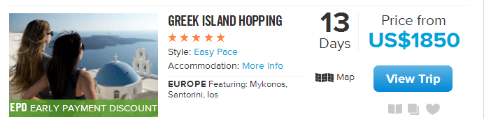
Most travellers feel lucky to get a quick ferry stop at an island like Santorini. But small samples aren't the Greek Island Hopping style. With 3-nights in Mykonos, Ios, Santorini & Athens, you'll have plenty of time to explore charming fishing villages, shops, volcanoes & spotless beaches, getting deep beyond the ouzo(茴香酒) and the olives and the ancient statues.
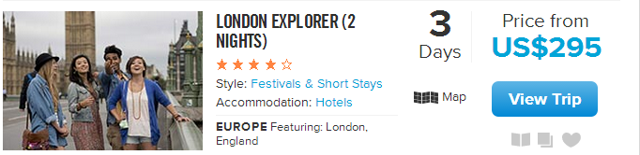
The gateway to Europe can be a network of confusion for the new kid in town. Skip the weeks of struggling with maps, catching wrong trains, & accidentally eating at all the wrong places with Contiki's London Explorer. Including the essential open top bus tour, a ticket to the theatre and a new crowd to explore with, you'll be feeling like a London local in no time.
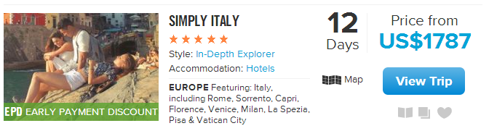
12-days floating around Italy --- now there's an idea! Learn to make pizza, watch the complicated art of Italian leather, and enjoy Chianti & antipasto at a 16th century Tuscan winery. Rome, Florence, Milan, Venice and beyond…
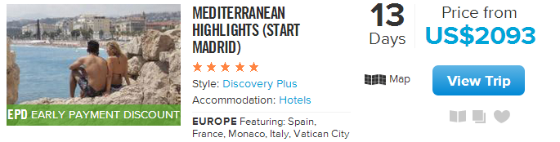
If you're quite fond of beautiful beaches, sunset cocktails and eating enough fine food to sink a small yacht(游艇), then congratulations! You are human. And you're going to love the Contiki Mediterranean Highlights. Kicking off in Madrid, we will sail to Barcelona then around the French Riviera before getting very well familiar with the best spots in Italy.
21. Which column of a website does the selection come from?
A. News. B. Geography. C. Travelling. D. Advertisements.
22. If Mr Black is interested in wine making, which would he most probably choose?
A. GREEK ISLAND HOPPING. B. LONDON EXPLORER.
C. SIMPLY ITALY. D. MEDITERRANEAN HIGHLIGHTS.
23. Which of the following makes MEDITERRANEAN HIGHLIGHTS different from others?
A. Covering several countries. B. Possessing beach scenery.
C. Presenting local lifestyle. D. Taking longest time.

3.试卷内容贴近时代，贴近生活，素材符合考生认知水平
从历年的高考英语试卷可以看出，从试卷中的听力、完形填空、阅读和书面表达等，各部分的选材尽量体现以上原则。如果考生知识面较广，对这些内容的背景知识有一定程度的了解，会在阅读中占领先机。
例3：2018届全国100所名校最新高考模拟示范卷 英语卷（一）
语法填空题型
第三部分：英语知识运用（共两节，满分45分）
第二节（共10小题；每小题1.5分，满分15分）
阅读下面材料，在空白处填入适当的内容（1个单词）或括号内单词的正确形式。
No one knows 61 the first kite was made．The first record of a kite was more than 2，000 years ago in China.
Kites 62 （fly）in Japan for hundreds of years．In the 1700s，kites were flown in autumn to give thanks for a good harvest．They were also flown to send good wishes to couples 63 had their first son．Today in Japan，kites are often flown as part of a 64 (celebrate) ，such as the beginning of a new year．And kite festivals are held each year in many parts of the country．
Kites have been used for 65 (science) purposes in the western world．In 1752，Benjamin Franklin 66 (tie) a key to a kite and flew it in a storm to find out 67 lightening was a form of electricity．From 1898 until 1933，the United States Weather Bureau used box kites 68 (collect) weather data．The Wright brothers also experimented with kites．What they learnt 69 (help) them make 70 first airplane flight in 1903.
4.素材体现对核心素养的蕴涵式考查和引导，传递课程改革理念
部分素材的选取特别注重对目的语国家社会生活和文化知识的介绍和传递，体现文化内涵。部分素材可能体现情感和正面价值观等思想，体现英语教学的教育性。
例4：全国大联考 2018届高三第一次联考
完形填空
第三部分 英语知识运用（共两节，满分45分）
第一节 完形填空（共20小题；每小题1.5分，满分30分）
阅读下面短文，从短文后各题所给的A、B、C和D四个选项中，选出可以填入空白处的最佳选项。
http://www.rd.com/true-stories/inspiring/grandfather-granddaughter-memory-books/
Some teens dream of a new car or a big party for their sweet 16. __41__, one grandfather spent years making a much more __42__ gift for his granddaughter.
When Lauren Blank was __43__ two years old, her grandpa __44__ taking notes every time they got to spend time together. He kept the __45__ up until she was five years old, __46__ three notebooks over the three years.
On Blank’s 16th birthday, her grandfather believed she was old enough to fully __47__ the meaning behind the notebooks, so he gave them to her as a present. When Blank __48__ what the gift was, she was in total __49__. “Then I could hardly hold my feelings. I was really __50__ by the gift,” she says. The rest of her family was just as surprised __51__ her grandpa hadn’t told anyone about his plan.
Blank posted a __52__ of the present on Twitter, and up to now the tweet has received more than 600,000 __53__.
The notebook entries detailed __54__ things Blank had said or done, __55__ her feelings to really connect her memories to how she was. Her grandpa recorded his __56__ of the two of them laughing and playing made-up games. “Throughout the stories he would __57__ add how much he loved and cared for me,” says Blank.
Blank says she will __58__ the gift forever. In her opinion, it __59__ more than any other materialistic present. “The gift will forever be the greatest gift I have __60__ because of how much value and meaning it has behind it,” she says.
41. A. Besides B. Instead C. However D. Therefore
42. A. formal B. expensive C. instructive D. thoughtful
43. A. therefore B. still C. yet D. anyway
44. A. started B. risked C. imagined D. remembered
45. A. hobby B. discipline C. habit D. interest
46. A. taking up B. filling up C. giving up D. breaking up
47. A. stress B. evaluate C. express D. appreciate
48. A. realized B. guessed C. admitted D. announced
49. A. secret B. panic C. terror D. shock
50. A. freezed B. moved C. confused D. embarrassed
51. A. because B. though C. until D. while
52. A. part B. form C. picture D. cover
53. A. tips B. likes C. rewards D. agreements
54. A. absurd B. complex C. random D. specific
55. A. along with B. except for C. owing to D. regardless of
56. A. judgments B. conclusions C. memories D. impressions
57. A. unintentionally B. deliberately C. immediately D. repeatedly
58. A. treasure B. recognize C. promote D. decorate
59. A. charges B. functions C. means D. affects
60. A. known B. received C. deserved D. expected
5.书面表达
新课标高考注重对考生写作能力的有效考查。话题贴近考生生活经历和认知水平，为了保证测试公平，多从日常生活中寻找命题情境的切入点。在设计形式方面，为了尽量提高信度，命题者尽力在开放性和控制性间谋求最佳平衡点。

例5：2018届全国100所名校最新高考模拟示范卷 英语卷（七）
第二节 书面表达（满分25分）
假定你是李华，你校特邀武汉大学的张教授来校举行一场有关孟子（Mencius）的讲座。请给你校外教Jack发一封电子邮件，邀请他听讲座。内容包括：
1. 时间和地点；
2. 内容：介绍孟子思想；
3. 听讲座前准备：简要了解孟子。
注意：
1.词数100左右；
2.可以适当增加细节，以使行文连贯。
例6：2018届第一次百万联考
假定你是李华。周末你市一家剧院将举办一场京剧演出，外教Jackson 对此很感兴趣并向你打听相关事宜，请你用英语给他写封邮件，内容包括：
- 中国京剧简要介绍；
- 演出内容：京剧名段；
- 邀请他一同前往观看。
注意：
- 词数100左右；
- 可以适当增加细节，以使行文连贯。
例7：2018届第二次百万联考
假定你是李华。你的美国网友Jane擅长中文，喜欢中国小品（sketch）。最近他打算学习演小品，特发邮件来向你请教相关事宜。就此请用英语给他回一封邮件，主要内容包括：
- 简要介绍小品；
- 表演小品的注意事项；
- 给出相应建议。
注意：
1. 词数100左右；
2. 可适当增加细节，以使行文连贯。
例8：2018届第四次百万联考
假定你是李华，你的美国朋友Peter春节期间来到北京旅游，欢乐祥和的春节气氛让他对春联（Spring Festival couplets）产生了浓厚兴趣。上周他来信要求你就春联的相关事情进行简要介绍。就此请你用英语写一封回信，为他介绍春联的用途、内容和寓意等。
注意：
1. 总词数100左右；
2. 可适当增加细节以使行文连贯。

欢迎访问“高中试卷网”——http://sj.fjjy.org

