绝密★启封前 试卷类型A
2017年普通高等学校招生全国统一考试（新课标I）
英 语
（考试时间120分钟 试卷满分150分）
注意事项
1.本试卷由四个部分组成。其中，第一、二部分和第三部分的第一节为选择题。第三部分的第二节和第四部分为非选择题。
2.答卷前，考生务必将自己的姓名、准考证号填写在答题卡上。
3.回答选择题时，选出每小题答案后，用2B铅笔把答题卡上对应题目的答案标号涂黑；回答非选择题时，将答案写在答题卡上，写在本试卷上无效。
4.考试结束后，将本试卷和答题卡一并交回。
第一部分 听力(共两节，满分30分)
做题时，先将答案标在试卷上。录音内容结束后，你将有两分钟的时间将试卷上的答案转涂到答题卡上。
第一节 （共5小题；每小题1.5分，满分7.5分）
听下面5段对话。每段对话后有一个小题，从题中所给的A、B、C三个选项中选出最佳选项，并标在试卷的相应位置。听完每段对话后，你都有10秒钟的时间来回答有关小题和阅读下一小题。每段对话仅读一遍。WWW.ziyuanku.com
例How much is the shirt?
A. £ 19. 15. B. £ 9. 18. C. £ 9. 15.
答案是 C。
1.What does the woman think of the movie?
A.It’s amusing B.It’s exciting C.It’s disappointing
2.How will Susan spend most of her time in France?
A. Traveling around B.Studying at a school C.Looking after her aunt
3.What are the speakers talking about?
A. Going out B.Ordering drinks C.Preparing for a party
4.Where are the speakers?
A.In a classroom B.In a library C.In a bookstore
5.What is the man going to do ?
A.Go on the Internet B.Make a phone call C.Take a train trip
第二节 （共15小题；每小题1.5分，满分22.5分）

听下面5段对话或独白。每段对话或独白后有几个小题，从题中所给的A、B、C三个选项中选出最佳选项，并标在试卷的相应位置。听每段对话或独白前，你将有时间阅读各个小题，每小题5秒钟；听完后，各小题将给出5秒钟的作答时间。每段对话或独白读两遍。
听第6段材料，回答第6、7题。
6. What is the woman looking for?
A. An information office B.A police station C.A shoe repair shop
7. What is the Town Guide according to the man?
A. A brochure B.A newspaper C.A map
听第7段材料，回答第8、9题。
8.What does the man say about the restaurant?
A.It’s the biggest one around.
B.It offers many tasty dishes.
C. It’s famous for its seafood.
9.What will the woman probably order?
A.Fried fish. B.Roast chicken. C.Beef steak.
听第8段材料，回答第10至12题。
10.Where will Mr. White be at 11 o’clock?
A.At the office. B.At the airport. C.At the restaurant.
11.What will Mr. White probably do at one in the afternoon?
A.Receive a guest. B.Have a meeting. C.Read a report.
12.When will Miss Wilson see Mr. White?
A.At lunch time B.Late in the afternoon. C.The next morning.
听第9段材料，回答第13至16题。
13.Why is Bill going to Germany?
A.To work on a project. B.To study German. C.To start a new company.
14.What did the woman dislike about Germany？
A.The weather. B.The food. C. The schools.
15. What does Bill hope to do about his family？
A.Bring them to Germany.
B.leave them in England.
C.Visit them in a few months.
16. What is the probable relationship between the speaker?
A. fellow-travelers
B.Colleagues.
C.Classmates.
听第10段材料，回答第17至20题。
17.When did it rain last time in Juarez?
A.Three days ago.
B.A month ago.
C.A year ago.
18. What season is it in Juarez?
A.Sping.
B.Summer
C.Autumn
19.What are the elderly advised to do?
A.Take a walk in the afternoon.
B.Keep their homes cool.
C.Drink plenty of water.
20.What is the speaker doing?
A.Hosting a radio program.
B.Conducting a seminar.
C.Forecasting the weather.
第二部分 阅读理解(共两节，满分40分)
第一节 (共15小题；每小题2分，满分30分)中·华.资*源%库 ziyuanku.com
阅读下列短文，从每题所给的A、B、C和D四个选项中，选出最佳选项，并在答题卡上将该项涂黑。
A
Pacific Science Center Guide
◆Visit Pacific Science Center’s Store
Don’t forget to stop by Pacific Science Center’s Store while you are here to pick up a wonderful science activity or remember your visit. The store is located(位于) upstairs in Building 3 right next to the Laster Dome.
◆Hungry
Our exhibits will feed your mind but what about your body? Our café offers a complete menu of lunch and snack options, in addition to seasonals. The café is located upstairs in Building 1 and is open daily until one hour Pacific Science Center closes.
◆Rental Information
Lockers are available to store any belongs during your visit. The lockers are located in Building 1 near the Information Desk and in Building 3. Pushchairs and wheelchairs are available to rent at the Information Desk and Denny Way entrance. ID required.
◆Support Pacific Science Center
Since 1962 Pacific Science Center has been inspiring a passion(热情) for discovery and lifelong @ in science, math and technology. Today Pacific Science Center serves more than 1.3 million people a year and beings inquiry based science education to classrooms and company events all over Washington State. It’s an amazing accomplishment and one we connect science without generous support from individuals, corporations, and other social organizations. Wish pacificorganzier.org to find various ways you can support Pacific Science Center.中·华.资*源%库 ziyuanku.com
21.Where are you buy a at Science Center?
A.In Building 1.
B. In Building 3.
C.At the last Denny.
D.At the Denny Way entrance.
22.What does Pucific Science Center do for schools?
A.Traitn Scicnce teachers.
B.Disncie scicnce books.
C. Disncie scicnctific research.
D.Take scicnce to the classroom.
23.What is the purpose of the last part of the text?
A.To encourage donations.
B.To advertise coming events.
C.To introbace spocial exhibits.
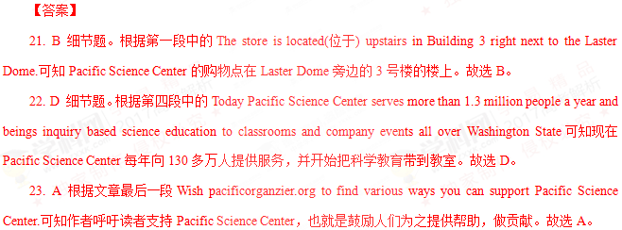
B
I work with Volunteers for Wildlife, a rescue and education organization at Bailey Arboretum in Locust Valley. Trying to help injured, displaced or sick creatures can be heartbreaking; survival is never certain. However, when it works, it is simply beautiful.
I got a rescue call from a woman in Muttontown. She had found a young owl(猫头鹰) on the ground. When I arrived, I saw a 2-to 3-week-old owl. It had already been placed in a carrier for safety.
I examined the chick(雏鸟) and it seemed fine. If I could locate the nest, I might have been able to put it back, but no luck. My next work was to construct a nest and anchor it in a tree.
The homeowner was very helpful. A wire basket was found. I put some pine branches into the basket to make this nest safe and comfortable. I placed the chick in the nest, and it quickly calmed down.
Now all that was needed were the parents, but they were absent. I gave the homeowner a recording of the hunger screams of owl chicks. These advertise the presence of chicks to adults; they might also encourage our chick to start calling as well. I gave the owner as much information as possible and headed home to see what news the night might bring.
A nervous night to be sure,but sometimes the spirits of nature smile on us all! The homeowner called to say that the parents had responded to the recordings. I drove over and saw the chick in the nest looking healthy and active. And it was accompanied in the nest by the greatest sight of all — LUNCH！The parents had done their duty and would probably continue to do so.
24.What is unavoidable in the author’s rescue work according ro paragraph 1?
A.Efforts made in vain.
B.Getting injured in his work.
C.Feeling uncertain about his future.
D.Creatures forced out of their homes.
25.Why was the author called to Muttontown?
A.To rescue a woman.
B.To take care of a woman.
C.To look at a baby owl.中·华.资*源%库 ziyuanku.com
D.To cure a young owl.
26.What made the chick calm down?
A.A new nest.
B.Some food.
C.A recording.
D.Its parents.
27.How would the author feel about the outcome of the event?
A.It’s unexpected.
B. It’s beautiful.
C. It’s humorous.
D. It’s discouraging.
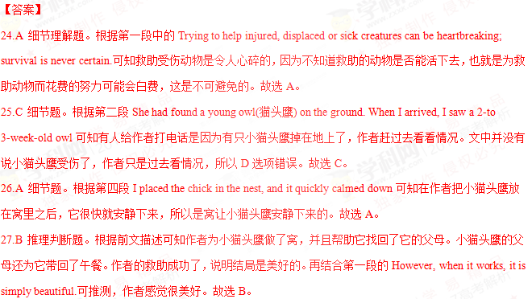C
Some of the world’s most famous musicians recently gathered in Paris and New Orleans to celebrate the first annual International Jazz Day. UNESCO( United Nations Educational, Scientific and Cultural Organization) recently set April 30 as a day to raise awareness of jazz music, its significance, and its potential as a unifying(联合) voice across cultures.
Despite the celebrations, though, in the U.S. the jazz audience continues to shrink and grow older, and the music has failed to connect with younger generations.
It’s Jason Moran’s job to help change that. As the Kennedy Center’s artistic adviser for jazz, Moran hopes to widen the audience for jazz, make the music more accessible, and preserve its history and culture.
“Jazz seems like it’s not really a part of the American appetite,” Moran tells National Public Radio’s reporter Neal Conan. “What I’m hoping to accomplish is that mu generation and younger start to reconsider and understand that jazz is not black and write anymore. It’s actually color, and it’s actually digital.”
Moran says one of the problems with jazz today is that the entertainment aspect of the music has been lost. “The music can’t be presented today the way it was in 1908 or 1958. It has to continue to move, because the way the world works is not the same,” says Moran.
Last year, Moran worked on a project that arranged Fats Waller’s music for a dance party, “Just to kind of put it back in the mind that Waller is dance music as much as it is concert music,” says Moran. “For me, it’s the recontextualization. In music, where does the emotion(情感) lie? Are we, as abstract as a Charlie Parker record gets us into a dialogue about our emotions and our thoughts? Sometimes we lose sight that the music has a wider context,” says Moran, “So I want to continue those dialogue. Those are the things I want to foster.”
28．Why did UNESCO set April 30 as International Jazz Day?
A．To remember the birth of jazz.
B．To protect cultural diversity.
C．To encourage people to study music.
D．To recognize the value of jazz.
29．What does the underlined word “that” in Paragraph 3 refer to?
A．Jazz becoming more accessible.
B．The production of jazz growing faster.
C．Jazz being less popular with the young.
D．The jazz audience becoming larger.
30．What can we infer about Moran’s opinion on jazz?
A．It will disappear gradually.
B．It remains black and white.
C．It should keep up with the times.
D．It changes every 50 years.
31．Which of the following can be the best title for the text?
A．Exploring the Future of jazz.
B．The Rise and Fall of jazz.
C．The Story of a jazz Musician.
D．Celebrating the Jazz Day.
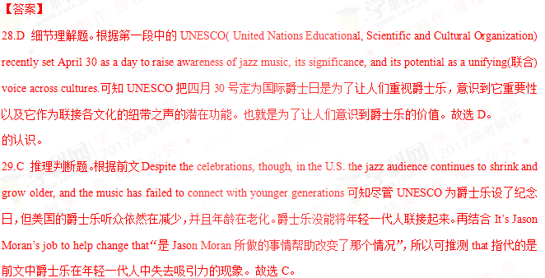30.C 细节理解题。根据第五段中的The music can’t be presented today the way it was in 1908 or 1958. It has to continue to move, because the way the world works is not the same可知Moran认为爵士乐不能以1908或1958年的方式来表达当代，因为世界运转的方式不同，所以爵士乐必须继续前进才行。说明随着时代的发展，爵士乐也要跟上时代才不会被年轻一代所抛弃。故选C。
31.A 推理判断题。通读全文可知本文主要讲UNESCO为提高人们对爵士乐的重视设立爵士日，但实际收效甚微。有人认为爵士乐应随着时代的进步而进步，否则将失去吸引力。可知本文主要探索爵士乐的未来，故选A。
D
A buld-it-yourself solar still（蒸馏器） is one of the best ways to obtain drinking water in areas where the liquid is not readily available. Developed by two doctors in the U.S. Department of Agriculture, it’s an excellent water collector. Unfortunately, you must carry the necessary equipment with you, since it’s all but impossible to find natural substitutes. The only components required, though, are a 5’ 5’ sheet of clear or slightly milky plastic, six feet of plastic tube, and a container— perhaps just a drinking cup — to catch the water. These pieces can be folded into a neat little pack and fastened on your belt.中/华-资*源%库
To construct a working still, use a sharp stick or rock to dig a hole four feet across and three feet deep. Try to make the hole in a damp area to increase the water catcher’s productivity. Place your cup in the deepest part of the hole. Then lay the tube in place so that one end rests all the way in the cup and the rest of the line runs up — and out — the side of the hole.
Next, cover the hole with the plastic sheet, securing the edges of the plastic with dirt and weighting the sheet’s center down with a rock. The plastic should now form a cone(圆锥体) with 45-degree-angled sides. The low point of the sheet must be centered directly over, and no more than three inches above, the cup.
The solar still works by creating a greenhouse under the plastic. Ground water evaporates (蒸发) and collects on the sheet until small drops of water form, run down the material and fall off into the cup. When the container is full, you can suck the refreshment out through the tube, and won’t have to break down the still every time you need a drink.
32.What do we know about the solar still equipment from the first paragraph?
A.It’s delicate. B.It’s expensive.
C.It’s complex. D.It’s portable
33.What does the underlined phrase “the water catcher” in paragraph 2 refer to?
A.The tube B.The still
C.The hole D.The cup
34.What’s the last step of constructing a working solar still?
A.Dig a hole of a certain size B.Put the cup in place
C.Weight the sheet’s center down D.Cover the hole with the plastic sheet
35.When a solar still works, drops of water come into the cup form .
A.the plastic tube B.outside the hole
C.the open air D.beneath the sheet
【答案】
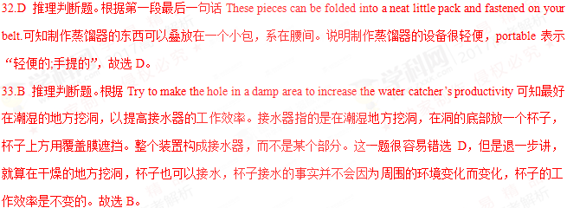34.C 细节题。根据第三段Next, cover the hole with the plastic sheet, securing the edges of the plastic with dirt and weighting the sheet’s center down with a rock.可知最后一步是weighting the sheet’s center down with a rock“放一块石头在覆盖膜的中间，把它压下去”，故选C。
35.D 推理判断题。结合第四段中的Ground water evaporates (蒸发) and collects on the sheet until small drops of water form, run down the material and fall off into the cup可知地下水蒸发，在覆盖膜上聚集起来直到形成小水滴落在杯子里。覆盖膜是在杯子上面的，水滴落入杯子里。所以水滴是凝聚在覆盖膜的下面。故选D。
第二节 (共5小题；每小题2分，满分10分)
根据短文内容，从短文后的选项中选出能填入空白处的最佳选项。选项中有两项为多余选项。
If anyone had told me three years ago that I would be spending most of my weekends camping. I would have laughed heartily. Campers, in my eyes, were people who enjoyed insects bites, ill-cooked meals, and uncomfortable sleeping bags. They had nothing in common with me. 36 Ziyuanku.com
The friends who introduced me to camping thought that it meant to be a pioneer.
37 We sleep in a tent, cooked over an open fire, and walked a long distance to take the shower and use the bathroom. This brief visit with Mother Nature cost me two days off from work, recovering from a bad case of sunburn and the doctor`s bill for my son`s food poisoning.
I was, nevertheless, talked into going on another fun-filled holiday in the wilderness.
38 Instead, we had a pop-up camper with comfortable beds and an air conditioner. My nature-loving friends had remembered to bring all the necessities of life.
39 We have done a lot of it since. Recently, we bought a twenty-eight-foot travel trailer complete with a bathroom and a built-in TV set. There is a separate bedroom, a modern kitchen with a refrigerator. The trailer even has matching carpet and curtains.
40 It must be true that sooner or later, everyone finds his or her way back to nature. I recommend that you find your way in style.
A．This time there was no tent.
B．Things are going to be improved.
C．The trip they took me on was a rough one.
D．I was to learn a lot about camping since then, however.
E．I must say that I have certainly come to enjoy camping.
F. After the trip, my family became quite interested in camping.
G. There was no shade as the trees were no more than 3 feet tall.
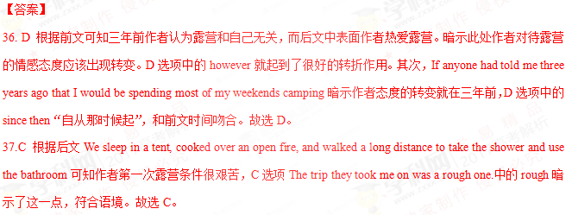38.A根据前文We sleep in a tent, cooked over an open fire, and walked a long distance to take the shower and use the bathroom可知作者第一次露营时住帐篷，露天生火做饭，走很远的距离去洗澡上厕所，条件很艰苦。而后文中Instead, we had a pop-up camper with comfortable beds and an air conditioner. 说明作者第二次露营有床有空调 A选项This time there was no tent“这次没有帐篷了”暗示作者进行了第二次露营，而且条件比较好，符合语境。故选A。
39.F 根据后文we bought a twenty-eight-foot travel trailer complete with a bathroom and a built-in TV set. There is a separate bedroom, a modern kitchen with a refrigerator. The trailer even has matching carpet and curtains.可知作者一家为了露营买了房车，里面设备齐全。既然花了这么大精力，说明作者一家人是喜欢露营的。F选项After the trip, my family became quite interested in camping“那次露营之后，我的家人开始对它感兴趣”符合语境，故选F。
40.E 根据后文It must be true that sooner or later, everyone finds his or her way back to nature. I recommend that you find your way in style.可知作者希望每个人能找到适合自己的回归自然的方法，而根据前文可知作者回归
第三部分 语言知识运用(共两节，满分45分)
第一节 完形填空(共20小题；每小题1.5分，满分30分)
阅读下面的短文，从短文后各题所给的A、B、C和D四个选项中，选出可以填入空白处的最佳选项，并在答题卡上将该项涂黑。
While high school does not generally encourage students to explore new aspects of life,college sets the stage for that exploration. I myself went through this 41 process and found something that has changed my 42 at college for the betterI discovered ASL-American Sign Language(美式手语).
I never felt an urge to 43 any sign language before.My entire family is hearing,and so are all my friends.The 44 language were enough in all my interactions(交往).Little did I know that I would discover my 45 for ASL.
The 46 began during my first week at college. I watched as the ASL Club 47 their translation of a song. Both the hand movements and the very 48 of communicating without speaking 49 me. What I saw was completely unlike anything I had experienced in the 50 .This newness just left me 51 more.
After that, feeling the need to 52 further, I decided to drop in on one of ASL club`s meetings. I only learned how to 53 the alphabet that day. Yet instead of being discouraged by my 54 progress,I was excited. I then made it a point to 55 those meetings and learn all I could.
The following term, I 56 an ASL class. The professor was deaf and any talking was 57 . I soon realized that the silence was not unpleasant. 58 , if there had been any talking, it would have 59 us to learn less. Now, I appreciate the silence and the 60 way of communication it opens.
41. A. searching B. planning C. natural D. formal
42. A. progress B. experience C. major D. opinion
43. A. choose B. read C. learn D. create
44. A. official B. foreign C. body D. spoken
45. A. love B. concern C. goal D. request
46. A. meeting B. trip C. story D. task
47. A. recorded B. performed C. recited D. discussed
48. A. idea B. amount C. dream D. reason
49. A. disturbed B. supported C. embarrassed D. attracted
50. A. end B. past C. course D. distance
51. A. showing B. acting C. saying D. wanting
52. A. exercise B. explore C. express D. explain
53. A. print B. write C. sign D. count
54. A. slow B. steady C. normal D. obvious
55. A. chair B. sponsor C. attend D. organize
56. A. missed B. passed C. gave up D. registered for
57. A. prohibited B. welcomed C. ignored D. repeated
58.A.Lastly B.Thus C.Instead D.However
59.A.required B.caused C.allowed D.expected
60.A.easy B.popular C.quick D.new
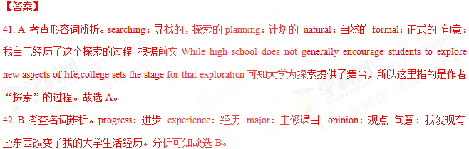43. C 考查动词辨析。choose选择 read看，读 learn学习 create创造 句意我以前从没有过学习手语的冲动 分析可知故选C。
44. D 考查形容词辨析。official官方的foreign外国的body肢体的spoken口语的 根据前文My entire family is hearing,and so are all my friends.可知作者的家人及朋友都可以听得到，作者认为在平时的交流中，再加上肢体语言就足够了。body language肢体语言 故选D。WWW.ziyuanku.com
45. A考查名词辨析。love热爱concern关心，顾虑 goal目标request请求 句意我没想过我会发现自己对美式手语的热爱。前文中I never felt an urge to learn any sign language before作者表明以前从未想过学习手语，而根据后文内容可知作者非常喜欢手语。故选A。
46. C 考查名词辨析。meeting会议 trip旅行story故事task任务 句意故事发生在我上大学的第一周 分析可知在这里作者开始讲述在大学学习手语的事情，故选C。
47. B 考查动词辨析。record记录 perform表现，表演 recite背诵discuss讨论 句意在ASL 俱乐部表演一首歌的翻译时，我正观看着。分析可知ASL 俱乐部是手语俱乐部，应该是在用手语表演一首歌。故选B。
48. A 考查名词辨析。idea想法amount数量dream梦想reason原因 句意手部的动作和不用语言进行交流的想法吸引了我 分析可知作者当时在看手语表演，而手语就是为了想借助手势进行交流。故选A。
49. D 考查动词辨析。disturb打扰 support支持embarrass使...难堪attract吸引 分析语境可知ASL 俱乐部的表演吸引了作者，否则作者也不会去学习手语。故选D。
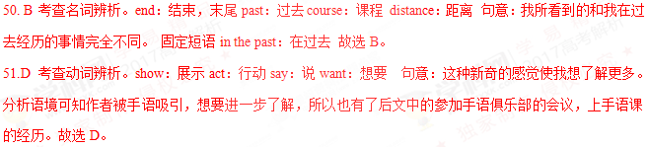52.B考查动词辨析。exercise锻炼 explore探索 express表达explain解释 句意在那之后，我感觉到想要探索更多关于手语的东西，我参加了ASL 俱乐部的一次会议。故选B。
53.C 考查动词辨析。print打印write写sign签名；打手势count数 句意那天我只学会了写字母表。分析可知作者第一次参加手语俱乐部的会议，学会的应该是最基本的写字母表。当然，打印字母表、在字母表上签名、数字母表和学习手语都没有联系。故选C。
54.A考查形容词辨析。slow缓慢的steady平稳的 normal正常的obvious明显的 句意我并没有因为缓慢的进步而沮丧，相反我很兴奋。因为作者只学会了写字母表，所以进步是很慢的。故选A。
55.C 考查动词辨析。chair主持；使…入座sponsor赞助 attend参加 organize组织 句意我下定决心参加俱乐部所有的会议去学习我能学习的一切。attend meeting参加会议 故选C。
56.D 考查动词辨析。miss错过，想念pass通过give up放弃register for报名注册 句意接下来的一个学期，我报名上了一个手语班。故选D。
57.A 考查动词辨析。prohibit禁止welcome欢迎ignore忽视repeat重复 句意教授的耳朵听不见，任何口语交流都是禁止的。根据后文if there had been any talking可知在课堂上没有口语交流。故选A。
58.C 考查副词辨析。lastly最后，终于thus因此；如此instead反而however然而 句意反而，如果当时有口语交流，那只会造成我们学的手语更少。根据前文I soon realized that the silence was not unpleasant.可知作者很快意识到安静并不是令人不愉快的。反而有口语交流会影响手语的学习。故选C。
59.B 考查动词辨析。require要求cause造成 allow允许expect期待 句意如果当时有口语交流，那只会造成我们学的手语更少。故选B。
60.D 考查形容词辨析。easy简单的popular受欢迎的quick快速的 new新的 句意现在我很感激当时的安静并且享受它带来的一种新的交流方式 分析可知手语对于作者来说是一种新的交流方式，故选D。

第二节 (共10小题；每小题1.5分，满分15分)
阅读下面短文，在空白处填入 1个适当的单词或括号内单词的正确形式。
There has been a recent trend in the food service industry toward lower fat content and less salt. This trend, which was started by the medical community（医学界） 61 a method of fighting heart disease, has had some unintended side 62 (effect) such as overweight and heart disease—the very thing the medical community was trying to fight.
Fat and salt are very important parts of a diet. They are required 63 (process) the food that we eat, to recover from injury and for several other bodily functions. When fat and salt 64 (remove) from food, the food tastes as if is missing something. As 65 result, people will eat more food to try to make up for that something missing. Even 66 (bad), the amount of fast food that people eat goes up. Fast food 67 (be) full of fat and salt; by 68 (eat) more fast food people will get more salt and fat than they need in their diet.
Having enough fat and salt in your meals will reduce the urge to snack(吃点心) between meals and will improve the taste of your food. However, be 69 (care) not to go to extremes. Like anything, it is possible to have too much of both, 70 is not good for the health.
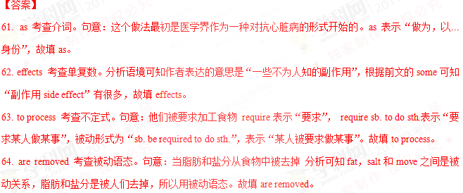65. a 考查冠词。固定短语as a result表示“结果”，句意结果，人们将吃更多的食物去弥补损失的东西。故填a。
66. worse 考查比较级。句意更糟糕的是，人们所吃快餐的数量增加了。故填worse。
67. is 考查主谓一致。句意快餐食物中充满了脂肪和盐。fast food的意思是“快餐”，表示一类食物，为不可数名词，谓语动词用单数形式。故填is。
68. eating 考查动名词。句意通过吃更多的快餐，人们将在饮食中摄入超过需求量的脂肪和盐。根据前文中的by可知此处应该填名词，所以填eat的动名词形式。故填eating。
69. careful 考查形容词。句意然而，注意不要走极端。分析语境可知be后面应该用形容词做表语，故填careful。
70. which 考查非限制性定语从句。句意很可能摄入过多的脂肪和盐，那对健康没有好处。分析可知which is not good for the health为非限制性定语从句，先行词为前文中的have too much of both“摄入过多的脂肪和盐”。故填which。

第四部分 写作(共两节，满分35分)
第一节 短文改错(共10小题；每小题l分，满分10分)
假定英语课上老师要求同桌之间交换修改作文，请你修改你同桌写的以下作文。文中共有10处语言错误，每句中最多有两处。每处错误仅涉及一个单词的增加、删除或修改。
增加在缺词处加一个漏字符号(∧)，并在其下面写出该加的词。
删除把多余的词用斜线(＼)划掉。
修改在错的词下画一横线，并在该词下面写出修改后的词。
注意
1. 每处错误及其修改均仅限一词；
2. 只允许修改10处，多者(从第11处起)不计分。
In the summer holiday following my eighteen birthday, I took driving lessons. I still remember how hard first day was. Before getting into the car, I thought I had learned the instructor’s orders, so once I started the car, my mind goes blank, I forgot what he had said to me altogether. The instructor kept repeating the word, “Speed up!” “Slow down!” “Turning left!” I was so much nervous that I could hardly tell which direction was left. A few minutes late, the instructor asked me to stop the car. It was a relief and I came to a suddenly stop just in the middle on the road.

73 so改为but 考查连词。根据句意可知作者本以为自己已经掌握了教练的话，结果一发动车，脑中一片空白。所以前后文为转折关系。故将so改为but。
74 goes改为went 考查时态。根据前文中的started可知时态为一般过去时，故将goes改为went。
75 word改为words 考查单复数。句意教练一直喊“加速”，“减速”，“左转” word的意思主要是“单词,消息”，words 可以表示为word的复数，也表示某人说的话。这里指教练说的那些话，故将word改为words。

78 late改为later 考查副词。做形容词的时候，later是late的比较级，如Their deadline is quite late. Ours is even later.（他们的截止日期很迟.我们的更迟.）做副词的时候，late是迟的意思，later是稍后、随后的意思。句意几分钟之后 故将late改为later。
79 suddenly改为sudden 考查形容词。句意我来了个紧急刹车。suddenly是副词，表示“意外地，忽然地”。 sudden为形容词，表示“突然的；迅速的”。a sudden stop表示“急刹车”。故将suddenly改为sudden。
80 on改为of 考查介词。分析语境可知作者表示“在路中间急刹车”，on the road表示“在路上”， the middle of the road表示“路的中央”，强调的是“the middle”。故将on改为of。
第二节 书面表达(满分25分)
假定你是李华，正在教你的英国朋友Leslie学习汉语。请你写封邮件告知下次上课的计划。内容包括
（1）时间和地点；
（2）内容学习唐诗；
（3）课前准备简要了解唐朝的历史。
注意
1.词数100左右；
2.可以适当增加细节，以使行文连贯。

