绝密★启用前
2017年普通高等学校招生全国统一考试（天津卷）
英语笔试
本试卷分为第I卷（选择题）和第II卷（非选择题）两部分，共130分，考试用时100分钟。第I卷1至10页。第II卷11至12页。
答卷前，考生务必将自己的姓名，准考号填写在答题卡上，并在规定位置粘贴考试用条形码，答卷时，考生务必将答案写在答题卡上，答在试卷上的无效。考试结束后，将本试卷和答题卡一并交回。
祝各位考生考试顺利！
第I 卷
注意事项：
1. 每小题选出答案后，用铅笔将答题卡上对应题目的答案标号涂黑。如果改动，用橡皮擦干净后，再选涂其他答案标号。
2. 本卷共55小题，共95分。
第一部分：英语知识运用（共两节，满分45分）
第一节：单项填空（共15小题；每小题1分，满分15分）
从A、B、C、D四个选项中，选出可以填入空白处的最佳选项。
例：Stand over there___________ you’ll be able to see it better.
A. or B. and C. but D. while
答案是B。
1.—Albert’s birthday is on next Saturday, and I’m planning a surprise party for him.
—__________. I’ll bring some wine.
A. Sounds like fun B. It depends
C. Just a minute D. You are welcome
【答案】A
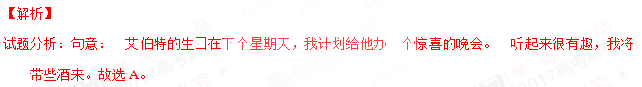2. My room is a mess, but I __________clean it before I go out tonight. I can do it in the morning.
A. daren’t B.shouldn’t C.needn’t D.mustn’t
【答案】C
【解析】
试题分析： 句意：我的房间很乱，但是在今晚我出去之前不需要打扫，我可以明天早晨再打扫。A.不敢；B.不应该；C不需要；D.不许。根据句意，故选C。
3. —I want to see Mr. White. We have an appointment.
—I’m sorry, but he is not ________ at the moment, for the meeting hasn’t ended.
A. busy B. active C. concerned D. available
【答案】D
【解析】
试题分析：句意：--我想见怀特先生，我们有约。--对不起，他现在没空，因为会议还没有结束。A.忙碌；B.积极，活跃；C关心；D.有空。根据语境，故选D。
4. She asked me _______ I had returned the books to the library, and I admitted that I hadn’t.
A. when B. where C. whether D. what
【答案】C
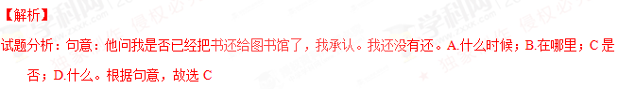5. Mr. and Mrs. Brown would like to see their daughter _____, get married, and have kids.
A. settled down B. keep off C. get up D. cut in
【答案】A
【解析】
试题分析：句意：布朗先生和夫人想要看到他们的女儿安顿下来，结婚生子。A.安顿下来；B.远离；C起床；D.擦嘴。根据句意，故选A。
6. Nowadays, cycling, along with jogging and swimming, _______ as one of the best all-round forms of exercise.
A. regard B. is regarded C. are regarded D. regards
【答案】B
【解析】
试题分析：句意：现在骑自行车，慢跑和游泳被认为是最全面的锻炼方式之一。根据动词短语regard...as..把...看做..和句意确定应该用被动语态排除A和D，再根据主语部分是由介词短语along with 连接的三个动名词做主语，应该谓语动词应该就前一致，即用单数，排除C，故选B。
7. —Michael was late for Mr. Smith’s chemistry class this morning.
—________? As far as I know, he never came late to class.
A. So what B. Why not C. Who cares D. How come
【答案】D
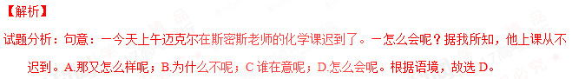8. I ________down to London when I suddenly found that I was on the wrong road.
A. was driving B. have driven C. would drive D. drove
【答案】A
【解析】
试题分析：根据固定句型：was/ were doing sth + when (suddenlu) did ... 句意：正在做某事，就在这时（那时）突然，根据句意，故选A。
9. My eldest son, _______ work takes him all over the world, is in New York at the moment.
A. that B. whose C. his D. who
【答案】B
【解析】
试题分析：本句是一个非限制性定语从句，先行词是my eldest son, 根据句意和空后名词，确定引导词做定语，在定语从句中只有引导词whose修饰名词做定语，意为：...的...。故选B。
10. I was watching the clock all through the meeting, as I had a train ______.
A. catching B. caught C. to catch D. to be caught
【答案】C
【解析】试题分析：句意：在整个会议期间我一直在看钟表，因为我要去敢火车。根据上文判断出as引导原因状语从句，根据have在本句中，词义为“有”，根据固定结构 Sb have sth to do 某人又某事要做（在本句中to do 由主语完成），根据句意判断出本句符合本结构。故选C。
11. It was when I got back to my apartment ______ I first came across my new neighbors.
A. who B. where C. which D. that
【答案】D
【解析】
试题分析：句意：当我回到我的公寓的时候，我首先遇见了我的新邻居。根据关键词It was开头，后面连词首选that，，构成强调句型，但需要验证，本句中去掉It was 和that，句意完整，所以确定是强调句型。故选D。
12. When you drive through the Redwood Forests in California, you will be _____ trees that are over 1,000 years old.
A. among B. against C. behind D. below
【答案】A
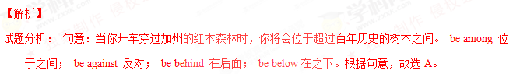13. We offer an excellent education to our students. ________, we expect students to word hard.
A. On average B. At best C. in return D. After all
【答案】C
【解析】
试题分析：句意：我们给我们的学生们提供极好的教育，作为回报，我们期待我们的学生们努力学习。A. 平均起来，一般说来 B. 最多，充其量 C. 作为汇报 D. 毕竟，终究。根据句意故选C。
14. The hospital has recently obtained new medical equipment, _____ more patients to be treated.
A. being allowed B. allowing C. having allowed D. allowed
【答案】B
【解析】
试题分析：句意：近期这个医院购进了新的医疗设备，允许更多的病人被治疗。前句购进医疗设备和后面允许更多的病人被治疗之间是必然的结果关系，用doing即现在分词作结果状语，表示顺理成章的结果。A. being allowed 表示被动且正在进行 C. having allowed 强调先于谓语动词发生 D. allowed 表示被动且完成，故选B。
15. —Do you have Betty’s phone number?
—Yes. Otherwise, I ______able to reach her yesterday.
A. hadn’t been B. wouldn’t have been C. weren’t D. wouldn’t be
【答案】B
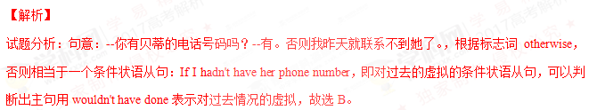第二节：完形填空（共20小题；每小题1.5分，满分30分）
阅读下面短文，掌握其大意，然后从16-35各题所给的A、B、C、D四个选项中，选春最佳选项。
At my heaviest I weighed 370 pounds. I had a very poor relationship with food: I used it to
16 bad feelings, to make myself feel better, and to celebrate. Worried about my health, I tried many different kinds of 17 but nothing worked. I came to believe that I could do nothing about my 18 .
When I was 50, my weight problem began to affect me 19 . I didn’t want to live the rest of my life with this 20 weight any more.
That year, I 21 a seminar where we were asked to create a project that would touch the world. A seminar leader shared her 22 story —she had not only 125 pounds, but also raised $25,000 for homeless children.
23 by her story, I created the As We Heal(痊愈), the World Heals 24 . My goal was to lose 150 pounds in one year and raise $50,000 25 a movement founded 30 years ago to end hunger. This combination of healing myself and healing the world 26 me as the perfect solution.
27 I began my own personal weight program, I was filled with the fear that I would
28 the same difficulties that beat me before. While the 29 hung over my head, there were also signs that I was headed down the right 30 . I sent letters to everyone I knew, telling them about my project. It worked perfectly. Donations began 31 in from hundreds of people.
Of course, I also took some practical steps to lose weight. I consulted with a physician（内科医生）, I hired a fitness coach, and I began to eat small and 32 meals. My fund-raising focus also gave me new motivation to exercise 33 .
A year later, I 34 my goal: I lost 150 pounds and raised $50,000! I feel that I’ve been given a second life to devote to something that is 35 and enormous.
16.A.add B. mix C. kill D. share
17.A. diets B. drinks C. fruits D. dishes
18.A. height B. ability C. wisdom D. weight
19.A. temporarily B. recently C. seriously D. secretly
20.A.ideal B. extra C. normal D. low
21.A. attended B. organized C. recommended D. mentioned
22.A. folk B. success C. adventure D. science
23.A. Surprised B. Amused C. Influenced D. Disturbed
24.A. project B. business C. system D. custom
25.A. in search of B.in need of C. in place of D. in support of
26.A.scared B. considered C. confused D. struck
27.A. As B.Until C.If D. Unless
28.A. get over B. run into C. look for D. put aside
29.A.excitment B. joy C. anger D. fear
30.A.row B. hall C. path D. street
31.A. breaking B. flooding C. jumping D. stepping
32.A. heavy B. full C. expense D. healthy
33.A. regularly B. limitlessly C. suddenly D. randomly
34.A. set B. reached C. missed D. dropped
35.A. stressful B. painful C. meaningful D. peaceful
16.【答案】C
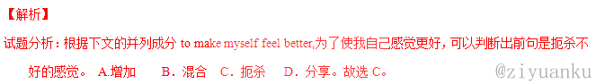考点：考查动词辨析。
- 【答案】A
【解析】
试题分析：根据段首句at my heaviest I weighed 370 pounds. 和上文Worried about my health, ，可知本句：我尝试了不同种类的饮食但都没有起作用。A. 饮食 B. 饮料 C. 水果 D. 菜。根据句意，故选A。
考点：考查名词辨析。
18.【答案】D
【解析】
试题分析：根据上文I tried many different kinds of diets but nothing worked.，可知下文是：我开始觉得我对于我的体重无能为力。A. 身高 B. 能力 C. 聪明 D. 体重。根据句意，故选D。
考点：考查名词辨析。
19.【答案】C
【解析】
试题分析：根据上文可知作者减肥没有成功，可知本句：当我五十岁时，我的体重严重影响了我。A. 临时地 B. 近期 C. 严重地 D. 秘密地。故选C。
考点：考查副词辨析。
20.【答案】B
【解析】
试题分析：根据下文affect me seriously，可知下文：我不想我的余生带着这些额外的体重。A.理想的 B. 额外的 C.正常的 D. 低的。故选B。
考点：考查形容词辨析。
21.【答案】A
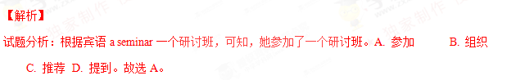考点：考查动词辨析。
22.【答案】B
【解析】
试题分析：根据下文she had not only 125 pounds, but also raised $25,000 for homeless children.
，可知，研讨会的一个领导和我分享了她的成功的故事。A. 民间 B. 成功 C. 探险 D. 科学
。故选B。
考点：考查名词辨析。
23.【答案】C
【解析】
试题分析：根据上文成功的故事和下文I created the As We Heal(痊愈), the World Heals 24 .，可知，我被她的故事所影响。A. 感到惊讶 B. 感到高兴 C. 被影响 D. 被打扰。故选C。
考点：考查形容词辨析。
24.【答案】A
【解析】
试题分析：根据上文下文My goal was ...可知，我创建了这个As We Heal(痊愈), the World Heals 工程。A. 工程 B. 生意 C. 系统 D. 风俗习惯。故选A。
考点：考查名词辨析。
25.【答案】D
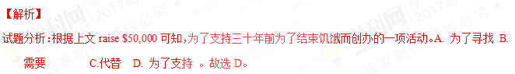考点：考查介词短语辨析。
26.【答案】D
【解析】
试题分析：根据主语：This combination of healing myself and healing the world ，可知，这种既治愈自己又治愈世界的结合在我看来似乎是一个完美的解决方案。根据句意和关键词as判断出这是考查固定短语：strike sb as ...， 在某人看来似乎是...。故选D。
考点：考查动词辨析。
27.【答案】A
【解析】
试题分析：根据主句：I was filled with the fear... 我充满了恐惧，可知上文，当我开始我的个人体重项目时。A. 当...的时候 B.直到 C.如果 D. 除非。故选A。
考点：考查连词辨析。
- 【答案】B
【解析】
试题分析：根据上文fear和下文he same difficulties that beat me before可知，我充满了遇到以前打败我的同样的困难的恐惧。A. 克服，战胜 B. 遇到 C. 寻找 D. 把...放到一边。故选B。
考点：考查动词短语辨析。
29.【答案】D
【解析】
试题分析：根据上文I was filled with the fear that ...，可知，尽管恐惧围绕在我的脑海。A.兴奋B. 高兴 C. 生气 D. 恐惧。故选D。
考点：考查名词辨析。
30.【答案】C
【解析】
试题分析：根据上文While the fear hung over my head,可知，有迹象表明我正走向正确的道路。A.排 B. 大厅 C. 路 D. 街道。故选C。
考点：考查名词辨析。
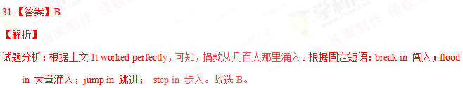考点：考查动词辨析。
- 【答案】D
【解析】
试题分析：根据上文hired a fitness coach可知，我开始吃少量的且健康的食物。A. 重的 B. 满的 C. 贵的 D. 健康的。故选D。
考点：考查形容词辨析。
33.【答案】A
【解析】
试题分析：根据exercise可知，我的募集资金的关注也给了我定期锻炼的激励。A. 定期地 B.无限度地 C. 突然地 D. 随意地 。故选A。
考点：考查副词辨析。
34.【答案】B
【解析】
试题分析：根据下文I lost 150 pounds and raised $50,000! 可知，我实现了我的目标。A. 制定 B. 实现，达到 C.错过 D. 使降低 。故选B。
考点：考查动词辨析。
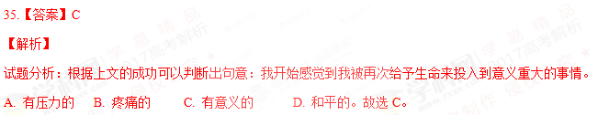考点：考查形容词辨析。
第二部分：阅读理解 （共20小题； 每小题2.5分，满分50分）
阅读下列短文，从每题所给的A、B、C、D四个选项中，选出最佳选项。
A
Suppose you’re in a rush, feeling tired, not paying attention to your screen, and you send an email that could get you in trouble.
Realisation will probably set in seconds after you’ve clicked “send”. You freeze in horrors and burn with shame.
What to do? Here are four common email accidents, and how to recover.
Clicking “send” too soon
Don’t waste your time trying to find out if the receivers has read it yet. Write another email as swiftly as you can and send it with a brief explaining that this is the correct version and the previous version should be ignored.
Writing the wrong time
The sooner you notice, the better. Respond quickly and briefly, apologizing for your mistake. Keep the tone measured: don’t handle it too lightly, as people can be offered, especially if your error suggests a misunderstanding of their culture(I.e. incorrect ordering of Chinese names).
Clicking “reply all” unintentionally
You accidentally reveal(透露)to entire company what menu choices you would prefer at the staff Christmas dinner, or what holiday you’d like to take. In this instance, the best solution is to send a quick, light-hearted apology to explain your awkwardness. But it can quickly rise to something worse, when everyone starts hitting “reply all” to join in a long and unpleasant conversation. In this instance, step away from your keyboard to allow everyone to calm down.
Sending an offensive message to it’s subject
The most awkward email mistake is usually committed in anger. You write an unkind message about someone, intending to send it to a friend, but accidentally send it to the person you’re discussing. In that case, ask to speak in person as soon as possible and say sorry. Explain your frustrations calmly and sensibly—see it as an opportunity tic hear up any difficulties you may have with this person.
36. After realizing an email accident, you are likely to feel _______.
A. curious B. tired C. awful D. funny
37. If you have written the wrong name in an email, it is best to ________.
A. apologise in a serious manner
B. tell the receiver to ignore the error
C. learn to write the name correctly
D. send a short notice to everyone
38. What should you do when an unpleasant conversation is started by your “reply all” email?
A. Try offering other choices.
B. Avoid further involvement.
C. Meet other staff members.
D. Make a light-hearted apology.
39. How should you deal with the problem caused by an offensive email?
A. By promising not to offend the receiver again.
B. By seeking support from the receiver’s friends.
C. By asking the receiver to control his anger.
D. By talking to the receiver face to face.
40. What is the passage mainly about?
A. Defining email errors.
B. Reducing email mistakes.
C. Handling email accidents.
D. Improving email writing.
36.【答案】C
【解析】
试题分析：根据表第二段第二句：You freeze in horrors and burn with shame.。故选C。
考点：考查细节理解。
37.【答案】A
【解析】
试题分析：根据第二个标题句Writing the wrong time后面内容Respond quickly and briefly, apologizing for your mistake. Keep the tone measured: don’t handle it too lightly, as people can be offered, especially if your error suggests a misunderstanding of their culture(I.e. incorrect ordering of Chinese names).。故选A。
考点：考查细节理解。
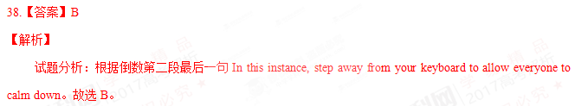考点：考查细节理解。
39.【答案】D
【解析】
试题分析：据最后一段第三行In that case, ask to speak in person as soon as possible and say sorry。故选D。
考点：考查细节理解。
40.【答案】C
【解析】
试题分析：前三段内容通过问问题和说明情况以及引出介绍下面的处理邮件问题的具体方法可以判断出本文主要讲的是处理邮件问题。故选C。
B
Fifteen years ago, I took a summer vacation in Lecce in southern Italy. After climbing up a hill for a panoramic(全景的) view of the blue sea, white buildings and green olive trees, I paused to catch my breath and then positioned myself to take the best photo of this panorama.
Unfortunately, just as I took out my camera, a woman approached from behind, and planted herself right in front of my view. Like me, this woman was here to stop, sigh and appreciate the view.
Patient as I was, after about 15 minutes, my camera scanning the sun and reviewing the shot I would eventually take, I grew frustrated. Was it too much to ask her to move so I could take just one picture of the landscape? Sure, I could have asked her, but something prevented me from doing so. She seemed so content in her observation. I didn’t want to mess with that.
Another 15 minutes passed and I grew bored. The woman was still there. I decided to take the photo anyway. And now when I look at it, I think her presence in the photo is what makes the image interesting. The landscape, beautiful on its own, somehow coms to life and breathes because this woman is engaging with it.
This photo, with the unique beauty that unfolded before me and that woman who “ruined” it, now hangs on a wall in my bedroom. What would she think if she knew that her figure is captured(捕捉) and frozen on some stranger’s bedroom wall? A bedroom, after all, is a very private space, in which some woman I don’t even know has been immortalized(使……永存). In some ways, she lives in my house.
Perhaps we all live in each others’ space. Perhaps this is what photos are for: to remind us that we all appreciate beauty, that we all share a common desire for pleasure, for connection, for something that is greater than us.
That photo is a reminder, a captured moment, an unspoken conversation between two women, separated only by a thin square of glass.
41. What happened when the author was about to take a photo?
A. Her camera stopped working.
B. A woman blocked her view.
C. Someone asked her to leave
D. A friend approached from behind.
42. According to the author, the woman was probably_______.
A. enjoying herself
B. losing her patience
C. waiting for the sunset
D. thinking about her past
43. In the author’s opinion, what makes the photo so alive?
A. The rich color of the landscape.
B. The perfect positioning of the camera.
C. The woman’s existence in the photo.
D. The soft sunlight that summer day.
44. The photo on the bedroom wall enables the author to better understand ________.
A. the need to be close to nature
B. the importance of private space
C. the joy of the vacation in Italy
D. the shared passion for beauty
45. The passage can be seen as the author’s reflections upon _______.
A. a particular life experience
B. the pleasure of traveling
C. the art of photography
D. a lost friendship
41.【答案】B
【解析】
试题分析：根据第二段第一句：Unfortunately, just as I took out my camera, a woman approached from behind, and planted herself right in front of my view。故选B。
考点：考查细节理解。
42.【答案】A
【解析】
试题分析：根据第三段的句子She seemed so content in her observation.。故选A。
考点：考查细节理解。
43.【答案】C
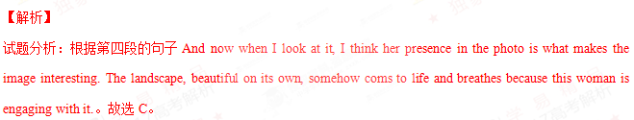考点：考查细节理解。
44.【答案】D
【解析】
试题分析：根据倒数第五段的句子This photo, with the unique beauty that unfolded before me and that woman who “ruined” it, now hangs on a wall in my bedroom. 。故选D。
考点：考查推理判断。
45.【答案】A
【解析】
试题分析：最后两段内容是作者这次特殊经历的的感悟的总结，是 所以这篇文章可以看做是作者对于一次特殊经历的深入思考。故选A。
考点：考查推理判断。
C
This month, Germany’s transport minister, Alexander Dobrindt, proposed the first set of rules for autonomous vehicles(自主驾驶车辆). They would define the driver’s role in such cars and govern how such cars perform in crashes where lives might be lost.
The proposal attempts to deal with what some call the “death valley” of autonomous vehicles: the grey area between semi-autonomous and fully driverless cars that could delay the driverless future.
Dobrindt wants three things: that a car always chooses property(财产) damage over personal injury; that it never distinguishes between humans based on age or race; and that if a human removes his or her hands from the driving wheel — to check email, say — the car’s maker is responsible if there is a crash.
“The change to the road traffic law will permit fully automatic driving,” says Dobrindt. It will put fully driverless cars on an equal legal footing to human drivers, he says.
Who is responsible for the operation of such vehicles is not clear among car makers, consumers and lawyers. “The liability(法律责任) issue is the biggest one of them all,” says Natasha Merat at the University of Leeds, UK.
An assumption behind UK insurance for driverless cars, introduces earlier this year, insists that a human “ be watchful and monitoring the road” at every moment.
But that is not what many people have in mind when thinking of driverless cars. “When you say ‘driverless cars’, people expect driverless cars.”Merat says. “You know — no driver.”
Because of the confusion, Merat thinks some car makers will wait until vehicles can be fully automated without operation.
Driverless cars may end up being a form of public transport rather than vehicles you own, says Ryan Calo at Stanford University, California. That is happening in the UK and Singapore, where government-provided driverless vehicles are being launched.
That would go down poorly in the US, however. “The idea that the government would take over driverless cars and treat them as a public good would get absolutely nowhere here,” says Calo.
46. What does the phrase “death valley” in Paragraph 2 refer to?
A. A place where cars often break down.
B. A case where passing a law is impossible.
C. An area where no driving is permitted.
D. A situation where drivers’ role is not clear.
47. The proposal put forward by Dobrindt aims to __________.
A. stop people from breaking traffic rules
B. help promote fully automatic driving
C. protect drivers of all ages and races
D. prevent serious property damage
48. What do consumers think of the operation of driverless cars?
A. It should get the attention of insurance companies.
B. It should be the main concern of law makers.
C. It should not cause deadly traffic accidents.
D. It should involve no human responsibility.
49. Driverless vehicles in public transport see no bright future in __________.
A. Singapore
B. the UK
C. the US
D. Germany
50. What could be the best title for passage?
A. Autonomous Driving: Whose Liability?
B. Fully Automatic Cars: A New Breakthrough
C. Autonomous Vehicles: Driver Removed
D. Driverless Cars: Root of Road Accidents
46.【答案】D
【解析】
试题分析：根据第二段的句子the grey area between semi-autonomous and fully driverless cars that could delay the driverless future.。故选D。
考点：考查词义猜测。
47.【答案】B
【解析】
试题分析：根据第二段的句子The proposal attempts to deal with what some call the “death valley” of autonomous vehicles:。故选B。
考点：考查推理判断。
48.【答案】D
【解析】
试题分析：根据第六段内容。故选D。
考点：考查细节理解。
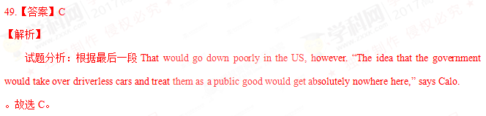考点：考查细节理解。
50.【答案】A
【解析】
试题分析：通读全文可以知道，本文主要讲述了谁来对无人驾驶的机动车辆负责。故选A。
考点：考查主旨大意。
D
I read somewhere that we spend a full third of our lives waiting. But where are we doing all of this waiting, and what does it mean to an impatient society like ours? To understand the issue, let’s take a look at three types of “waits”.
The very purest form of waiting is the Watched-Pot Wait. It is without doubt the most annoying of all. Take filling up the kitchen sink(洗碗池) as an example. There is absolutely nothing you can do while this is going on but keep both eyes fixed on the sink until it’s full. During these waits, the brain slips away from the body and wanders about until the water runs over the edge of the counter and onto your socks. This kind of wait makes the waiter helpless and mindless.
A cousin to the Watched-Pot Wait is the Forced Wait. This one requires a bit of discipline. Properly preparing packaged noodle soup required a Forced Wait. Directions are very specific. “Bring three cups of water to boil, add mix, simmer three minutes, remove from heat, let stand five minutes.”I have my doubts that anyone has actually followed the procedures strictly. After all, Forced Waiting requires patience.
Perhaps the most powerful type of waiting is the Lucky-Break Wait. This type of wait is unusual in that it is for the most part voluntary. Unlike the Forced Wait, which is also voluntary, waiting for your lucky break does not necessarily mean that it will happen.
Turning one’s life into a waiting game requires faith and hope, and is strictly for the optimists among us. On the surface it seems as ridiculous as following the directions on soup mixes, but the Lucky-Break Wait well serves those who are willing to do it. As long as one doesn’t come to rely on it, wishing for a few good things to happen never hurts anybody.
We certainly do spend a good deal of our time waiting. The next time you’re standing at the sink waiting for it to fill while cooking noodle soup that you’ll have to eat until a large bag of cash falls out of the sky, don’t be desperate. You’re probably just as busy as the next guy.
51. While doing a Watched-Pot Wait, we tend to ___________.
A. keep ourselves busy
B. get absent-minded
C. grow anxious
D. stay focused
52. What is the difference between the Forced Wait and the Watched-Pot Wait?\
A. The Forced Wait requires some self-control.
B. The Forced Wait makes people passive.
C. The Watched-Pot Wait needs directions.
D. The Watched-Pot Wait engages body and brain.
53. What can we learn about the Lucky-Break Wait?
A. It is less voluntary than the Forced Wait.
B. It doesn’t always bring the desired result.
C. It is more fruitful than the Forced Wait.
D. It doesn’t give people faith and hope.
54. What does the author advise us to do the next time we are waiting?
A. Take it seriously.
B. Don’t rely on others.
C. Do something else.
D. Don’t lose heart.
55. The author supports his view by _________.
A. exploring various causes of “waits”.
B. describing detailed processes of “waits”.
C. analyzing different categories of “waits”
D. revealing frustrating consequences of “waits”
51.【答案】B
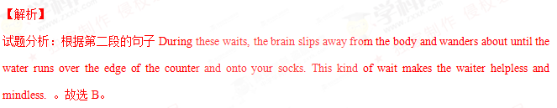考点：考查细节理解。
52.【答案】A
【解析】
试题分析：根据第三段的句子This one requires a bit of discipline.，故选A。
考点：考查细节理解。
53.【答案】B
【解析】
试题分析：根据第四段的句子which is also voluntary, waiting for your lucky break does not necessarily mean that it will happen. 。故选B。
考点：考查细节理解。
54.【答案】D
【解析】
试题分析：根据第最后一段中don’t be desperate.。可以判断出当我等待的时候作者建议我们不要灰心，绝望。故选D。
考点：考查细节理解。
55.【答案】C
【解析】
试题分析：通读全文可以知道，作者通过2,3,4段列举了三种类型的等待，所以判断出作者是通过分析不同种类的等待来支持自己的观点的。故选C。
考点：考查标题判断。
2017年普通高等学校招生全国统一考试（天津卷）
英 语 笔 试
第II卷
注意事项：
1.用黑色墨水的钢笔或签字笔将答案写在答题卡上。
2.本卷共6小题，共35分。
第三部分： 写作
第一节：阅读表达（共5小题；每小题2分，满分10分）
阅读短文，并按照题目要求用英语回答问题。
In the years of my growing up, Dad was strict with me. He made sure I made my bed and did my homework. He would call in advance to make sure there was no alcohol at the party. I got so angry with him for laying down the law. I would scream, “ I hate you!” Dad would yell back, “Good! I don’t care!” Deep down I knew he did.
One time at a party, I drank too much alcohol and got so sick. I said, “ Call my dad.” Next thing, Dad was carrying me to the car. I woke up the next morning, thinking I would definitely be criticized. As expected, I got a roasting, but I now understand why I need discipline.
Dad was 29 when he got his big roles in films. I had an early start at the age of nine with a role in a 1990s TV series, but it wasn’t until I finished film studies that I pursued my career as an actress. Like those early days for Dad, I faced lots of rejections. Working in such a competitive industry, I’ve sometimes thought, “ I can’t do this any more.”
Once, after a trip to Hollywood, I returned to Australia so depressed and spent months in my bedroom painting, listening to Eckhart Tolle’s music and trying to find myself again. Dad sat me down and said,“Alice, I know it’s hard, but it’s all about persistence(坚持不懈).”
Now I get to work with Dad a lot, which I love. We both passionate about acting, which comes from us being so interested in people. If it weren’t for Dad, I wouldn’t be where I am today. He’s my biggest fan, and when you have that in your life you can go a long way.
56. What rules did Alice’s father set for her when she was growing up?(no more than 15 words)
57. What does the underlined part in Paragraph 2 mean?(no more than 5 words)
58. What did Alice’s father do when she felt depressed?(no more than 5 words)
59. According to the last paragraph, what do Alice and her father have in common?(no more than 10 words)
60. What do you think of Alice’s father? Please explain.(no more than 20 words)
56. 【答案】
She should make her bed, do her homework and drink no alcohol
Or: Making her bed, doing her homework and drinking no alcohol
【解析】
试题分析：根据文章第一段的句子He made sure I made my bed and did my homework. He would call in advance to make sure there was no alcohol at the party. I got so angry with him for laying down the law. I,可知作者爱丽斯的父亲给他制定了铺床，做作业和不许喝酒的规章制度。
57. 【答案】
I got/was criticised/scolded
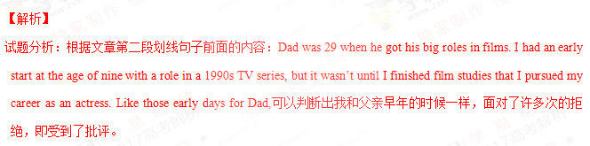
58. 【答案】He encouraged/comforted/inspired her
【解析】
试题分析：根据文章第一段内容Once, after a trip to Hollywood, I returned to Australia so depressed and spent months in my bedroom painting, listening to Eckhart Tolle’s music and trying to find myself again. Dad sat me down and said,“Alice, I know it’s hard, but it’s all about persistence(坚持不懈).”可以判断出在爱丽斯感到精神不振的 时候，父亲鼓励或者安慰或者激励了她。
59. 【答案】
They are both passionate about acting and interested in people
【解析】
试题分析：根据文章最后一段中We both passionate about acting, which comes from us being so interested in people.可以判断出爱丽斯和她的父亲的共同点就是对演艺事业充满了激情，对人们感兴趣。
60. 【答案】
He is a good/devoted/caring/loving father because he was strict with his daughter and encouraged her when she was in trouble
.Or: He is always supportive/a source of strength. Whenever she is in trouble, he is there
for her.
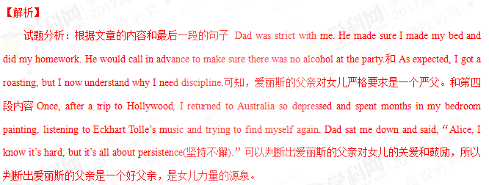第二节：书面表达（满分25分）
假设你是李津，与你以前的外籍教师Mrs. Green 一直保持联系。近日她来信询问你的近况，请根据以下提示给她回复一封邮件。
（1）简要介绍自己的学习和生活；
（2）告知你已成为八月底在津举办的第十三届全运会的志愿者，并介绍为此所做的准备（如深入了解天津等）；
（3）希望她有机会重访天津。
注意：
（1）词数不少于100；
（2）可适当加入细节，使内容充实、行文连贯；
（3）开头已给出，不计入总词数。
参考词汇：第十三届全运会 the 13th National Games
Dear Mrs. Green,
I’m glad to hear from you. ______________________________________________________________
________________________________________________________________________________________
________________________________________________________________________________________
Yours,
Li Jin

【答案】略
