绝密★启用前

选择题部分
第一部分 听力（共两节，满分30分）
做题时，先将答案标在试卷上。录音内容结束后，你将有两分钟的时间将试卷上的答案转涂到答题纸上。
第一节（共5小题；每小题1.5分，满分7.5分）

听下面5段对话。每段对话后有一个小题，从题中所给的A、B、C三个选项中选出最佳选项，并标在试卷的相应位置。听完每段对话后，你都有10秒钟的时间来回答有关小题和阅读下一小题。每段对话仅读一遍。
例：How much is the shirt?
A. £19.15 B. £9.18 C. £9.15
答案是C.
1. What does the woman think of the movie?
A. It's amusing. B. It's exciting. C. It's disappointing.
2. How will Susan spend most of her time in France?
A. Traveling around B. Studying at a school. C. Looking after aunt.
3. What are the speakers talking about?
A. Going out. B. Ordering drinks. C. Preparing for a party.
4. Where are the speakers?
A. In a classroom B. In a library C. In a bookstore
5. What is the man going to do?
A. Go on the Internet. B. Make a phone call. C. Take a train trip.
第二节（共15小题；每小题1.5分，满分22.5分）
听下面5段对话或独白。每段对话或独白后有几个小题，从题中所给的A、B、C三个选项中选出最佳选项，并标在试卷的相应位置。听每段对话或独白前，你将有时间阅读各个小题，每小题5秒钟；听完后，各小题将给出5秒钟的作答时间。每段对话或独白读两遍。
听第6段材料，回答第6、7题。
6. What is the woman looking for?
A. An information office. B. A police station. C. A shoe repair shop.
7. What is the Town Guide according to the man?
A. A brochure B. A newspaper C. A map.
听第7段材料，回答第8、9题。
8. What does the man say about the restaurant?
A. It's the biggest one around.
B. It offers many tasty dishes.Ziyuanku.com
C. It's famous for its seafood.
9. What will the woman probably order?
A. Fried fish B. Roast chicken. C. Beef steak
听第8段材料，回答第10 到12题。
10. Where will Mr.White be at 11 o'clock?
A. At the office. B. At the airport C. At the restaurant.
11. What will Mr.White probably do at one in the afternoon?
A. Receive a guest. B. Have a meeting. C. Read a report.
12. When will Miss Wilson see Mr.Whie?
A. At lunch time. B. Late in the afternoon. C. The next norning.
听第9段材料，回答第13到16题。
13. Why is Bill going to Germany?
A. To work on a project. B. To study German. C. To start a new company.
14. What did the woman dislike about Germany?
A. The weather. B. The food. C. The schools.
15. What does bill hope to do about his family?
A. Bring them to Germany. B. Leave them in England. C. Visit them in a few months.
16. What is the probable relationship between the speakers?
A. Fellow-travelers. B. Colleagues. C. Classmates.
听第10段材料，回答第17至20题。
17. When did it rain last time in Juárez?
A. Three days ago B. A month ago C. A year ago.
18. What season is it now in Juárez?
A. Spring B. Summer C. Autumn.
19. What are the elderly advised to do?
A. Take a walk in the afternoon.
B. Keep their homes cool.
C. Drink plenty of water.
20. What is the speaker doing?
A. Hosting a radio program.
B. Conducting a seminar.
C. Forecasting the weather.Ziyuanku.com
第二部分 阅读理解（共两节，满分35分）
第一节（共10小题；每小题2.5分，满分25分）
阅读下列短文，从每题所给的A、B、C和D四个选项中，选出最佳选项，并在答题纸上将该项涂黑。
Benjamin West,the father of American painting, showed his talent for art when he was only six years of age. But he did not know about brushes before a visitor told him he needed one. In htose days ,a brush was made from camel’s hair. There were no camels nearby. Benjamin decided that cat hair would work instead. He cut some fur from the family cat to make a brush.
The brush did nott last long. Soon Benjamin needed more fur. Before long, the catbegan to look ragged （蓬乱）. His father said that the cat must be sick. Benjamin was forced to admit what he had been doing.
The cat’s lot was about to improve. That year, one of Benjamin’s cousins, Mr.Pennington, came to visit. He was impressed with Benjamin’s drawings. When he went home, he sent Benjamin a box of paint and some brushes. He also sent six engravings （版画）by an artist. These were the forst pictures and first real paint and brushes Benjamin had ever seen. In 1747，when Benjamin was nine years old，Mr.Pennington retured for another visit .He was amazed at what Benjamin had done with his gift.He asked Benjamin’s parents if he might take the boy to Philadelphia for a visit.
In the city, Mr.Pennington gave Benjamin materials for creating oil paintings.The boy began a landscape (风景) painting.Wiliams ,a well-known painter,came to see him work . Wiliams was impressed with Benjamin and gave him two classic books on painting to take home .The books were long and dull. Benjamin could read only a little,having been a poor student.But he later said,”Those two books were my companions by day,and under my pillow at night.”While it is likely that he understood very little of the books,they were his introduction to classical paintings.The nine-year-old boy decided then that he would be an artist.
21. What is the text mainly about?
A. Benjamin’s visit to Philadelphia.
B. Williams’ influence on Benjamin.
C. The beginning of Benjamin’s life as an artist.
D. The friendship between Benjamin and Pennington.
22. What does the underlined sentence in paragraph 3 suggest?
A. The cat would be closely watched.$来&源：ziyuanku.com
B. The cat would get some medical care.
C. Benjamin would leave his home shortly.
D. Benjamin would have real brushes soon.
23. What did Pennington do to help Benjamin develop his talent?
A. He took him to see painting exhibitions.
B. He provided him with painting materials.
C. He sent him to a school in Philadelphia.
D. He taught him how to make engravings.
24. Williams’ two books helped Benjamin to ________.
A. master the use of paints
B. appreciate landscape paintings
C. get to know other painters
D. make up his mind to be a painter
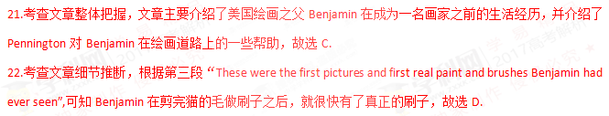23.考查文章细节理解，根据最后一段“Mr. Pennington gave Benjamin materials for creating oil paintings”, 可知Pennington为了帮助Benjamin培养绘画天赋，给他提供了一些绘画材料，故选B.
24．考查文章细节理解，根据最后一段“While it is likely that he understood very little of the books, they were his introduction to classical paintings. The nine-year-old boy decided then that he would be an artist, 可知：这两本书帮助Benjamin坚定了自己成为一名画家的决心，故选D.
B
Getting less sleep has become a bad habit for most American kids. According to a new survey(调查) by the National Sleep Foundation, 51% of kids aged 10 to 18 go to bed at 10 pm or later on school nights, even though they have to get up early. Last year the Foundation reported that nearly 60% of 7- to 12-year-olds said that they felt tired during the day, and 15% said they had fallen asleep at school.
How much sleep you need depends a lot on your age. Babies need a lot of rest: most of them sleep about 18 hours a day! Adults need about eight hours. For most school-age children, ten hours is ideal(理想的). But the new National Sleep Foundation survey found that 35% of 10- to 12-year-olds get only seven or eight hours. And guess what almost half of the surveyed kids said they do before bedtime? Watch TV.
“More children are going to bed with TVs on, and there are more opportunities(机会) to stay awake, with more homework, the Internet and the phone,” says Dr. Mary Carskadon, a sleep researcher at Brown University Medical School. She says these activities at bedtime can get kids all excited and make it hard for them to calm down and sleep. Other experts say part of the problem is chemical. Changing levels of body chemicals called hormones not only make teenagers’ bodies develop adult characteristics, but also make it hard for teenagers to fall asleep before 11 pm.
Because sleepiness is such a problem for teenagers, some school districts have decided to start high school classes later than they used to. Three years ago, schools in Edina, Minnesota, changed the start time from 7:25 am to 8:30 am. Students, parents and teachers are pleased with the results.
25. What is the new National Sleep Foundation survey on?
A. American kids’ sleeping habits. B. Teenagers’ sleep-related diseases.
C. Activities to prevent sleeplessness. D. Learning problems and lack of sleep.
26. How many hours of sleep do 11-year-olds need every day?
A. 7 hours. B. 8 hours. C. 10 hours. D. 18 hours.
27. Why do teenagers go to sleep late according to Carskadon?
A. They are affected by certain body chemicals.
B. They tend to do things that excite them.
C. They follow their parents’ examples.
D. They don’t need to go to school early.
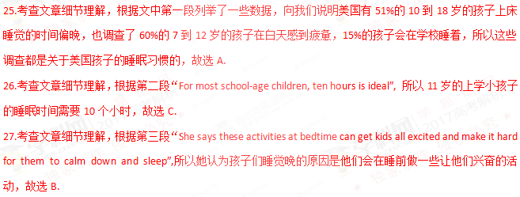C
FLORENCE, Italy—Svetlana Cojochru feels hurt. The Moldovan has lived here seven years as a caregiver to Italian kids and elderly, but in order to stay she’s had to prove her language skills by taking a test which requires her to write a postcard to an imaginary friend and answer a fictional job ad.
Italy is the latest Western European country trying to control a growing immigrant(移民) population by demanding language skills in exchange for work permits, or in some cases, citizenship.
Some immigrant advocates worry that as hard financial times make it more difficult for natives to keep jobs, such measures will become a more vehicle for intolerance than integration(融合). Others say it’s only natural that newcomers learn the language of their host nation, seeing it as a condition to ensure they can contribute to society.
Other European countries laid down a similar requirement for immigrants, and some terms are even tougher. The governments argue that this will help foreigners better join the society and promote understanding across cultures.
Italy, which has a much weaker tradition of immigration, has witnessed a sharp increase in immigration in recent years. In 1990, immigrants numbered some 1.14 million out of Italy’s then 56.7 million people, or about 2 percent. At the start of this year, foreigners living in Italy amounted to 4.56 million of a total population of 60.6 million, or 7.5 percent, with immigrants’ children accounting for an even larger percentage of births in Italy.
Cojochru, the Moldovan caregiver, hoped obtaining permanent residence(居住权) would help her bring her two children to Italy; they live with her sister in Moldova, where salaries are among the lowest in Europe. She was skeptical that the language requirement would encourage integration.中/华-资*源%库
Italians always “see me as a foreigner,” an outsider, even though she’s stayed in the country for years and can speak the local language fluently, she said.
28. Why does Cojochru have to take a language test?
A. To continue to stay in Italy. B. To teach her children Italian.
C. To find a better job in Italy. D. To better mix with the Italians.
29. Some people worry that the new language requirement may ________.
A. reduce Italy’s population quickly B. cause conflicts among people
C. lead to financial difficulties D. put pressure on schools
30. What do we know about Cojochru?
A. She lives with her sister now in Italy.
B. She enjoys learning the Italian language.
C. She speaks Italian well enough for her job.
D. She wishes to go back to her home country.
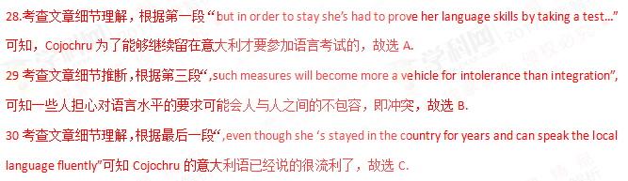第二节（共5小题；每小题2分，满分10分）
根据短文内容，从短文后的选项中选出能填入空白处的最佳选项。选项中有两项为多余选项。
How to Do Man-on-the-Street Interviews
The man-on-the-street interview is an interview in which a reporter hits the streets with a cameraman to interview people on the sport. _____31_____ But with these tips, your first man-on-the-street interview experience can be easy.
- When your boss or professor sends you out to do man-on-the-street interviews for a story, think about the topic and develop a list of about ten general questions relating to it. For example, if your topic is about environmental problems in America, you might ask, “Why do you think environmental protection is important in America?” _____32_____
- Hit the streets with confidence. _____33_____ Say, “Excuse me, I work for XYZ News, and I was wondering if you could share your opinion about this topic.” This is a quick way to get people to warm up to you.中·华.资*源%库 ziyuanku.com
Move on to the next person if someone tells you she is not inter
Don’t get discouraged.
● 34 Each interview that you get on the street shouldn’t be longer than ten minutes. As soon as you get the answer you need, move on to the next person. Make sure that as you go from interview to interview, you are getting a variety of answers. If everyone is giving you the same answer, you won’t be able to use it. A safe number of interviews to conduct is about six to ten. 35
● If your news station or school requires interviewees to sign release forms to appear on the air, don’t leave work without them.
A. Limit your time.
B. As you approach people, be polite.
C. If you don’t own a camera, you can buy one.
D. For new reporters, this can seem like a challenging task.
E. To get good and useful results, ask them the same question.中·华.资*源%库 ziyuanku.com
F. That number of interviews should give you all the answers you need.
G. With a question like this, you will get more than a “Yes” or “No” reply.
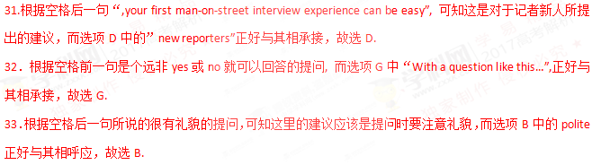34．根据空格后一句“Each interview that you get on the street shouldn’t be longer than ten minutes.”可知这一段的建议是要限制采访的时间，故选A.
35.根据空格前一句“A safe number of interviews to conduct is about six to ten”, 而选项F中“That number of interviews…”正好与其相呼应，故选F.
第三部分 语言运用（共两节，满分45分）
第一节 完形填空（共20小题；每小题1.5分，满分30分）
阅读下面短文，从短文后各题所给的A、B、C和D四个选项中，选出可以填入空白处的最佳选项，并在答题纸上将该项涂黑。
Alia Baker is a librarian in Iraq. Her library used to be a 36 place for all who loved books and liked to share knowledge. They 37 various matters all over the world. When the war was near, Alia was 38 that the fires of war would destroy the books, which are more 39 to her than mountain of gold. The books are in every language — new books, ancient books, 40 a book on the history of Iraq that is seven hundred years old.
She had asked the government for 41 to move the books to a 42 place, but they refused. So Alia took matters into her own hands. 43 , she brought books home every night, 44 her car late after work. Her friends came to 45 her when the war broke out. Anis who owned a restaurant 46 to hide some books. All through the 47 , Alia, Anis, his brothers and neighbours took the books from the library, 48 them over the seven-foot wall and 49 them in the restaurant. The books stayed hidden as the war 50 . Then nine days laters, a fire burned the 51 to the ground.中·华.资*源%库 ziyuanku.com
One day, the bombing stopped and the 52 left. But the war was not over yet. Alia knew that if the books were to be safe, they must be 53 again while the city was 54 . So she hired a truck to bring all the books to the houses of friends in the suburbs(郊区). Now Alia waited for the war to end and 55 peace and a new library.
36. A. meeting B. working C. personal D. religious
37. A. raised B. handled C. reported D. discussed
38. A. worried B. angry C. doubtful D. curious
39. A. practical B. precious C. reliable D. expensive
40. A. then B. still C. even D. rather
41. A. permission B. confirmation C. explanation D. information
42. A. large B. public C. distant D. safe
43. A. Fortunately B. Surprisingly C. Seriously D. Secretly
44. A. starting B. parking C. filling D. testing
45. A. stop B. help C. warn D. rescue
46. A. intended B. pretended C. happened D. agreed
47. A. war B. night C. building D. way
48. A. put B. opened C. passed D. threw
49. A. hid B. exchanged C.burnt D. distributed
50. A. approached B. erupted C. continued D. ended
51. A. restaurant B. library C. city D. wall
52. A. neighbours B. soldiers C. friends D. customers
53. A. sold B. read C. saved D. moved
54. A. occupied B. bombed C. quiet D. busy
55. A. dreamed of B. believed in C. cared about D. looked for
【解析】本文是一篇记叙文。主要讲述了Alia Baker是伊拉克图书馆的馆长，当伊拉克爆发战争时，Alia Baker害怕战争会破坏图书，于是向政府求助，在遭到拒绝后，Alia Baker自己用双手一点点把书搬出来，最后在家人、朋友和邻居的帮助下，Alia Baker将书转移到了安全的地方。
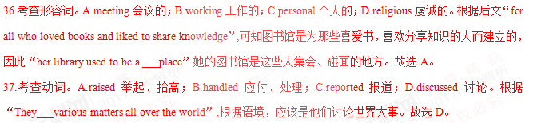38.考查形容词。A.worried担心；B.angry生气；C.doubtful怀疑的；D.curious好奇的。根据后文“So Alia took matters into her own hands”，Alia用双手搬书，可知“Alia was ___that the fires of war would destroy the books”,Alia担心战火会破坏书。故选A。
39.考查形容词。A.practical实践的；B.precious珍贵的；C.reliable可靠的；D.expensive昂贵的。根据后文“which are more__to her than mountains of gold”,由more可知，是将书与金山作比较，可见书的珍贵性。故选B。
40.考查副词。A.then然后；B.still仍然；C.even甚至；D.rather稍微。根据“a book on the history of Iraq that is seven hundred years old”,这本关于伊拉克历史的书已经有了七百年的历史，因此是比较宝贵的，与前面“new books,ancient books”是一种层次上的上升与递进关系。故选C。
41.考查名词。A.permission许可；B.confirmation确认；C.explanation解释；D.information信息。根据“She had asked the government for__to move the books to a__place”,可知她想获得政府的许可，将书转移到安全的地方。故选A。
42.考查形容词。A.large大的；B.public公共的；C.distant遥远的；D.safe安全的。根据“She had asked the government for permission to move the books to a__place”,她想获得政府的许可，将书转移到（ ）的地方。故选D。
43.考查副词。A.Fortunately幸运地；B.Surprisingly惊奇地；C.Seriously严重地；D.Secretly秘密地。根据“she brought books home every night”,可知她是在秘密地转移书籍。故选D。
44.考查动词。A. Starting开始；B.parking停车；C.filling装满；D.testing测试。根据“__her car late after work”,可知，在工作之后，她的车都被书装满的。故选C。
45.考查动词。A.stop停止；B.help帮助；C.warn警告；D.rescue营救。根据后文“Anis who owned a restaurant 46 to hide some books.”可知，她的朋友们都过来帮她转移书。故选B。
46.考查动词。A. intended 打算；B. pretended假装；C. happened 发生；D. agreed同意。根据“Anis who owned a restaurant 46 to hide some books”根据语境分析，Anis同意把书藏在她的饭店里面。故选D。
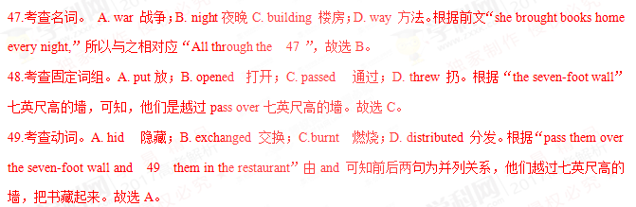50.考查动词。A. approached 接近；B. erupted 爆发；C. continued D. ended 结束。由后文
“Then nine days laters, a fire burned the 51 to the ground.”可知，战争仍在继续。故选C。
- 考查名词。A. restaurant 饭店；B. library 图书馆；C. city 城市；D. wall 墙壁。根据后文“Now Alia waited for the war to end and 55 peace and a new library”可知原来的图书馆已经损毁，所以“a fire burned the 51 to the ground.”战火蔓延到了图书馆。故选B。
- 考查名词。A. neighbours 邻居；B. soldiers 士兵；C. friends 朋友；D. customers 顾客。“the bombing stopped and the 52 lef”，and连接两个并列句，轰炸停止，与之相对应的是，士兵离开了。故选B。
- 考查动词。A. sold 卖；B. read 阅读；C. saved救；D. moved 移动。根据“So she hired a truck to bring all the books to the houses of friends in the suburbs(郊区)”，可知，她决定要再次移动书。故选D。
- 考查形容词。A. occupied 占据；B. bombed 轰炸；C. quiet 安静的；D. busy 忙的。“the bombing stopped and the soldiers left”根据语境，战争刚结束，城市应该很安静。
55.考查动词词组。A. dreamed of 梦想；B. believed in 相信；C. cared about 关心；D. looked for 寻找。根据“Now Alia waited for the war to end and 55 peace and a new library.”可知，她期望和平的到来。故选A。
非选择题部分
第三部分 语言运用（共两节，满分45分）
第二节（共10小题：每小题1.5分，满分15分）
阅读下面材料，在空白处填入适当的内容（1个单词）或括号内单词的正确形式。
Last October ,while tending her garden in Mora ,Sweden ,Lena Pahlsson pulled out a handful of small 56 (carrot) and was about to throw them away .But something made her look closer ,and she noticed a 57 (shine) object .Yes ,there beneath the leafy top of one tiny carrot was her long-lost wedding ring.
Pahlsson screamed 58 loudly that her daughter came running from the house .“she thought I had hurt 59 (I),”says Pahlsson Sixteen years 60 (early),Pahlsson had removed the diamond ring 61 (cook) a meal. When she
wanted to put the ring back on later, it was gone. She
supected that one of her three daughters-then ten. eight, and six- had picked it up, but the girls said they hadn't. Pahlsson and her husband 62 (seareh) the kitchen, checking every corner. but turned up nothing. “I gave up hope of finding my ring again," she says. She never replaced it.
Pahlsson and her husband now think the ring probably got 63 (sweep) into a pile of kitchen rubbish and was spread over the garden, 64 it remained until the carrot’s leafy top accidentally sprouted (生长) through it. For Pahlsson, its return was 65 wonder.
【解析】本文是一篇记叙文。主要讲述了Lena Pahlsson在花园里采摘胡萝卜时，找到了丢失已久的结婚戒指的那种失而复得心情。
- 考查名词。根据“one tiny carrot was her long-lost wedding ring.”，及“a handful of ”，故填carrots。
- 考查形容词。“she noticed a 57 (shine) object”a为冠词，object为名词，横线处应填写形容词。故填shiny或shining。
- 考查固定句式。根据“Pahlsson screamed 58 loudly that her daughter came running from the house”，so…that,如此…以至于，故填so。
- 考查代词。I had hurt 59 (I)，主语为I,横线处为宾语，替代主语时，应用代词。故填myself。
- 考查形容词。says Pahlsson Sixteen years 60 (early)，此句为倒装句，用形容词修饰Sixteen years。故填earlier。
- 考查动词不定式。Pahlsson had removed the diamond ring 61 (cook) a meal，一个句子不能出现双重谓语，所以用不定式表目的状语。故填to cook。
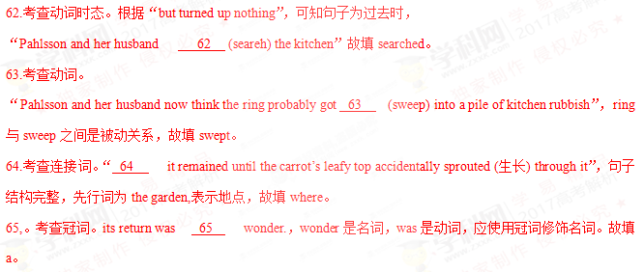第四部分 写作（共两节，满分40分）
第一节 应用文写作（满分15分）
假定你是李华，计划组织一次郊游，请给你的英国朋友Chris写封邮件邀请他参加。内容包括：
1.参加者；
2.时间、地点；
3.活动：登山、野餐等。
注意：
1.词数80左右；
2.可以适当增加细节，以使行文连贯。
第二节 读后续写（满分25分）
阅读下面短文，根据所给情节进行续写，使之构成一个完整的故事。
On a bright, warm July afternoon, Mac Hollan, a primary school teacher, was cycling from his home to Alaska with his friends. One of his friends had stopped to make a bicycle repair, but they had encouraged Mac to carry on, and they would catch up with him soon. As Mac pedaled ( 骑行)
along alone, he thought fondly of his wife and two young daughters at home. He hoped to show them this beautiful place someday.
Then Mac heard quick and loud breathing behind him. “Man, that's a big dog!" he thought. But when he looked to the side, he saw instantly that it wasn’t a dog at all,but a wolf:, quickly catching up with him.
Mac’s heart jumped. He found out his can of hear spray. With one hand on the bars, he fired the spray at the wolf. A bright red cloud enveloped the animal, and to Mac's relief, it fell back, shaking its head. But a minute later, it was by his side again. Then it attacked the back of Mac's
bike, tearing open his tent hag. He fired at the wolf a second time, and again, it fell back only to quickly restart the chase（追赶）。
Mac was pedaling hard now. He waved and yelled at passing cars but was careful not to show down. He was a steep uphill climb before him. He knew that once he hit the hill, he’d be easy caught up and the wolf’s teeth would be tearing into his flesh.
At this moment, Paul and Beeky were driving their car on their way to Alaska. They didn’t think much of it when they saw two cyclists repairing their bike on the side of the road. A bit later, they spotted what they, too, assumed was a dog running alongside a man on a bike. As they got closer, they realized that the dog was a wolf. Mac heard a large vehicle behind him. He pulled in front of it as the wolf was catching up fast, just a dozen yards away now.

注意：
1. 所续写短文的词数应为150左右；
2. 应使用5个以上短文中标有下划线的关键词语；
3. 续写部分分为两段，每段开头语已为你写好；
4. 续写完成后，请用下划线标出你所使用的关键词语。

