乌鲁木齐市第四中学2020-2021学年度下学期阶段性诊断测试
高一英语试题
(满分：150分 考试时间：100分钟)

第Ⅰ卷
第一部分 听力（共两节，满分30分）（略）
第二部分 阅读理解（共两节，满分40分）
第一节（共15小题；每小题2分，满分30分）
阅读下列短文，从每题所给的四个选项（A、B、C和D）中，选出最佳选项，并在答题卡上将该项涂黑。
A
Top Music Festivals
The festival season is just kicking off, and there is a lot to look forward to in the upcoming months.
Pitchfork Music Festival
Anyone who likes indie (独立的) music and up-and-coming artists will have an amazing time at the Pitchfork Music Festival in Chicago’s Union Park. It is an indie rock heaven where you can explore more underground and lesser-known bands than at the other big Chicago summer festival, Lollapalooza.
Date: July 14—16
Location: Chicago, Illinois, USA
Music Type: Indie rock
Price: $126—$2,700
Essence Music Festival
No matter what time of the year it is, New Orleans is an amazing place if you love live music. The Essence Music Festival is a celebration of well-known artists like Diana Ross, Chaka Khan, and Mary J. Blige.
Date: June 29—July 2
Location: New Orleans, Louisiana, USA
Music Type: R& B, soul, rock
Price: $75—$365
Sziget Festival
Budapest knows how to hold a party, and Sziget is one of the biggest celebrations of music and culture in all of Europe. You can expect to find favorite artists like Bad Religion and Mac DeMarco playing here during this three-day festival.
Date: August 9—11
Location: Budapest, Hungary
Music Type: Eclectic, Indie rock
Price: $70—$296
Flow Festival
The Flow Festival is a great excuse to explore the city of Helsinki. Artists including Lana Del Rey and The XX will be playing, among many others. Come to this festival to enjoy yourselves with an earth-friendly belief.
Date: August 11—13
Location: Helsinki, Finland
Music Type: Rock, soul, jazz
Price: $106—$199
21. What do the music festivals have in common?
A. They are given in the open air. B. They are held in the USA.
C. They include rock music. D. They take place from July to August.
22. Which music festival will last for the longest time?
A. Essence Music Festival. B. Sziget Festival.
C. Flow Festival. D. Pitchfork Music Festival.
23. What can we know about Budapest from the text?
A. It has the longest cultural tradition in Europe. B. It is home to many well-known bands.
C. It is a city of high living cost in all of Europe. D. It is good at organizing parties.

B
I speak Spanish, because I was born in Spain. But then at primary school I had to learn Russian, and at high school, I was taught how to speak German. But I always wanted to speak English.
At last I came to America. Everywhere there was English! But even if I heard and felt its presence, it was hard for me to understand it and express myself in it. The few lessons of English that I had taken in Spain gave me only a chance to introduce myself, and I didn’t even know how to buy things and ask directions.
To talk to somebody, I went to a high school to take a course in English for foreigners. Disappointingly, it took almost an hour to get through the process of introducing ourselves. Everyone had to learn something that I had already known from my books – the English alphabet (字母表) and numbers. I thought it was a waste of time, so I quit.
After a month, I tried again, but this time at college. After 15 minutes of introducing ourselves, a teacher gave us a lecture about the history of English. Then we were told that it was very important to know English in an English-speaking country. It took three hours for the teacher to tell us this. Again, I quit.
But I didn’t stop looking for something or someone that would help me to achieve my goal, and I found a tutor from Literacy Volunteers of America. But I still wasn’t happy with the classes. And when it was my turn to give a speech, I was happy to use all the long, complicated words that I had learned from one of my English books. When I had finished, my tutor said “Well, I think I have to learn English before coming to teach you!” This time, the tutor quit!
24. How many languages has the writer learned?
A. Two. B. Four. C. Three. D. Five.
25. Why did the author leave the high school?
A. Because no one wanted to talk to him.
B. Because everyone had to learn the English alphabet and numbers.
C. Because the lessons were too easy. D. Because the courses were prepared for the natives.
26. Which of the following words can be used to describe the writer?
A. happy. B. crazy. C. serious. D. friendly.
27. What is the main idea of the passage?
A. The writer learnt many foreign languages.
B. The writer tested the teachers’ English abilities.
C. The writer researched different ways of learning English.
D. The writer tried to look for a proper way to learn English.

C
Do you remember what happened on Sponge Bob Square Pants yesterday? The day before? If so, you may be in need of a TV timeout!
Kids today are watching more TV than they watched before, researchers say. Kids ages 6 to 11 in the United States watch more than three hours of TV each day. Ten years ago, children watched only about two hours and 40 minutes of TV each day.
Why the increase? Experts(专家) say more TV shows today are focused, or aimed, at kids.
Some people want to limit(限制) kids’ TV time. Researchers say that children who watch TV shows for more than three hours a day do not do as well in school. However, some programs can help kids learn. One example is BrainSurge. Some people say the show teaches kids facts.
How do you know whether a TV show can make you smart? Think about what you learn from watching, says Aletha Huston. She is a TV expert. But, she warns, don't spend too much time watching. “Limit the amount you watch. Get off the couch and do something else.”
TV Guide
This pie chart (饼状图) shows how long kids ages 6－11 use different types of TV technology each week.
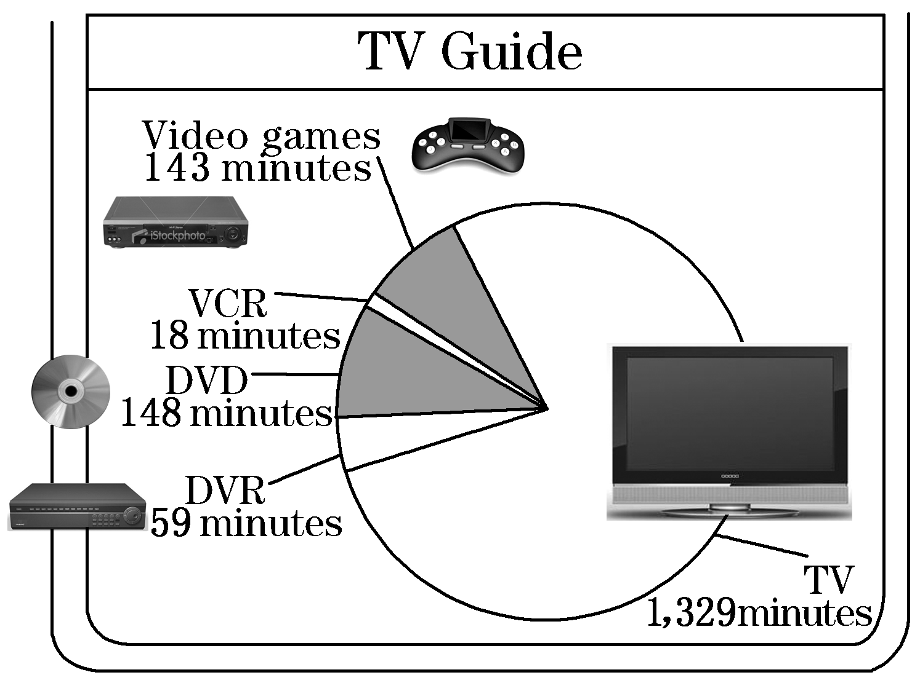
28. What is the main idea of the text?
A. Kids today watch more TV than they did before.
B. BrainSurge helps kids learn facts.
C. Kids do not watch proper TV shows.
D. More TV shows today are created for kids ages 6－11.
29. The underlined word “focused” can be replaced by ________.
A. unusual B. aimed C. suitable D. pleasant
30. How many kinds of TV technology are mentioned in the chart?
A. Three. B. Five. C. Four. D. Six.
31. According to the pie chart, kids spend the least time using________.
A. Video games B. DVD C. VCR D. TV

D
I was 9 years old when I found out my father was ill. It was 1944, but I can remember my mother’s words as if it were yesterday, “Kerrel, I don’t want you to take food from your father, because he has AIDS. Be very careful when you are around him.”
AIDS wasn’t something we talked about in my country when I was growing up. From then on, I knew that this would be a family secret. My parents were not together anymore, and my dad lived alone. For a while, he could take care of himself. But when I was 12, his condition worsened. My father’s other children lived far away, so it fell to me to look after him.
We couldn’t afford all the necessary medication for him, and because Dad was unable to work, I had no money for school supplies and often couldn’t even buy food for dinner. I would sit in class feeling completely lost, the teacher’s words muffled(消声) as I tried to figure out how I was going to manage. I did not share my burden(负担) with anyone. I had seen how people reacted to AIDS. Kids laughed at classmates who had parents with the disease. And even adults could be cruel. When my father was moved to the hospital, the nurses would leave his food on the bedside table even though he was too weak to feed himself.
I had known that he was going to die, but after so many years of keeping his condition a secret, I was completely unprepared when he reached his final days. Sad and hopeless, I called a woman at the nonprofit National AIDS Support. That day, she didn’t know any about me and my father, but kept me on the phone for hours. I was so lucky to find someone who was so kind. She saved my life.
I was 15 when my father died. He took his secret away with him, having never spoken about AIDS to anyone, even me. He didn’t want to call attention to AIDS. I do.
32. What was Kerrel’s life like when she was little?
A. She often took food from her father.
B. She had to be careful when staying with her father.
C. She didn’t look after her father until she was 15.
D. She worked hard to pay for her father’s medication.
33. How did Kerrel feel after her father became worse?
A. She couldn’t understand her teacher.
B. She had special difficulty in hearing.
C. She was too concerned to focus on the lesson.
D. She was too tired to hear her teacher’s words.
34. Why did Kerrel keep her father’s disease a secret?
A. She thought it was shameful to have AIDS.
B. She was afraid of being looked down upon.
C. She found no one willing to listen to her. D. She wanted to obey her mother.
35. What is the best title of this passage?
A. A secret never spoken. B. The sufferings of my father.
C. The terrible AIDS. D. Dark days in childhood.

第二节（共5小题；每小题2分，满分10分）
根据短文内容，从短文后的选项中选出能填入空白处的最佳选项, 有两项为多余选项。
How to Avoid the Flu
The flu (流感) can easily spread from one person to another. This is especially true for people who are weak. When you are weak, you are more likely to catch the flu. Do you know how to avoid it? __ 36 _.
Wash your hands
Washing your hands is an easy way to avoid the flu. You should wash your hands when coming home, before eating, after using the toilet, etc. _ 37 _. It’s better to wash them for several minutes.
Eat healthy food
Another good way to avoid the flu is to have healthy food, because healthy food can provide you with rich nutrition. For example, milk, eggs, vegetables and fruits are good choices for you. They will benefit your health. _ 38 _.
_ 39 _.
Doing exercise will make you stronger. If you often do exercise, you may keep fit. You can play ping-pong, go swimming, have a walk and so on. No matter what kind of exercise you do, you should do it regularly.
Keep away from people with the flu
_ 40 _. If your classmates or friends have the flu, keep away from them until they are well. You may catch it easily by staying close with them. Besides, you'd better wear a mask(口罩) in crowded places.
A. Do exercise
B. Talk with friends happily
C. Here are some suggestions for you
D. You should use running water to wash your hands
E. So it is good for you to eat healthy food every day
F. You can donate some money to help people in need
G. Keeping away from people with the flu is an effective way

第三部分 英语知识运用（共两节，满分45分）
第一节 完形填空（共20小题；每小题1.5分，满分30分）
阅读下面短文，从短文后各题所给四个选项（A、B、C和D）中，选出可以填入空白处的最佳选项，并在答题卡上将该项涂黑。
Yesterday I had a walk with a friend in the street. When we were passing by a house, I 41 a BlackBerry cellphone. I picked it up and it still 42 ! I started checking the contact list and calling numbers. I wanted to see 43 I could get some information about the owner of the phone. 44 , only one person answered and she didn’t recognize the 45 that I was calling from. In the end, she said, “It is just so nice that you are trying to 46 whose phone it is.”
Since that lady didn’t know whose phone it was, my friend 47 me to go back to the street. I _ 48 .We went back to the street and to the house 49 which we had found the BlackBerry cellphone. I 50 the door. Two college students 51 and said they hadn’t lost their phones. But when I told them the story and 52 some names on the contact list, one of them said that he 53 had those names so it must be the phone of one of his 54 .
They said it was 55 that I took the time to find the 56 . I really didn't have anything to say because in my mind I was just doing the 57 thing. I never considered 58 the phone — it wasn’t mine. I immediately tried to find the owner because that is exactly what I would want 59 to do if any of my family members 60 their phones.
41. | A. bought | B. dropped | C. repaired | D. found
42. | A. rang | B. sang | C. worked | D. shook
43. | A. that | B. if | C. what | D. how
44. | A. Probably | B. Interestingly | C. Finally | D. Unluckily
45. | A. number | B. street | C. man | D. name
46. | A. talk about | B. think of | C. find out | D. care about
47. | A. advised | B. pushed | C. helped | D. showed
48. | A. laughed | B. understood | C. argued | D. agreed
49. | A. at the back of | B. in front of | C. on the top of | D far away from
50. | A. turned to | B. looked for | C. knocked on | D. broke into
51. | A. answered | B. shouted | C. ran | D. passed
52. | A. spelled | B. wrote | C. mentioned | D. remembered
53. | A. sometimes | B. also | C. hardly | D. always
54. | A. kids | B. parents | C. students | D. friends
55. | A. exciting | B. necessary | C. wonderful | D. impossible
56. | A. phone | B. information | C. buyer | D. owner
57. | A. important | B. right | C. strange | D. brave
58. | A. giving | B. borrowing | C. mending | D. keeping
59. | A. them | B. him | C. someone | D. myself
60. | A. lost | B. described | C. needed | D. lent

第II卷
第三部分 英语知识运用（共两节，满分45分）
第二节（共10小题；每小题1.5分，满分15分）
阅读下面材料，在空白处填入适当的内容（1个单词）或括号内单词的正确形式。将答案填写在答题卡的相应位置。
We high school students do have some growing pains, 61 we can get rid of them correctly and wisely. First, some of us are upset 62 their body styles and looks. It’s unnecessary and it’s not important at all. We needn’t care about it. It is one’s inner beauty 63 is important. Second, we sometimes seem to 64 (misunderstand) by our teachers, parents and classmates. 65 (face) with this, we can find a proper time to have a heart-to-heart talk with them, trying to remove the misunderstanding. Some of us have 65 (few) friends than before. I think 67 (be) open-minded and friendly will do you good. Third, we may fall behind others, 68 makes us stressed. Actually we can encourage ourselves to work efficiently, full of 69 (determine). At last, some of us don’t have much pocket money, so they feel 70 (happy). Isn’t it strange? So long as we have some, that’s enough. And we can learn how to spend money.

第四部分 写作（共两节，满分35分）
第一节 短文改错（共10小题，每小题1分，满分10分）
假定英语课上老师要求同桌之间交换修改作文，请你修改你同桌写的以下作文。文中共有10处语言错误，
增加: 在缺词处加一个漏字符号(^)，并在其下面写出该加的词。
删除: 把多余的词用斜线(\)划掉。
修改: 在错的词下划一横线，并在该词下面写出修改后的词。
注意:
1. 每处错误及其修改均仅限一词;
2. 只允许修改10处，多者(从第11处起)不计分。
My father go fishing alone every Sunday. This morning when we were got up , it was fine. My father decided to go fishing, so my mother stopped him, said that it was going to rain according to the weather forecast. She asked him to put off his raincoat, but he did not take her advices. When he got to the river, it was cloud. Soon the rain began to fall heavily and he was caught in it. After she got home, he was wet through. “Did you catch some fish?” asked my mother. “No, but I caught bad cold,” he answered.

第二节 书面表达（满分25分）
假设你是李华，学校广播站英语角招聘广播员，你感觉这是-次很好的锻炼机会。请写一封自荐信， 包括以下要点:
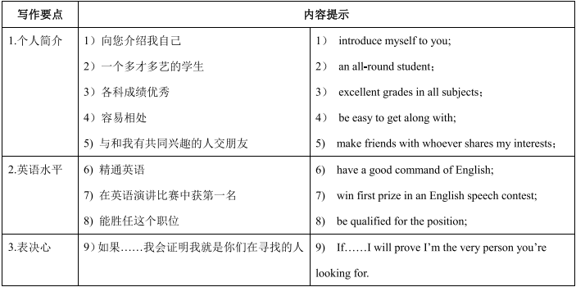
注意: 1.词数100左右:
2.可适当增加细节，使行文流畅;
3.开头和结尾已给出，不计入总词数。
Dear Sir or Madam,
I’m writing to you in response to the position advertised for an announcer, hoping that I would have the chance to team up with you.

Thanks a lot for your consideration. An early reply would be highly appreciated.
Yours,
Li Hua
高一下期末英语答案
阅读理解
21 - 23 CAD
24 - 27 BCCD
28-31 ABBC
32-35 BCBA

七选五
36-40 CDEAG

完型填空
41-45 DCBDA 46-50 CADBC 51-55 ACBDC 56-60 DBDCA

语法填空
61. but
62. about
63. that
64. be misunderstood
65. Faced
66. fewer
67. being
68. which
69.determination
70. unhappy

短文改错
1.go-goes
2. 划掉got 前的were
3. so-but
4. said-saying
5. off-on
6. advices-advice
7. cloud-cloudy
8. she-he
9. some-any
10. caught后加 a

