威海市2020-2021学年高一下学期期末考试
英 语
本试卷共11页。满分150分。考试用时120分钟。考试结束后，将答题卡交回。
注意事项：
1. 答卷前，务必用0.5毫米黑色签字笔将自己的姓名、座号、考试号填写在答题卡上。
2. 选择题，选出每小题答案后，用铅笔把答题卡上对应题目的答案标号涂黑；如需改动，用橡皮擦干净后，再选涂其他答案标号。笔答题，用0.5毫米黑色签字笔将答案写在答题卡上。不能答在本试卷上，否则无效。
第一部分 听力（共两节，满分30分）
该部分分为第一、第二两节。注意：回答听力部分时，请先将答案标在试卷上。听力部分结束前，你将有两分钟的时间将你的答案转涂到客观题答题卡上。
第一节 （共5小题；每小题1.5分，满分7.5分）
听下面5段对话。每段对话后有一个小题，从题中所给的A、B、C三个选项中选出最佳选项，并标在试卷的相应位置。听完每段对话后，你都有10秒钟的时间来回答有关小题和阅读下一小题。每段对话仅读一遍。
1. What were the speakers going to do this weekend?
A. Go on a picnic. B. Stay at home. C. Go shopping.
2. When will Jack come?
A. Next Monday. B. Next Tuesday. C. Next Thursday.
3. What is the conversation mainly about?
A. How to use the health care service.
B. How to make an online appointment.
C. How to reach a doctor in health center.
4. What is Julian going to do?
A. Sing on a big stage. B. Give a speech. C. Play the piano.
5. Where will the man meet Professor Robinson?
A. In Room 413. B. In Room 506. C. In the library.
第二节 （共15小题；每小题1.5分，满分22.5分）
听下面5段对话或独白。每段对话或独白后有几个小题，从题中所给的A、B、C三个选项中选出最佳选项，并标在试卷的相应位置。听每段对话或独白前，你将有时间阅读各个小题，每小题5秒钟；听完后，各小题将给出5秒钟的作答时间。每段对话或独白读两遍。
听下面一段对话，回答第6和第7题。
6. What might Anna be?
A. A poet. B. A composer. C. A painter.
7. How did Anna feel when people talked about her work?
A. She was shy about their praise.
B. She was proud of her achievement.
C. She was embarrassed at their criticism.
听下面一段对话，回答第8至第10题。
8. What is the project aimed for?
A. Looking for volunteers.
B. Building a cleaner community.
C. Bettering a plastic recycling system.
9. Which is the responsibility of the volunteers?
A. Learning how to sort waste properly.
B. Organizing people in groups to collect plastics.
C. Collecting and sending plastics to the recycling station.
10. When should the woman hand in her application?
A. By Thursday. B. By Friday. C. By Saturday.
听下面一段对话，回答第11至第13题。
11. How many countries has Mr. Robinson been to this year?
A. About 13. B. More than 50. C. Nearly 30.
12. Why is Mr. Robinson interested in Australia?
A. It is recommended by his father.
B. He likes its scenery and wildlife.
C. His fans want to see more photos of it.
13. What is the biggest trouble for Mr. Robinson while travelling in Australia?
A. Losing belongings. B. Poor traffic conditions. C. Getting lost in the forest.
听下面一段对话，回答第14至第16题。
14. What’s Minnie’s attitude to the geography study?
A. She always finds it boring.
B. She works hard on geology.
C. She prefers learning conservation.
15. What did the geography teacher ask students to do?
A. Introduce the extinction of iguanas.
B. Go to the library and read about iguanas.
C. Write about the conservation of an animal.
16. Why was Minnie's assignment criticized?
A. It was not informative.
B. It lacked interesting stories.
C. The theme wasn’t highlighted.
听下面一段独白，回答第17至第20题。
17. How many paintings did Van Gogh create in his life?
A. About 2,100 pieces. B. Over 900 pieces. C. Less than 1,200 pieces.
18. What can visitors do in the Gallery Section?
A. Find a link to other museums.
B. Search a list of Van Gogh’s paintings.
C. Appreciate Van Gogh’s paintings online.
19. In which section can visitors learn about the influence of Van Gogh’s work?
A. The Letters Section. B. The Artistic Influences Section. C. The News Section.
20. Where is the text most probably from?
A. A lecture. B. A tour commentary. C. A travel brochure.
第二部分 阅读理解（共两节，满分40分）
第一节（共15小题；每小题2分，满分30分）
阅读下列短文，从每题所给的四个选项（A、B、C和D）中选出最佳选项，并在答题卡上将该项涂黑。
A
I have a pretty good idea of how big Lake Superior is because I walked all the way around it. I walked about ten miles a day, and it took me five and a half months.
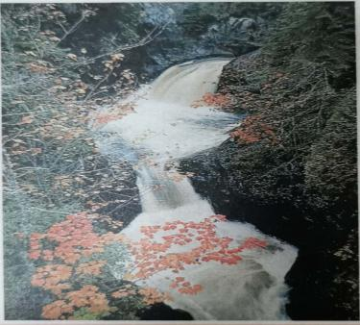
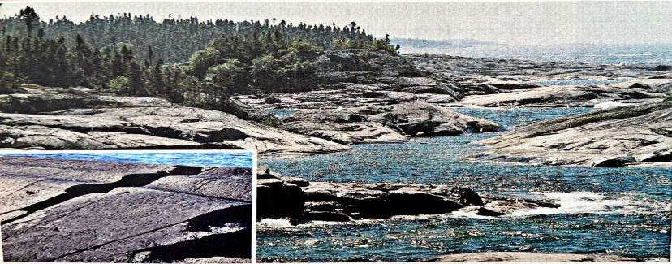
Lake Superior was created by a glacier (冰川) a mile thick, which pushed south from Canada. It dug a huge basin that filled with water when the glacier melted about ten thousand years ago. All the soil was blown off, leaving behind only hard rocks.
The Cascade River falls over rocky pools before running into the lake. (Cascade River State Park, Minnesota)
2
1

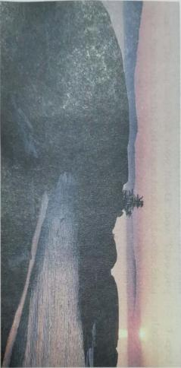
This is one of my favorite places on the trip. Here the trail runs over some of the oldest and hardest rocks on Earth. (Pukaskwa National Park, Ontario, Canada)

3
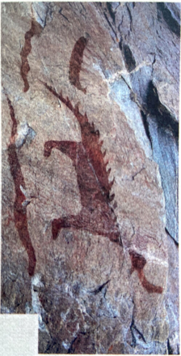
This rock painting was made by Ojibway Indians. It records a crossing of the lake by about fifty men in four or five canoes. (Lake Superior Provincial Park, Ontario, Canada)

4

I was surprised to be treated in such a special way by the people I met on my trip. I got gifts of food and invitations to share meals and stay in people’s homes. Somehow the trip was important to these people, too. People asked me questions like “What kind of food do you eat?” and “Don’t your feet get tired?” I’m glad nobody asked me why I did the walk. I’m not exactly sure myself. All I know is that it was the best thing I’ve done in my life.
21. Which picture and caption (说明文字) shows the origin of Lake Superior?
A. The first. B. The second. C. The third. D. The fourth.
22. What’s the geological feature of Lake Superior area?
A. Hilly. B. Sandy. C. Rocky. D. Muddy.
23. What does the writer think of the trip?
A. Tiring. B. Surprising. C. Adventurous. D. Wonderful.
B
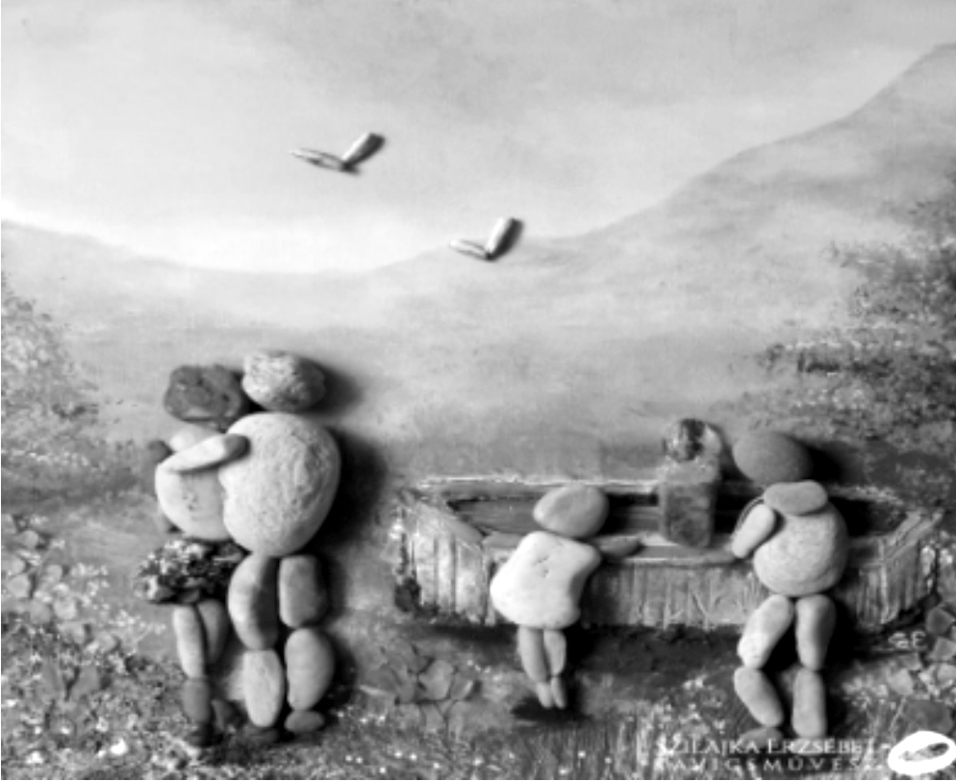
Szilajka Erzsebet is a Hungarian artist who turns ordinary pebbles (鹅卵石) into amazing works of art. The artist says she’s inspired by the pebbles’ shape, the richness of their patterns, and the beauty of nature. “I use all the pebbles in their original form shaped only by nature itself.” says Szilajka.
When Szilajka is creating her art, she lets her feelings shape the details. “This way the completed picture becomes dynamic (动态的) in spite of the fact that the pebbles themselves play a static role in the work of art,” explains the artist. “It’s like a photo taken in the perfect time. It includes the movement, the feeling, the story which can be continued. This way there are not only pebbles in the pictures but invisible fingerprints and ‘soul-prints’ as well.”
When creating her art, Szilajka often relies on her customers’ ideas but uses her artistic freedom as well. “If I only listen to myself, I do think that the most essential elements in life stand on the simplest things,” says the artist. “For me, art is adding that little something extra to simple subject matters.”
The artist believes that the completed work of art is not only her own but a common creation of the artist and the receiver. “These two things together is pebble art,” explains Szilajka. “It only becomes a real work of art if it really means something to the receivers as they have the opportunity to add their own feelings and thoughts as well. Pebbles have no face, so anyone can enter and play a part in a pebble picture…”
24. What’s the feature of her work according to Szilajka?
A. It’s original and dynamic. B. It’s creative and picturesque.
C. It’s imaginative and static. D. It’s emotional and inspiring.
25. What does the underlined “It” refer to in Paragraph 2?
A. A pebble. B. A pebble picture. C. A photo. D. Nature itself.
26. What are the last two paragraphs mainly about?
A. The inspiration of Szilajka’s creation. B. The concept of Szilajka’s creation.
C. The significance of Szilajka’s creation. D. The rewards of Szilajka’s creation.
27. What’s the genre (体裁) of the text?
A. A feature. B. An argumentative essay.
C. A biography. D. A personage introduction.
C
Elderly people have a higher chance of suffering from illnesses such as diabetes, cancer, and heart disease. One common health problem that affects them is Alzheimer’s disease, which affects a person’s memory, behavior, and thinking. Because of memory loss and behavioral changes, people with Alzheimer’s may slowly become unable to take care of themselves, eventually requiring constant care from family members or caregivers.
There is no cure for Alzheimer’s at the moment--drugs can only treat its symptoms.
But technology can improve the lives of those living with the condition by making it easier for them to go about their daily activities. For example, tracking devices placed in watches or jewelry can monitor where a person is. Automated reminders can also be stored in motion sensors and placed around the house. When a sensor detects movement, it can play a recorded voice message to remind the person to lock the door or turn off the stove.
Alzheimer’s disease is a huge challenge, but we may be getting close to finding a solution. In the future, it might be possible to treat Alzheimer’s without using drugs. A team of researchers in Australia has created a form of technology that can send sound waves into the brain. These sound waves help to clear waste in the brain that contributes to Alzheimer’s. The team has tested their technology and found that it helped to restore memory in 75 percent of mice. Work on the technology isn’t complete, but, if successful, it could prevent memory loss in people with Alzheimer’s. This really does fundamentally change the understanding of how to treat this disease and researchers foresee a great future for this approach.
28. Alzheimer’s is a disease that mainly affects the ____.
A. muscles B. blood C. brain D. heart
29. Up to now, which can help Alzheimer’s patients who get lost easily?
A. Tracking devices. B. Automated reminders.
C. Sending sound waves into the brain. D. Restoring memory.
30. Which of the following can replace “contributes to” in the last paragraph?
A. Helps to cure. B. Helps to cause. C. Helps to worsen. D. Helps to prevent.
31. What’s the main idea of the text?
A. Elderly people will begin to face many challenges.
B. Society should provide enough healthcare to elderly people.
C. There’s a need to better understand the cause of Alzheimer’s.
D. Technology might solve some problems of people with Alzheimer’s.
D
“The past is a different country; they do things differently there," L.P. Hartley wrote in one of his best-known novels, The Go-Between. To the British novelist, the past was irrelevant. And one of my Chinese students once told me "I have no interest in the past. I'm only interested in the present and the future." I have to disagree. The "past" is a very interesting country, and the more we know about it, the more we will be able to understand the present and thus, prepare ourselves for the future.
An ideal place, as I see it, that can allow us to look back on the past is the museum. I prefer to visit museums as if you are sitting in the same room with some of the greatest men in history. While no museums can claim to offer a complete picture of human history, the lessons we can learn from the events and wonders of the past are of great value.
Thanks to modern technology, museums are being transformed from places of looking and learning to spaces of participation and interaction. A large number of immersive (沉浸式) multi-media displays, which allow visitors to engage with its exhibits during their visit, play a big part at the Shanghai Natural History Museum.
The rise in technology has also made museums more accessible than ever. Since the outbreak of COVID-19, traditional museums have started to think outside of the box in order to create new ways for visitors to experience their collections online. It is definitely good news for those who are fascinated by museums but are struggling to actually go there. However, you shouldn't expect to get the same experience that an in-person visit would provide, at least, that is, for now.
International Museum Day is observed on May 18 every year. This is a quick reminder that you should always spare some time to visit museums and appreciate the "must-see 'em" things that are an important part of the cultural heritage of humankind.
32. What does the writer think of “the past”?
A. Different. B. Significant. C. Unrelated. D. Understandable.
33. Why is the museum an ideal place to look back on the past?
A. It’s where to learn and reflect.
C. It’s where to meet with great minds.
B. It’s where to learn about previous events.
D. It’s where to appreciate ancient wonders.
34. What does “outside of the box way” refer to?
A. Offering online exhibits. B. Allowing more in-person visits.
C. Adding multi-media displays. D. Showing a complete picture of history.
35. Which could be the best title for the text?
A. Technology Revives Museums B. Observe International Museum Day
C. Museums Are “Must-see 'ems” D. Visit Museums In-person or Online
第二节（共5小题；每小题2分，满分10 分）
根据短文内容，从短文后的选项中选出能填入空白处的最佳选项。选项中有两项为多余选项。将相应选项的标号（A、B、C、D、E…）涂在答题卡上。
A garden for wildlife in your backyard doesn’t have to be a jungle of untidy plant life. It can and should be a quiet shelter for you and animals. In fact, you don’t need a great deal of space to create a wildlife garden. 36 Use what you have and build from there. A successful garden for wildlife is built on four aspects: shelter and protection, food sources, water sources and nesting areas.
37 As you create a wildlife garden, keep this in mind. Your goal should be a pleasing mix of evergreen and deciduous (落叶的) trees and bushes. Plants that make your winter garden beautiful will also provide shelter and protection.
Bird feeders are a must for any garden for wildlife. Try making your own! Take into account that different birds feed at different levels and eat different kinds of seed, fruit and fats. Try to choose as many local varieties as possible. 38 Also, look for plants that produce berries to serve as a food source in fall and winter.
All animals need water to survive. An easy way to ensure the arrival of wildlife is to provide a clean water source. The traditional birdbath is fine, but placing a bowl at ground level will give some other creatures a chance. The low, boggy spot in the yard may be the perfect spot to dig out a pond for fish, frogs and birds. 39
As you create a wildlife garden, plan for nesting areas. A few bird boxes around the yard can be an invitation to the surrounding bird population. 40 Nesting birds are territorial and won’t nest too close to their neighbors.
A. Don’t put those boxes too close together.
B. It will make your backyard lovely and peaceful.
C. A larger space only increases the variety of the creatures.
D. The boxes should be measured specifically for birds in your area.
E. Even the smallest preformed pool can add wildlife interest to your yard.
F. Almost all wild creatures use plants not only for protection but also for shelter.
G. Seeds, nectar and insects are all possible food sources for some little creatures.
第三部分 语言运用（共三节，满分35分）
第一节（共10小题；每小题1分，满分10分）
阅读下面短文，从短文后各题所给的四个选项（A、B、C和D）中，选出可以填入空白处的最佳选项，并在答题卡上将该项涂黑。

An active person, Erin Brown becomes especially expressive when she talks about competing in the triathlon at the Paralympics Games (残奥会) in Tokyo in 2021. Her hands flying, her eyes 41 , she explains that COVID-19, which has 42 gyms and beaches in the Bahamas, has only somewhat slowed her training. She found a private pool to swim in, and she is cycling indoors.
Sports competition is extremely empowering for people with disabilities, giving them more 43 in controlling their life. She says, “People don’t 44 what you look like. They only focus on the efforts and 45 you’ve made.”
In fact, the forty-year-old mother of two children has made empowering disabled people the driving force of her own life. She runs a small firm to 46 in many areas, including health care and employment. She is the one-person department of disability affairs at the University of The Bahamas, which has become more 47 since COVID-19 complicated the 48 faced by students with disabilities. And she plans on becoming a disabilities rights attorney (代理人).
She’s empowering disabled people to engage, to be aware of their 49 , whether that’s in employment, in making health services more 50 , or in getting them at the forefront of planning.
41. A. red B. open C. watery D. bright
42. A. closed B. limited C. changed D. destroyed
43. A. attention B. confidence C. options D. reasons
44. A. ask B. know C. care D. ignore
45. A. mistakes B. decisions C. responses D. achievements
46. A. compare B. plan C. help D. improve
47. A. challenging B. deserving C. inspiring D. amusing
48. A. tests B. difficulties C. dangers D. questions
49. A. rights B. advantages C. impact D. value
50. A. child-friendly B. customer-friendly C. eco-friendly D. disability-friendly
第二节（共10小题；每小题1.5分，满分15分）
阅读下面材料，在空白处填入适当的内容（不多于1个单词）或括号内单词的正确形式。
Most of you have heard of the term "big data". If anyone 51 (confuse) by it, let me explain it. When a company records the information of millions of users, it can analyze this "big data" to discover patterns and trends, allowing them to make better business decisions. It sounds like a science experiment, but every single user who gives up their information 52 (become) an unwilling test subject. Companies claim that the data is used to provide "better service," 53
is really an excuse for them to make more money.
Take shopping on Taobao 54 an example. You will get product recommendations
55 (base) on your previous purchases, making it much 56 (easy) to finish a shopping list. However, did you really end up only 57 (purchase) items you originally had in mind? Or did you add a few more to the cart? That's where the business wins. And the customer? They just become one more point of data in the system.
As technology grows more advanced, there will only be more 58 (opportunity) for you to be exposed. Every single photo, text or video you post on the internet is there to help someone paint 59 better picture of you. Perhaps in the near future, someone will have collected enough data 60 (predict) the future decisions you will make before you even make them.
第三节 （共10小题；每小题1分，满分10分）
请根据汉语意思及首字母将单词的完整形式写在答题卡上。
- That system g______(保证) the survivors a basic help after that earthquake.
- These d______(捐助) with other funding sources will help the village to open a library.
- The incredible d______(渴望) to think and share is the real spirit of invention.
- Three Days To See has always been one of the most inspiring c______(经典作品).
- F_______(坦率地) speaking, I don’t think it wise to tell her the truth directly.
- More kinds of butterflies have been found here, s_____(发……信号) environmental progress.
- Harry Portter became an i______(立即的) best-seller when it was eventually released.
- Our English teacher is quite outgoing and often e______(逗乐) us in class.
- I have a dream to set foot on all the c______(大洲) on the earth during my life.
- Foxes, used to be caught stealing chickens frequently, are r______(很少) seen nowadays.

第四部分 写作（共两节，满分45分）
第一节 概要写作（满分20分）
阅读下面短文, 根据内容写一篇60词左右的内容概要。
The power of persuasion
You’re shopping, and you see two similar products. How do you decide which one to buy? You might think you make this decision by yourself--but this isn’t always the case.
Don’t believe it? Try this. What word is missing?
APPLE TREE GRASS GR_______
What was the first word you thought of? Did you think of “green”? That’s probably because we influence your answer. The words “tree” and “grass” made you think of the color green, right? This is an example of priming.
Priming is a way to “use hints to influence your attitudes and responses, often without you even noticing.” Priming speeds up our decision-making. That’s why advertisers use it to persuade us to buy things.
Use of color is one type of priming. Studies show that red gives people warm and positive feelings. We feel good about products connected with the color red, so we want to buy them. Green, on the other hand, makes products seem natural. Food companies often use green packages to make their food seem healthy.
Descriptions in ads and signs also influence buying decisions. For example, studies show that if an ad says there’s a limit to the number of items you can buy, you’ll want more of them. Why? According to psychologist, something becomes more attractive if it’s rare.
The sounds in ads also influence decision-making. For example, advertisers sometimes use rhymes in their ads. In a study, researchers showed people pairs of messages with the same meaning--one that rhymed and one that didn’t. The study found that people are more likely to believe the rhyming message.
Advertisers use a lot of techniques to persuade customers to buy their products. You might think you’re in control when you shop, but maybe you’re not. Priming strategies would be influencing your decision.

第二节 应用文写作（满分25分）
阅读下面网页，写一篇100词左右的博文，注意不得透露学校、姓名等任何个人信息。



+
This global site is a place for teenagers to share their stories about travel. So, if you want to tell about your story, get in touch–we’d love to hear from you!

Travel Broadens My Mind

