芮城中学高三年级
英 语 试 题
（满分：150分；时间：120分钟；命题人：肖芬）
2017.9
第一部分 阅读理解（共两节，满分60分）
第一节 （共15小题；每小题3分，满分45分）
阅读下列短文，从每题所给的四个选项（A、B、C和D）中，选出最佳选项，并在答题卡上将该项涂黑。
A
We live in central Phoenix，near the canal. Every day I used to see a homeless old man and his scruffy little dog hanging out down there．
I would tell my husband we should give him food for the little dog. It wouldn’t have been a problem；we have our own“mini farm”of animals! But he would say“OK!”and then blow the idea off because of our business．
Being in Phoenix, Arizona, you can just imagine how hot it gets here, but his winter was really chilly! I had just come from KFC with takeout food for dinner, As l was turning by the canal, the man and his dog were sitting right there all bundled up. (穿着暖和的衣服)Even the doggy had a coat on! Not even thinking about it，I pulled into the parking lot along the canal and piled up a plate of chicken with all the fixings for the man and his little buddy, I gave it to him with a soda and a bottle of water for the little dog．He said，“Thank you, sweetie. You are an angel．”And there were tears welling up in his eyes! I told him he was so welcome, and then went home．
When my husband dug into the KFC bag he asked，“Were you hungry, or what?”I told him what I did and he said，“Only you!”Then he told me I had done a good thing．
A few weeks later, we were walking along the canal and found the man walking to me，with his little dog. He asked whether I would mind adopting the dog. With tears in eyes, he said it had gotten too hard for him to care for the dog. He added that he was planning on heading to Washington State but his dog wouldn’t have been up to it, so he hoped to give it to me．“Only you! In this city，you are the only person I can believe in!”
Now, every time I watch and pat the puppy lying near the fireplace. I will recall the old man’s words and wish him good luck．
1．The author and her husband didn’t help the old man at the beginning because ．
A．they had a farm of animals to feed
B．they didn’t have food even for themselves
C．they worked busily and often forgot it
D．they were unwilling to help a man with a dog
2．What can we learn about the author from Paragraph 3?
A．She gave the old man some food on a cold day．
B．She met the old man after finishing her dinner．
C．She offered the old man nothing but chicken．
D．She burst into tears after helping the old man.
3．What did the author's husband feel when she told him what she had done？
A．Grateful． B．Delighted． C．Indifferent. D．Disappointed．
4．What can we infer from the ending of the passage?
A．The author refused the old man’s request．
B．The author misses the old man and his dog．
C. The author feels the old man was very lucky．
D．The author adopted the old man’s dog．
B
I’m not so sure I like my friends any more. I used to like them—to be honest. We’d have lunch, talk on the phone or exchange emails, and they all seemed normal enough. But then came FaceBook, and I was introduced to a sad fact: many of my friends have dark sides that they had kept from me．
Today my friends show off the more unpleasant aspects of their personalities via FaceBook. No longer hidden, they’re thrown in my face like TV commercials—unavoidable and endless advertisements for the worst of their personalities．
Take Fred. If you were to have lunch with him, you’d find him warm, and self-effacing(谦逊的). Read his FaceBook and you’ll realize he’s an unbearable，food-obsessed boring man. He’d pause to have a cup of coffee on his way to save a drowning man—and then write about it．
Take Andy. You won’t find a smarter CEO anywhere, but now he’s a CEO without a company to run. So he plays Mafia Wars on FaceBook. He’s doing well—level 731. Thanks to FaceBook, I know he’s playing about 18 hours a day. Andy, you’ve run four companies—and this is how you spend your downtime? What happened to golf? What happened to getting another job?
Take Liz．She is positive that the flu vaccine will kill us all and that we should avoid it. And then comes Chris who likes to post at least 20 times a day on every website he can find，so I get to read his thoughts twice, once on FaceBook and once on Twitter．
In real life, I don’t see these sides of people. Face to face, my friends show me their best. They’re nice, smart people. But face to FaceBook, my friends are like a blind date which goes horribly wrong．
I’m left with a dilemma. Who is my real friend? Is it the Liz I have lunch with or the antivaccine mad woman on FaceBook? Is it the Fred I can grab a sandwich with or the Fred who weeps if he’s at a party and the wine isn’t up to his standards?
5. Who is opposed to the flu vaccine in the text?
A. Fred． B. Andy． C. Liz． D. Chris．
6. What’s Andy probably busy in doing now?
A. He’s running his company． B. He’s playing golf all day．
C. He’s looking for another job． D. He’s playing computer games．
7. What does “it” underlined in the last paragraph refer to?
A. a dilemma B. my real friend C. FaceBook D. Twitter
8. The text is developed mainly by_________．
A. giving examples B. following the time order
C. listing figures D. raising questions
C
Our Center
We have information about over 300 volunteering opportunities with more than 250 local organizations (charities, statutory organizations such as hospitals and social services and community groups). We are a registered charity and our service is free of charge.
We do not run volunteering projects ourselves bur recruit (招募) volunteers for a whole range of organizations across Cambridge and South Cambs.
Volunteering Links
National Council for voluntary Organizations
A center to champion and strengthen the voluntary sector in the UK with advice, support and public policy.
Cambridge Council for voluntary Service
An independent registered charity to help community and voluntary groups in Cambridge, South Cambridge, Shire and Fenland.
Volunteering Wales
Volunteering and volunteer Centers in Wales.
Volunteer Development Scotland
Volunteering and Volunteer Centres in Scotland.
Community Service Volunteers
Volunteer placements in the UK.
Student Hubs
A branch of Student Hubs, a youth-led charity working across the UK to transform student involvement in charitable activities.
Timebank
A national campaign inspiring and connecting people to share and give time.
Registration Information
If you spot an opportunity that you like, you can go through a simple online registration process and then we will send you the details.
Alternatively you can down load a VOLUNTEER REGISTRATION FORM (please save it to your own computer before editing) and email the completed form to us at info@carn-volunteer.org.uk.
If you need a bit more help, then we can offer you a confidential one-to-one chat with a member of staff to discuss what you would like to do. But you must make an appointment beforehand.
You don’t have to visit the Volunteer Centre in person to get help. We can also provide information by e-mail, post or over the telephone.
9. Which of the following is not true about the center?
A. Volunteers can find plenty of opportunities in the center.
B. The center does not charge money for their service.
C. The center does not run volunteering projects themselves.
D. Organizations like Student Hubs belong to the center.
10. Which organizations are suitable for a teacher to volunteer in Wales?
A. National Council for Voluntary Organizations and Student Hubs.
B. Cambridge Council for Voluntary Service and Timebank.
C. Volunteering Wales and Volunteer Development Scotland.
D. Community Service Volunteers and Volunteering Wales.
11. If a student wants to volunteer through the center, he must_______.
A. get registered at the center for recruitment
B. make an appointment with the center
C. visit the center in person to fill in the form
D. directly contact voluntary organizations
D
Life can be so wonderful, full of adventure and joy. It can also be full of challenges，setbacks(挫折)and heartbreaks．Whatever our circumstances, we generally still have dreams. hopes and desires--that little something more we want for ourselves and our loved ones．Yet knowing we can have more can also create a problem，because when we go to change the way we do things, up come the old patterns and pitfalls(陷阱)that stopped us from seeking what we wanted in the first place．
This tension between what we feel we can have and what we’re seemingly able to have is the niggling(烦人的) suffering, the anxiety we feel. This is where we usually think it’s easier to just give up. But we’re never meant to let go of the part of us that knows we can have more. The intelligence behind that knowing is us—in real us. It’s the part that believes life and its possibilities．If you drop that，you begin to feel a little “dead” inside because you’re dropping “you”．
So, if we have this capability but somehow life seems to keep us stuck, how do we break these patterns?
Decide on a new course and make one decision at a time. This is good advice for a new adventure or just getting through today’s challenges．
While，deep down，we know we can do it，our mind—or the minds of those close to us usually says we can’t ,That isn’t a reason to stop，it’s just the mind，that little man or woman on your shoulder, trying to talk you out of something again. It has done it many times before．It’s all about starting simple and doing it now．
Decide and act before overthinking. When you do this you may feel a little，or large，release from the jail of your mind and you’ll be on your way．
12．It can be inferred from the first two paragraphs that we should
A．slow down and live a simple life
B．be careful when we choose to change
C．stick to our dreams under any circumstances
D．be content with what we already have
13．What is the key to breaking the old patterns?
A．To focus on every detail． B．To decide and take immediate action．
C．To listen to those close to us． D．To think twice before we act．
14．Which of the following best explains the underlined part in the last paragraph?
A．Escape from your punishment． B．Realization of your dreams．
C．Freedom from your tension． D．Reduction of your expectations．
15．What does the author intend to tell us?
A．It’s easier than we think to get what we want．
B．It’s important to learn to accept sufferings in life．
C．It’s impractical to change our way of thinking．
D．It’s harder than we expect to follow a new course．
第二节 七选五阅读（共5小题：每小题3分，满分15分）
根据短文内容,从短文后的选项中选出能填入空白处的最佳选项。选项中的两项为多余选项。
Mobile Phones：Hang Up or Keep Talking?
Millions of people are using mobile phones today. In many places, it is actually considered unusual not to have one. 16 They found that the phones are more than a means of communication—having a mobile phone shows that they’re cool and connected.
The explosions around the world in mobile phone use make some health professionals worried. Some doctors are concerned that in the future many people may suffer health problems from the use of mobile phones. Mobile phone companies are worried about the negative publicity (负面报道) of such ideas. 17
On the other hand, signs of change in the issues of the brain and head can be detected with modern scanning equipment. In one case, a traveling salesman had to retire at a young age because of serious memory loss. 18 This man used to talk on his mobile phone for about six hours a day，every day of his working week, for a couple of years.
19 The answer is radiation. High tech machines can detect very small amounts of radiation from mobile phones. Mobile phone companies agree that there is some radiation, but they say the amount is too small to worry about.
As the discussion about safety continues, it appears that it’s best to use mobile phones less often. 20 Use your mobile phone only when you really need it. In the future, mobile phones may have a warning label that says they’re bad for your health. So for now, it’s wise not to use your mobile phone too often.
A．They will possibly affect their benefits.
B．In many countries, mobile phones are very popular with young people.
C．What do the doctors worry about?
D．What is it that makes mobile phones potentially harmful?
E．They say that there is no proof that mobile phones are bad for people’s health.
F．He couldn’t remember even simple tasks.
G．Use your regular phone if you want to talk for a long time.
第二部分 英语知识运用（共两节，满分55分）
第一节 完形填空（共20小题；每小题2分，满分40分）
阅读下面短文，从短文后各题所给的四个选项(A、B、C和D)中，选出可以填入空白处的最佳选项。
A man was exploring some caves by the seashore. In one cave he 21 a bag of hardened clay (粘土)balls．It seemed that someone had 22 some clay and baked the balls in the sun. They didn't look like 23 things, but they interested him, 24 he took the bag out of the cave with him．
As he walked along the beach he 25 the clay balls one at a time out into the ocean as far as he could．He thought 26 about it until he dropped one of the balls and it cracked open on a rock. 27 was a beautiful, precious stone. 28 ,the man started breaking open the remaining clay balls． 29 contained a similar treasure．He found thousands of dollars’worth of jewels in the 20 or so clay balls he had 30 ,and then it struck him: 31 thousands of dollars in treasure, he could have had tens of thousands, with the 50 or 60 clay balls with their 32 treasures which were now in the ocean．He just 33 the chance．
Sometimes it's like that with 34 . When we look at a person, we usually only see “the outside clay shell". It isn't always beautiful or shining, so we 35 the person；we see him as less important than someone more beautiful or more 36 . But we haven't taken the time to look for the 37 inside that person．If we spend the time getting to know that person, the clay will 38 and the brilliant jewel will shine. We are 39 made, not only with our physical bodies, but also with our spiritual selves, which are sometimes hidden 40 others by the "earthen shell”.
21．A．searched  22．A．rolled  23．A．dangerous  24．A．while  25．A．pushed  26．A．little  27．A．Out  28．A．Moved  29．A．Each  30．A．given  31．A．In case of  32．A．hidden  33．A．forgot  34．A．money  35．A．pity 36．A．warm-hearted  37．A．clay  38．A．come off  39．A．normally  40． A．from | B．lost  B．pressed  B．valuable  B．though  B．put  B．long  B．Inside  B．Satisfied  B．Much  B．taken  B．In return for  B．obvious  B．missed  B．life  B．blame  B．honest  B．treasure  B．break away  B．gradually  B．behind | C．made  C．dug  C．annoying  C．if  C．threw  C．hard  C．Next  C．Worried  C．None  C．left  C．Instead of  C．well-known  C．abandoned  C．people  C．ignore  C．famous  C．ball  C．run out  C．wonderfully  C．with | D．found  D．cut  D．ordinary  D．so  D．pulled  D．well  D．Below  D．Excited  D．Few  D．dropped  D．Because of  D．questionable  D．faced  D．friends  D．hate  D．stylish  D．shell  D．dry up  D．expensively  D．by
注意：将答案写在答题卡上。写在本试卷上无效。
第二节 语法填空 (共10小题；每小题I.5分，满分15分)
阅读下列材料，在空白处填上适当的内容或括号内单词的正确形式（不多于3个词）。
As an exchange student. Wei Hua studied in a British high school for one year. She was happy 41 the school hours in Britain because school starts around 9 a m and ends about 3: 30 P. m
On the first day. all the new students 42 (attend)an assembly in the school hall. Wei Hua sat next to a girl 43 name was Diana. During the assembly, the headmaster told the students that the best way to earn respect was to devote themselves 44 study and achieve high 45 (grade). As there were different students in some classes, 46 was a struggle for Wei Hua to remember all the faces and names．
Although the homework was not as heavy as 47 she used to get in her old school It was a bit 48 (challenge)for her at first because all the homework was in English. Luckily，all her teachers gave her much 49 (encourage). To improve her English, Wei Hua used English every day and spent an hour each day 50 (read)
English books in the library．
In a word, studying in Britain was a very enjoyable and exciting experience tor Wei Hua．
第三部分 写作（共两节，满分35分）
- 短文改错(共10小题；每小题1分，满分10分)
假定英语课上老师要求同桌之间交换修改作文，请你修改你同桌写的以下作文。文中共有10处语言错误，每句中最多有两处。每处错误仅涉及一个单词的增加、删除或修改。
增加：在缺词处加一个漏字符号（∧），并在其下面写出该加的词。
删除：把多余的词用斜线（\）划掉。
修改：在错的词下划一横线，并在该词下面写出修改后的词。
注意：1.每处错误及其修改均仅限一词;
2.只允许修改10处，多者(从第11处起)不计分。
I am grateful to my English teacher Susan, with whose help I couldn’t have won first prize in English Talent Competition for high school student last week．
I used to be poor in speaking English. I was too shy to speak in class. Since she teaches US last term, she has been encouraging him to overcome fear and speak out in class．Thanks to her, I have made great progresses. Besides, I practiced several times in the front of her. It was her advice which made me a better speaker and full of confidence. And I owe my success to her．
Susan set me a good example, I am determined to become an English teacher when I grow up．
第二节：书面表达（满分25分）
你是吴刚，是个交流学生(an exchange student), 四年前住在美国Johnson 家。现在你已经回国。根据以下要点，用英语写一篇100词左右的感谢信。开头和结尾已给出，不计入总词数。
1．感谢四年来Johnson一家人对你在生活、学习等方面的关心与帮助。
2．感悟美国家庭教育与中国家庭教育的差异(劳动态度、独立生活能力)。
3．现在正在找工作。欢迎到中国来。
Dear Mr and Mrs Johnson，
I am Wu Gang. I have been back home in China.

Best wishes!
Yours truly，
Wu Gang
高三英语答案
A篇

B篇
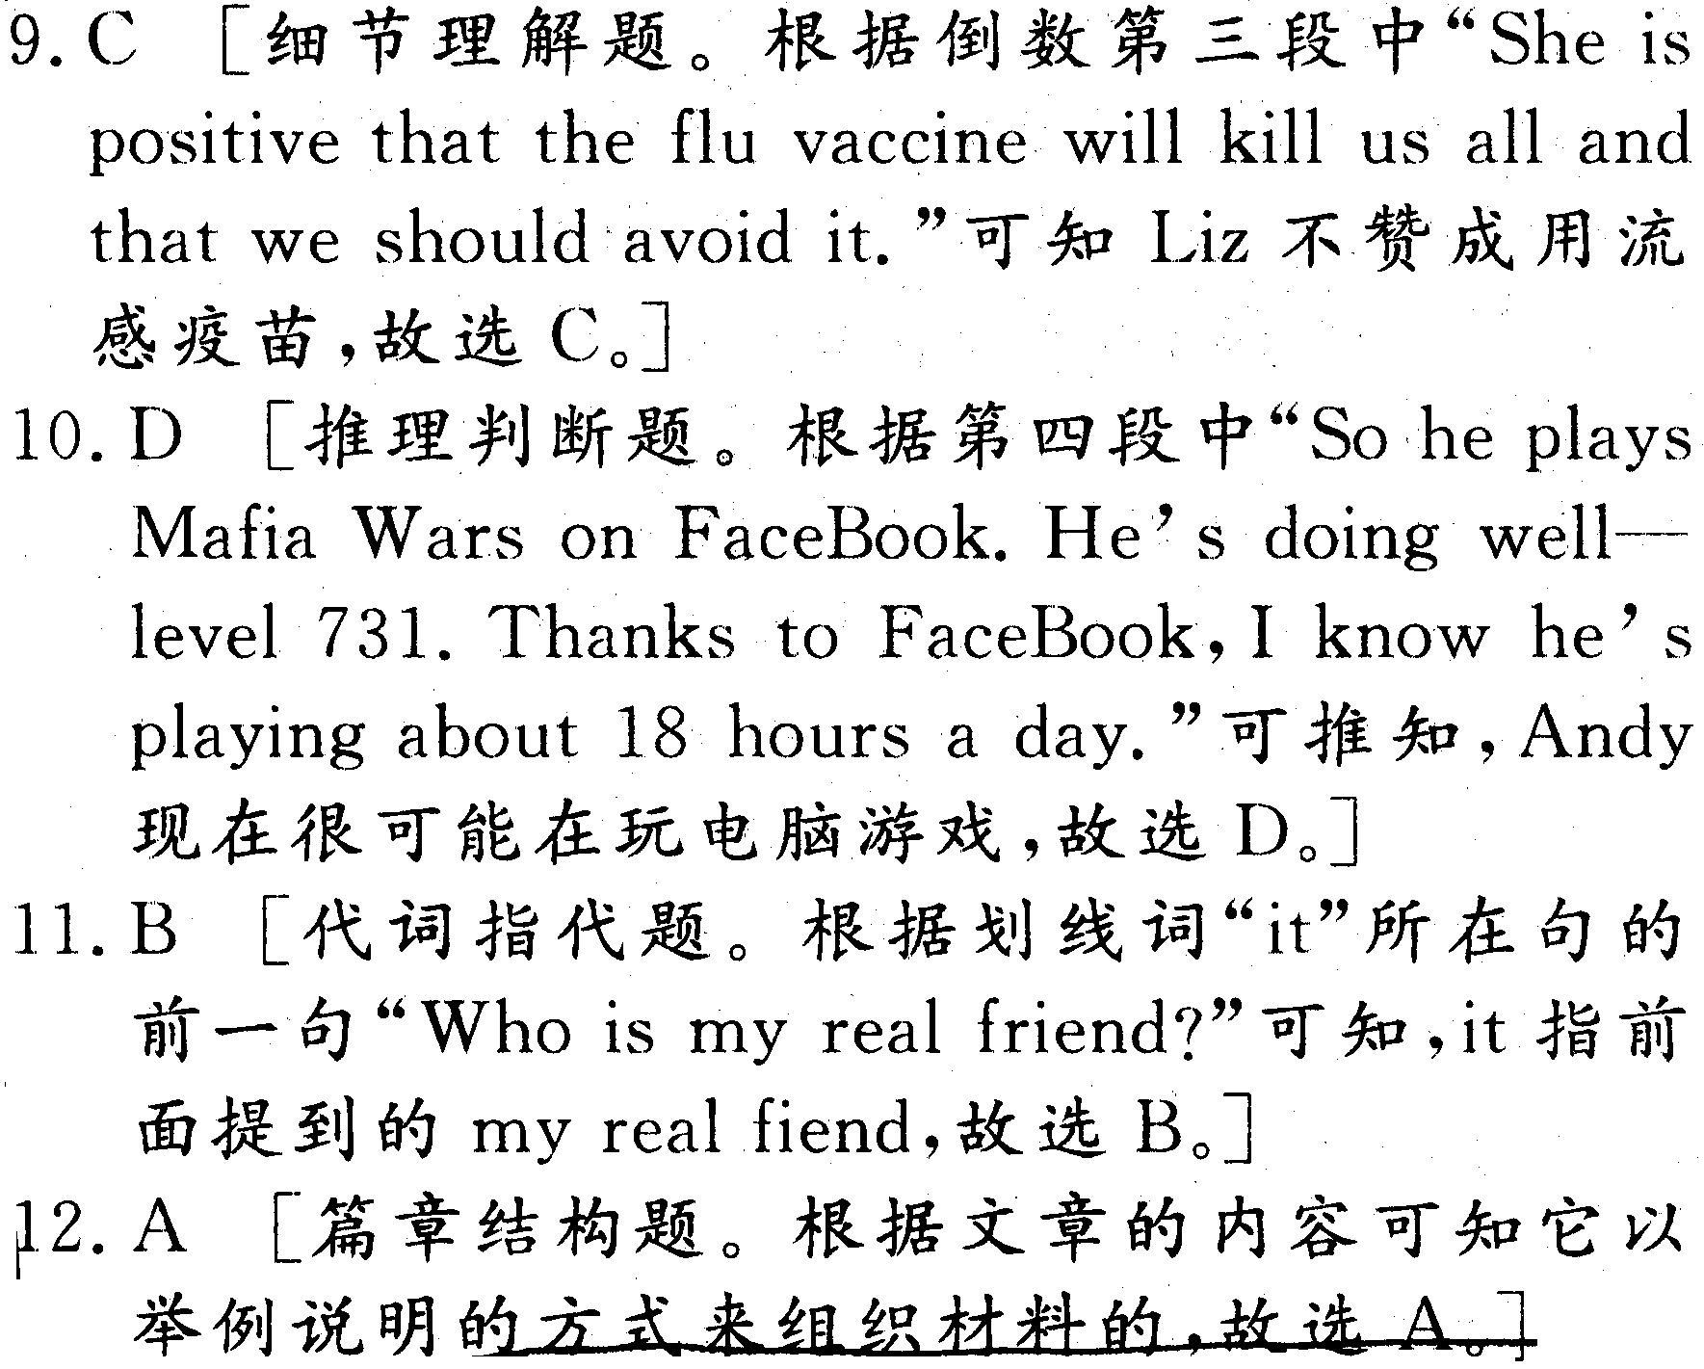
5.
6.
7.
8.
15.
C篇
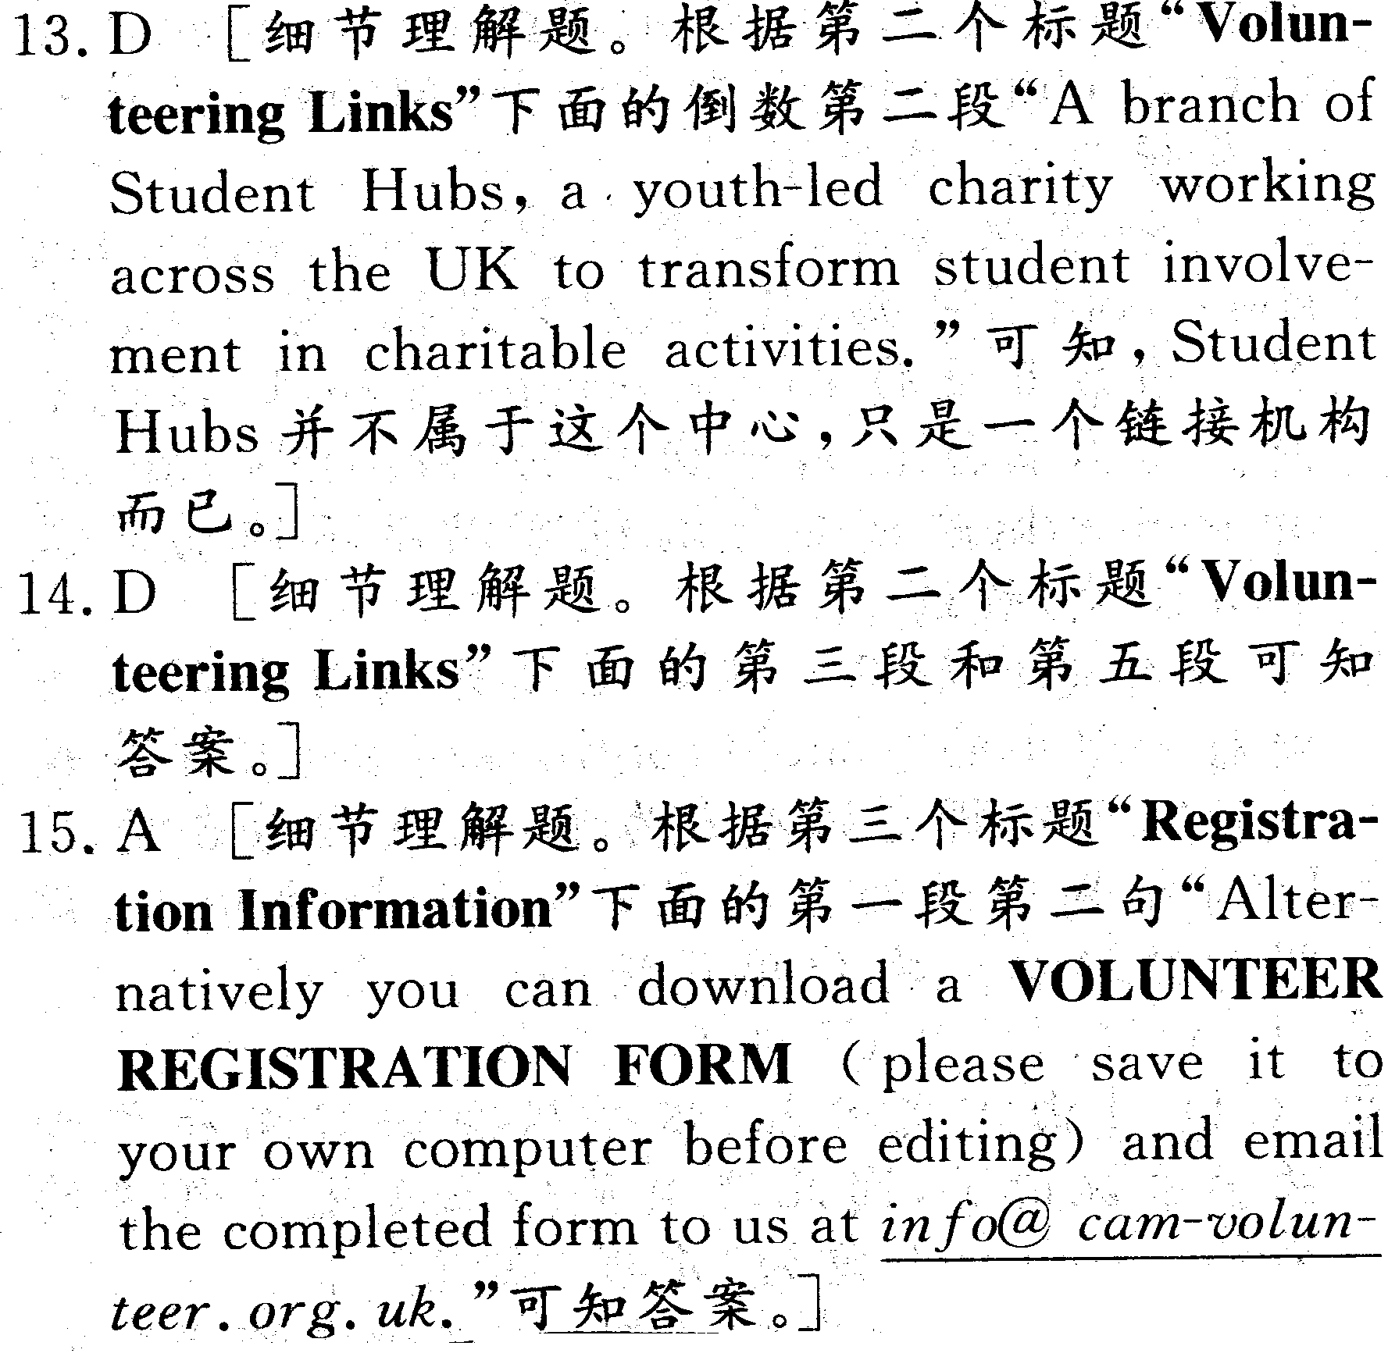
9.
10.
11.
D篇
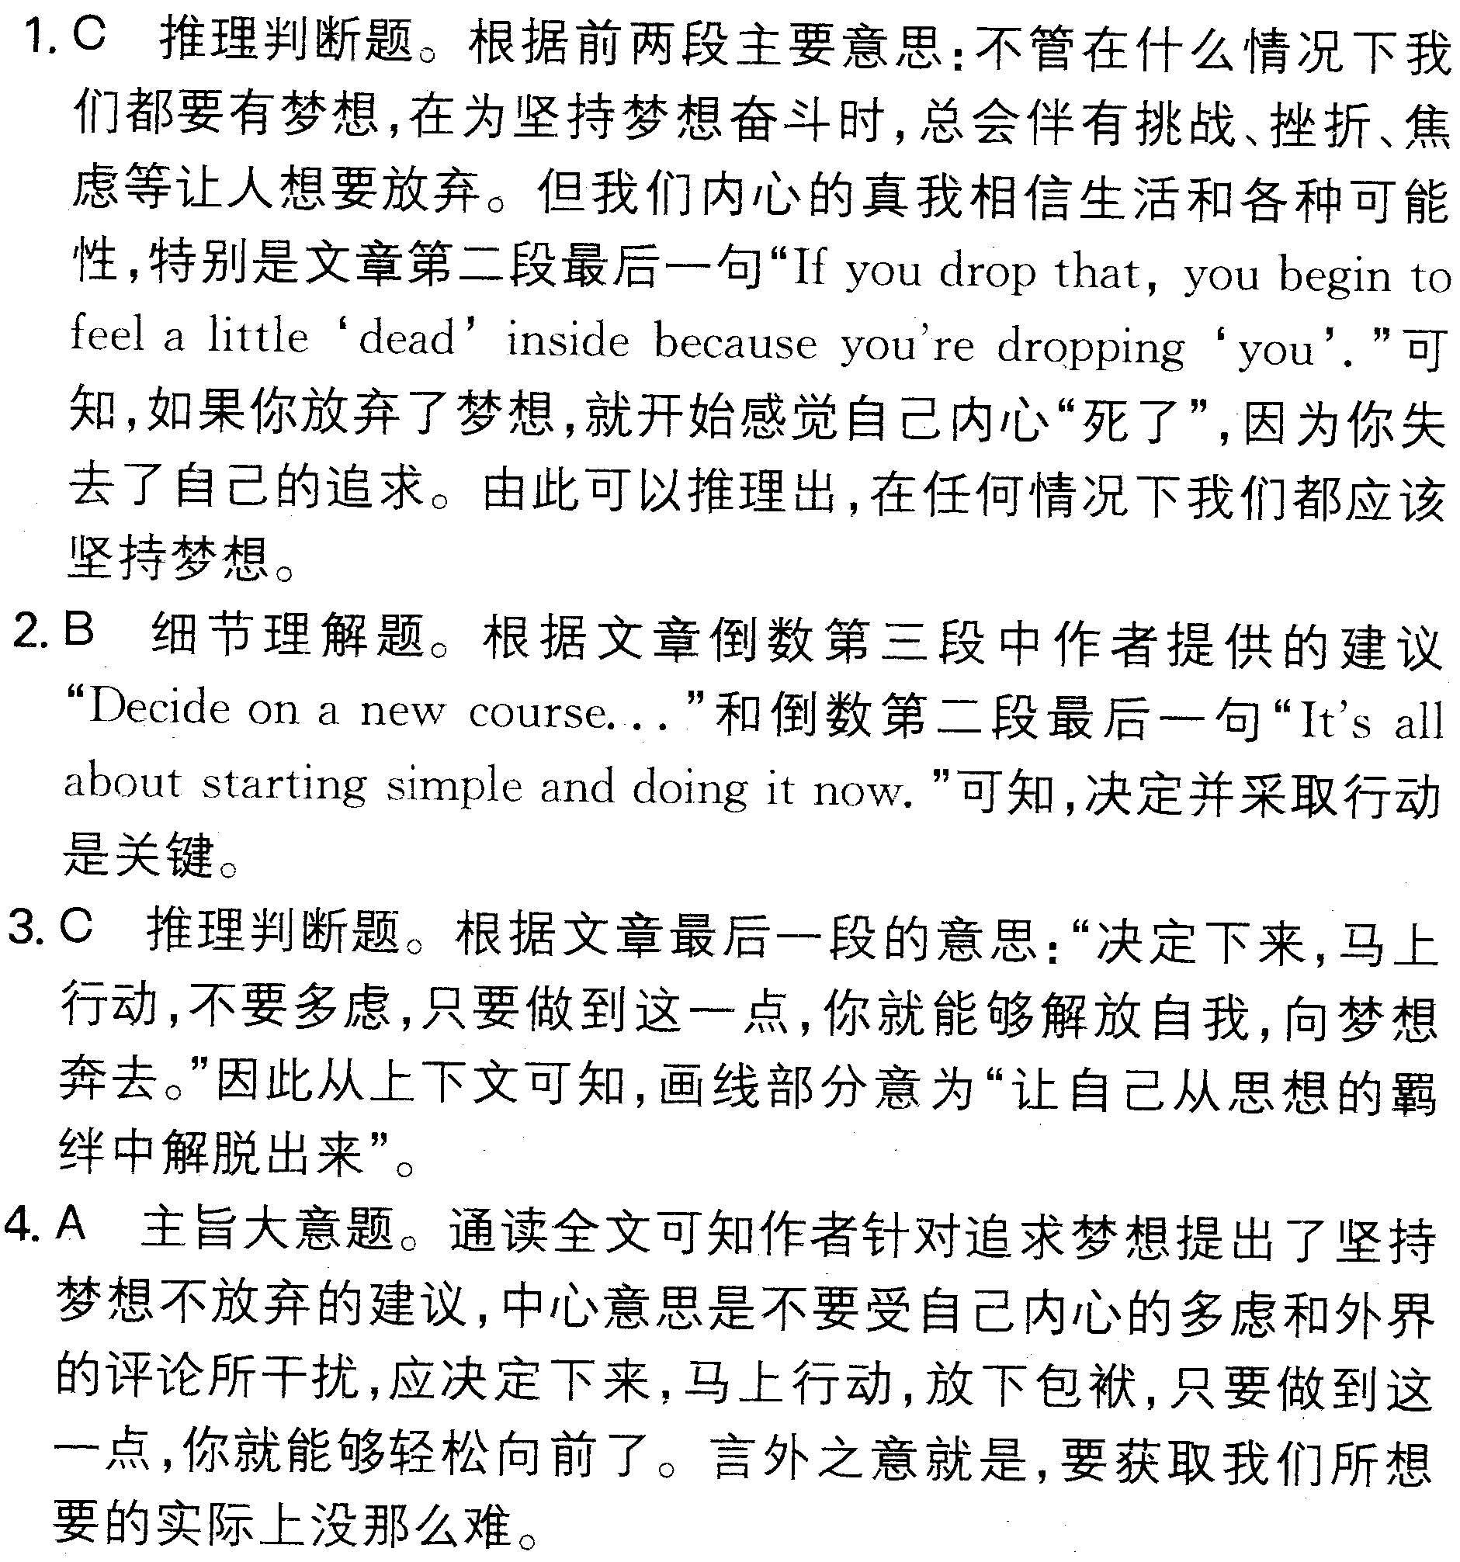
12.
13.
14.
七选五 16. B 17. E 18. F 19. D 20. G
完形填空
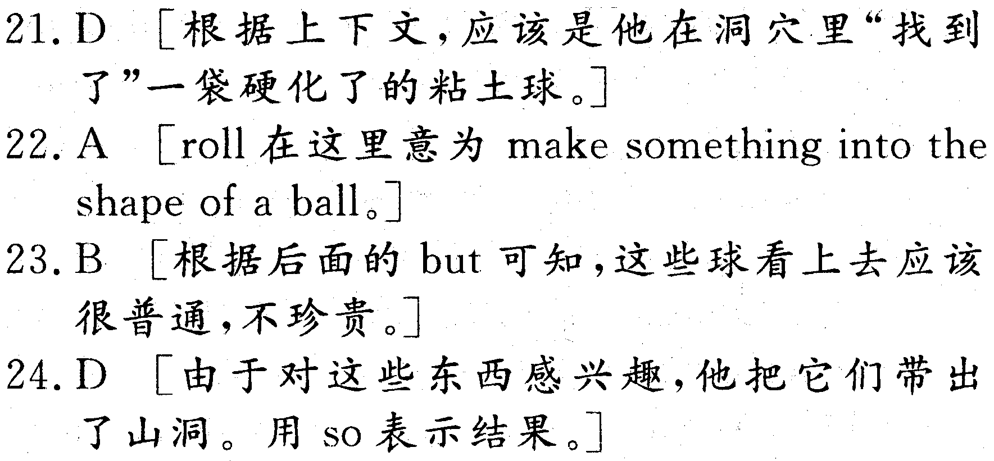
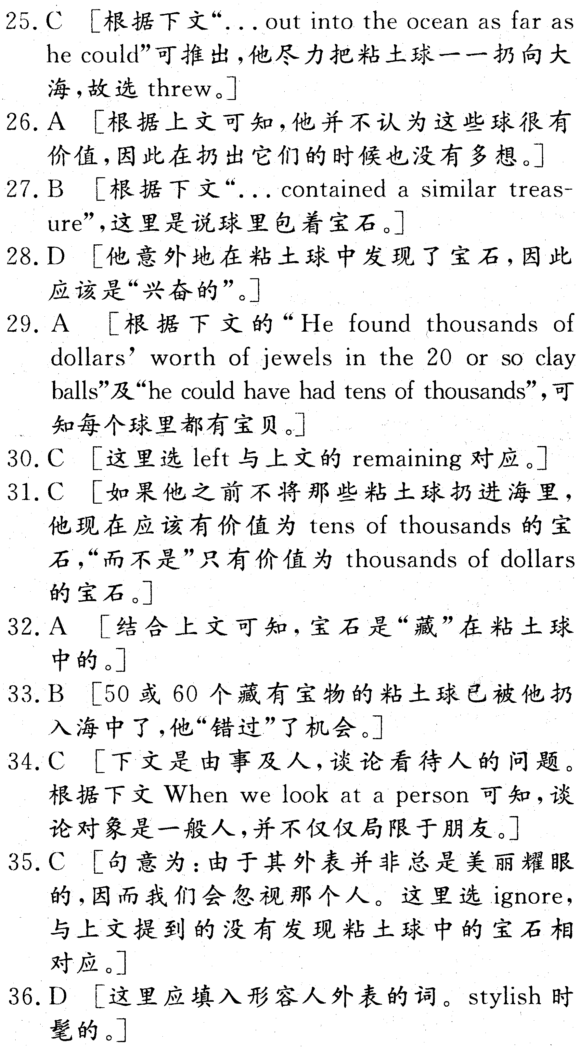
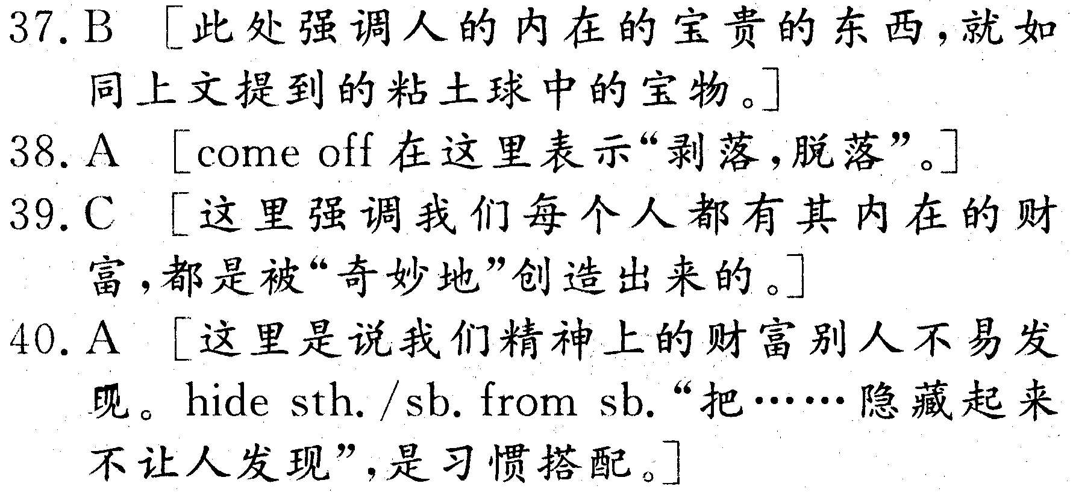
语法填空
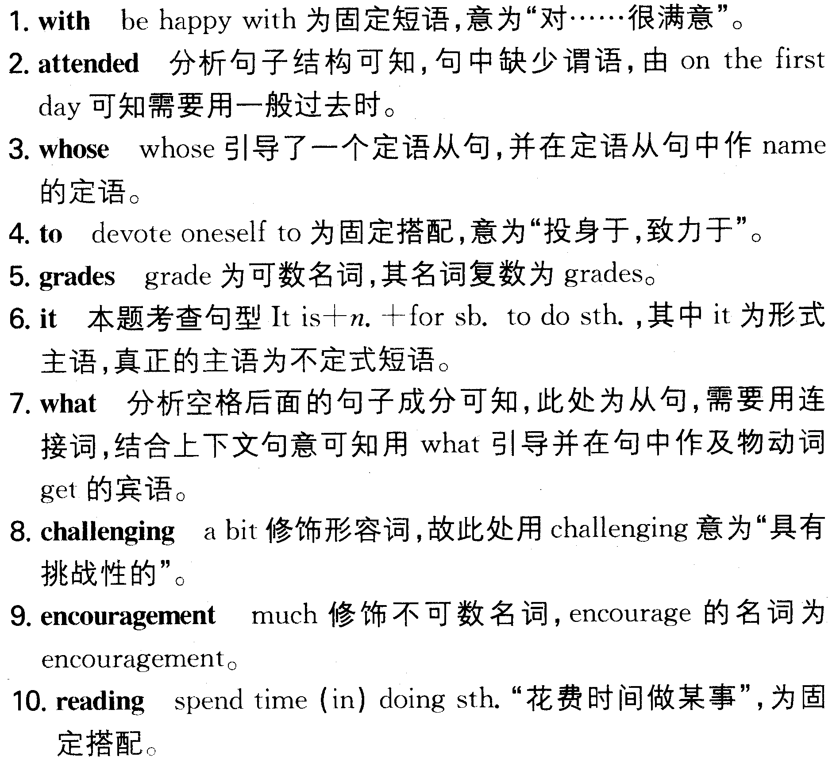

短文改错
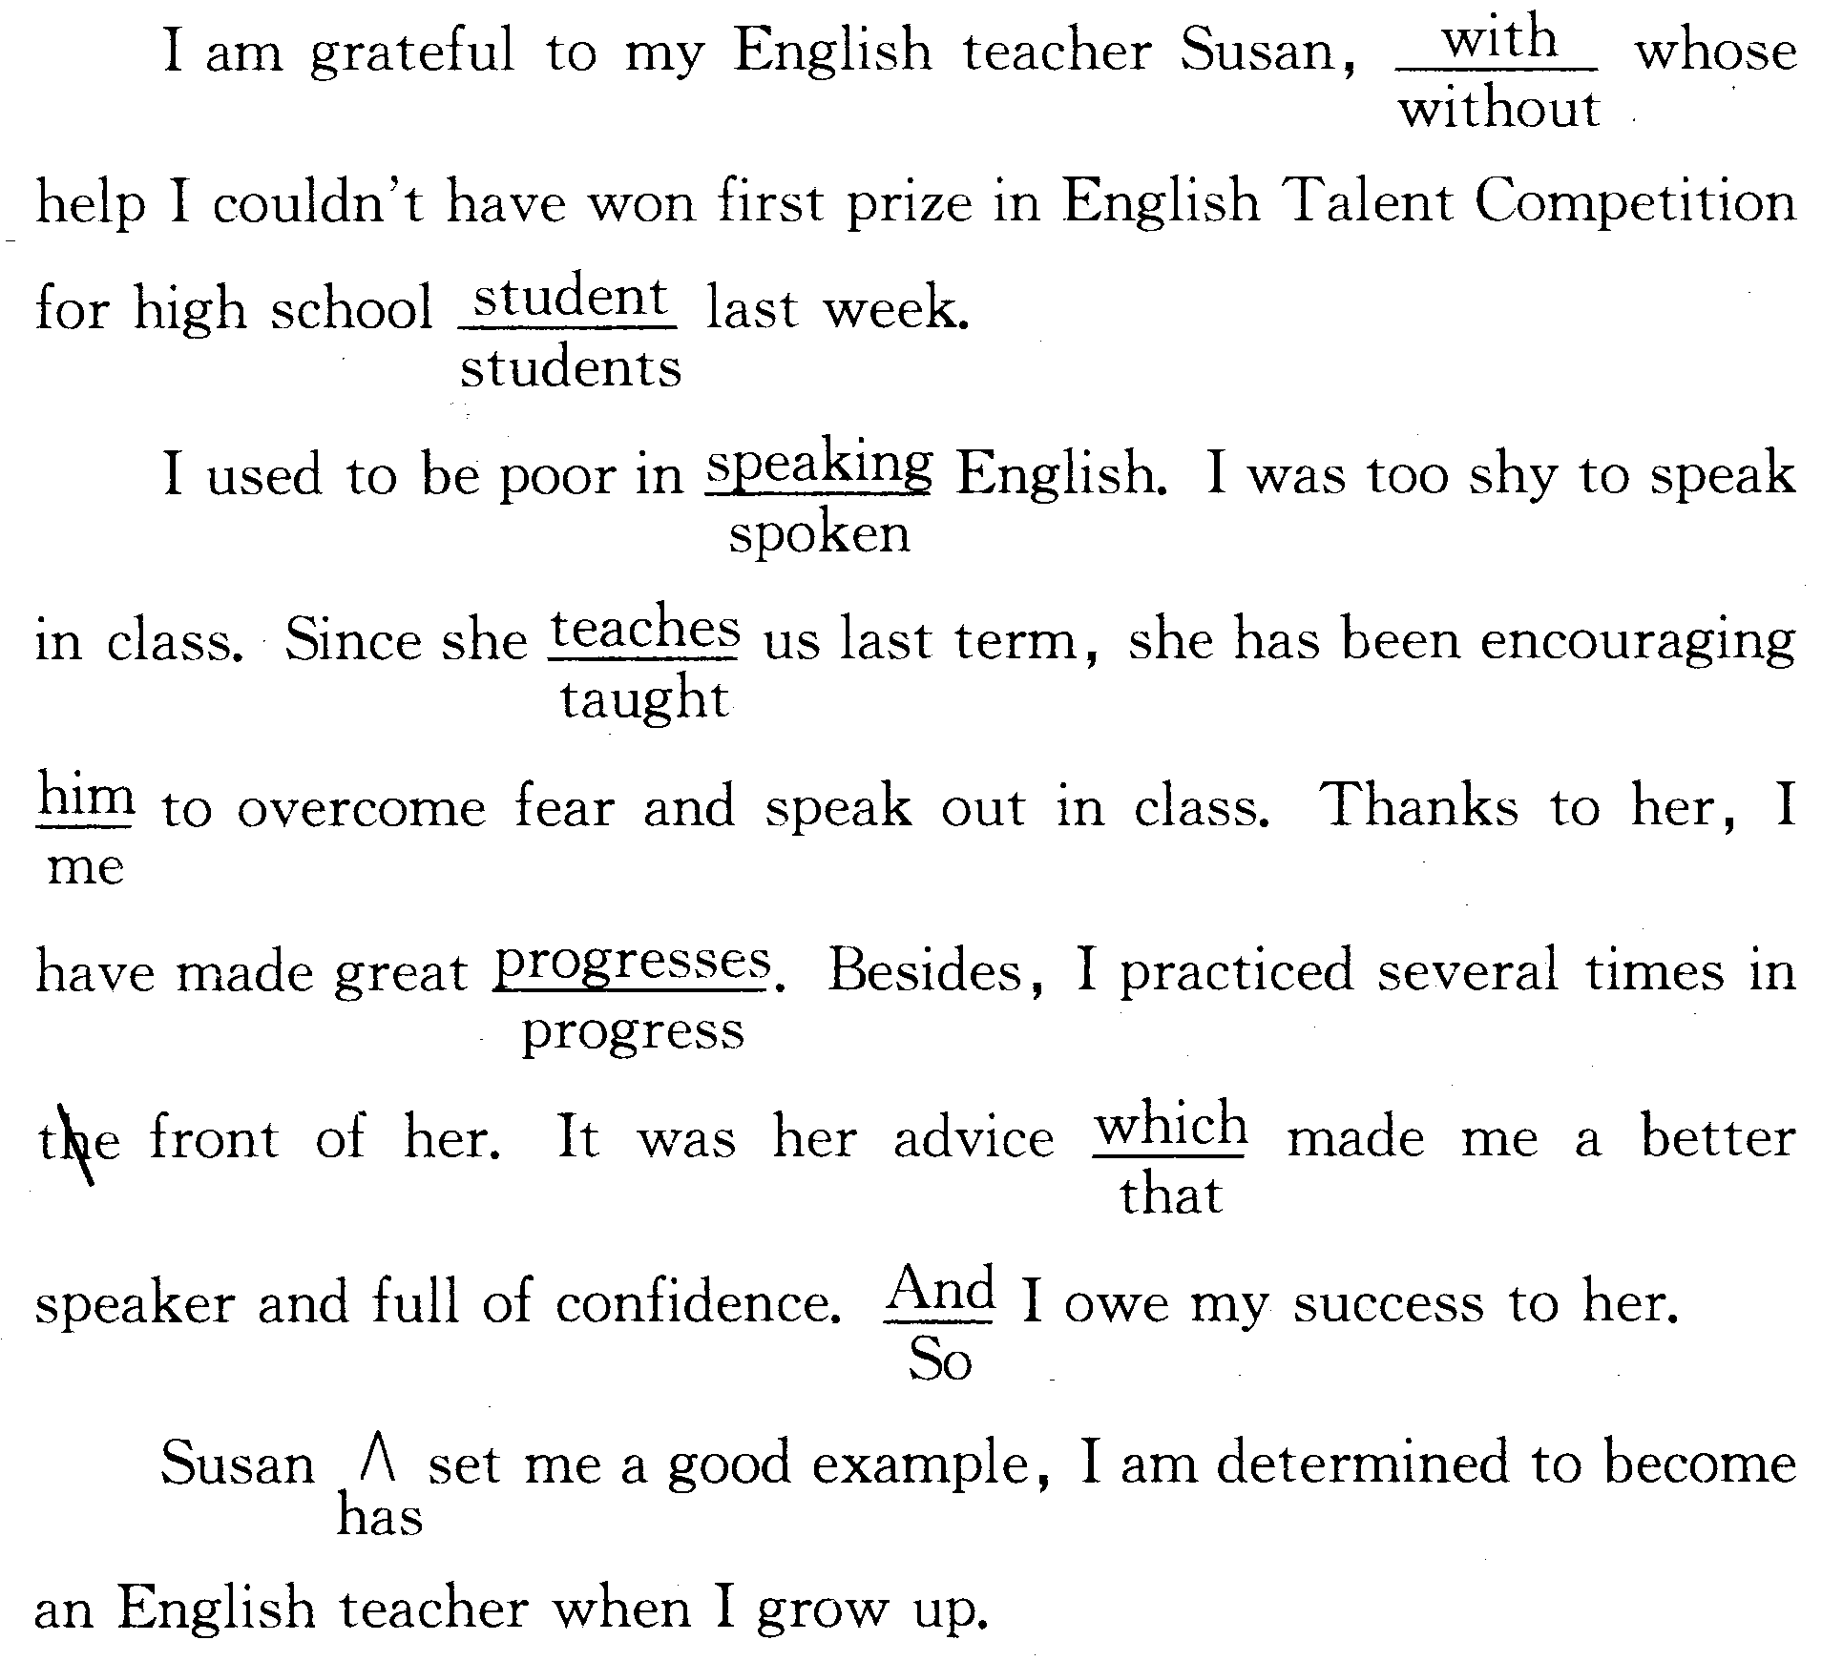

作文

